How to Read Blind: https://toptechtidbits.com/read
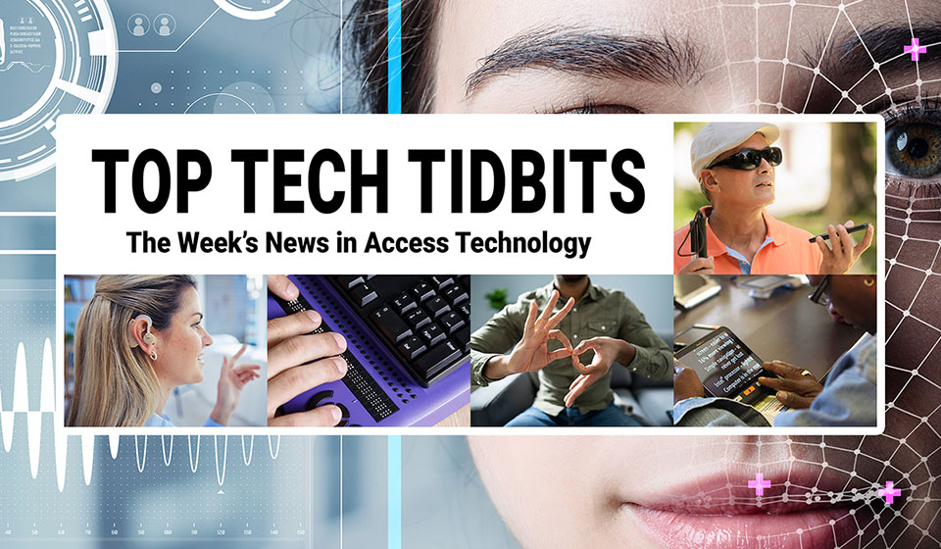
 |  |  |  |  |  |  |  |  |  |  |  | 
Top Tech Tidbits for Thursday, August 7, 2025 - Volume 1027
♿️ The Week's News in Access Technology
Top Tech Tidbits. The world's #1 online resource for current news and trends in access technology.
A Mind Vault Solutions, Ltd. Publication
Subscribers: 41,090 🔢️ opt-in subscribers were sent this issue via email.

Sponsors 🏅️
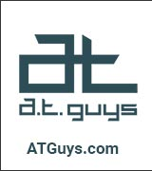 |  |  |  | 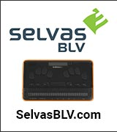 | 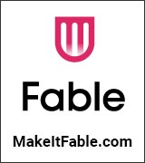
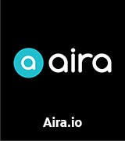 | 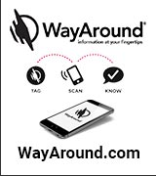 | 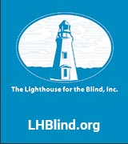 | 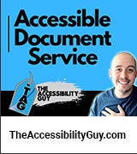 |  | 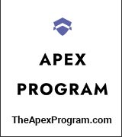
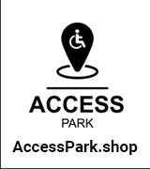 | 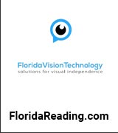 |  | 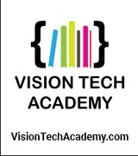 | 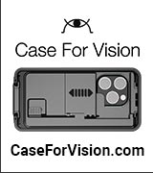 | 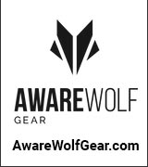
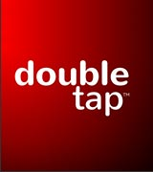 | 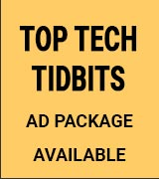 | 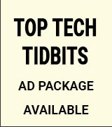 | 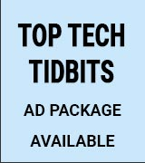 | 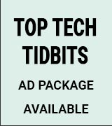 | 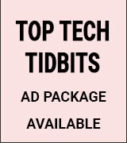

Access Awareness: Updates That Matter ♿️
Neuralink Reveals First Female Patient | The Tesla Space | July 30, 2025
Elon Musk's Neuralink successfully implanted its brain-computer interface into two new patients on the same day — Nick Ray, an ALS patient, and Audrey Cruz, the company's first female participant, a quadriplegic since a teen car accident. Using 128 electrode threads (double those of the first patient), Audrey can already draw and plans to write a book, while both participants control computers purely by thought in an application Neuralink calls “telepathy.” Beyond these milestones, Neuralink is collaborating with universities in California and Spain on a bionic-eye project that could eventually restore — and even enhance — vision by feeding camera data directly into the brain.
This Week's Featured Advertisement 🎯️
Five (5) Sponsorship Packages Currently Available. Support Free Access Technology News For Disabled Readers All Over The World While Increasing Traffic To Your Properties Each Week. Advertise in every issue. Or just one.
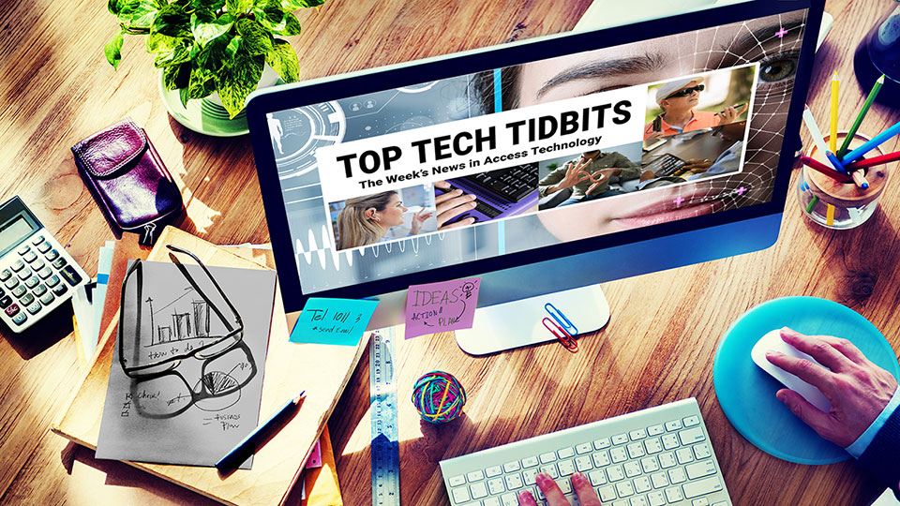
Join Top Tech Tidbits as a Sponsor today and begin reaching over 40,000 access technology subscribers each week, all while supporting the ongoing distribution of Top Tech Tidbits for those very same readers. Only $200 / month.
Key Newsletter Statistics:
- Subscribers: 40,000 + per week and growing.
- Open Rate: 46% (Average. Last 12 months.)
- Click Rate: 42% (Average. Last 12 months.)
- Bounce Rate: 1.1% (Average. Last 12 months.)
- Ad CTRs: 2-12% (Average. Last 12 months.)
Benefits All Sponsors Receive:
- One (1) Sponsor Profile on the Top Tech Tidbits website.
- One (1) Sponsor Profile in each weekly newsletter.
- One (1) Sponsor Wall Brand Advertisement on the Top Tech Tidbits home page.
- One (1) Sponsor Wall Brand Advertisement in each weekly newsletter.
- One (1) Classified Advertisement in each weekly newsletter.
- 50% Discount on all Sponsored Tidbit Advertisements.
- Free link tracking.
- Permanent SEO benefits.
- Gratitude from over 40,000 access technology subscribers for keeping Top Tech Tidbits free to read.
With additional benefits for Sponsors that pay quarterly or annually. Learn more today.
News 📰️
👉 Submit a Tidbit for free here, with timing and placement determined by our editors.
👉 Submit a Sponsored Tidbit here, with timing and placement determined by you.

1.) Top 5 Most Clicked Tidbits From Last Week 📊️
A.) How To Use Windows Magnifier: A Quick Tutorial For Low Vision Users 2025 | Sam Seavey | The Blind Life | YouTube.com | July 30, 2025
Learn how to activate and effectively use the Windows Magnifier, complete with setup advice and a demonstration of the Magnifier reader. Explore practical scenarios where this accessible tool can enhance productivity for low vision users without requiring additional downloads.
B.) Oakley Meta Glasses Review: A Familiar Formula With Some Upgrades | Engadget.com | July 29, 2025
Meta's Oakley-branded smart glasses offer performance-focused features, including improved battery life and a higher-quality camera for video recording. However, despite some solid upgrades, their design and price may not appeal to everyone, especially considering similar models are available at lower costs.
C.) How to Handle Difficult Scans with Complex Layouts in ABBYY FineReader PDF | The Accessibility Guy | YouTube.com | July 25, 2025
Learn effective techniques for managing complex page layouts in ABBYY FineReader. Master zoning, correct reading orders, verify OCR results, and produce clean, accessible PDFs with precise settings and options.
D.) I Lived With Alexa+ For A Week. Here's How It Went | Wired.com | July 29, 2025
The new Alexa+ introduces a more conversational and responsive AI experience on Echo Show devices, making interactions feel more engaging. With improved voice capabilities and the option for visual conversation elements, Alexa+ stands out, although it still has some limitations to address before going public.
E.) The Accessible Cube Resource | TactileCuber.com | July 26, 2025
TactileCuber is unique — an accessible resource for blind cubers solving tactile Rubik's Cubes and other twisty puzzles by touch. Here, you'll find algorithms and instructions in 100% plain text, all designed for screen readers and refreshable braille displays, with no advertisements, no videos, no diagrams, and no mouse-only controls.
2.) Five (5) Sponsorship Packages Currently Available | TopTechTidbits.com | August 7, 2025
There are Five (5) Sponsorship Packages currently available. Would your product, service or message benefit from reaching over 40,000 access technology subscribers each week? For just $200 / month? If you're thinking yes, we invite you to try a Sponsorship Package with Top Tech Tidbits. The benefits are amazing and the traffic delivered to your properties each week is measurable. No obligation. Cancel anytime. When there are no Sponsorship Packages available, you can join the waiting list here.
3.) One Time Advertisements Available | TopTechTidbits.com | August 7, 2025
One time advertisements are available to anyone, with or without a Sponsorship. Would your product, service or message benefit from reaching over 40,000 access technology subscribers? If you're thinking yes, we invite you to check out our one time advertising options. They are cost-effective, targeted and measurable. Scheduling is optional. Learn more today.
4.) Premium Subscribers | TopTechTidbits.com | August 7, 2025
Next Issue: Premium Subscribers will receive their 14th issue of the Top 60 Most Clicked News Articles for April, May and June of 2025 on Monday, October 6, 2025. Back Issues: There are currently 13 back issues available. Premium Subscribers are entitled to all back issues, anytime they sign up. All available back issues will be sent to you via email within 24 hours of purchasing your subscription. Please Join Us: If you would like to receive a perfectly formatted and searchable Word Document with each of the Top 60 Most Clicked News Articles of the last 3 months listed neatly within it, please consider joining us today for just $1 a month.
5.) Sponsored Tidbits | TopTechTidbits.com | August 7, 2025
Use Sponsored Tidbits to reach the access technology community when you need to. Whether you are a current Sponsor or not. Drive traffic to your access product and service announcements, events, updates or fundraisers using this incredibly cost-effective and easy-to-use advertisement tool. Learn more today.
6.) Do You Have A Link In This Issue? Learn How To Track It For Free | TopTechTidbits.com | August 7, 2025
This article outlines, step-by-step, how you can get free website traffic reporting on any link to your domain (AKA domain name, website or web address) that has been published by Top Tech Tidbits since January 18, 2024, when we launched this feature.

7.) Apple Updates 🍎️
Skip this Tidbit to skip all updates on Apple.

A.) AppleVis Unlimited: What's New and Noteworthy for July 2025 | AppleVis.com | July 29, 2025
The July 2025 edition of AppleVis Unlimited highlights the latest accessible apps for the visually impaired, including new entries and updates on existing applications. Featured apps include Glory Frontline, an Audible First-Person Shooter, and other innovative tools designed to enhance user experience for blind and low vision individuals.

8.) AI Updates 🤖️
Skip this Tidbit to skip all updates on AI.

A.) I Tested 3 Text-to-Speech AI Models To See Which Is Best — Hear My Results | ZDNet.com | August 5, 2025
The article reviews three leading text-to-speech AI models, emphasizing their capabilities in generating humanlike speech. It highlights the unique features and performance of ElevenLabs, Hume AI, and Descript, noting the variability in realism and expressiveness among the tools, which cater to different user needs and preferences.
B.) Join Us For Our Comprehensive AI Training Series To Empower Your Future In The Workplace | FreedomScientific.com | August 2, 2025
The new AI training series offers live webinars and online guides focused on using AI tools like ChatGPT and Copilot to enhance productivity and independence in the workplace. The program caters to all skill levels, beginning with foundational concepts and progressing to practical applications.
C.) The $299 Halo Smart Glasses Will Remember The Names Of People You Meet | TheVerge.com | August 1, 2025
Brilliant Labs unveils the $299 Halo smart glasses, featuring the Noa multimodal AI agent, a Narrative memory system that recalls names and conversations, and a microOLED display with bone-conduction audio. Preorders are open now with shipping slated for late November 2025.
D.) Uber Eats Is Adding AI To Menus, Food Photos, And Reviews | TheVerge.com | July 31, 2025
Uber Eats is introducing AI enhancements to its menus, food photos, and reviews, allowing businesses to automatically generate menu descriptions and enhance image quality. Additionally, customers can now upload their own meal pictures, potentially earning credits if published, and a new Live Order Chat feature will enable direct communication between businesses and customers to address order inquiries.

Tips, Tutorials, Guides, Reviews, Walk-Throughs and How-To's 📚️

9.) JAWS Power Tip: How To Access Task View in Windows 11 | Freedom Scientific | TopTechTidbits.com | August 7, 2025
Use Task View in Windows 11 to manage open applications, virtual desktops, and recently opened files.
10.) JAWS Power Tip: How To Flag a Message in the New Outlook | Freedom Scientific | TopTechTidbits.com | August 7, 2025
Flagging a message in Outlook is an effective method to indicate that further action is needed. For example, you can flag a message you want to follow up on by a certain date. As you navigate your messages, JAWS will announce those that are flagged.
11.) Document Structure In Word: The Essentials | DigitalAccessTraining.com | August 1, 2025
This article provides essential insights into structuring documents in Microsoft Word for optimal accessibility and usability. Key techniques focus on improving navigability and content hierarchy to enhance reader experience.

News, Trends, Updates and Opinion Editorials 📰️

12.) Your Emails: Guide Dog Retirement, Brain Science & Blind Super Senses | Double Tap | YouTube.com | August 6, 2025
Listeners share personal stories about technology and its impact on blindness, from innovative solutions like the WeWALK Smart Cane to emotional experiences surrounding guide dog retirement. Engaging discussions cover topics such as sensory substitution, AI advancements, and the intersection of disability identity and technology.
13.) Navigating Life With Low Vision: Book Review | Sam Seavey | The Blind Life | YouTube.com | August 6, 2025
Explore a valuable resource for individuals living with low vision and their supporters through an insightful review of "Navigating Life with Low Vision" by Patrick Fischer. This comprehensive guide offers practical tools, information, and strategies designed to enhance independence and improve quality of life.
14.) Podcast: Eyes on Success Episode 2532 Tactile Cubing | August 6, 2025
How would you solve a Rubik's Cube if you were blind? Hosts Nancy and Peter talk with Paul Martz, author of the book "Solve It! The only speedsolving guide for blind cubers". Paul, who is blind, describes how he uses textures, memory skills, and blazing speed to participate in timed challenges against blind as well as sighted participants.
15.) The AI Assistant Revolution Is Quietly Happening — Literally | Double Tap | YouTube.com | August 5, 2025
Steven and Shaun explore the transformative impact of Google Gemini and Alexa's new "Plus" mode on smart speakers, featuring insights from listeners John and David. The episode delves into the challenges of smart home integration, subscription frustrations, and the ethical concerns surrounding ever-listening devices, all from a tech-savvy perspective catered to blind and low-vision users.
16.) New Group For The Discussion Of Multi-Line Braille Displays | Tech-VI List | August 5, 2025
A new discussion group has launched for users and enthusiasts of multi-line Braille displays, focusing on products like Monarch, Cadence, Codex, Canute, and Dot Pad. The group will cover features, troubleshooting, user demos, and plans to host Zoom discussions to foster deeper engagement.
17.) Blind-Friendly Pill Bottle Scanner You Can Use Anywhere | Double Tap | YouTube.com | August 4, 2025
Gregg Hayes presents Speakaboo, an innovative mobile app that utilizes AI to scan prescription pill bottles and audibly announce their contents. Designed for blind and senior users, this app operates offline and ensures reliable and private access to medication information without requiring special tags or hardware.
18.) Brava: The Infrared Oven That's Changing Accessible Cooking | Double Tap | YouTube.com | August 4, 2025
Brava revolutionizes cooking through its light-powered technology, allowing food to be prepared quickly and uniformly without preheating. Co-founders Travis and Zac share their commitment to accessibility, detailing the collaborative efforts made to ensure their app serves all users, including those with visual impairments.
19.) WeWALK: The Smart Cane That Does More Than Detect Obstacles | Double Tap | YouTube.com | August 4, 2025
Jean-Marc from WeWALK presents an innovative smart cane designed to revolutionize mobility for blind users. Featuring turn-by-turn navigation, obstacle detection, and user-friendly app connectivity, the WeWALK cane enhances independence while evolving through continual feedback from the blind community.
20.) Where Did All The Accessible Audio Apps Go? | Double Tap | YouTube.com | August 4, 2025
Marc from Montreal highlights the dwindling options for blind users in the realm of accessible audio-first social apps. As hosts Steven and Shaun delve into the decline of platforms like Zello and Clubhouse, they explore alternatives and emphasize the ongoing need for community-driven, accessible audio solutions.
21.) Clearing Up The JAWS Pricing Confusion | Double Tap | YouTube.com | August 4, 2025
Matt Ater and Ryan Jones clarify the complexities surrounding JAWS license types and pricing adjustments, including the recent removal and reinstatement of the Home Annual subscription. They delve into the implications of price changes and discuss innovations planned for the software's 30th anniversary, along with valuable insights into how organizations select screen reader platforms.
22.) Feel The Memories: 3D Printing Photos For The Blind | Double Tap | YouTube.com | August 4, 2025
CavCo's Robert Newman introduces groundbreaking AI-driven technology that transforms standard photographs into tactile 3D pieces of art, allowing blind individuals to connect with cherished memories through touch. With a focus on accessibility inspired by personal experience, CavCo aims to simplify the process so blind users can create their own tactile prints at home.
23.) J-Key: A Smarter iOS Keyboard For Motor And Visual Impairments | Double Tap | YouTube.com | August 4, 2025
J-Key revolutionizes the iOS typing experience for users with motor and visual impairments. Developed by Jamie Wallace, this innovative keyboard employs a unique clustering design that enhances precision and integrates seamlessly with VoiceOver, making texting easier and more accessible for individuals with disabilities.
24.) Kapsys Minivision 2+: The Simplified Smartphone For Blind Users | Double Tap | YouTube.com | August 4, 2025
Aram from Kapsys introduces the MiniVision 2+, a fully voice-operated smartphone designed to empower blind and low vision users with easy phone independence. Featuring a tactile keypad and accessible apps that allow for seamless navigation via voice commands or buttons, this device caters to seniors and others who find traditional smartphones challenging to use.
25.) Monarch, Mantis, And More: What's New From HumanWare | Double Tap | YouTube.com | August 4, 2025
HumanWare showcases groundbreaking innovations including the Monarch multi-line Braille display and Hark AI reading device. Martin Roberts reveals how these tools are transforming accessibility for blind professionals and students, highlighting features like spreadsheet navigation and AI-powered handwriting recognition.
26.) New Accessible USB Book Speaker With Bookmarking | Double Tap | YouTube.com | August 4, 2025
Synapptic reveals its innovative smartwatch and USB speaker tailored for individuals with vision loss. Highlighting a new Bluetooth speaker with bookmarking capabilities and an advanced smartwatch featuring accessibility features, Mary discusses how Synapptic is redefining technology for the visually impaired with future innovations hinted at but not fully revealed.
27.) One Remote To Speak Them All: Unwired Things For Accessible Living | Double Tap | YouTube.com | August 4, 2025
Unwired Things unveils a groundbreaking approach to assistive technology with a suite of devices controlled by a single talking remote. This innovative system allows for economic and flexible access to essential tools for blind users, with a range of new products on the horizon, designed to be both affordable and universally appealing.
28.) Samsung Galaxy Z Fold 7: A Game-Changer For Low Vision Users? | Double Tap | YouTube.com | August 4, 2025
Marc Aflalo showcases the Samsung Galaxy Z Fold 7, highlighting its sleek design, innovative hinge, and robust accessibility features tailored for users with low vision. The review elaborates on how its dual-screen capability enhances user experience, potentially shifting the landscape for foldable devices in the tech market.
29.) Tactile Cubing: Solving Rubik's Cube Without Sight | Double Tap | YouTube.com | August 4, 2025
Paul Martz shares his inspiring journey from vision loss to solving the Rubik's Cube, advocating for blind cubers through his innovative screen reader-friendly guide. Delve into the mechanics of tactile cubes and the cognitive benefits of cubing, while examining broader accessibility challenges in technology.
30.) In-Process 4th August 2025 | NVAccess.org | August 4, 2025
NV Access invites NVDA users to participate in the NVDA Satisfaction Survey 2025 to enhance the user experience. The announcement also shares insights on NVDA 2025.2 Beta 5, a close step towards the upcoming release candidate, highlighting changes and new features introduced in the beta version.
31.) National Braille Press Launches New Program To Produce Braille Products To Improve Accessibility For The Blind And Vision Impaired | PrWeb.com | August 4, 2025
National Braille Press has introduced a new braille products program utilizing advanced UV Ink printing technology to enhance accessibility in public spaces. The program focuses on creating ADA-compliant signage and other materials, improving navigation for blind and visually impaired individuals.

This Week's Spotlight Advertisement 🎯️
Vermont Association For The Blind And Visually Impaired Seeks A Visionary Executive Director
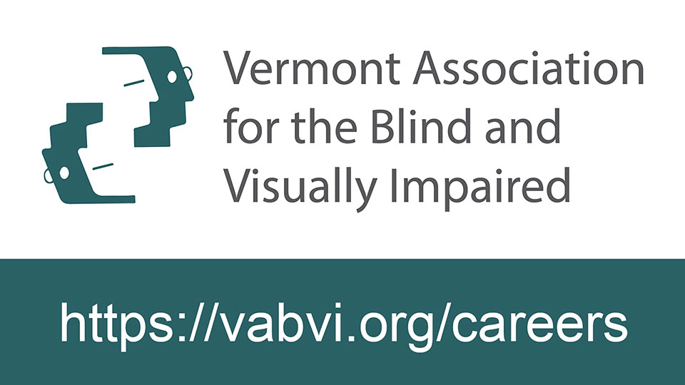
The Vermont Association for the Blind and Visually Impaired seeks a visionary Executive Director to lead our management team.
Headquartered in South Burlington, Vermont, VABVI is the only private, nonprofit, statewide agency providing training, services and support to infants, children and adults throughout Vermont. VABVI has an annual operating budget of $4.1 million.
The successful candidate will possess a vision for the future and strive to fulfill a mission that encourages and assists blind and visually impaired people to achieve or maintain their independence and quality of life. Salary range is $120,000 to $150,000 depending on experience.
Complete details of the responsibilities and qualifications for this position, as well as the Application process are available at: https://vabvi.org/careers.
📅 Application Deadline: August 31, 2025

32.) Elon Musk Makes Big Announcement About New Technology | MSN.com | August 4, 2025
Neuralink plans to launch human trials for its first vision-restoration brain implant within the coming year.
33.) I Don't Use Scripts: The Reality of a JAWS User | Accessibility4all.net | August 3, 2025
JAWS users often undervalue the significance of scripts, which enhance the functionality and efficiency of the software. The piece elaborates on how default scripts facilitate various tasks and improve productivity, ultimately arguing that every JAWS user utilizes scripts, whether they acknowledge it or not.
34.) Jieshuo Screen Reader's Suspend Screen Reader Gestures Function | AccessibleAndroid.com | August 3, 2025
A new function in the Jieshuo beta version allows users to suspend screen reader gestures, enhancing the typing experience by reducing lag. This functionality enables users to seamlessly activate items on-screen while maintaining gesture navigation for essential commands.
35.) Exploring The Latest Assistive Tech At The NFB 2025 National Convention In New Orleans | Sam Seavey | The Blind Life | YouTube.com | August 2, 2025
Participants experienced a diverse range of innovative assistive technologies at the 2025 NFB National Convention in New Orleans. From cutting-edge solutions to enhancements of classic tools, attendees had the opportunity to assess new products designed to improve accessibility for individuals who are blind or visually impaired.
36.) Finding Accessible Wireless Microphones | TimDixon.net | August 2, 2025
In this article, Tim Dixon shares his experience and findings on accessible wireless microphone systems, comparing the DJI Mic 2 and Rode Wireless Mic Pro. After evaluating features, compatibility, and accessibility, he ultimately selects the Rode Wireless Mic Pro as the best option for capturing clear audio without the hassle of tangled cables during his trip to Sight Village 2025.
37.) The Workplace Accessibility Debate: NVDA, JAWS, and What's Fair | Double Tap | YouTube.com | August 1, 2025
In a spirited follow-up discussion, Steven and Shaun delve into the complexities surrounding the adoption of NVDA in professional settings, countering security myths with insights from passionate listeners. The conversation addresses enterprise readiness, compares screen readers, and highlights systemic barriers affecting blind workers' participation in the workforce.
38.) Congratulations, You've Unlocked 'Expert Mode'! | NimerBlogs.blogspot.com | August 1, 2025
This article explores the challenges faced by individuals with disabilities in a world designed without their needs in mind, emphasizing issues like inaccessible technology, the burden of maintaining obsolete equipment, and the isolation created by modern design choices. It advocates for true equity and proper universal design, underscoring the need for genuine accessibility in both physical and digital spaces.
39.) Blindshell Monthly Newsletter 25th Edition | August 1, 2025
Hello, BlindShell friends. When we published the first issue in August 2023, we had no idea how much joy, feedback, and new ideas our community would bring us. Today marks two years since the publication of the first issue of the Monthly Newsletter, so we have prepared some interesting information for you. You can look forward to an interview with the developers and a competition!
40.) Troubleshooting And Tips For Connecting Monarch To A School Network | APH.org | August 1, 2025
Connecting the Monarch device to a school Wi-Fi network is essential for enabling its full range of learning features, such as email and book downloads. The article provides a detailed guide on how to connect, troubleshoot common issues, and emphasizes the importance of having the latest software updates for optimal performance.
41.) Horizontal Scrolling Containers Are Not A Content Strategy | AdrianRoselli.com | August 1, 2025
Adrian Roselli critiques the use of horizontal scrolling containers as a design trend, highlighting usability and accessibility issues they create for various user groups. He emphasizes the need to reconsider these design choices in favor of better content organization and accessibility for all users.
42.) Smart Assistive Device Helping Visually Impaired People To Navigate More Confidently Wins Funding | ATToday.co.uk | July 31, 2025
A postgraduate student at University College London has developed a smart assistive device aimed at empowering visually impaired individuals to navigate safely and independently. The initiative, led by Ramneek Ahluwalia, secures funding to further develop and prototype the device with input from the visually impaired community.
43.) Podcast: Blind Level Tech: Interviews The CEO Of New Haptics To Discuss The Codex Multi-Line Braille Display | Podcasts.apple.com | July 31, 2025
Evan Starnes interviews Alex Russomanno, CEO of New Haptics, about the Codex — an innovative 4x32 multi-line braille display featuring pneumatic actuation, a touch interface, mechanical Perkins keys, and Linux-based software, designed for long-term, daily use with screen reader integrations and onboard applications.
Last Week 📅️
44.) Neuralink Develops Bionic Eye To Treat Blindness | TechCentral.ie | July 30, 2025
Neuralink has initiated a clinical trial aimed at developing an AI-powered bionic eye to restore vision for blind patients. The company plans to use its Blindsight chip, expected to be implanted in humans by 2030, and aims to support 20,000 surgeries annually by 2031.
45.) Smart Blind Technology Enhances Accessibility For UK's 16.1 Million Disabled Residents | BusinessMole.com | July 30, 2025
Motorised Blinds UK is revolutionizing accessibility for the 16.1 million disabled individuals in the UK through their innovative voice-controlled blind systems. These products not only adhere to the Equality Act 2010 but also improve the quality of life for users by enabling control without physical interaction.
46.) Kindle Software Update 5.18.4 Adds New Accessibility Features | Blog.the-eBook-Reader.com | July 30, 2025
Amazon's latest update for 11th and 12th gen Kindles introduces significant accessibility features, including an Assistive Reader that reads books aloud. The update also allows for larger text sizes and features a redesigned menu page view, although it is currently unavailable for 10th gen Kindles.
47.) Neuralink Reveals First Female Patient | The Tesla Space | July 30, 2025
Elon Musk's Neuralink successfully implanted its brain-computer interface into two new patients on the same day — Nick Ray, an ALS patient, and Audrey Cruz, the company's first female participant, a quadriplegic since a teen car accident. Using 128 electrode threads (double those of the first patient), Audrey can already draw and plans to write a book, while both participants control computers purely by thought in an application Neuralink calls “telepathy.” Beyond these milestones, Neuralink is collaborating with universities in California and Spain on a bionic-eye project that could eventually restore — and even enhance — vision by feeding camera data directly into the brain.
48.) Foundations: Types Of Assistive Technology And Adaptive Strategies | Tetralogical.com | July 28, 2025
This article provides a comprehensive overview of common assistive technologies and adaptive strategies that support individuals with various disabilities. It emphasizes the importance of using tailored tools and approaches to ensure accessibility and inclusive experiences for everyone.
49.) Neuralink Joins UCSB-Led Clinical Trial to Develop Smart Bionic Eye | WION | July 28, 2025
In July 2025, Neuralink announced its participation in a clinical study led by the University of California, Santa Barbara, aimed at developing a Smart Bionic Eye — an AI-powered visual prosthesis. Termed Blindsight, the technology seeks to help blind individuals recognize faces, navigate environments, and read by directly stimulating the visual cortex. Neuralink's role will involve incorporating its patients “once available” into the trial, with human implants expected by late 2025. The company has previously received FDA Breakthrough Device status for Blindsight.
50.) Countdowns And Timers — Forgotten Detail That Can Make Your Users Really Hate Your Product | Cerovac.com | July 26, 2025
The importance of considering all users when developing countdowns and timers is highlighted, especially in financial sectors where legal requirements for timeout notifications are prevalent. The article emphasizes the necessity of testing with screen readers to ensure accessibility, as excessive status messages can lead to a frustrating user experience.
51.) Implementing Accessible SVG Elements | A11Y-Collective.com | July 24, 2025
Learn essential techniques for creating accessible Scalable Vector Graphics (SVG) across digital platforms. This guide covers SVG accessibility fundamentals, best practices, and the implementation of ARIA roles that enhance the experience for users relying on assistive technologies.
52.) How To Create Audio Description VTT Files For Free: No Fancy Tools Needed | Meryl.net | July 24, 2025
This article provides a step-by-step guide for creating audio description VTT files using captioning tools without requiring paid software. It addresses common issues with audio description file formatting and offers tips for hosting and embedding accessible videos on a WordPress site using Able Player.
53.) Windows PC To PC Migration Tool Its Seriously Time To Think About A New Windows 11 System! | AccessiblePass.net | July 23, 2025
The article outlines a guide for users transitioning from Windows 10 to Windows 11, highlighting Microsoft's built-in PC to PC migration tool that simplifies the transfer of data, settings, and apps. It explains the setup process and emphasizes the accessibility features designed to aid users with screen readers, ensuring a smooth migration experience.
54.) Embedding Accessibility SMEs In Remote Teams | Buttondown.com | July 23, 2025
The article explores the logistics and benefits of integrating embedded accessibility resources within product teams, emphasizing the importance of structure, communication, and alignment with compliance goals. It discusses the potential challenges, such as knowledge isolation and burnout, while highlighting strategies for effective embedding that enhance overall accessibility maturity.
55.) State Of HTML 2025 Now Open! | LeaVerou.me | July 22, 2025
The State of HTML 2025 survey is now open for participants, encouraging all web platform workers to voice their opinions. The survey results will play a crucial role in shaping browser roadmaps and prioritizing features that developers care about.
56.) Font Comparison And Review: Atkinson Hyperlegible Mono | Anthes.is | July 22, 2025
This review evaluates the Atkinson Hyperlegible Mono font's advantages in character distinction and readability, especially when compared to popular programming fonts like JetBrains Mono and Fira Code. It highlights unique features such as enhanced letterforms and design choices aimed at improving legibility for developers.
57.) Designing For User Font-Size And Zoom | OddBird.net | July 22, 2025
This article explores the challenges of adjusting font sizes across different user preferences and site designs. It discusses approaches to integrate user preferences with author designs, highlighting the necessity of fluid typography to enhance user experience while navigating varying text size requirements.
58.) Super Short Note: Placeholder Perfidy | Html5Accessibility.com | July 21, 2025
The placeholder attribute is intended as a short hint for users during data entry, but should not replace proper labels for accessible naming. The author expresses regret for previously implying that placeholder content is a suitable alternative and highlights the importance of correctly associating labels and accessible names in web forms.
59.) Why Use Able Player Instead Of 'Video'? | JoeDolson.com | July 19, 2025
Able Player provides a consistent and accessible video experience, addressing limitations of the native video element across different browsers. With features like full track support and a navigable transcript, it enhances user interaction, particularly for those requiring additional accessibility features like audio descriptions and synchronized sign language.
60.) Introducing Accented | Accented.dev | July 16, 2025
Accented offers real-time accessibility auditing for web applications with minimal setup, using axe-core to detect issues as they arise during development. The tool highlights problematic elements, facilitating quick fixes and enhancing overall application accessibility without the need for manual audits.
61.) Testing Methods: Identify Purpose | DennisDeacon.com | July 15, 2025
This article outlines the WCAG Success Criterion 1.3.6, which focuses on identifying the purpose of interface components and content regions to enhance accessibility, particularly for users with cognitive disabilities. It evaluates testing methods including automated, AI-based, and manual approaches to ensure effective implementation of accessibility standards.
62.) Why I'm Writing Pure HTML & CSS In 2025 | Joeldare.com | July 14, 2025
Utilizing pure HTML and CSS simplifies web development by eliminating complexity from frameworks and JavaScript, resulting in faster, lightweight pages. This approach enhances accessibility, SEO, and reduces security vulnerabilities, making it effective for sustainable web practices.
Featured Events 📅️
👉 Submit your event for consideration within this section here.

August 7, 2025 | Fireside Chat: Digital Accessibility With Hard Of Hearing & Legally Blind Experts | Blind Institute of Technology
10:00 AM PT, 11:00 AM MT, 12:00 PM CT, 1:00 PM ET, 5:00 PM GMT
Join Candice Dexter and James Warnken for a candid 45-minute discussion exploring digital accessibility through the lived experiences of individuals who are hard of hearing and legally blind. Gain practical advice, user-centered insights, and a deeper understanding of how to move beyond compliance to create inclusive digital environments that empower everyone.
August 7, 2025 | Breaking Down Barriers — An Introduction To AI And JAWS | Freedom Scientific
9:00 AM PT, 10:00 AM MT, 11:00 AM CT, 12:00 PM ET, 4:00 PM GMT
In this new webinar series from Freedom Scientific, Elizabeth Whitaker and Rachel Buchanan introduce practical ways to harness Artificial Intelligence using JAWS, ZoomText, and Fusion. Learn how to enhance productivity with AI tools built into JAWS, explore popular mainstream AI solutions, and discover how to integrate them into your workflow for greater accessibility.
August 9, 2025 | BARD Website And DA2 Release | Maryland State Library For The Blind And Print Disabled
7:00 AM PT, 8:00 AM MT, 9:00 AM CT, 10:00 AM ET, 2:00 PM GMT
The Technology User Group presents an overview of updates to the NLS BARD website and the upcoming DA2 player for qualified patrons. Attendees will learn about key differences from the previous DA1 model and explore new features designed for accessibility and enhanced user experience.
August 11, 2024 | How To Get Started With Project-Based Accessibility Research And Testing | MakeItFable
10:00 AM PT, 11:00 AM MT, 12:00 PM CT, 1:00 PM ET, 5:00 PM GMT
Fable hosts a practical webinar on launching accessibility testing initiatives, focusing on how to begin testing with assistive technology users even without a large program. Learn to define manageable scopes, engage stakeholders, and communicate findings that influence product development and internal momentum.
August 13, 2025 | Clearview Go – Portability And Magnification Power (Acvrep Ce Approved, Assistive Technology Webinar) | Access Ingenuity
10:00 AM PT, 11:00 AM MT, 12:00 PM CT, 1:00 PM ET, 5:00 PM GMT
Ian Ramos from Access Ingenuity and Joe McDaniel from Vispero explore the features and benefits of the ClearView Go, a portable magnifier with full-HD display and a folding design ideal for use in any environment. ACVREP continuing education credit is available for eligible participants.
August 13, 2025 | Learn How To Format Documents Using Markdown | Conklin Davis Center
1PM PT, 2PM MT, 3PM CT, 4PM ET, 8PM GMT
In this one-hour Tech Time session, the Conklin Davis Center demonstrates how Markdown enables users to create richly formatted documents without relying on word-processing software. Participants will learn practical techniques for writing and sharing Markdown on smartphones and other devices.
August 18, 2024 | Unlocking The Value Of Accessibility Testing With Assistive Technology Users | MakeItFable
10:00 AM PT, 11:00 AM MT, 12:00 PM CT, 1:00 PM ET, 5:00 PM GMT
Fable presents a foundational session exploring the impact of accessibility testing with real users. Discover how assistive technology works in daily life, why human insight is crucial beyond automated tools, and how inclusive testing can be integrated into your workflow through small, actionable steps.
August 19, 2024 | Innosearch Game Night: Mystery Game Night (Finale!) | Innosearch
6:00 PM PT, 7:00 PM MT, 8:00 PM CT, 9:00 PM ET, 1:00 AM GMT
Innosearch wraps up the Game Nights series with a surprise finale challenge, rewarding top performers, most referrals, and consistent attendees with bonus credits and cash prizes. Full details here. Questions? Email us at support@innosearch.ai 📧️.
August 20, 2025 | AI Reality Check for Disability Advocates and Innovators | Mai Ling Chan | Exceptional Leaders Network
2:00 PM PT, 3:00 PM MT, 4:00 PM CT, 5:00 PM ET, 9:00 PM GMT
Think AI is just hype? Think again — it's already shaping disability access, often without your voice. Join Mai Ling Chan, CCC-SLP, for a candid, interactive 1-hour session that will challenge what you think you know about AI and disability advocacy. Discover where AI is getting it wrong, how biased data and inaccessible tools are creeping into hiring, healthcare, and education, and — most importantly — how you can take back control. You'll learn practical ways to influence AI, protect yourself and your clients, and stop being sidelined by systems built without your input. Perfect for disability professionals, educators, content creators, and advocates ready to lead, not follow. Don't let AI create a future without you — step up, get informed, and be part of the solution. Reserve your spot now — and be a part of this epic event!
August 20, 2025 | Part 2: PDF Accessibility Basics – How To Test For Accessibility With JAWS (Digital Accessibility Webinar) | Access Ingenuity
10:00 AM PT, 11:00 AM MT, 12:00 PM CT, 1:00 PM ET, 5:00 PM GMT
Join Rachel Reeves to learn how to test PDF documents for accessibility using JAWS. This session outlines both automated and manual testing strategies aligned with WCAG requirements to ensure digital content meets accessibility standards.
August 25, 2025 | Join Selvas BLV At This Upcoming Webinar | Selvas BLV
5PM PT, 6PM MT, 7PM CT, 8PM ET, 1AM GMT
Selvas BLV's Earle Harrison and Hims' Jenny Axler showcase the newest features of the BrailleSense 6 Android tablet and Braille eMotion smart display during this free, one-hour evening webinar.
August 27, 2025 | Outlook With JAWS: Custom Rules And Signature Creation (Assistive Technology Webinar) | Access Ingenuity
10:00 AM PT, 11:00 AM MT, 12:00 PM CT, 1:00 PM ET, 5:00 PM GMT
Assistive Technology Specialists Mark Schaffer and Ian Ramos explain how to enhance email workflows using JAWS and Microsoft Outlook, covering custom rules, email management techniques, and creating professional signatures.
August 28, 2025 | Supercharge Your Bottom Line Through Disability Inclusion Webinar: From Rocket Science To Inclusion Science: Paolo Gaudiano's Data-Driven Path To Disability ROI | Dr. Kirk Adams
11AM PT, 12PM MT, 1PM CT, 2PM ET, 6PM GMT
In this live webinar, Dr. Kirk Adams and Paolo Gaudiano of Aleria demonstrate how data-driven tools like the Inclusion Impact Calculator can expose the hidden costs of exclusion and reveal measurable returns from disability inclusion, offering leaders clear, actionable steps to drive competitive advantage through evidence-based workplace equity.
August 28, 2025 | Selvas BLV Product Overview | Selvas BLV
3:00 PM PT, 4:00 PM MT, 5:00 PM CT, 6:00 PM ET, 10:00 PM GMT
Earle Harrison and Antonio Guimaraes provide an overview of SELVAS BLV's productivity tools, including Braille tablets, Braille displays, and multimedia devices designed for seamless use and accessibility.
September 16-17, 2025 | The Deaf And Hard Of Hearing Accessible Technology's State Of Science Conference | Gallaudet University's Technology Access Program
6:00 AM PT, 7:00 AM MT, 8:00 AM CT, 9:00 AM ET, 1:00 PM GMT
In this two-day hybrid gathering, Gallaudet University's Technology Access Program showcases cutting-edge research on caption quality, hearing-technology accessibility and sign-language innovation, featuring keynotes, breakout discussions and student presentations aimed at advancing equitable communication tools for the Deaf and Hard of Hearing community.
September 22, 2025 | Twenty-Sixth Audio Description Institute | American Council Of The Blind
1:00 PM PT, 2:00 PM MT, 3:00 PM CT, 4:00 PM ET, 8:00 PM GMT
Led by Dr. Joel Snyder, this five-day virtual training from the American Council of the Blind offers an in-depth introduction to the theory, techniques, and applications of audio description. Attendees will gain practical skills through lectures, discussions, and collaborative sessions, and receive a certificate of completion along with a training manual.
November 15, 2025 | International Neurology Conference 2025 | PubScholars Group
12:00 AM PT, 1:00 AM MT, 2:00 AM CT, 3:00 AM ET, 8:00 AM GMT
The International Neurology Conference 2025 is a flagship hybrid event hosted by PubScholars Group on November 15-16, 2025, at the Hard Rock Hotel at Universal Orlando (5800 Universal Blvd, Orlando, FL) and streamed online. The conference explores "Mind-Brain Connection: Understanding Neuroscience through Mental Health," aiming to integrate cutting-edge science with clinical relevance. Who Should Attend: Neurologists, neurosurgeons, neuroscientists, psychologists, rehabilitation professionals, engineers, industry leaders, students, and allied health practitioners. Important Dates & times: Abstract Submission Deadline: September 15, 2025. Registration Deadline: September 30, 2025. Event Timing: November 15, 2025 (8 AM start) - November 16, 2025 (6 PM close). Format: Hybrid Event (In-person & Virtual. Contact Person: Richard A. Email: info@pubscholars.org 📧️. Phone: +91 7042134266 📱️. Venue: Hard Rock Hotel at Universal Orlando, 5800 Universal Blvd, Orlando, FL 32819, USA.
May 21, 2026 | Tech Blitz 2026: Assistive Technology Showcase Brings Together Blind, Deafblind, And Low Vision Community For Innovation, Discovery, And Connection. | Helen Keller Services
3:00 PM PT, 4:00 PM MT, 5:00 PM CT, 6:00 PM ET, 11:00 PM GMT
In this in-person showcase hosted by Helen Keller Services, assistive technology vendors, innovators, and users come together for a day of interactive demonstrations, in-depth discussions, and community connection focused on advancing access and independence for the blind, DeafBlind, and low vision communities.

Directories 📝️
1) Top Tech Tidbits App Directory | Submit
2) Top Tech Tidbits Game Directory | Submit
3) Top Tech Tidbits Listserv Directory | Submit
4) Top Tech Tidbits Podcast Directory | Submit
5) Top Tech Tidbits YouTube Directory | Submit

Surveys 📝️
👉 Submit your survey for consideration within this section here.

1.) Survey: Interest Form: Accessible Data Structures Study for BVI Participant | NSITE | Deadline: August 31, 2025
Thank you for your interest in participating in our study on accessible data structure representations for blind and visually impaired (BVI) computer science learners. This short form will help us determine eligibility and schedule sessions. All information will be kept confidential. Participants will receive a $40 gift card after completing a 60-minute session. If you choose to participate in person, you may receive up to an additional $30 to help with transportation costs. You can read more details about the study in this document here. If you have any questions, feel free to contact Brianna Wimer at blwimer@uw.edu 📧️.
2.) Survey: NVDA Satisfaction Survey 2025 | Deadline: August 31, 2025
At NV Access we are always interested in understanding the satisfaction of our NVDA users. Plus we like to understand clearly what is important to you and also identify what we can do more effectively. We encourage you to complete the NVDA Satisfaction Survey 2025 to assist us with improving the NVDA user experience. It is a short, three question survey, which is anonymous and does not require signing in.
3.) Survey: Investigating The Use Of Generative AI To Support Travel Planning And Navigation For Blind And Low Vision Individuals | Forms.gle | Deadline: September 6, 2025
Monash University is conducting a study to explore how blind and low vision individuals use generative AI tools for travel planning and navigation, comparing their effectiveness with traditional orientation and mobility methods. Participants will complete a brief survey with the option to join a follow-up interview and enter a gift card draw.

Buy, Sell or Trade 📝️
👉 List your new, gently-used or refurbished item in FOUR (4) consecutive issues of Top Tech Tidbits for just $5 USD.

1.) FOR SALE: One Buy, Sell or Trade Advertisement (Just like this one.)
Price: $5.00 USD | Description: List your new, gently-used or refurbished item in FOUR (4) consecutive issues of Top Tech Tidbits for just $5 USD.

Sponsor Classified Ads 🎯️

⬆︎ 19.) Sponsor: Double Tap

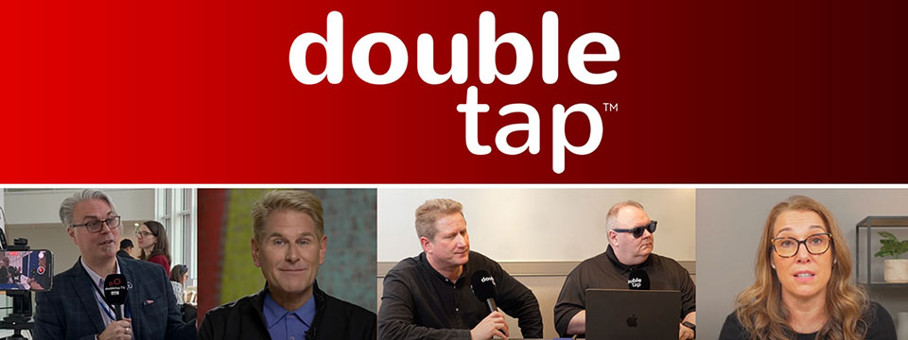

Sponsor Since: March 15, 2025 📅️
Website: https://doubletaponair.com/ 🌐️
About: Founded in 2017 as “Double Tap Canada” on AMI-audio, Double Tap has grown into a weekday podcast, radio show and YouTube series whose tagline proudly declares it "The Podcast Where Blind People Talk Tech." Its Glasgow-based creator Steven Scott, Manchester-based producer-co-host Shaun Preece and Canadian executive producer Marc Aflalo now helm more than 600 episodes that drop every weekday at noon ET, alongside written articles and video clips on DoubleTapOnAir.com.
Each episode blends mainstream gadget news with deep dives into assistive tools, all filtered through the lived experience of blind hosts. Listener emails, voicemails and WhatsApp messages are woven into the conversation, while spin-offs such as Shaun of the Shed (beginner tutorials) and past TV projects like Access Tech Live extend the brand across platforms in partnership with Accessible Media Inc. The result is a vibrant, multi-platform ecosystem that reaches audiences via AMI-audio, every major podcast app, YouTube and even specialist players like the Victor Reader Stream.
The community's enthusiasm shows: Double Tap recently surpassed one million cumulative downloads and, in March 2025 alone, attracted nearly 27K listeners generating 38K downloads; Apple Podcasts users rate it around 4.8 / 5. Authentic insights, daily consistency and professional production continue to position Double Tap as an essential, trusted voice at the intersection of mainstream tech and accessibility.
Newsletter (Double Tap Digest) | Facebook | Instagram | LinkedIn | TikTok | X (Formerly Twitter) | YouTube

⬆︎ 18.) Sponsor: Awarewolf Gear

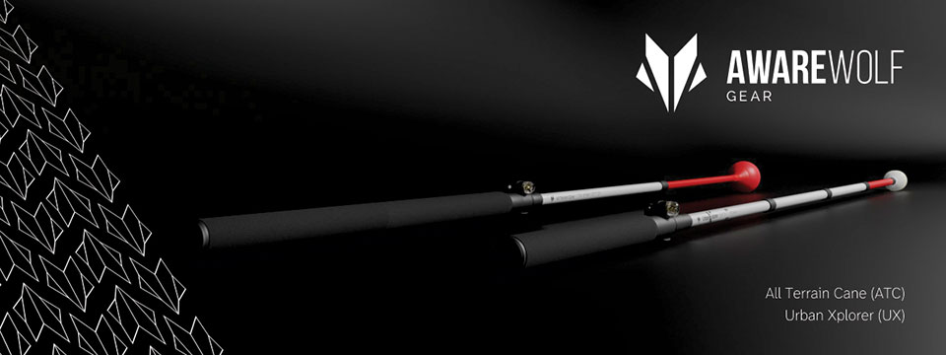

Sponsor Since: February 28, 2025 📅️
Website: https://awarewolfgear.com/ 🌐️
About: Awarewolf Gear is built on innovation, resilience, and a passion for adventure — especially for those in the blind and low vision community.
Awarewolf Gear is dedicated to redefining mobility through high-performance, thoughtfully engineered canes.
With the core belief that everyone deserves to explore confidently, our mission is encapsulated in our tagline, "Power for Life's Adventure."
Our product line, community initiatives, and inspirational storytelling all work in tandem to empower users to navigate diverse terrains with ease and independence.
Product Line
⚫️ All Terrain Cane (ATC)
Design & Purpose: The All Terrain Cane was originally engineered for the rugged trails of Sedona, Arizona. Made from durable titanium alloy, it is built to handle everything from sandy beaches to rocky mountain paths. Its adjustable 16-inch handle and high-performance roller ball tip provide stability and versatility across varied surfaces.
⚫️ Urban Xplorer Cane (UX)
Innovation & Versatility: Merging the rugged design of the ATC with enhancements for urban mobility, the Urban Xplorer Cane features an adjustable handle and a specially designed "Dome" cane tip. Available in multiple sizes (small, medium, large and extra-large), this lightweight, robust cane is ideal for navigating busy city streets as well as more challenging environments.
⚫️ Cane Tips
Customization & Performance: Awarewolf Gear's Cane Tips are designed to elevate your mobility experience by ensuring smooth, reliable navigation across all terrains. Crafted for both durability and style, these premium replacement tips allow users to personalize their canes while enhancing performance.
⚫️ Accessories and Apparel
Customization & Expression: Beyond canes, Awarewolf Gear offers a range of accessories — such as colorful replacement cane tips designed for visibility and personal expression — and apparel that carry the brand's adventurous spirit.
Instagram | Facebook | LinkedIn | YouTube

⬆︎ 17.) Sponsor: Case for Vision

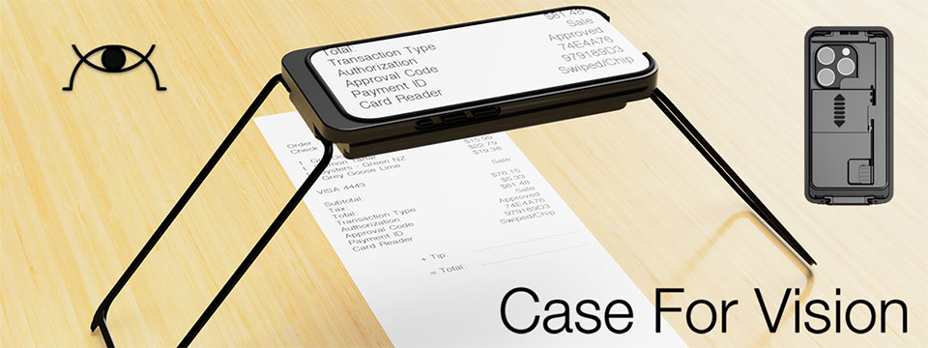

Sponsor Since: February 27, 2025 📅️
Website: https://caseforvision.com/ 🌐️
Phone: +1 (781) 343-1071 📱️
Email: contact@caseforvision.com 📧️
About: At Case For Vision, we design and manufacture assistive devices, for visually impaired people or those who suffer age-related vision loss.
Purpose: Leveraging technology with precision engineering and optics. We want to return the purchasing power to people, and disrupt the existing practice by replacing expensive proprietary devices or components with ubiquitous, mass-produced, powerful smartphones, tablets, and computers.
Case For Vision ( CFV ): The first device that we have launched is built for the iPhone. Find out how Case For Vision can aid you in everyday life.
The Case For Vision is an innovative iPhone-based optical mechanical case that functions as a hands-free local or distance high-quality magnifier when used with the Case For Vision 2.0 specialized software application. Designed to resemble a standard smartphone protective case, it is a powerful magnification tool for people with vision loss.
Case for Vision comes with a Lifetime Warranty and a Free Upgrade if you get a new phone.

⬆︎ 16.) Sponsor: Vision Tech Academy

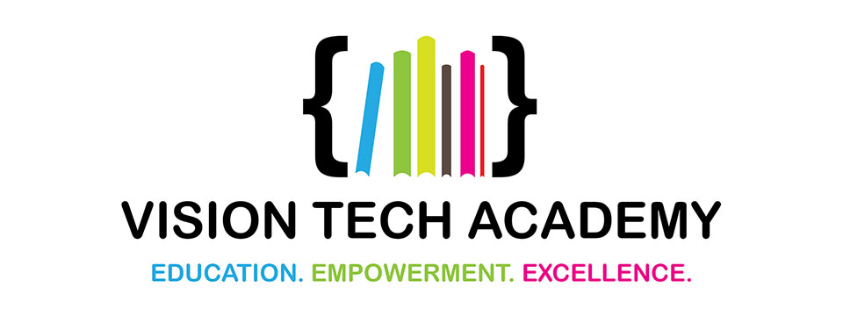

Sponsor Since: January 15, 2025 📅️
Website: https://visiontechacademy.com/ 🌐️
About: Vision Tech Academy is a website, platform and online directory dedicated to empowering blind and low-vision individuals by connecting them with trusted assistive technology educators for free.
Vision Tech Academy is the home of the free, access-technology specific, Online Directory of Educators (ODE).
Inspired by the legacy of John Panarese, the Academy website serves as a hub for accessible learning, offering a free directory of access educators, live and recorded courses, and resources to foster learning independence and success.
With an ongoing mission to provide high-quality, trusted, personalized training on tools like VoiceOver, JAWS, NVDA and Braille technology, Vision Tech Academy bridges the gap between technology and accessibility, ensuring inclusive and accessible education for all.
📖️ Free Directory for Students
📖️ Free General Profiles for All Access Educators
🏅️ Premium Profiles for Access Educators Who Want More Reach

⬆︎ 15.) Sponsor: Elegant Insights Braille Creations

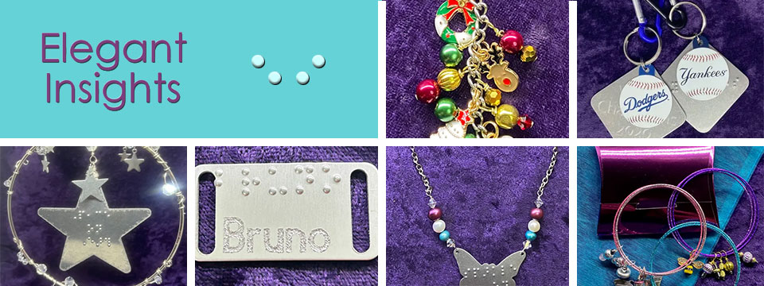
👉️ Classified Advertisement: Prepare For Takeoff: Summer Is Travel Season!
Going somewhere? Bring along our Clever travel accessories that will keep you organized and fashionable wherever your journeys take you. Our 3-piece Travel Ready Jewelry Case and Care set includes a mini zip-around jewelry box, polishing cloths, and anti-tarnish tabs to keep your jewelry sparkling all vacation long. The many colorful choices in our 3-piece makeup bag, lipstick case, and coin purse set will help you find your smaller items quickly in a tote or handbag. Headed to the NFB convention? Carry our special keytag that features a carabiner clip, a split ring for keys, a USA shaped charm braille-embossed with 2025 and a steel dog tag with the NFB motto "live the life you want" embossed in grade 2 braille. Finally, whether you'll be exhibiting, presenting, or networking, keep your calling cards, ID, or credit cards in one of our classy metal business card cases. Call +1 (702) 605-1265 or shop online at https://elegantinsightsjewelry.com. Bon voyage!
x (Formerly Twitter) | Facebook | Instagram

Sponsor Since: November 22, 2024 📅️
Website: https://elegantinsightsjewelry.com/ 🌐️
About: Elegant Insights Braille Creations, founded by Laura Legendary, offers a distinctive collection of handcrafted jewelry and accessories embossed with crisp, readable braille.
Inspired by a personal experience, Laura, who is blind, established the brand to merge style with accessibility, providing beautiful and inclusive products. Each piece is made in the USA and can often be personalized or custom-designed to meet individual preferences.
Beyond her work with Elegant Insights, Laura co-founded The Fashionability Channel podcast, which provides beauty, fashion, and lifestyle information for people with disabilities. She also maintains two blogs: the Accessible Insights Blog, offering information on products and services for individuals with low or no vision, and the Sparkle On Blog, which provides jewelry education, design trends, and style information.
Laura's dedication to accessibility and advocacy extends to her role as a speaker, author, and educator specializing in these areas. Her multifaceted efforts aim to empower individuals with disabilities, ensuring they have access to stylish, functional, and meaningful products and information.
Home | About Elegant Insights | Ordering, Shipping and FAQs | My Account | Checkout | Cart | Shop The Boutique | Wish List | Testimonials | Subscribe

⬆︎ 14.) Sponsor: Florida Vision Technology

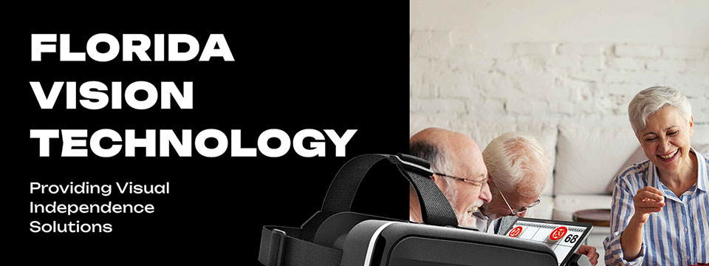

Sponsor Since: October 13, 2024 📅️
Website: https://floridareading.com/ 🌐️
About: Florida Vision Technology is officially celebrating its 20th anniversary. When I started in February 2000, the assistive technology industry was young, and there were just a handful of manufacturers.
Opening the business felt right, and I was ready to jump in. The biggest challenge, in the beginning, was getting a used bulky desk into the shed in my backyard, which my daughters named "Lesa Berg Kretschmer World Headquarters."
Three years later, in June of 2003, we moved into our first offsite location and opened a low vision superstore!
Home | Shop | Blogs | About Us | Contact Us

⬆︎ 13.) Sponsor: Access Park

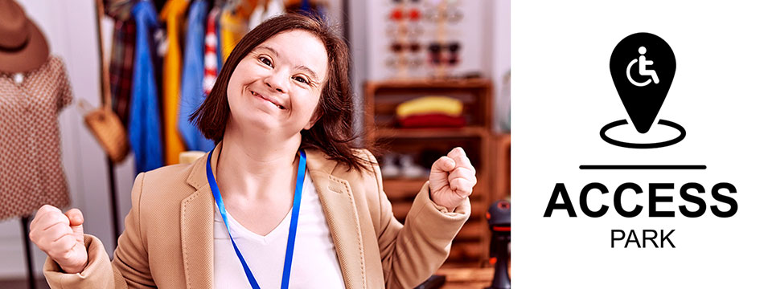
👉️ Classified Advertisement: Donna J. Jodhan's Pottery - Piece By Piece! Building Blocks For Inspiration And Creation! | Access Park
My pottery pieces are designed to inspire your creativity and imagination! Each piece is crafted with care, offering a unique touch to your home and dining experience. Whether you're looking for elegant dinnerware, functional art, or custom pieces, I can help you bring your vision to life. From rustic charm to modern elegance, I specialize in creating pottery that fits your personal style and elevates your dining table. Let me customize a one-of-a-kind creation that reflects your taste and enhances your space, adding beauty and warmth to every meal. And check out the highlight of the month.

Sponsor Since: September 20, 2024 📅️
Website: https://accesspark.shop 🌐️
About: Access Park is your premier destination for accessible shopping.
At Access Park, we offer a curated selection of products aimed at enhancing the daily lives of persons with disabilities.
Whether you're looking for accessible tech gadgets, specialty assistive devices, or just everyday essentials, you'll find them here.
Access Park provides a shopping experience that prioritizes keyboard navigability, screen reader compatibility, and high-contrast visuals for those with visual impairments, in addition to other enhancements that provide an elevated shopping experience to users of various assistive technologies.
Access Park. Where inclusivity is always in stock. ^{(TM)}

⬆︎ 12.) Sponsor: The Apex Program

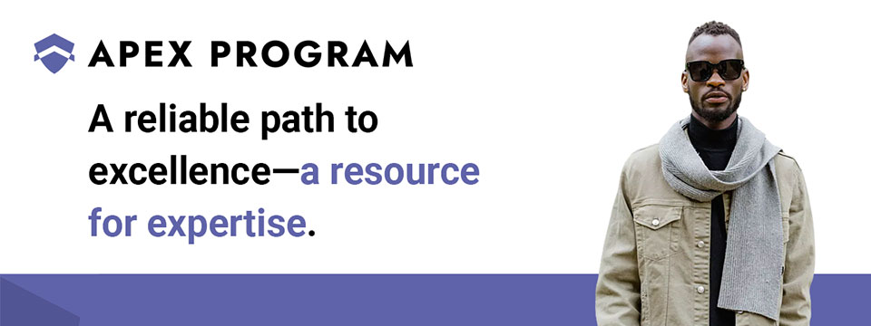
👉️ Classified Advertisement: Jumpstart Your Cybersecurity Career with the Apex Program! | The Apex Program
Are you ready to advance your career in cybersecurity? The Apex Program offers a comprehensive 12-week training course designed to prepare you for the CompTIA Network+ and Security+ certification exams. Tailored for the blind, visually impaired, disabled, and veteran communities, our program combines informative lectures, video tutorials, and quizzes, with expert instructor support every step of the way.
Get started today — Classes start on the first Monday of every month!
Don't miss this opportunity to join a diverse and inclusive workforce in the cybersecurity sector. Visit https://TheApexProgram.com to learn more and secure your spot today!
Sponsor Since: July 16, 2024 📅️
Website: https://theapexprogram.com 🌐️
About: Unlocking Abilities, Securing Futures. Founded on the principles of inclusivity and opportunity, the Apex Program is a pioneering educational initiative in cybersecurity, tailored for the blind, visually impaired, disabled, and veteran communities. Created by a Novacoast employee and inspired by his own journey from disability to Security Operations Center manager, the curriculum is designed to create a strong foundation of IT security knowledge, while instilling confidence and ensuring competence in the IT talent pool. Our ten-week program culminates in industry-recognized CompTIA certifications and a guaranteed pathway to employment, courtesy of Novacoast's dedicated IT Staffing division. At Apex, we don't just teach cybersecurity; we transform lives by unlocking potential and advocating for diversity in the IT security workforce.
Mission: The Apex Program is committed to bridging the gap in cybersecurity talent by empowering the blind, visually impaired, disabled, and veteran communities through inclusive, accessible, and comprehensive training. Our mission is to nurture a diverse workforce equipped with the necessary IT security skills and certifications to thrive in the cybersecurity sector. In partnership with Novacoast, we ensure a solid educational foundation and job placement in the industry, further fostering a future where every individual can focus their distinct abilities on building a more secure digital world.
Novacoast: Novacoast is a cybersecurity and IT services company that helps organizations enhance their security posture. They offer a range of services, including cybersecurity advisory, security engineering, identity and access management, development and integration, penetration testing, managed security services, and incident response. Their managed services include co-managed SIEM, DLP, EDR, vulnerability and patch management, phishing monitoring, and threat operations. Novacoast also provides specialized services for different industries such as finance, healthcare, and gaming. Additionally, they offer staffing solutions and training programs. Learn more today.
Home | A Division of Novacoast | Novacoast Federal | The Program | About Us | Partnerships | Media | Contact

⬆︎ 11.) Sponsor: Innosearch.ai

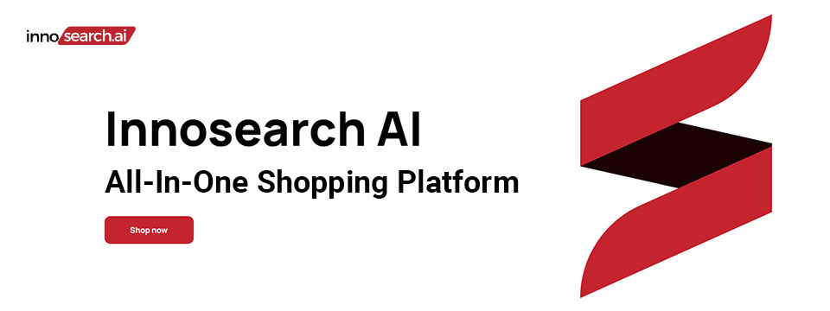
👉️ Classified Advertisement: Shop by Phone — No Screens, Just Your Voice!
Call 1-855-SHOP-GPT (1-855-746-7478)
Shopping online can be hard if you're blind, visually impaired, or not tech-savvy. That's why Innosearch AI created Shop by Phone — a 100% free, voice-only service.
Just call and say what you need:
👉 “Find me a phone charger.”
👉 “Add it to my cart.”
👉 “Check out.”
No apps, no websites — just easy, hands-free shopping from over 500,000 stores.
- ✔ Free to use
- ✔ Works anywhere, anytime
- ✔ Perfect for seniors, blind, and low-vision users
Available in:
- 🇬🇧 UK: +44 7727 247467 📱️
- 🇨🇦 Canada: +1 782 222 7467 📱️
- 🇦🇺 Australia: +61 489 267 467 📱️
- 🇺🇸 USA: 1-855-SHOP-GPT 📱️ (1-855-746-7478 📱️)
Call now and shop with ease!
Sponsor Since: June 7, 2024 📅️
Website: https://www.innosearch.ai 🌐️
Email: info@innosearch.ai 📧️
About: Innosearch is an all-in-one shopping platform augmented with a cutting-edge AI-powered shopping assistant. This innovative feature mimics the experience of shopping in real life by allowing you to interact with the assistant using natural language. It aggregates millions of products from top US online retailers, bringing them directly to you. With this advanced generative AI, Innosearch offers personalized product recommendations, highlights the best deals, and provides comprehensive information including reviews, total prices, shipping options, and more. Innosearch delivers a seamless end-to-end shopping experience, eliminating the need to search and browse in multiple tabs across retailers.
YouTube Review By Sam Seavey: https://youtube.com/watch?v=-rjL-HAwaZY.
Key Features: Key Features of the Innosearch All-in-One AI Shopping Platform include:
➜ Research Products: Easily compare products across retailers, or weigh pros and cons of similar products to make informed decisions.
➜ Uncover the Best Deals: Never miss a door buster, coupon, or clearance sale again. Get notified about the best prices and offers.
➜ AI Summarized Trusted Reviews: See what others are saying and make confident purchases.
➜ All in One: Innosearch brings millions of products from top online retailers directly to you, allowing you to shop the best deals with easy checkout and personalized AI assistance.
➜ Shop with Confidence: Rest assured, Innosearch has you covered with free shipping and returns on every purchase.
➜ Know Before You Buy: Innosearch equips you with expert buying guides, empowering you to make well-informed decisions.
How To Shop: Simply create a free account and start shopping today!

⬆︎ 10.) Sponsor: The Accessibility Guy

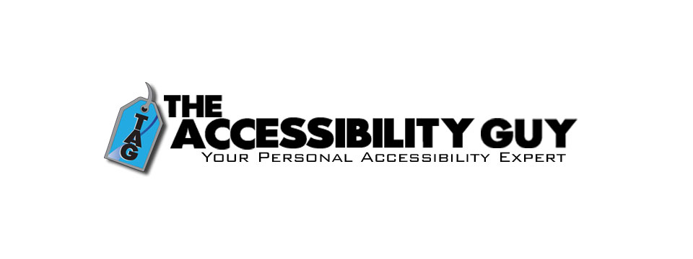
👉️ Classified Advertisement: How to Tag Multiple Languages in a PDF | The Accessibility Guy
More Adobe Acrobat accessibility tips!
My latest post explains how to properly tag individual language sections in a multilingual PDF. Adobe Acrobat offers tools to assign language codes to specific sections, allowing screen readers to interpret and vocalize the content accurately.
Check out The Accessibility Guy's full suite of Accessibility services.
Sponsor Since: August 3, 2023 📅️
Website: https://theaccessibilityguy.com/ 🌐️
YouTube: https://youtube.com/@TheAccessibilityGuy 📹
About: My name is Shawn Jordison and I love helping others learn the ins and outs of digital accessibility.
I have made over 100 thousand documents accessible, provided hundreds of trainings in the areas of accessibility and document remediation, and reviewed many websites and mobile applications for accessibility.
I have developed and reviewed VPATs, LMS courses, and other pieces of training. I am the accessibility Swiss army knife. Let me be your personal accessibility expert.
➜ Over 13 years of experience in the field of accessibility.
➜ Passionate about providing equal access to information for everyone.
➜ Wide range of project experience, including document accessibility, training, and more.
➜ Expertise in captioning, assistive technology, and accessibility best practices. I'm here to help you create a more accessible world.
The Blog: This blog covers topics like making Word, PDF & PowerPoint files accessible, Closed Captioning, assistive technology, and other important accessibility topics.
Training and Consulting: Offering customized training and consulting for implementing accessibility best practices.
Accessible Document Service: Providing top-tier document remediation services for all types of files, ensuring compliance with WCAG, 508, and PDF UA standards.

⬆︎ 9.) Sponsor: The Lighthouse for the Blind, Inc.

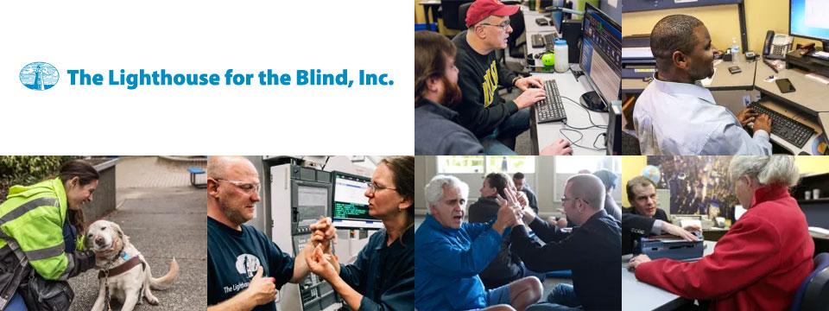
Sponsor Since: December 29, 2022 📅️
Website: https://lhblind.org/ 🌐️
Phone: (800) 914-7307 📱️
Fax: (206) 329-3397 ░
Contact Us: https://lhblind.org/contact-us/
About: The Lighthouse for the Blind, Inc. is a private, not-for-profit social enterprise providing employment, support, and training opportunities for people who are blind, deafblind, and blind with other disabilities. The Lighthouse has provided employment and support to people who are blind in our community since 1918.
The Lighthouse for the Blind, Inc. is a successful manufacturing organization with over 60 years of experience in precision machining. We produce an array of machined parts and plastic injection molding for various aerospace manufacturers, as well as a host of office products and hydration equipment sold to the Federal Government and the U.S. Military. We also own and operate stores on military bases along the West Coast. Our products and services include:
• Manufacturing: We are a successful manufacturing organization committed to making jobs accessible to individuals who are blind. Our manufacturing operations center on making quality products for the Federal Government under the AbilityOne Program and producing parts for aerospace manufacturers.
• Managed Services: The Lighthouse for the Blind, Inc. offers a variety of services to our commercial, federal, and military customers. These include Contract Management Support (CMS) services for government contracting offices.
• Base Supply Centers: We operate 12 AbilityOne Base Supply Centers (BSCs) that offer easy customer access to Lighthouse products, direct feedback and communication with customers, and employment opportunities for individuals who are blind in geographic areas not served by larger nonprofit agencies.

⬆︎ 8.) Sponsor: Wayaround

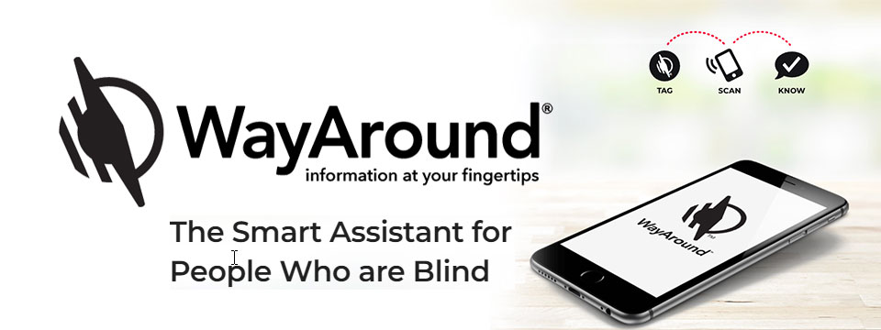
👉️ Classified Advertisement: FREE Sampler Pack with a Purchase of Any 25-pack of WayTags | Wayaround
WayAround is a smartphone-based labeling app that works with your preferred accessibility settings. You just need the free mobile app and some WayTags ® to label items in the kitchen, garden, closet, office & more.
If you want to label something that's inside, outside, wet, dry, hot, or cold, there's a WayTag that will attach securely. WayTags come as stickers, buttons, magnets, and clips. Each of the different styles of WayTags work exactly the same. Simply choose the WayTag that's best for what you want to label.
Purchase a 25-pack of any style of WayTag and get a free Sampler Pack so you can try all seven different WayTags. Enter the coupon code SAMPLE at checkout and the Sampler Pack will automatically be added to your cart. This is a $14.99 value! Limit one Sample pack per order.
Sponsor Since: January 5, 2023 📅️
Website: https://www.wayaround.com/ 🌐️
General Sales & Support: (888) 898-4465 📱️
Business Sales & Support: (888) 898-4465 📱️
Email: connect@wayaround.com 📧️
About: WayAround is the app for your smart device that provides on-demand details about everyday things. The simple tag-and-scan approach lets you quickly and easily identify things around you. It also provides extra details, like how something works or when it expires. The result? Doing more of the things you want, with more confidence and more independence.
All the information you want with just a tap of your phone. No more waiting around to ask someone. You need just two things to get started: The free mobile app for iOS or Android and some of our smart WayTags®.
Accessible labels for the blind, deafblind, and anyone with vision loss. Your biggest problem isn't poor eyesight. It's that so much of the information in the world is visual. But you shouldn't have to wait around for someone else to get the information you need. Or carry around a bulky, outdated device. There is a better way to get accurate and complete information every time. So you can reduce stress and gain independence.
Download The App (Apple): https://itunes.apple.com/us/app/wayaround-tag-and-scan/id1294361140?mt=8
Download The App (Android): https://play.google.com/store/apps/details?id=com.wayaround.wayaround

⬆︎ 7.) Sponsor: Aira

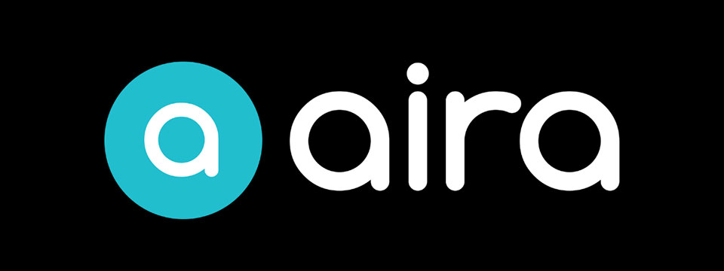
Sponsor Since: August 4, 2022 📅️
Website: https://aira.io/ 🌐️
Download the App: Apple App Store | Google Play Store
Plans and Pricing: https://aira.io/pricing/
Phone: NA: +1.800.835.1934 📱️ | AU: +1.800.765.096 📱️ | UK: +0.800.046.5668 📱️ | NZ: +1.800.425.451 📱️
Text Message: NA: +1.858.242.4457 📱️ | AU: +61.488.839.767 📱️ | UK: +44.149.320.2474 📱️
Email: support@aira.io 📧️
About: At Aira, we believe access to information is a human right. Aira breaks down accessibility barriers by providing on-demand video remote interpreting for both the blind and low-vision community, and the Deaf Community. People can download the Aira Explorer app or the Aira ASL app, and be instantly connected to a professional interpreter. Available 24/7/365, interpreters work with callers to facilitate more efficient communication and accomplish tasks together. Aira is proud to lead the way in delivering secure, on-demand, inclusive services that transform lives and open doors to new opportunities for all.
Contact Us | Access Partners | Plans and Pricing
Step One: Subscribe and Download. Pick the plan that lets you explore on your terms and on your time, sign up in a few minutes, and download the Aira app to your smartphone. Plans shown are for the United States, Canada, Australia, New Zealand and the United Kingdom. Add or cancel at any time.
Step Two: Connect with an Aira Agent. On the first call, connect with one of our certified, specially-trained Agents and learn how everything works.
Step Three: Real-time Assistance. At the touch of a button, Aira delivers instant access to visual information, when and where you want it.
Social: Twitter | Facebook | LinkedIn | YouTube | Instagram

⬆︎ 6.) Sponsor: Fable Tech Labs

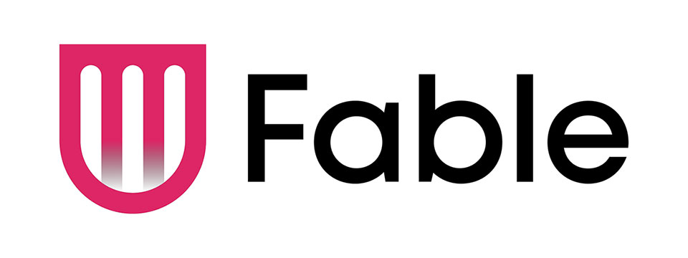
👉️ Classified Advertisement: Learn Management Skills For Free. Get The Job You Want | Fable
Everyone deserves equal access to the internet which is why Fable works with people with disabilities who use assistive technologies like switch controls to improve the accessibility of websites and apps. Fable Pathways, a free, accessible, and on-demand skill-building program, is an extension of Fable's mission. Fable Pathways provides new opportunities for people with disabilities to gain the skills they need, from experts like Judy Heumann and Kelly Ford, to contribute to improving digital accessibility.
Sponsor Since: June 30, 2022 📅️
Website: https://makeitfable.com/ 🌐️
Email: community@makeitfable.com 📧️
About: Fable is an accessibility platform powered by people with disabilities, connecting them to accessibility managers, user researchers, designers, and developers to build accessible user experiences.
Opportunities:
➜ Accessibility Tester: Testers drive meaningful change in digital accessibility by sharing feedback on the websites and apps of the companies that care. As a Tester, earn a competitive tech industry wage, learn valuable transferrable skills, and grow your career. Fable is looking for assistive technology users in the US or Canada to work the hours that they want, completely from home. No experience or resume required.
➜ Survey Respondent: Survey Respondents enjoy a remote, low-commitment income opportunity, all while contributing to accessibility research. Surveys are typically sent out once a month, and you can earn $5 to $50 per survey. Apply today if you identify as having a disability and live in the US or Canada. You do not need to use assistive technology to apply.

⬆︎ 5.) Sponsor: SelvasBLV

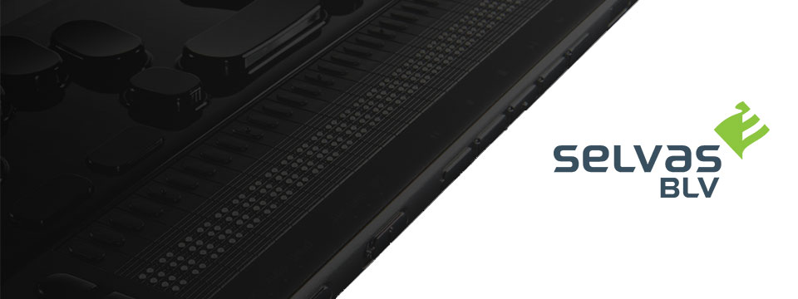
👉️ Classified Advertisement: Join SELVAS BLV At These Upcoming Webinars!
Please join Earle Harrison from SELVAS BLV, the proud North America distributors of HIMS blindness and low vision products, and Jenny Axler from HIMS the manufacturer, as they share new and innovative developments as they relate to the BrailleSense 6 Android tablet and the Braille eMotion Smart Braille display.
The presentation will take place on Monday, August 25th from 8:00 until 9:00 PM Eastern time in the Pat Price Training Room found at:
https://us02web.zoom.us/j/839935813?pwd=eXFMRHpxNnhFZlRiMHAzRWNWYXM3Zz09
You may also join Earle Harrison for a general webinar taking place Thursday, August 28th at 5PM-6PM Eastern Time as he shares new and innovative developments as they relate to the BrailleSense 6 Android tablet.
The presentation link can be found at: https://us02web.zoom.us/j/81211089088
We look forward to seeing you!
Sponsor Since: September 30, 2021 📅️
Website: https://selvasblv.com/ 🌐️
Shop All Products: https://selvasblv.com/shop-all-products/ 🛒️
Phone: (512) 837-2000 📱️
YouTube: https://www.youtube.com/watch?v=5R9NjA1nfWo
Sales: sales@selvasblv.com 📧️
Support: support@selvasblv.com 📧️
About: SelvasBLV is a global manufacturer and distributor that has provided braille, magnification and accessible healthcare devices since 1999.

⬆︎ 4.) Sponsor: Carroll Center for the Blind


👉️ Classified Advertisement: Attend the Screen Reader User Tester Training Program at the Carroll Center for the Blind | Carroll Center for the Blind
Launch your career in the digital accessibility field! The Carroll Center for the Blind's new 7-week intensive Screen Reader User Tester Training program allows participants to learn and grow their ability to professionally explore, test, and report findings regarding the accessibility of websites, mobile applications, and digital document files using screen readers. Want to learn more? Start your journey to becoming a Screen Reader User Tester today.
Sponsor Since: August 5, 2021 📅️
Website: https://carroll.org/ 🌐️
Phone: (617) 969-6200 📱️
Fax: (617) 969-6204 ░️
Shop: https://carroll.org/store/ 🛒️
Donate: https://carroll.org/donate ❤️
Social: Facebook | Twitter | YouTube | LinkedIn | Instagram
About: The Carroll Center for the Blind is the foremost leader in vision rehabilitation services for individuals confronted by the challenges of vision loss. Our mission is to empower those who are blind or visually impaired to achieve independence and to lead a fulfilling life. Established in 1936, the renowned Carroll Center for the Blind has been serving those with vision impairment for over eight decades; we are known nationally as a premier Vision Rehabilitation Center. Located just outside of Boston on a sprawling campus in Newton, Massachusetts, we proudly serve ALL ages and ALL stages of vision loss. With the ongoing promise of improving the lives of people with vision-related problems, The Carroll Center for the Blind has pioneered many innovative services allowing people who are blind or have low vision to learn the skills to be independent in their homes, in class settings, and in their work places. Our services include vision rehabilitation, vocational and transition programs, assistive technology training, educational support, and recreation opportunities for individuals who are visually impaired of all ages. For over 80 years, the expertise of Carroll Center staff has provided help for thousands of blind and visually impaired persons with diverse opportunities for success and independent living.

⬆︎ 3.) Sponsor: Pneuma Solutions

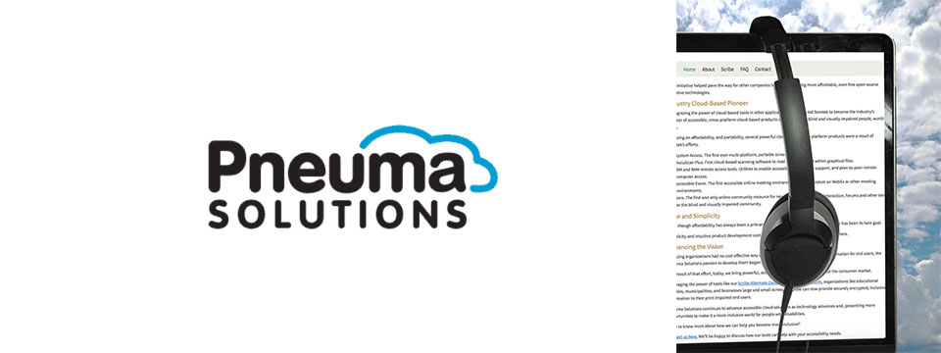
👉️ Classified Advertisement: Take Your Accessibility To The Next Level With Pneuma Solutions: Providing The Best In Cloud-Based Accessibility Solutions | Pneuma Solutions
When it comes to people's lives and their disabilities, access to information is not a privilege…It's a right. Pneuma Solutions believes organizations like yours have the right to provide the best tools for your consumers, students, employees, and citizens. We also believe, since you are here, that you're interested in joining us in making this a more inclusive world. The solutions we provide allow you or your organization to do just that. From near-perfect document remediation, to accessible realtime teleconference slides, to unparalleled remote desktop access, Pneuma Solutions is here to bring you the best in quality, reliability, and accessibility.
Sponsor Since: June 3, 2021 📅️
Website: https://pneumasolutions.com/ 🌐️
Email Newsletter: Click here to receive periodic news via email concerning Pneuma Solutions products for business, consumers and education.
Sales: (866) 202-0520 📱️
Support: (650) 249-1000 📱️
About: Backed by two decades of creating award-winning accessible cloud technologies for people with visual impairments, Pneuma Solutions is the global leader in accessible cloud-based solutions. Pneuma Solutions was founded by long-time accessibility developers Mike Calvo and Matt Campbell. For more information on their individual profiles, click on their respective bio pages. We're proud to be the first company to develop cloud-based accessibility at the network level. Our tools provide organizations, like yours, a way to deliver secure, accessible information right from your network or from our secure servers. You can provide your print disabled consumers, students, employees, and citizens with a multitude of accessible options. Additionally, we offer a suite of cloud-based applications to blind and print disabled consumers directly from our website. Our consumer products are designed to make the day-to-day lives of blind and print disabled individuals more accessible and simpler to manage. Access to information is not a privilege, it's a right. It's also your right to obtain affordable, accessible cloud solutions to serve your end user. When organizations like yours implement our tools, together we help make it a more inclusive world for people with disabilities. Want to know more about how we can help you become more inclusive?
Contact us here. We'll be happy to discuss how our tools can help with your accessibility needs.

⬆︎ 2.) Sponsor: Freedom Scientific

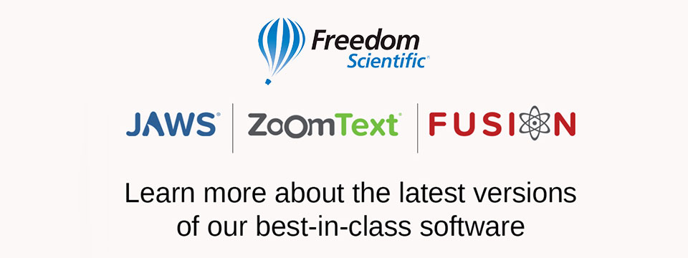
👉️ Classified Advertisement: Freedom Scientific Focus Blue 5th Generation Refreshable Braille Displays | Freedom Scientific
Our world-class refreshable Braille displays deliver efficient Braille input and outstanding output for your PC or mobile device. The robust Bluetooth® connectivity provides seamless use with Windows®, Mac®, iPhones®, iPads®, and Android TM smartphones and tablets. Ergonomic navigation features allow quick, natural hand movements for greater productivity. When used with JAWS® screen reading software, they support our popular Braille Study Mode, an interactive tool for teaching and learning Braille. Learn more today.
Sponsor Since: April 15, 2021 📅️
Website: https://www.freedomscientific.com/ 🌐️
Email: info@vispero.com 📧️
Phone: (800) 444-4443 📱️
Facebook | Twitter | YouTube (Training)
About: Freedom Scientific, a Vispero brand, is a leading worldwide brand of assistive technology products for those with vision impairments. We offer products designed to promote independence, allowing blind and low vision individuals the same access to information as their sighted peers. World-renowned JAWS (Job Access With Speech) screen reading software and ZoomText screen magnification software provide users the independence and ability to seek education and obtain or maintain a career after vision loss. Our expansive product line includes both low vision and blindness technology for all aspects of daily living. The wide range of RUBY, TOPAZ, and ONYX desktop and portable video magnifiers are designed for their ease of use and assist with daily activities. Our impressive line of blindness hardware products include refreshable Braille displays and scanning and reading devices, offering many options tailored to fit individual needs.

⬆︎ 1.) Sponsor: A. T. Guys

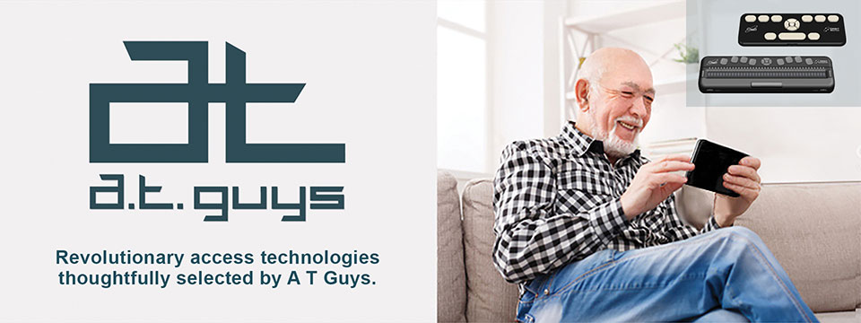
👉️ Classified Advertisement: Pluggable USB-C 7-in-1 Hub | A. T. Guys
If you're like me, you probably have more things to plug into your computer than available ports. That's why we've now added the Pluggable USB-C 7-in-1 Hub. Plug it into your laptop and you will get 3 USB ports, SD and Micro SD card slots, a USBC charging port, and an HDMI video port. It's available now for just $29.95.
Sponsor Since: June 11, 2020 📅️
Website: https://www.atguys.com/ 🌐️
Phone: (269) 216-4798 📱️
Email: support@atguys.com 📧️
Skype: atguys 💬️
X (Formerly Twitter): https://twitter.com/atguys (@atguys) 💬️
Facebook: https://facebook.com/atguys 💬️
About: ATGuys.com. Your access technology experts, home for cool gadgets, accessories, and more. Our products are all tested to work great for blind and visually impaired users but also work just as well for anyone. If there's an item you're looking for, or if you have a question, please don't hesitate to send us a message or call (269) 216-4798 📱️.

⬆︎ 20.) Sponsor: Your Name Here

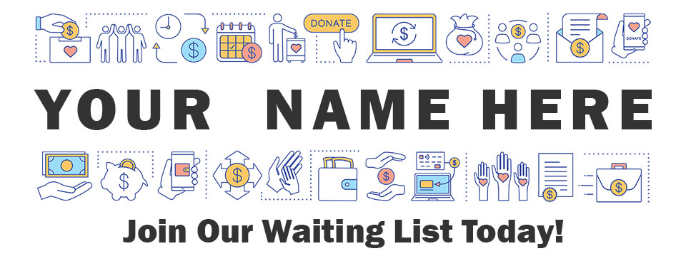
Join: Waiting List 📋️
Sponsor Since: Today 📅️
Website: https://toptechtidbits.com/sponsor 🌐️
Phone: (855) 578-6660 📱️
Email: enews@toptechtidbits.com 📧️
About: Founded in 2004, Top Tech Tidbits is the world's leading not-for-profit access technology publication that reaches over 40,000 blind, low vision, deaf, hard of hearing, deafblind, neurodivergent and/or disabled professionals, educators and enthusiasts, all over the world, each week. Subscribe here. Review the most recent issues here.

Top Tech Tidbits Supporters 🤝️
We couldn't do it without you! Thank you for your support!
Why: Top Tech Tidbits Supporters donate an amount of their choosing either one time or annually in order to assist with the ongoing distribution of the Top Tech Tidbits publication.
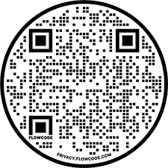
Benefits: All Top Tech Tidbits Supporters receive a listing within the "Our Supporters" section of each weekly newsletter, as well as a listing within the "Our Supporters" section of the Top Tech Tidbits website.
In addition, all Top Tech Tidbits Supporters automatically become Premium Subscribers as well, and therefore enjoy all of the benefits that a Premium Subscription has to offer.
One Time Donation: If you would like to become a Top Tech Tidbits Supporter by making a one time donation in an amount of your choosing to assist with the ongoing distribution of the Top Tech Tidbits publication, you may utilize this donate link, or scan the QR code to the right.
Annual Donation: If you would like to become a Top Tech Tidbits Supporter by making a small donation to assist with the ongoing distribution of the Top Tech Tidbits publication, we also offer the following options, all with our sincerest thanks, and most heartfelt gratitude for your ongoing support.
Support: In tandem with Our Sponsors, these are the people that make the ongoing distribution of Top Tech Tidbits possible.

Platinum Supporters:

Become a Top Tech Tidbits Platinum Supporter today.
1.) Gary Lee
Platinum Supporter since June 25, 2020
2.) Anonymous Donation
Platinum Supporter since July 9, 2020
3.) Pshon Barrett
Platinum Supporter since January 28, 2021
4.) Robin Millar
Platinum Supporter since April 6, 2023

Gold Supporters:

Become a Top Tech Tidbits Gold Supporter today.
1.) Howard Goldstein
Gold Supporter since June 4, 2020
2.) David Goldstein
Gold Supporter since June 12, 2020
3.) Katherine Crohan
Gold Supporter since January 14, 2021
4.) Neil Jarvis
Gold Supporter since April 28, 2022

Silver Supporters:

Become a Top Tech Tidbits Silver Supporter today.
1.) Timothy Gorbold
Silver Supporter since July 19, 2023
2.) Vojtech Polasek
Silver Supporter since December 29, 2023

Bronze Supporters:

Become a Top Tech Tidbits Bronze Supporter today.
1.) Steven Wettlaufer
Bronze Supporter since July 16, 2020
2.) Lions Clubs International
Bronze Supporter since July 13, 2020

One Time Supporters:
One Time Supporters donate an amount of their choosing — one time to assist with the ongoing distribution of the Top Tech Tidbits Publication.
Become a Top Tech Tidbits One Time Supporter today.
1.) Beth Wright
One Time Supporter on November 28, 2023
2.) Your name here.
One Time Supporter on ...

Top Tech Tidbits News Team 🗞️

Distribution: Sponsors, Supporters, Advertisers and Mind Vault Solutions, Ltd.

Distribution Since: 2004
As of June 4, 2020 the distribution of Top Tech Tidbits is made possible by our Sponsors, our Supporters, our Advertisers and Mind Vault Solutions, Ltd., a leading international provider of professionally outsourced marketing administration and consultation services.
Any time the Top Tech Tidbits Publication carries less than its Sponsor limit, Mind Vault Solutions, Ltd. donates the remaining dollars necessary to keep the publication running.
Please help us to support the ongoing distribution of this publication. Learn more about the benefits of Sponsorship today.

Publisher: Aaron Di Blasi

Publisher Since: June 4, 2020
Location: Cleveland, Ohio
Time Zone: Eastern Standard Time (EST/EDT) (GMT-5/GMT-4)
In addition to serving as Publisher for Top Tech Tidbits Aaron also serves as Publisher for the Access Information News and AI-Weekly newsletters, PR-Director for the AT-Newswire Press Release News Distribution Service, and President and Senior Project Management Professional for Mind Vault Solutions, Ltd.
As Publisher Aaron oversees the weekly distribution of Top Tech Tidbits on behalf of Mind Vault Solutions, Ltd.
Aaron Di Blasi, PMP
Email: publisher@toptechtidbits.com 📧️
Toll Free: +1 (855) 578-6660 📱️
PR Director (2024-Present)
AT-Newswire 🌐
Access Technology's Digital Newswire
Publisher (2024-Present)
AI-Weekly 🌐
The Week's News in Artificial Intelligence
Publisher (2022-Present)
Access Information News 🌐
The Week's News in Access Information
Publisher (2020-Present)
Top Tech Tidbits 🌐
The Week's News in Access Technology
Sr. Project Management Professional (2006 - Present)
Mind Vault Solutions, Ltd. 🌐
Innovative ideas. Solutions that perform.
Certified:
Digital Marketing Associate
Meta Certified (2022 - Present)
Social Marketing Professional
Hootsuite Certified (2020 - Present)
Email Marketing Professional
Constant Contact Certified (2019 - Present)
Specializing in:
Digital Strategy and Content Marketing
Social Media Advertising
Online Fundraising
ADA, WCAG and Section 508 Compliance

Editor: John Hanlin

Editor Since: June 4, 2020
Location: Boulder, Colorado
Time Zone: Mountain Standard Time (MST/MDT) (GMT-7/GMT-6)
In addition to serving as an Editor to Top Tech Tidbits John also serves as an Editor to the Access Information News and AI-Weekly newsletters and is also an attorney-at-law specializing in long-term disability claims for persons who are blind or low-vision.
John is also a long-time contractor and member of the Board of Trustees at Mind Vault Solutions, Ltd.
John Hanlin, Esq.
Editor (2024-Present)
AI-Weekly 🌐
The Week's News in Artificial Intelligence
Editor (2022-Present)
Access Information News 🌐
The Week's News in Access Information
Editor (2020-Present)
Top Tech Tidbits 🌐
The Week's News in Access Technology
Board of Trustees (2006 - Present)
Mind Vault Solutions, Ltd. 🌐
Innovative ideas. Solutions that perform.

Editor: Jenna Lang

Editor Since: June 4, 2020
Location: Des Moines, Iowa
Time Zone: Central Standard Time (CST/CDT) (GMT-6/GMT-5)
In addition to serving as an Editor to Top Tech Tidbits Jenna also serves as an Editor to the Access Information News and AI-Weekly newsletters and runs her own advocacy foundation.
Jenna also serves as a certified Project Management Professional (PMP) for Mind Vault Solutions, Ltd.
Jenna's son was born blind and she is always seeking new and innovative ways to empower him through technology.
Jenna Lang, PMP
Editor (2024-Present)
AI-Weekly 🌐
The Week's News in Artificial Intelligence
Editor (2022-Present)
Access Information News 🌐
The Week's News in Access Information
Project Management Professional (2022 - Present)
Mind Vault Solutions, Ltd. 🌐
Innovative ideas. Solutions that perform.
Editor (2020-Present)
Top Tech Tidbits 🌐
The Week's News in Access Technology

Editor: Stephen (Alex) Marositz

Editor Since: October 7, 2021
Location: Los Angeles, California
Time Zone: Pacific Standard Time (PST/PDT) (GMT-6/GMT-7)
In addition to serving as an Editor to Top Tech Tidbits Alex is also the Accessible Technology Coordinator for California State University, Dominguez Hills. He has worked in accessibility in higher education since 2005, is certified by the International Association of Accessibility Professionals, and in his spare time plays for the San Gabriel Valley Panthers Beep Baseball Team. He can be reached on twitter at: @samarositz.
Stephen (Alex) Marositz
Editor (2021-Present)
Top Tech Tidbits 🌐
The Week's News in Access Technology
Accessible Technology Coordinator
California State University, Dominguez Hills 🌐

Editor: Ben Moxey

Editor Since: January 1, 2022
Location: Newcastle, Australia
Time Zone: Australia Eastern Standard Time (AEST/AEDT) (GMT+10)
In addition to serving as an Editor to Top Tech Tidbits Ben is also an Access and Technology Advisor for Guide Dogs, New South Wales, Australian Capital Territory (NSW/ACT).
Hi, Tidbits readers, my name's Ben Moxey and I'm based in Newcastle, Australia. I'm really happy to be part of the Tidbits Team and look forward to supporting this valuable publication.
A bit about me and how I came to work in the BVI area. I grew up with very low vision in one eye due to retinal issues and relied on magnification and speech throughout school. They also tried to teach me Braille, but let's just say that I wasn't the best student! I was determined to use my remaining vision, no matter how impractical it was becoming.
When I was 20, the other retina came off and I've now been totally blind for about 21 years. This is when my love for assistive technology, and technology in general, really kicked in. I'll be honest, I was a bit of a computer nerd anyway, but I could quickly see how technology was my key to enhanced independence and lifestyle. I embraced screen readers, early smart phones and mobility aids. I even finally realised the huge value of Braille and finished off the course, though I'm still pretty slow!
Long story short (not one of my strong points), I've worked in the BVI area for 12 years with much of that spent reviewing, recommending and teaching assistive technology that suits the individual. I'm currently a proud employee of Guide Dogs NSW/ACT where I was the Practice Lead for the assistive technology service, and I've now moved into an Access and Technology Advisor role. Basically, this involves a strong focus on accessibility and technology innovation.
Feel free to look me up on LinkedIn, but I'll warn you in advance that I haven't given my profile the recommended attention!
All the best and happy reading!
Ben Moxey
Editor (2022-Present)
Top Tech Tidbits 🌐
The Week's News in Access Technology
Access and Technology Advisor
Guide Dogs, New South Wales, Australian Capital Territory (NSW/ACT) 🌐

Editor: David Woodbridge

Editor Since: February 6, 2023
Location: Central Coast, New South Wales, Australia
Time Zone: Australia Eastern Standard Time (AEST/AEDT) (GMT+10)
In addition to serving as an Editor to Top Tech Tidbits David also serves as an Editor to the Access Information News publication and is also the National Commercial Assistive Technology Advisor for Vision Australia where he has worked since 1990. Over this time he has assisted people who are blind or vision impaired in their home, education, and work settings to take advantage of the benefits of using assistive and main stream technology.
In the last seventeen years, he has also been involved with evaluating technology for use by people who are blind or vision impaired covering both low and high tech equipment (including Microsoft, Samsung, Google, Amazon, and Apple). David is also one of the key spokespersons for Vision Australia relating to technology.
He has been an Apple Ambassador for Apple Australia since 2009 with a group of other Ambassadors / Apple Distinguished Educators (ADE)'s covering the range of Apple's Accessibility solutions throughout Australia.
David produces a range of podcasts (since 2011) covering Apple and other technologies which are distributed on his own podcast (http://davidwoodbr.podbean.com). In addition, he also has a regular Talking Tech program (since 2013) which can be heard every Tuesday at 4:30 Eastern Summer Time on Vision Australia Radio Melbourne (available online) or via https://omny.fm/shows/talking-tech-vision-australia-radio
David also runs a weekly Tech Monday where people can chat about assistive and main stream technology, share information, and any tips and tricks.
David lost his sight when he was 8 years old and had to learn Braille. Since then, he completed high school, went to Sydney University receiving a Social Work degree, spent 4 years drug and alcohol counselling, and then moved into his current job.
As a person who is blind, David believes that as a user of the technology that he recommends to others, that he is well situated to look at the strengths and shortcomings of the assistive technology that he comes across in both his professional and personal life, in particular, mainstream technology that is accessible.
In addition to his weekly contributions to Top Tech Tidbits and Access Information News, David's regularly occurring activities are his weekly tech radio show, bi-monthly exploring tech webinars for Vision Australia, his iSee podcast when something of note grabs his attention, and the weekly Tech Monday chat sessions.
David Woodbridge
X (Formerly Twitter): @dwoodbridge
Mastodon: woody@dragonscave.space
iSee Podcast: https://davidwoodbr.podbean.com
Vision Australia Radio Talking Tech: https://omny.fm/shows/talking-tech-vision-australia-radio
Editor (2023-Present)
Top Tech Tidbits 🌐
The Week's News in Access Technology
Editor (2023-Present)
Access Information News 🌐
The Week's News in Access Information
National Commercial Assistive Technology Advisor
(1990 - Present)
Vision Australia 🌐
Live the life you choose. We're here to support all Australians who are blind or have low vision.

Editor: Vicki Walton

Editor Since: January 9, 2024
Location: Benton City, WA
Time Zone: Pacific Standard Time (PST/PDT) (GMT-6/GMT-7)
IIn addition to serving as an Editor to Top Tech Tidbits Vicki also serves as an Editor to the Access Information News publication and works as a Web Accessibility Specialist / IT Quality Assurance Tester at Washington State Board for Community and Technical Colleges.
Vicki Walton
Editor (2024-Present)
Top Tech Tidbits 🌐
The Week's News in Access Technology
Editor (2024-Present)
Access Information News 🌐
The Week's News in Access Information
Web Accessibility Specialist / IT Quality Assurance Tester
Washington State Board for Community and Technical Colleges 🌐
Better Jobs, Brighter Futures, a Stronger Washington

Subscription Information 📰️
ABOUT ♿️
Founded in 2004, Top Tech Tidbits is the world's leading not-for-profit access technology publication that reaches over 40,000 blind, low vision, deaf, hard of hearing, deafblind, neurodivergent and/or disabled professionals, educators and enthusiasts, all over the world, each week. Subscribe here. Review the most recent issues here. Access Technology broadly encompasses technologies that enable access to information and communication systems for persons with disabilities. Adaptive Technology is a subset of Access Technology designed to assist individuals in performing tasks that might otherwise be challenging due to their particular disabilities. Assistive Technology includes any device, software, or equipment that helps people work around their challenges. Top Tech Tidbits is a Mind Vault Solutions, Ltd. Publication. Publisher: Aaron Di Blasi. Editors: John Hanlin, Jenna Lang, Stephen (Alex) Marositz, Ben Moxey, David Woodbridge and Vicki Walton. Top Tech Tidbits is a sponsor, reader and advertiser supported publication.
RELEASE SCHEDULE 📅️
Top Tech Tidbits is released every Thursday morning at 6:00 AM ET.
SUBSCRIBE 📧️
Do you, a friend, or colleague wish to receive the Top Tech Tidbits newsletter? If so, please use or pass along our CAPTCHA-free sign-up link. You can also subscribe to receive the Top Tech Tidbits newsletter on the Top Tech Tidbits Website. Either of these methods will provide you with an accessibly friendly and secure medium through which you can subscribe to our mailing list. Just enter your email address, click send, and begin receiving the Top Tech Tidbits newsletter. It's that easy.
WEBSITE 🌐️
Visit the Top Tech Tidbits website online at: https://toptechtidbits.com.
PREMIUM SUBSCRIBER 💸️
Only Top Tech Tidbits Premium Subscribers receive our special quarterly issue listing the Top 60 Most Clicked News Articles of the Last 3 Months. Just $12 USD per year. This special quarterly issue is provided to Premium Subscribers as a native Microsoft Word document with full headings, links and abstracts to all 60 articles. There are no restrictions placed on these documents. Complete list of all back issues available. Premium Subscribers are entitled to all back issues, anytime they sign up. Join us today and begin receiving this incredibly informative issue every 3 months.
SPONSOR 🏅️
If you would like to become 1 of only 24 Top Tech Tidbits Sponsors whose ongoing support makes the distribution of Top Tech Tidbits possible, we offer you the following advertising benefits, with our sincerest thanks, and most heartfelt gratitude for your ongoing support.
ADVERTISE 🎯️
Top Tech Tidbits offers a variety of one-time advertising options to both Sponsors and non-Sponsors alike. Here we offer a sample newsletter that provides a breakdown of exactly what those one-time advertising options are, where they appear, and what they cost per publication.
DONATE ❤️
If you would like to become a Top Tech Tidbits Supporter by making a small donation to assist with the ongoing distribution of the Top Tech Tidbits publication, we offer the following options, with our sincerest thanks, and most heartfelt gratitude for your support.
STORE 🛒️
Are you blind or do you live with low vision? Are you deaf, hard of hearing or deafblind? Do you require a wheelchair for mobility? Do you consider yourself to be neurodivergent or otherwise disabled? The Top Tech Tidbits Online Store For Digital Downloads specializes in information that can improve your quality of life. Learn more today.
FACEBOOK 💬️
Are you on Facebook? Follow Top Tech Tidbits on Facebook to begin receiving current news and trends in Access Information as part of your Facebook News Feed.
X (FORMERLY TWITTER) 💬️
Are you on X? Follow Top Tech Tidbits on X to begin receiving current news and trends in Access Information as part of your X News Feed.
MASTODON 💬️
Are you on Mastodon? Follow Top Tech Tidbits on Mastodon to begin receiving current news and trends in Access Information as part of your Mastodon News Feed or by searching for @news@mastodon.toptechtidbits.com on your server today.
LINKEDIN 💬️
Are you on LinkedIn? Follow Top Tech Tidbits on LinkedIn to begin receiving current news and trends in Access Information as part of your LinkedIn News Feed.
YOUTUBE ▶️
Are you on YouTube? Follow Top Tech Tidbits on YouTube to begin receiving current news and trends in Access Information as part of your YouTube Video Feed.
RSS 📡️
Do you prefer RSS? Follow Top Tech Tidbits via RSS today to begin receiving current news and trends in Access Information using your choice of news aggregator.
QUESTIONS ❓️
Tidbits are intentionally concise. As a result we know that some readers may not always understand all of the items listed because little explanation is given. If a particular Tidbit brings up a question in your mind, feel free to ask, and we will try to answer as time and knowledge permit.
ARCHIVE 🗄️
Read the most recently released issues of Top Tech Tidbits online here. Visit the Top Tech Tidbits Archive here, where you can read back issues.
CONTENT CONTRIBUTORS ✍️
Any information for future issues of Top Tech Tidbits may be submitted online via our News Item Submission Form or directed to our Editors via email.
THANK YOU 🙏️
Thank you for reading. On behalf of all of us here at Top Tech Tidbits we look forward to keeping you informed.
Information provided by:
Top Tech Tidbits
https://toptechtidbits.com/ 🌐
A Mind Vault Solutions, Ltd. Publication
1284 SOM Center Road, PMB 194,
Mayfield Heights, Ohio 44124
+1 (855) 578-6660 📱️

