How to Read Blind: https://toptechtidbits.com/read
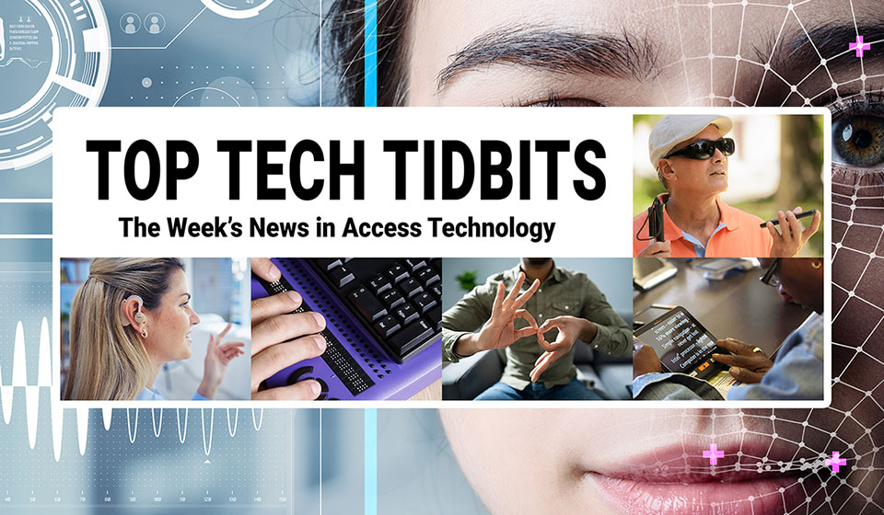
 |  |  |  |  |  |  |  |  |  |  |  | 
Top Tech Tidbits for Thursday, August 21, 2025 - Volume 1029
♿️ The Week's News in Access Technology
Top Tech Tidbits. The world's #1 online resource for current news and trends in access technology.
A Mind Vault Solutions, Ltd. Publication
Subscribers: 41,350 🔢️ opt-in subscribers were sent this issue via email.

Sponsors 🏅️
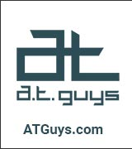 |  |  |  | 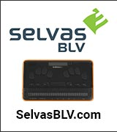 | 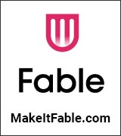
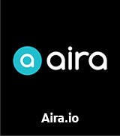 | 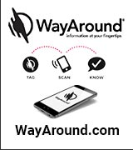 | 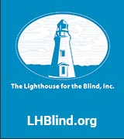 | 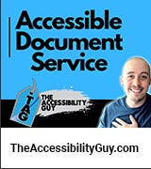 |  | 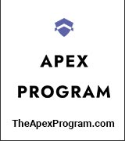
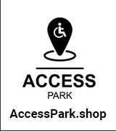 | 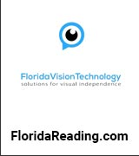 |  | 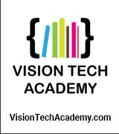 | 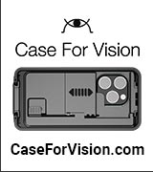 | 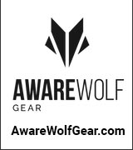
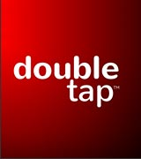 | 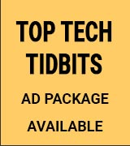 | 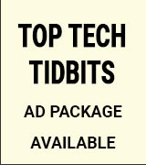 | 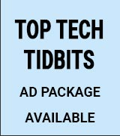 | 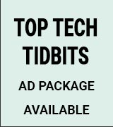 | 
Access Awareness: Updates That Matter ♿️
JAWS & ZoomText UK Pricing Explained: What You Need to Know | Double Tap | August 18, 2025
JAWS and ZoomText pricing in the UK is changing, and users are confused. Steven Scott and Shaun Preece bring in Stuart Lawler from Sight & Sound Technology to break down the new subscription model, explain Software Maintenance Agreements (SMAs), and clarify what the changes mean for long-time users. Plus, a hands-on look at the Keychron Q6 Max mechanical keyboard, updates on Aira desktop support, and a listener email about life with prosthetic eyes. This episode tackles one of the biggest questions in UK accessibility tech right now: what's happening with JAWS and ZoomText pricing? Steven and Shaun are joined by Stuart Lawler from Sight & Sound Technology to cut through the confusion. Stuart explains why Vispero has moved to a subscription model, what the pricing tiers look like, and how current users can still benefit from SMAs before the October deadline.
This Week's Featured Advertisement 🎯️
Five (5) Sponsorship Packages Currently Available. Support Free Access Technology News For Disabled Readers All Over The World While Increasing Traffic To Your Properties Each Week. Advertise in every issue. Or just one.
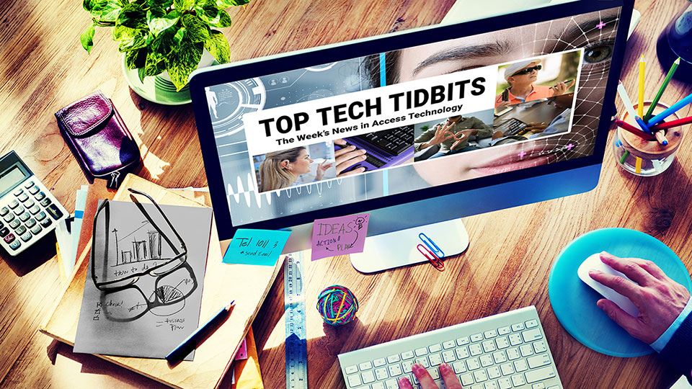
Join Top Tech Tidbits as a Sponsor today and begin reaching over 40,000 access technology subscribers each week, all while supporting the ongoing distribution of Top Tech Tidbits for those very same readers. Only $200 / month.
Key Newsletter Statistics:
- Subscribers: 40,000 + per week and growing.
- Open Rate: 46% (Average. Last 12 months.)
- Click Rate: 42% (Average. Last 12 months.)
- Bounce Rate: 1.1% (Average. Last 12 months.)
- Ad CTRs: 2-12% (Average. Last 12 months.)
Benefits All Sponsors Receive:
- One (1) Sponsor Profile on the Top Tech Tidbits website.
- One (1) Sponsor Profile in each weekly newsletter.
- One (1) Sponsor Wall Brand Advertisement on the Top Tech Tidbits home page.
- One (1) Sponsor Wall Brand Advertisement in each weekly newsletter.
- One (1) Classified Advertisement in each weekly newsletter.
- 50% Discount on all Sponsored Tidbit Advertisements.
- Free link tracking.
- Permanent SEO benefits.
- Gratitude from over 40,000 access technology subscribers for keeping Top Tech Tidbits free to read.
With additional benefits for Sponsors that pay quarterly or annually. Learn more today.
News 📰️
👉 Submit a Tidbit for free here, with timing and placement determined by our editors.
👉 Submit a Sponsored Tidbit here, with timing and placement determined by you.

1.) Top 5 Most Clicked Tidbits From Last Week 📊️
A.) BrailleGPT: How Dunya Hassan Is Teaching AI to Speak the Language of Touch | Aaron Di Blasi | AT-Newswire.com | August 12, 2025
Real-time, AI-driven Braille communication has never existed in a truly portable format, until now. For DeafBlind individuals, the absence of such a tool has meant relying on expensive, tethered equipment or intermediaries to access the spoken world. BrailleGPT changes that equation. BrailleGPT is a working prototype of a standalone device that listens to live speech, processes it through an onboard AI model for context and clarity, and instantly delivers it as tactile Braille on a refreshable display. No phone, no computer, just direct, mobile access to conversations, announcements, and AI-powered information through touch. It's an ambitious leap toward a more independent, private, and inclusive future for DeafBlind communication. In this article, I'll explore why this matters, starting with the access gap that mainstream AI continues to leave wide open for the DeafBlind community. We'll break down how BrailleGPT works at a high level, why it stands apart from traditional or desk-bound devices, and introduce the young innovator behind it. You'll see where the project stands today, what's next on the road to pilot testing, and how you can get involved, whether through testing, mentorship, or partnerships that help bring this groundbreaking technology into more hands, faster.
B.) Meta Ray-Ban Smart Glasses Just Got Smarter: New Accessibility Upgrade You Need to See | Sam Seavey | The Blind Life | YouTube.com | August 13, 2025
Sam from The Blind Life highlights the newly launched Detailed Responses feature within the Meta AI app, designed to provide visually impaired users with richer, more descriptive feedback about their environment. This significant update enhances the usability of the Meta Ray-Ban Smart Glasses, offering an improved experience for those seeking comprehensive details beyond the existing brief summaries.
C.) I Spent Months Living With Smart Glasses. People Talk To Me Differently Now. | WashingtonPost.com | August 7, 2025
Eyeglasses are being augmented with screens, artificial intelligence and the power to unnerve people. We tested a pair to see how.
D.) How To Choose Which Apple Watch To Buy | TheVerge.com | August 13, 2025
With the Apple Watch Series 10, Ultra 2, and second-gen SE now available, potential buyers are overwhelmed with options. This guide analyzes key factors like durability, connectivity, and budget to help consumers select the best Apple Watch for their needs, alongside nuances in features across models.
E.) A Decade After Losing Her Sight, A B.C. Woman Can See Again — Through Her Tooth | CBC.ca | August 9, 2025
Gail Lane, a 75-year-old woman from Victoria, B.C., regained her sight after undergoing a rare tooth-in-eye surgery, allowing her to see her partner and her service dog for the first time in ten years. The complex procedure, which replaces a patient's cornea with an implanted tooth and lens, was performed by Dr. Greg Moloney, marking a significant advancement in ophthalmic surgery in Canada.
2.) Five (5) Sponsorship Packages Currently Available | TopTechTidbits.com | August 21, 2025
There are Five (5) Sponsorship Packages currently available. Would your product, service or message benefit from reaching over 40,000 access technology subscribers each week? For just $200 / month? If you're thinking yes, we invite you to try a Sponsorship Package with Top Tech Tidbits. The benefits are amazing and the traffic delivered to your properties each week is measurable. No obligation. Cancel anytime. When there are no Sponsorship Packages available, you can join the waiting list here.
3.) One Time Advertisements Available | TopTechTidbits.com | August 21, 2025
One time advertisements are available to anyone, with or without a Sponsorship. Would your product, service or message benefit from reaching over 40,000 access technology subscribers? If you're thinking yes, we invite you to check out our one time advertising options. They are cost-effective, targeted and measurable. Scheduling is optional. Learn more today.
4.) Premium Subscribers | TopTechTidbits.com | August 21, 2025
Next Issue: Premium Subscribers will receive their 14th issue of the Top 60 Most Clicked News Articles for April, May and June of 2025 on Monday, October 6, 2025. Back Issues: There are currently 13 back issues available. Premium Subscribers are entitled to all back issues, anytime they sign up. All available back issues will be sent to you via email within 24 hours of purchasing your subscription. Please Join Us: If you would like to receive a perfectly formatted and searchable Word Document with each of the Top 60 Most Clicked News Articles of the last 3 months listed neatly within it, please consider joining us today for just $1 a month.
5.) Sponsored Tidbits | TopTechTidbits.com | August 21, 2025
Use Sponsored Tidbits to reach the access technology community when you need to. Whether you are a current Sponsor or not. Drive traffic to your access product and service announcements, events, updates or fundraisers using this incredibly cost-effective and easy-to-use advertisement tool. Learn more today.
6.) Do You Have A Link In This Issue? Learn How To Track It For Free | TopTechTidbits.com | August 21, 2025
This article outlines, step-by-step, how you can get free website traffic reporting on any link to your domain (AKA domain name, website or web address) that has been published by Top Tech Tidbits since January 18, 2024, when we launched this feature.

7.) AI Updates 🤖️
Skip this Tidbit to skip all updates on AI.

A.) The Wait Is Over! Meta And Oakley Just Released 6 New Smart Glasses | TechRadar.com | August 19, 2025
Meta and Oakley have unveiled their latest HSTN smart glasses with preorders available ahead of the August 26 release date. Starting at $399, various lens options cater to different sporting needs, all integrating advanced features including open-ear speakers and on-device AI to enhance user experience.
B.) On Dashes, A.I., And Screen Readers | TPGi.com | August 13, 2025
The discussion explores the use of em dashes in writing and whether their frequency indicates A.I. generated content. It examines how screen readers interpret em dashes, emphasizing that punctuation practice should prioritize reader experience over automated systems.
C.) Microsoft's Windows Future Is Built On AI, Voice, Cloud, And Context | PCWorld.com | August 14, 2025
Microsoft aims to enhance user interactions with Windows through AI, voice, and cloud integration. Their vision includes seamless access to cloud services, enabling intuitive multimodal interactions and context-aware computing.
D.) Be My Eyes Launches In The Care Sector With AI-Powered Accessibility For Care Homes And Home Care | BeMyEyes.com | August 15, 2025
Be My Eyes has officially launched in the assisted living and elder care sector, introducing AI assistance and live video support to enhance accessibility for individuals who are blind or have low vision. The tools aim to improve resident autonomy and dignity while alleviating staff burdens in care settings throughout the world.
E.) AppleVis Extra #110: Envision & The Ally Solos Smart Glasses | AppleVis.com | August 15, 2025
In this episode, hosts Dave Nason and Thomas Domville interview Karthik Kannan from Envision about the Ally Solos Smart Glasses, which feature lightweight design, integrated AI capabilities, and various functionalities aimed at aiding blind and low-vision users. Pre-orders are currently available, offering substantial early-bird discounts and a complimentary subscription to the Ally Pro service for the first year.
F.) HTC Leaps Into AI Smart Glasses With The VIVE Eagle's Voice-Activated Eyewear | AndroidCentral.com | August 15, 2025
HTC has launched the VIVE Eagle, a new pair of AI-driven smart glasses featuring voice activation and a 12MP ultra-wide camera. Designed for comfort and equipped with features such as music playback and real-time translation, the glasses also emphasize data privacy with local storage and encryption.
G.) One Of The Most Prolific VR Headset Makers (Not Meta) Now Has Smart Glasses (Not Ray-Bans) | Gizmodo.com | August 14, 2025
HTC has introduced the Vive Eagle smart glasses, an alternative for consumers uninterested in Meta's offerings. Featuring a stylish design, a Qualcomm Snapdragon AR1 chipset, dual cameras, and AI capabilities for tasks like text recognition and translation, the glasses aim to compete in the growing smart glasses market. However, pricing and competition from other brands may present challenges for HTC.
H.) Samsung's Smart Glasses Coming Soon: Here's What We Know | GlassAlmanac.com | August 14, 2025
Samsung is set to release screenless smart glasses integrated into the Galaxy ecosystem by the end of 2026, powered by AI and aimed at enhancing user interaction with smartphones and watches. These glasses will have features similar to Meta Ray-Ban and are expected to promote widespread adoption due to their lighter design, comfort, and affordability.
I.) A11M - Part I On A11y And LLMS | Nira11y.com | August 13, 2025
The article explores the evolving relationship between accessibility and modern technologies like large language models (LLMs). It highlights the transition from text-based web interfaces to chat interfaces, emphasizing the challenges and implications for accessibility standards and practices in a digital landscape increasingly reliant on AI.

Tips, Tutorials, Guides, Reviews, Walk-Throughs and How-To's 📚️

8.) JAWS Power Tip: How To Search for Text in a PDF | Freedom Scientific | TopTechTidbits.com | August 21, 2025
You can search for text in PDFs with JAWS using the Find command. With a PDF open in a browser, follow these steps.
9.) Convert My PowerPoint To PDF And Keep The Structure | The Accessibility Guy | YouTube.com | August 18, 2025
Explore effective techniques for converting PowerPoint presentations into accessible PDFs in 2025. Learn how to maintain structure, reading order, and incorporate essential accessibility tags to enhance user experience.
10.) Jamworks AI Notetaking | The Accessibility Guy | YouTube.com | August 15, 2025
Jamworks AI Notetaking revolutionizes student engagement with educational content by transforming recorded lectures and meetings into interactive study experiences. Focused on accessibility, Jamworks eliminates traditional learning barriers, making it an essential tool for modern students.

News, Trends, Updates and Opinion Editorials 📰️

11.) Accessibility Frustrations: Printers, Keyboards, and Screen Readers | Double Tap | YouTube.com | August 20, 2025
Steven Scott and Shaun Preece address the ongoing challenges of printer installations while sharing insights on the Keychron Q6 Max keyboard. They also explore listener feedback on topics ranging from online shopping accessibility to inclusion in the community, all while anticipating the upcoming Google Pixel 10 event.
12.) Podcast: Eyes on Success Episode 2534: From Overseas Friends to Soulmates | August 20, 2025
How does love blossom across decades and continents? Hosts Nancy and Peter Torpey talk with Judy and Chris Jones, a blind couple who first met abroad as children, reconnected years later, had a long-distance courtship, and married after a telephone proposal. They share their journey through cross-cultural moves, parenting, and beating the odds together.
13.) Meta Ray-Ban Accessories You Didn't Know Existed & Falling Out Of Love With AI | Double Tap | YouTube.com | August 19, 2025
Steven and Shaun take a deep dive into exciting new accessories for Meta Ray-Ban smart glasses, weighing their practicality against user skepticism. The duo transitions into a spirited debate on artificial intelligence's reliability and the challenges faced by blind users, punctuated by Steven's personal experiences with PC issues and listener insights regarding assistive technology.
14.) Milestones In Braille History: The Eureka A4 | LivingBraille.eu | August 19, 2025
The Eureka A4 is highlighted as a significant innovation in Braille technology, demonstrating how digital devices have transformed the lives of blind individuals. Although it lacks an integrated Braille display, it offers essential input capabilities through the Braille writing system.
15.) Paperback: A Lightweight, Fast And Accessible Ebook And Document Reader | Github.com | August 19, 2025
Paperback is a lightweight ebook and document reader built with C++ and wxWidgets, offering cross-platform compatibility, full screen reader accessibility, and a bloat-free experience. It features extensive format support, fast performance, intuitive tabbed navigation, powerful search capabilities, and seamless EPUB navigation with hotkey integration.
16.) BT Speak Quick Tips: Check Time, Date, And Battery Status On The Fly | BlazieTech.com | August 19, 2025
BT Speak offers quick hotkeys to retrieve the time, date, and battery status seamlessly while you are engaged in other tasks. The commands are designed to maintain your workflow without interruption, making it easier to access essential information on the fly.
17.) Are You Interested In Visual Studio Code? Join The Visual Studio Code Public Email List To Learn More And To Contribute To Discussions | BitsUsers.org | August 19, 2025
A public mailing list is available for those interested in Visual Studio Code, offering an opportunity to stay informed and participate in community discussions by subscribing via email.
18.) Podcast: Tech Talk 578: Ally Solos Glasses, Beta Testing Safely, Ad Spiers | RNIB | August 19, 2025
This week, we're speaking to Envision about the new 'Ally Solos Glasses', Hubert tackles the question of if beta testing is a safe way to test new features before the general public, plus, we'll be tackling some of your emails.
19.) JAWS & ZoomText UK Pricing Explained: What You Need to Know | Double Tap | YouTube.com | August 18, 2025
Clarity emerges on the updated subscription model for JAWS and ZoomText in the UK as Steven Scott, Shaun Preece, and Stuart Lawler from Sight & Sound Technology navigate the key changes. The conversation also features insights into assistive technologies and unique user experiences, providing a well-rounded perspective on current accessibility challenges and innovations.
20.) Explore The Zoom H6studio Handy Recorder | Zoom Sound Lab | YouTube.com | August 18, 2025
The Zoom H6studio Handy Recorder represents the pinnacle of portable audio technology. Featuring large-diaphragm XY microphones and advanced 32-bit float recording, it ensures professional-grade sound, making it ideal for a variety of recording environments.
21.) NVDA 2025.3beta1 Available For Testing | NVAccess.org | August 18, 2025
The beta version of NVDA 2025.3 is now available for testing, inviting users to download it and share feedback. This release features enhancements in Remote Access, braille functionality, and improvements for SAPI5 voices, among several other bug fixes and new features.
22.) Line Vs Page: María García | LivingBraille.eu | August 18, 2025
María García shares her personal experience with Braille displays, highlighting their advantages over printed Braille books. She discusses the multifunctionality of Braille displays, including reading, email communication, and online learning, emphasizing their impact on accessibility and educational opportunities for blind individuals.
23.) Podcast: Technically Working Episode 124: Smart Glasses, Perkins Braillers, and Vibe Coding (.MP3 File) | August 18, 2025
Michael and Damashe return with TW124 of Technically Working, diving into accessible tech and real-world experiences. Michael recounts his Perkins Brailler repair story and the costs of paper. Damashe explores new smart glasses from Solos, Ally and Envision, comparing features and accessibility. They discuss customizing AI prompts and the risks of prompt injection. The hosts talk about home networking upgrades and using Home Assistant, share progress on rebuilding their 'Builder' scheduling tool with Supabase, and reflect on 'vibe coding' — using natural language to guide code. They close with listener feedback and lots of laughs.
24.) New Pricing of JAWS the Screen Reader | BBC Radio 4 | August 17, 2025
There have been some changes to the way that the screen reader JAWS will be priced and issued to users. In Touch speaks to the company behind the software to get more information.
25.) Blind Rewind: Kitchen Tip — Labeling Spices | The Blind Life | YouTube.com | August 16, 2025
Learn practical strategies for labeling spices effectively, aimed at individuals with low vision. This tip enhances organization in the kitchen, ensuring that spices are easy to identify and access when cooking.
26.) Smart Glasses, Mental Health & Remote Storage For Blind Users | Double Tap | YouTube.com | August 15, 2025
Double Tap returns for its ninth season, featuring Steven Scott and Shaun Preece as they unpack the latest advancements in smart glasses and discuss the impact of AI in assistive technology. The episode also highlights listener insights on accessible remote storage and mental health resources for blind users, alongside an exciting discovery about Be My Eyes' real-time video feature.
27.) Read Newspapers Easily With Tech Freedom's EPapers | TechFreedom.in | August 15, 2025
The Tech Freedom App offers a pioneering ePapers feature designed specifically for visually impaired users, allowing easy access to various Indian newspapers in an accessible format. With daily updates and compatibility with screen readers, users can independently stay informed without the challenges posed by traditional printed papers.
28.) The Scanmarker Pro Simplifies Reading | EastersealsTech.com | August 12, 2025
The Scanmarker Pro is a lightweight, handheld device that allows users to digitally read text aloud by scanning it like a highlighter. Featuring built-in Wi-Fi for translation into over 89 languages and the inclusion of a Collins English Dictionary, it offers customizable reading experiences for various users, including ESL students.
29.) Digital Magazines Are Lacking On The Amazon Kindle | GoodEReader.com | August 10, 2025
The Amazon Kindle has experienced a significant decline in the availability of digital magazines, following the closure of its Newsstand service in early 2023. Current options for accessing magazines are limited to Kindle Unlimited subscriptions, which provide far fewer titles than previously available, as many publishers have shifted their focus to other platforms.
30.) AccessFest 2025: A Windswept Welcome And A Festival That Felt Like Home | AccessNow.com | July 17, 2025
AccessFest 2025 in Toronto was a groundbreaking event dedicated to showcasing accessibility, disability culture, and inclusive design, featuring performances and talks led by disabled artists and advocates. The festival prioritized community involvement and feedback, creating a learning experience around real-world accessibility issues and celebrating disabled voices in a vibrant, supportive environment.
Featured Events 📅️
👉 Submit your event for consideration within this section here.

August 21, 2025, 2024 | VPAT ® 101: Introduction To The Voluntary Product Accessibility Template | TPGI
9:00 AM PT, 10:00 AM MT, 11:00 AM CT, 12:00 PM ET, 4:00 PM GMT
In this free webinar, Brian Elton, Practice Manager of Training at TPGi, explains the purpose and benefits of the Voluntary Product Accessibility Template (VPAT), addressing what information it contains, whether it applies beyond websites, and how organizations can create or obtain one. Participants will gain clarity on best practices for documenting accessibility and determining whether to develop VPATs in-house or with third-party support.
August 21, 2025 | Six Ways To Manage PDFs More Efficiently With JAWS | Freedom Scientific
9:00 AM PT, 10:00 AM MT, 11:00 AM CT, 12:00 PM ET, 4:00 PM GMT
In this live webinar from Freedom Scientific, presenters Elizabeth Whitaker and Rachel Buchanan share six strategies for accessing, reading, and interacting with PDFs more efficiently using JAWS. Learn how to optimize Adobe Acrobat Reader settings, improve navigation, and apply practical techniques for both school and workplace accessibility.
August 21, 2025 | Six Ways To Manage PDFs More Efficiently With JAWS | Freedom Scientific
9:00 AM PT, 10:00 AM MT, 11:00 AM CT, 12:00 PM ET, 4:00 PM GMT
Learn how to improve your efficiency when working with Portable Document Format (PDF) files using JAWS in this webinar from Freedom Scientific. The session covers multiple methods to access, read, and interact with PDFs, along with tips for optimizing Adobe Acrobat Reader settings for smoother navigation in educational and workplace environments.
August 21, 2025 | The BT Braille From Blazie Technologies | Blazie Technologies
12:00 PM PT, 1:00 PM MT, 2:00 PM CT, 3:00 PM ET, 7:00 PM GMT
David Goldfield, marketing director at Blazie Technologies, introduces the BT Braille—an all-in-one computer with a Perkins-style keyboard and either a 20-cell or 40-cell Braille display. Featuring advanced storage, a powerful processor, and built-in apps like a calendar, email, web browsers, and more, BT Braille offers a portable yet high-performance solution for users seeking robust accessibility features.
August 25, 2025 | Join Selvas BLV At This Upcoming Webinar | Selvas BLV
5PM PT, 6PM MT, 7PM CT, 8PM ET, 1AM GMT
Selvas BLV's Earle Harrison and Hims' Jenny Axler showcase the newest features of the BrailleSense 6 Android tablet and Braille eMotion smart display during this free, one-hour evening webinar.
August 25, 2024 | Tek Talk Presentation | Selvas BLV
5:00 PM PT, 6:00 PM MT, 7:00 PM CT, 8:00 PM ET, 12:00 AM GMT
In this online session hosted by Selvas BLV, Earle Harrison and Jenny Axler will showcase the latest innovations in braille technology, highlighting new features of the BrailleSense 6 Android tablet and the Braille eMotion smart braille display.
August 26, 2025, 2024 | ADA Title II: What Public Entities Need To Know About Digital Accessibility | TPGI And 3Play Media
9:00 AM PT, 10:00 AM MT, 11:00 AM CT, 12:00 PM ET, 4:00 PM GMT
David Sloan, Chief Accessibility Officer at Vispero, and Erik Ducker, Senior Director of Product Marketing at 3Play Media, share insights on ADA Title II compliance for public entities. This session offers a plain-language guide to understanding requirements, building an actionable compliance roadmap, and adopting tools and strategies to make digital content fully accessible.
August 27, 2025 | Outlook With JAWS: Custom Rules And Signature Creation (Assistive Technology Webinar) | Access Ingenuity
10:00 AM PT, 11:00 AM MT, 12:00 PM CT, 1:00 PM ET, 5:00 PM GMT
Assistive Technology Specialists Mark Schaffer and Ian Ramos explain how to enhance email workflows using JAWS and Microsoft Outlook, covering custom rules, email management techniques, and creating professional signatures.
August 28, 2025 | Supercharge Your Bottom Line Through Disability Inclusion Webinar: From Rocket Science To Inclusion Science: Paolo Gaudiano's Data-Driven Path To Disability ROI | Dr. Kirk Adams
11AM PT, 12PM MT, 1PM CT, 2PM ET, 6PM GMT
In this live webinar, Dr. Kirk Adams and Paolo Gaudiano of Aleria demonstrate how data-driven tools like the Inclusion Impact Calculator can expose the hidden costs of exclusion and reveal measurable returns from disability inclusion, offering leaders clear, actionable steps to drive competitive advantage through evidence-based workplace equity.
August 28, 2024 | NFB Sponsor Virtual Seminar | Selvas BLV
2:00 PM PT, 3:00 PM MT, 4:00 PM CT, 5:00 PM ET, 9:00 PM GMT
Selvas BLV's Earle Harrison will present an in-depth look at the BrailleSense 6, BrailleSense 6 Mini, Braille eMotion, and SensePlayer, with live demonstrations and expert tips to maximize use of these advanced devices.
August 28, 2025 | Selvas BLV Product Overview | Selvas BLV
3:00 PM PT, 4:00 PM MT, 5:00 PM CT, 6:00 PM ET, 10:00 PM GMT
Earle Harrison and Antonio Guimaraes provide an overview of SELVAS BLV's productivity tools, including Braille tablets, Braille displays, and multimedia devices designed for seamless use and accessibility.
September 16-17, 2025 | The Deaf And Hard Of Hearing Accessible Technology's State Of Science Conference | Gallaudet University's Technology Access Program
6:00 AM PT, 7:00 AM MT, 8:00 AM CT, 9:00 AM ET, 1:00 PM GMT
In this two-day hybrid gathering, Gallaudet University's Technology Access Program showcases cutting-edge research on caption quality, hearing-technology accessibility and sign-language innovation, featuring keynotes, breakout discussions and student presentations aimed at advancing equitable communication tools for the Deaf and Hard of Hearing community.
September 20, 2025 | Disability Strong Virtual Conference: Building Change | Disability Strong Virtual Conference
1:00 PM PT, 2:00 PM MT, 3:00 PM CT, 4:00 PM ET, 8:00 PM GMT
Disability advocate and civic leader Nico Meyering shares his lived experience with orphan disease and navigating inaccessible systems toward impactful leadership. Drawing from his work in reshaping civic institutions, Nico offers practical insights on building power, forging coalitions, and creating inclusive spaces where Disabled people lead, thrive, and belong.
September 21, 2025 | Disability Strong Virtual Conference: From Trauma To Healing & Intersectionality Of Race And Disability | Disability Strong Virtual Conference
9:00 AM PT, 10:00 AM MT, 11:00 AM CT, 12:00 PM ET, 4:00 PM GMT & 1:00 PM PT, 2:00 PM MT, 3:00 PM CT, 4:00 PM ET, 8:00 PM GMT
Nicole Demos shares her personal journey of trauma and healing in Finland, highlighting the importance of self-care, advocacy, and safe spaces. Later, Nancy Williams-Nettles examines how racism and ableism intersect, creating unique challenges for people of color with disabilities, and explores ways to foster inclusive, justice-driven approaches.
September 22, 2025 | Disability Strong Virtual Conference: Civic Engagement, Policymaking, And Advocacy Panel | Disability Strong Virtual Conference
4:00 PM PT, 5:00 PM MT, 6:00 PM CT, 7:00 PM ET, 11:00 PM GMT
Panelists Nico Meyering, Nancy Williams-Nettles, and Jesse Schwartzman discuss practical ways to engage in community advocacy, both politically and non-politically. They share strategies for using personal experiences to drive change and highlight the power of active participation in shaping more inclusive communities.
September 22, 2025 | Twenty-Sixth Audio Description Institute | American Council Of The Blind
1:00 PM PT, 2:00 PM MT, 3:00 PM CT, 4:00 PM ET, 8:00 PM GMT
Led by Dr. Joel Snyder, this five-day virtual training from the American Council of the Blind offers an in-depth introduction to the theory, techniques, and applications of audio description. Attendees will gain practical skills through lectures, discussions, and collaborative sessions, and receive a certificate of completion along with a training manual.
September 23, 2025 | Disability Strong Virtual Conference: Using Inclusive Language / How To Be An Ally | Disability Strong Virtual Conference
5:00 PM PT, 6:00 PM MT, 7:00 PM CT, 8:00 PM ET, 12:00 AM GMT
Nicole Demos guides participants through strategies for fostering belonging, equity, and empathy by using inclusive language and practicing genuine allyship. Attendees will explore how words and actions can work together to make accessibility and inclusivity an everyday reality.
September 24, 2025 | Disability Strong Virtual Conference: How Violence And Disability Converge | Disability Strong Virtual Conference
5:00 PM PT, 6:00 PM MT, 7:00 PM CT, 8:00 PM ET, 12:00 AM GMT
Margaux Sorenson examines how violence disproportionately impacts people with disabilities, the systemic barriers to reporting, and the historical roots of ableism. The session highlights advocacy efforts centering disabled survivors and explores ways to promote safety, equity, and justice for all.
September 27, 2025 | NJCB Virtual Convention: The Grassroots Revival | New Jersey Council Of The Blind
9:00 AM PT, 10:00 AM MT, 11:00 AM CT, 12:00 PM ET, 4:00 PM GMT
The New Jersey Council of the Blind presents its 2025 Virtual Convention, The Grassroots Revival, bringing together expert speakers, live Q&A sessions, assistive technology demonstrations, and community engagement. Running for the first time in over 15 years, this online gathering highlights advocacy, access, and connection with presentations on adaptive living, accessible technology, healthcare, and independent living resources.
October 14, 2025 and October 15, 2025| Virtual Web Accessibility Training | WebAIM
9:00 AM PT, 10:00 AM MT, 11:00 AM CT, 12:00 PM ET, 4:00 PM GMT
In this two-day, expert-led online program from WebAIM, participants will learn essential and advanced web accessibility practices to ensure compliance with international guidelines and legal requirements. Designed for developers, designers, and accessibility professionals, the training covers WCAG principles, assistive technology use, inclusive design for various disabilities, evaluation techniques, and offers a complimentary document accessibility course.
November 15, 2025 | International Neurology Conference 2025 | PubScholars Group
12:00 AM PT, 1:00 AM MT, 2:00 AM CT, 3:00 AM ET, 8:00 AM GMT
The International Neurology Conference 2025 is a flagship hybrid event hosted by PubScholars Group on November 15-16, 2025, at the Hard Rock Hotel at Universal Orlando (5800 Universal Blvd, Orlando, FL) and streamed online. The conference explores "Mind-Brain Connection: Understanding Neuroscience through Mental Health," aiming to integrate cutting-edge science with clinical relevance. Who Should Attend: Neurologists, neurosurgeons, neuroscientists, psychologists, rehabilitation professionals, engineers, industry leaders, students, and allied health practitioners. Important Dates & times: Abstract Submission Deadline: September 15, 2025. Registration Deadline: September 30, 2025. Event Timing: November 15, 2025 (8 AM start) - November 16, 2025 (6 PM close). Format: Hybrid Event (In-person & Virtual. Contact Person: Richard A. Email: info@pubscholars.org 📧️. Phone: +91 7042134266 📱️. Venue: Hard Rock Hotel at Universal Orlando, 5800 Universal Blvd, Orlando, FL 32819, USA.
May 21, 2026 | Tech Blitz 2026: Assistive Technology Showcase Brings Together Blind, Deafblind, And Low Vision Community For Innovation, Discovery, And Connection. | Helen Keller Services
3:00 PM PT, 4:00 PM MT, 5:00 PM CT, 6:00 PM ET, 11:00 PM GMT
In this in-person showcase hosted by Helen Keller Services, assistive technology vendors, innovators, and users come together for a day of interactive demonstrations, in-depth discussions, and community connection focused on advancing access and independence for the blind, DeafBlind, and low vision communities.
Directories 📝️
1) Top Tech Tidbits App Directory | Submit
2) Top Tech Tidbits Game Directory | Submit
3) Top Tech Tidbits Listserv Directory | Submit
4) Top Tech Tidbits Podcast Directory | Submit
5) Top Tech Tidbits YouTube Directory | Submit
Surveys 📝️
👉 Submit your survey for consideration within this section here.

1.) Survey: Interest Form: Accessible Data Structures Study for BVI Participant | NSITE | Deadline: August 31, 2025
Thank you for your interest in participating in our study on accessible data structure representations for blind and visually impaired (BVI) computer science learners. This short form will help us determine eligibility and schedule sessions. All information will be kept confidential. Participants will receive a $40 gift card after completing a 60-minute session. If you choose to participate in person, you may receive up to an additional $30 to help with transportation costs. You can read more details about the study in this document here. If you have any questions, feel free to contact Brianna Wimer at blwimer@uw.edu 📧️.
2.) Survey: NVDA Satisfaction Survey 2025 | Deadline: August 31, 2025
At NV Access we are always interested in understanding the satisfaction of our NVDA users. Plus we like to understand clearly what is important to you and also identify what we can do more effectively. We encourage you to complete the NVDA Satisfaction Survey 2025 to assist us with improving the NVDA user experience. It is a short, three question survey, which is anonymous and does not require signing in.
3.) Survey: Investigating The Use Of Generative AI To Support Travel Planning And Navigation For Blind And Low Vision Individuals | Forms.gle | Deadline: September 6, 2025
Monash University is conducting a study to explore how blind and low vision individuals use generative AI tools for travel planning and navigation, comparing their effectiveness with traditional orientation and mobility methods. Participants will complete a brief survey with the option to join a follow-up interview and enter a gift card draw.
4.) Exploring Artificial Intelligence Use by People With and Without Disabilities | AFB.org | Deadline: September 30, 2025
As artificial intelligence (AI) chatbots and apps become more commonplace, we want to hear from you! We invite you to fill out our survey to tell us whether or not you've been using AI, what you use it for, what you think about AI, and any problems you have had with AI systems. We want to learn how AI experiences differ between people with and without disabilities. We'll use what we learn to inform AI companies and policymakers, so they can make AI as accessible as possible to everyone. Anyone in the United States who is at least 18 years old can fill out the survey. You do not have to have a disability to take the survey. The survey should take about 30-45 minutes to complete. You can take breaks while completing the survey. We invite people with any type of disability to take the survey. The survey is screen reader accessible. We offer a Certified Deaf Interpreter or a scribe who can record your spoken answers if you wish. You can also take the survey with your own ASL interpreter or communication assistant.

Buy, Sell or Trade 📝️
👉 List your new, gently-used or refurbished item in FOUR (4) consecutive issues of Top Tech Tidbits for just $5 USD.

1.) FOR SALE: One Gently Used Envision Professional Glasses
Listing Date: 8/21/2025 | Price: $2,000.00 USD | Condition: Gently Used | Description: Lux Sajama Tortoise Fashionable Frame: Embrace timeless style with the Lux Sajama Tortoise frame. This premium acetate frame features a chic black base with a subtle brown tortoise pattern, complemented by clear lenses that can be personalized at your local optician. Crafted with Italian finesse. I accept Zelle, Apple Pay, or Venmo. Contact: wolfm3813@gmail.com 📧️.
2.) FOR SALE: One New BrailleSense 6 32 HIMS Selvas Notetaker Braille Display
Listing Date: 8/14/2025 | Price: $2,850.00 USD | Condition: New | Description: Hello, for sale is a really new BrailleSense 6 32 from HIMS Selvas with its carrying case and charger etc. Still in its retail box. Asking only $2850 or best offer. Ask for Joe. Contact: js5lio021@gmail.com 📧️ or call / text +1 (949) 257-2670 📱️
3.) FOR SALE: One Buy, Sell or Trade Advertisement (Just like this one.)
Price: $5.00 USD | Description: List your new, gently-used or refurbished item in FOUR (4) consecutive issues of Top Tech Tidbits for just $5 USD.

Sponsor Classified Ads 🎯️

⬆︎ 2.) Sponsor: Freedom Scientific

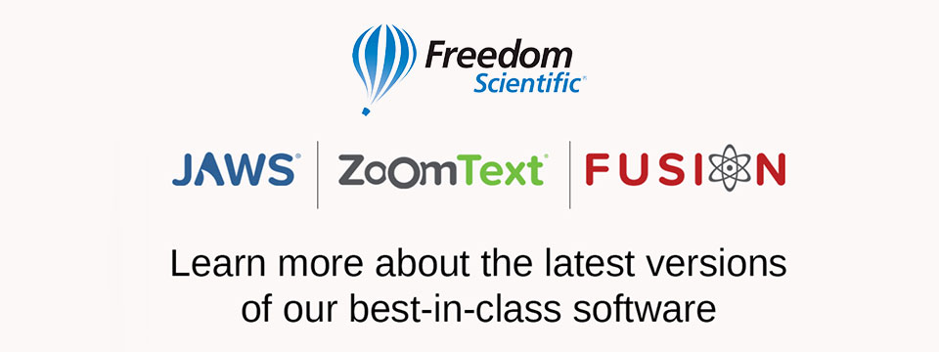
👉️ Classified Advertisement: Freedom Scientific Focus Blue 5th Generation Refreshable Braille Displays | Freedom Scientific
Our world-class refreshable Braille displays deliver efficient Braille input and outstanding output for your PC or mobile device. The robust Bluetooth® connectivity provides seamless use with Windows®, Mac®, iPhones®, iPads®, and Android TM smartphones and tablets. Ergonomic navigation features allow quick, natural hand movements for greater productivity. When used with JAWS® screen reading software, they support our popular Braille Study Mode, an interactive tool for teaching and learning Braille. Learn more today.
Sponsor Since: April 15, 2021 📅️
Website: https://www.freedomscientific.com/ 🌐️
Email: info@vispero.com 📧️
Phone: (800) 444-4443 📱️
Facebook | Twitter | YouTube (Training)
About: Freedom Scientific, a Vispero brand, is a leading worldwide brand of assistive technology products for those with vision impairments. We offer products designed to promote independence, allowing blind and low vision individuals the same access to information as their sighted peers. World-renowned JAWS (Job Access With Speech) screen reading software and ZoomText screen magnification software provide users the independence and ability to seek education and obtain or maintain a career after vision loss. Our expansive product line includes both low vision and blindness technology for all aspects of daily living. The wide range of RUBY, TOPAZ, and ONYX desktop and portable video magnifiers are designed for their ease of use and assist with daily activities. Our impressive line of blindness hardware products include refreshable Braille displays and scanning and reading devices, offering many options tailored to fit individual needs.

⬆︎ 1.) Sponsor: A. T. Guys

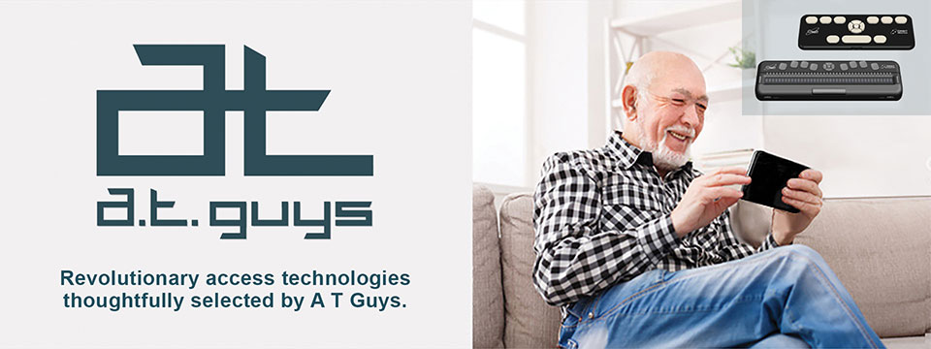
👉️ Classified Advertisement: Pluggable USB-C 7-in-1 Hub | A. T. Guys
If you're like me, you probably have more things to plug into your computer than available ports. That's why we've now added the Pluggable USB-C 7-in-1 Hub. Plug it into your laptop and you will get 3 USB ports, SD and Micro SD card slots, a USBC charging port, and an HDMI video port. It's available now for just $29.95.
Sponsor Since: June 11, 2020 📅️
Website: https://www.atguys.com/ 🌐️
Phone: (269) 216-4798 📱️
Email: support@atguys.com 📧️
Skype: atguys 💬️
X (Formerly Twitter): https://twitter.com/atguys (@atguys) 💬️
Facebook: https://facebook.com/atguys 💬️
About: ATGuys.com. Your access technology experts, home for cool gadgets, accessories, and more. Our products are all tested to work great for blind and visually impaired users but also work just as well for anyone. If there's an item you're looking for, or if you have a question, please don't hesitate to send us a message or call (269) 216-4798 📱️.

⬆︎ 19.) Sponsor: Double Tap

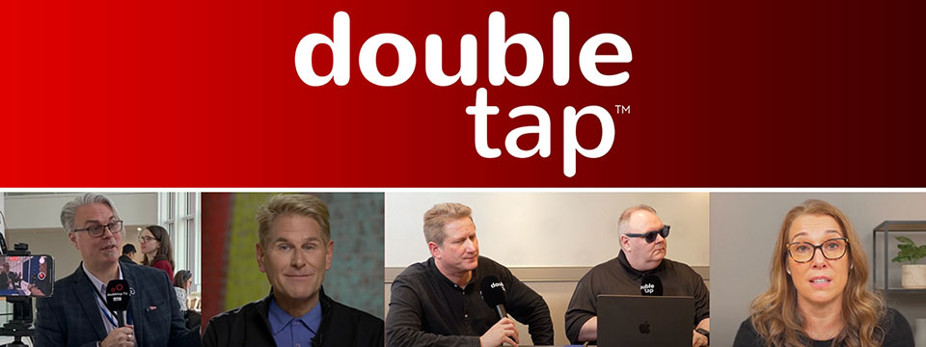

Sponsor Since: March 15, 2025 📅️
Website: https://doubletaponair.com/ 🌐️
About: Founded in 2017 as “Double Tap Canada” on AMI-audio, Double Tap has grown into a weekday podcast, radio show and YouTube series whose tagline proudly declares it "The Podcast Where Blind People Talk Tech." Its Glasgow-based creator Steven Scott, Manchester-based producer-co-host Shaun Preece and Canadian executive producer Marc Aflalo now helm more than 600 episodes that drop every weekday at noon ET, alongside written articles and video clips on DoubleTapOnAir.com.
Each episode blends mainstream gadget news with deep dives into assistive tools, all filtered through the lived experience of blind hosts. Listener emails, voicemails and WhatsApp messages are woven into the conversation, while spin-offs such as Shaun of the Shed (beginner tutorials) and past TV projects like Access Tech Live extend the brand across platforms in partnership with Accessible Media Inc. The result is a vibrant, multi-platform ecosystem that reaches audiences via AMI-audio, every major podcast app, YouTube and even specialist players like the Victor Reader Stream.
The community's enthusiasm shows: Double Tap recently surpassed one million cumulative downloads and, in March 2025 alone, attracted nearly 27K listeners generating 38K downloads; Apple Podcasts users rate it around 4.8 / 5. Authentic insights, daily consistency and professional production continue to position Double Tap as an essential, trusted voice at the intersection of mainstream tech and accessibility.
Newsletter (Double Tap Digest) | Facebook | Instagram | LinkedIn | TikTok | X (Formerly Twitter) | YouTube

⬆︎ 18.) Sponsor: Awarewolf Gear

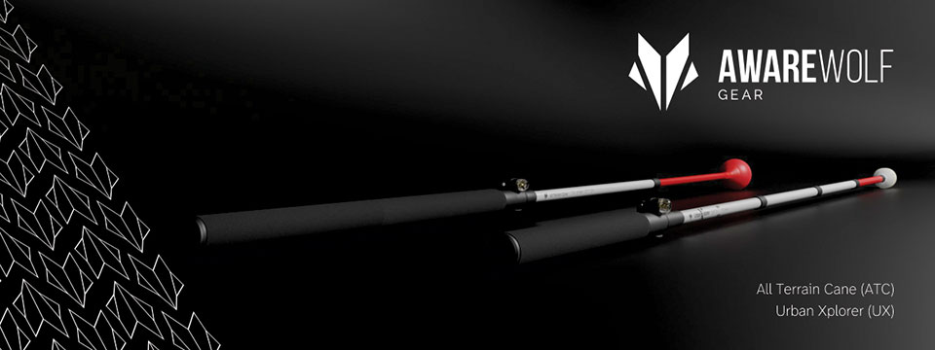

Sponsor Since: February 28, 2025 📅️
Website: https://awarewolfgear.com/ 🌐️
About: Awarewolf Gear is built on innovation, resilience, and a passion for adventure — especially for those in the blind and low vision community.
Awarewolf Gear is dedicated to redefining mobility through high-performance, thoughtfully engineered canes.
With the core belief that everyone deserves to explore confidently, our mission is encapsulated in our tagline, "Power for Life's Adventure."
Our product line, community initiatives, and inspirational storytelling all work in tandem to empower users to navigate diverse terrains with ease and independence.
Product Line
⚫️ All Terrain Cane (ATC)
Design & Purpose: The All Terrain Cane was originally engineered for the rugged trails of Sedona, Arizona. Made from durable titanium alloy, it is built to handle everything from sandy beaches to rocky mountain paths. Its adjustable 16-inch handle and high-performance roller ball tip provide stability and versatility across varied surfaces.
⚫️ Urban Xplorer Cane (UX)
Innovation & Versatility: Merging the rugged design of the ATC with enhancements for urban mobility, the Urban Xplorer Cane features an adjustable handle and a specially designed "Dome" cane tip. Available in multiple sizes (small, medium, large and extra-large), this lightweight, robust cane is ideal for navigating busy city streets as well as more challenging environments.
⚫️ Cane Tips
Customization & Performance: Awarewolf Gear's Cane Tips are designed to elevate your mobility experience by ensuring smooth, reliable navigation across all terrains. Crafted for both durability and style, these premium replacement tips allow users to personalize their canes while enhancing performance.
⚫️ Accessories and Apparel
Customization & Expression: Beyond canes, Awarewolf Gear offers a range of accessories — such as colorful replacement cane tips designed for visibility and personal expression — and apparel that carry the brand's adventurous spirit.
Instagram | Facebook | LinkedIn | YouTube

⬆︎ 17.) Sponsor: Case for Vision

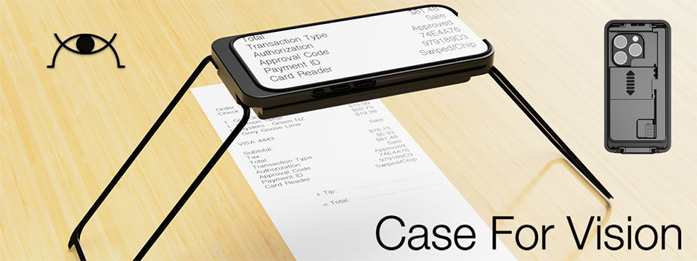

Sponsor Since: February 27, 2025 📅️
Website: https://caseforvision.com/ 🌐️
Phone: +1 (781) 343-1071 📱️
Email: contact@caseforvision.com 📧️
About: At Case For Vision, we design and manufacture assistive devices, for visually impaired people or those who suffer age-related vision loss.
Purpose: Leveraging technology with precision engineering and optics. We want to return the purchasing power to people, and disrupt the existing practice by replacing expensive proprietary devices or components with ubiquitous, mass-produced, powerful smartphones, tablets, and computers.
Case For Vision ( CFV ): The first device that we have launched is built for the iPhone. Find out how Case For Vision can aid you in everyday life.
The Case For Vision is an innovative iPhone-based optical mechanical case that functions as a hands-free local or distance high-quality magnifier when used with the Case For Vision 2.0 specialized software application. Designed to resemble a standard smartphone protective case, it is a powerful magnification tool for people with vision loss.
Case for Vision comes with a Lifetime Warranty and a Free Upgrade if you get a new phone.

⬆︎ 16.) Sponsor: Vision Tech Academy

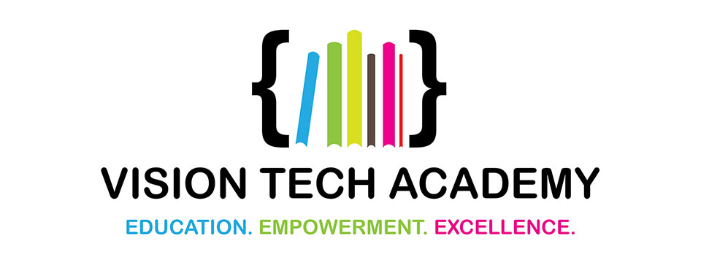

Sponsor Since: January 15, 2025 📅️
Website: https://visiontechacademy.com/ 🌐️
About: Vision Tech Academy is a website, platform and online directory dedicated to empowering blind and low-vision individuals by connecting them with trusted assistive technology educators for free.
Vision Tech Academy is the home of the free, access-technology specific, Online Directory of Educators (ODE).
Inspired by the legacy of John Panarese, the Academy website serves as a hub for accessible learning, offering a free directory of access educators, live and recorded courses, and resources to foster learning independence and success.
With an ongoing mission to provide high-quality, trusted, personalized training on tools like VoiceOver, JAWS, NVDA and Braille technology, Vision Tech Academy bridges the gap between technology and accessibility, ensuring inclusive and accessible education for all.
📖️ Free Directory for Students
📖️ Free General Profiles for All Access Educators
🏅️ Premium Profiles for Access Educators Who Want More Reach

⬆︎ 15.) Sponsor: Elegant Insights Braille Creations

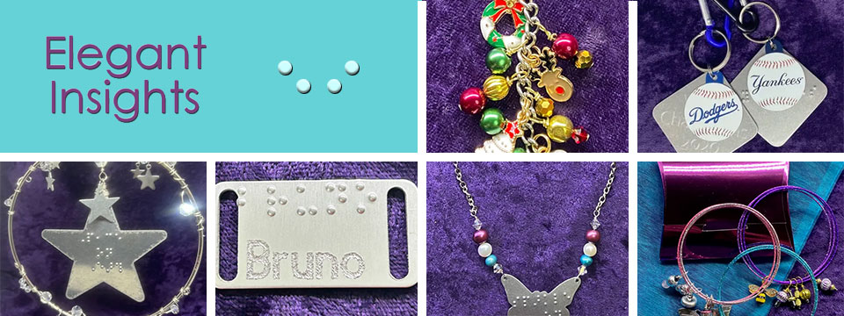
👉️ Classified Advertisement: Prepare For Takeoff: Summer Is Travel Season!
Going somewhere? Bring along our Clever travel accessories that will keep you organized and fashionable wherever your journeys take you. Our 3-piece Travel Ready Jewelry Case and Care set includes a mini zip-around jewelry box, polishing cloths, and anti-tarnish tabs to keep your jewelry sparkling all vacation long. The many colorful choices in our 3-piece makeup bag, lipstick case, and coin purse set will help you find your smaller items quickly in a tote or handbag. Headed to the NFB convention? Carry our special keytag that features a carabiner clip, a split ring for keys, a USA shaped charm braille-embossed with 2025 and a steel dog tag with the NFB motto "live the life you want" embossed in grade 2 braille. Finally, whether you'll be exhibiting, presenting, or networking, keep your calling cards, ID, or credit cards in one of our classy metal business card cases. Call +1 (702) 605-1265 or shop online at https://elegantinsightsjewelry.com. Bon voyage!
x (Formerly Twitter) | Facebook | Instagram

Sponsor Since: November 22, 2024 📅️
Website: https://elegantinsightsjewelry.com/ 🌐️
About: Elegant Insights Braille Creations, founded by Laura Legendary, offers a distinctive collection of handcrafted jewelry and accessories embossed with crisp, readable braille.
Inspired by a personal experience, Laura, who is blind, established the brand to merge style with accessibility, providing beautiful and inclusive products. Each piece is made in the USA and can often be personalized or custom-designed to meet individual preferences.
Beyond her work with Elegant Insights, Laura co-founded The Fashionability Channel podcast, which provides beauty, fashion, and lifestyle information for people with disabilities. She also maintains two blogs: the Accessible Insights Blog, offering information on products and services for individuals with low or no vision, and the Sparkle On Blog, which provides jewelry education, design trends, and style information.
Laura's dedication to accessibility and advocacy extends to her role as a speaker, author, and educator specializing in these areas. Her multifaceted efforts aim to empower individuals with disabilities, ensuring they have access to stylish, functional, and meaningful products and information.
Home | About Elegant Insights | Ordering, Shipping and FAQs | My Account | Checkout | Cart | Shop The Boutique | Wish List | Testimonials | Subscribe

⬆︎ 14.) Sponsor: Florida Vision Technology

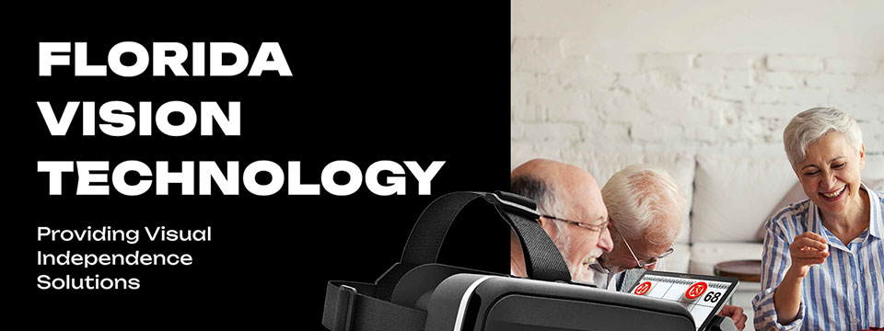

Sponsor Since: October 13, 2024 📅️
Website: https://floridareading.com/ 🌐️
About: Florida Vision Technology is officially celebrating its 20th anniversary. When I started in February 2000, the assistive technology industry was young, and there were just a handful of manufacturers.
Opening the business felt right, and I was ready to jump in. The biggest challenge, in the beginning, was getting a used bulky desk into the shed in my backyard, which my daughters named "Lesa Berg Kretschmer World Headquarters."
Three years later, in June of 2003, we moved into our first offsite location and opened a low vision superstore!
Home | Shop | Blogs | About Us | Contact Us

⬆︎ 13.) Sponsor: Access Park

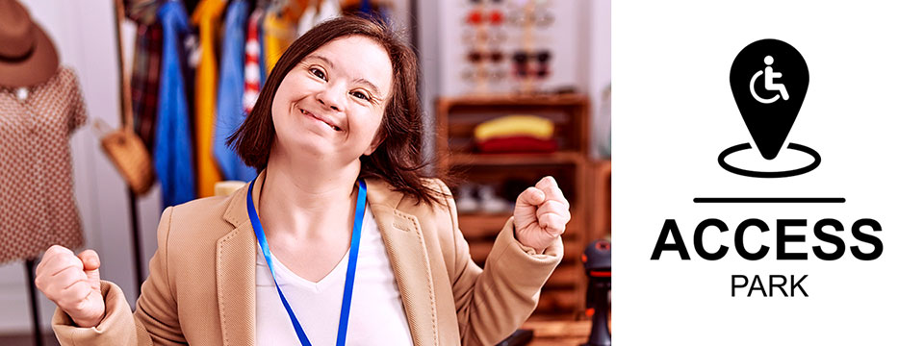
👉️ Classified Advertisement: Donna J. Jodhan's Pottery - Piece By Piece! Building Blocks For Inspiration And Creation! | Access Park
My pottery pieces are designed to inspire your creativity and imagination! Each piece is crafted with care, offering a unique touch to your home and dining experience. Whether you're looking for elegant dinnerware, functional art, or custom pieces, I can help you bring your vision to life. From rustic charm to modern elegance, I specialize in creating pottery that fits your personal style and elevates your dining table. Let me customize a one-of-a-kind creation that reflects your taste and enhances your space, adding beauty and warmth to every meal. And check out the highlight of the month.

Sponsor Since: September 20, 2024 📅️
Website: https://accesspark.shop 🌐️
About: Access Park is your premier destination for accessible shopping.
At Access Park, we offer a curated selection of products aimed at enhancing the daily lives of persons with disabilities.
Whether you're looking for accessible tech gadgets, specialty assistive devices, or just everyday essentials, you'll find them here.
Access Park provides a shopping experience that prioritizes keyboard navigability, screen reader compatibility, and high-contrast visuals for those with visual impairments, in addition to other enhancements that provide an elevated shopping experience to users of various assistive technologies.
Access Park. Where inclusivity is always in stock. ^{(TM)}

⬆︎ 12.) Sponsor: The Apex Program

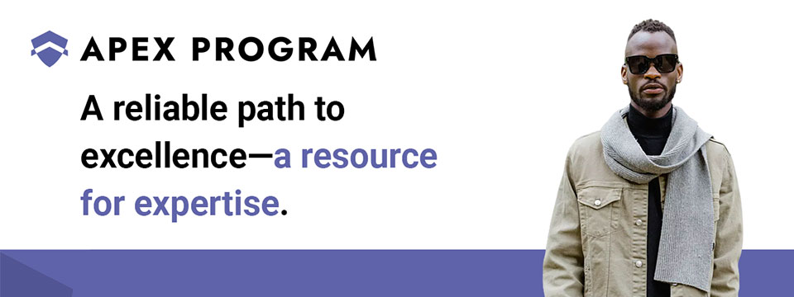
👉️ Classified Advertisement: Jumpstart Your Cybersecurity Career with the Apex Program! | The Apex Program
Are you ready to advance your career in cybersecurity? The Apex Program offers a comprehensive 12-week training course designed to prepare you for the CompTIA Network+ and Security+ certification exams. Tailored for the blind, visually impaired, disabled, and veteran communities, our program combines informative lectures, video tutorials, and quizzes, with expert instructor support every step of the way.
Get started today — Classes start on the first Monday of every month!
Don't miss this opportunity to join a diverse and inclusive workforce in the cybersecurity sector. Visit https://TheApexProgram.com to learn more and secure your spot today!
Sponsor Since: July 16, 2024 📅️
Website: https://theapexprogram.com 🌐️
About: Unlocking Abilities, Securing Futures. Founded on the principles of inclusivity and opportunity, the Apex Program is a pioneering educational initiative in cybersecurity, tailored for the blind, visually impaired, disabled, and veteran communities. Created by a Novacoast employee and inspired by his own journey from disability to Security Operations Center manager, the curriculum is designed to create a strong foundation of IT security knowledge, while instilling confidence and ensuring competence in the IT talent pool. Our ten-week program culminates in industry-recognized CompTIA certifications and a guaranteed pathway to employment, courtesy of Novacoast's dedicated IT Staffing division. At Apex, we don't just teach cybersecurity; we transform lives by unlocking potential and advocating for diversity in the IT security workforce.
Mission: The Apex Program is committed to bridging the gap in cybersecurity talent by empowering the blind, visually impaired, disabled, and veteran communities through inclusive, accessible, and comprehensive training. Our mission is to nurture a diverse workforce equipped with the necessary IT security skills and certifications to thrive in the cybersecurity sector. In partnership with Novacoast, we ensure a solid educational foundation and job placement in the industry, further fostering a future where every individual can focus their distinct abilities on building a more secure digital world.
Novacoast: Novacoast is a cybersecurity and IT services company that helps organizations enhance their security posture. They offer a range of services, including cybersecurity advisory, security engineering, identity and access management, development and integration, penetration testing, managed security services, and incident response. Their managed services include co-managed SIEM, DLP, EDR, vulnerability and patch management, phishing monitoring, and threat operations. Novacoast also provides specialized services for different industries such as finance, healthcare, and gaming. Additionally, they offer staffing solutions and training programs. Learn more today.
Home | A Division of Novacoast | Novacoast Federal | The Program | About Us | Partnerships | Media | Contact

⬆︎ 11.) Sponsor: Innosearch.ai

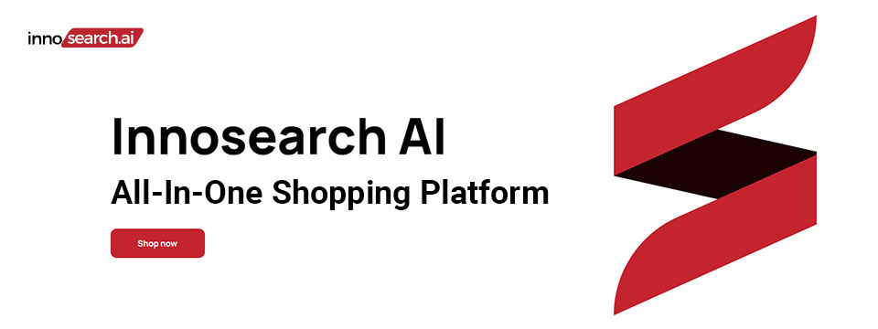
👉️ Classified Advertisement: Shop by Phone — No Screens, Just Your Voice!
Call 1-855-SHOP-GPT (1-855-746-7478)
Shopping online can be hard if you're blind, visually impaired, or not tech-savvy. That's why Innosearch AI created Shop by Phone — a 100% free, voice-only service.
Just call and say what you need:
👉 “Find me a phone charger.”
👉 “Add it to my cart.”
👉 “Check out.”
No apps, no websites — just easy, hands-free shopping from over 500,000 stores.
- ✔ Free to use
- ✔ Works anywhere, anytime
- ✔ Perfect for seniors, blind, and low-vision users
Available in:
- 🇬🇧 UK: +44 7727 247467 📱️
- 🇨🇦 Canada: +1 782 222 7467 📱️
- 🇦🇺 Australia: +61 489 267 467 📱️
- 🇺🇸 USA: 1-855-SHOP-GPT 📱️ (1-855-746-7478 📱️)
Call now and shop with ease!
Sponsor Since: June 7, 2024 📅️
Website: https://www.innosearch.ai 🌐️
Email: info@innosearch.ai 📧️
About: Innosearch is an all-in-one shopping platform augmented with a cutting-edge AI-powered shopping assistant. This innovative feature mimics the experience of shopping in real life by allowing you to interact with the assistant using natural language. It aggregates millions of products from top US online retailers, bringing them directly to you. With this advanced generative AI, Innosearch offers personalized product recommendations, highlights the best deals, and provides comprehensive information including reviews, total prices, shipping options, and more. Innosearch delivers a seamless end-to-end shopping experience, eliminating the need to search and browse in multiple tabs across retailers.
YouTube Review By Sam Seavey: https://youtube.com/watch?v=-rjL-HAwaZY.
Key Features: Key Features of the Innosearch All-in-One AI Shopping Platform include:
➜ Research Products: Easily compare products across retailers, or weigh pros and cons of similar products to make informed decisions.
➜ Uncover the Best Deals: Never miss a door buster, coupon, or clearance sale again. Get notified about the best prices and offers.
➜ AI Summarized Trusted Reviews: See what others are saying and make confident purchases.
➜ All in One: Innosearch brings millions of products from top online retailers directly to you, allowing you to shop the best deals with easy checkout and personalized AI assistance.
➜ Shop with Confidence: Rest assured, Innosearch has you covered with free shipping and returns on every purchase.
➜ Know Before You Buy: Innosearch equips you with expert buying guides, empowering you to make well-informed decisions.
How To Shop: Simply create a free account and start shopping today!

⬆︎ 10.) Sponsor: The Accessibility Guy

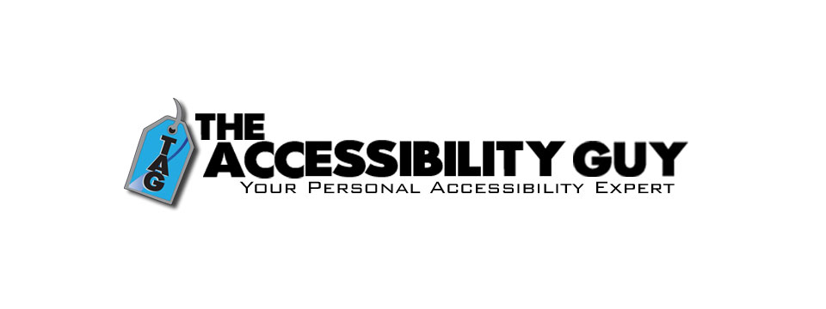
👉️ Classified Advertisement: How to Tag Multiple Languages in a PDF | The Accessibility Guy
More Adobe Acrobat accessibility tips!
My latest post explains how to properly tag individual language sections in a multilingual PDF. Adobe Acrobat offers tools to assign language codes to specific sections, allowing screen readers to interpret and vocalize the content accurately.
Check out The Accessibility Guy's full suite of Accessibility services.
Sponsor Since: August 3, 2023 📅️
Website: https://theaccessibilityguy.com/ 🌐️
YouTube: https://youtube.com/@TheAccessibilityGuy 📹
About: My name is Shawn Jordison and I love helping others learn the ins and outs of digital accessibility.
I have made over 100 thousand documents accessible, provided hundreds of trainings in the areas of accessibility and document remediation, and reviewed many websites and mobile applications for accessibility.
I have developed and reviewed VPATs, LMS courses, and other pieces of training. I am the accessibility Swiss army knife. Let me be your personal accessibility expert.
➜ Over 13 years of experience in the field of accessibility.
➜ Passionate about providing equal access to information for everyone.
➜ Wide range of project experience, including document accessibility, training, and more.
➜ Expertise in captioning, assistive technology, and accessibility best practices. I'm here to help you create a more accessible world.
The Blog: This blog covers topics like making Word, PDF & PowerPoint files accessible, Closed Captioning, assistive technology, and other important accessibility topics.
Training and Consulting: Offering customized training and consulting for implementing accessibility best practices.
Accessible Document Service: Providing top-tier document remediation services for all types of files, ensuring compliance with WCAG, 508, and PDF UA standards.

⬆︎ 9.) Sponsor: The Lighthouse for the Blind, Inc.

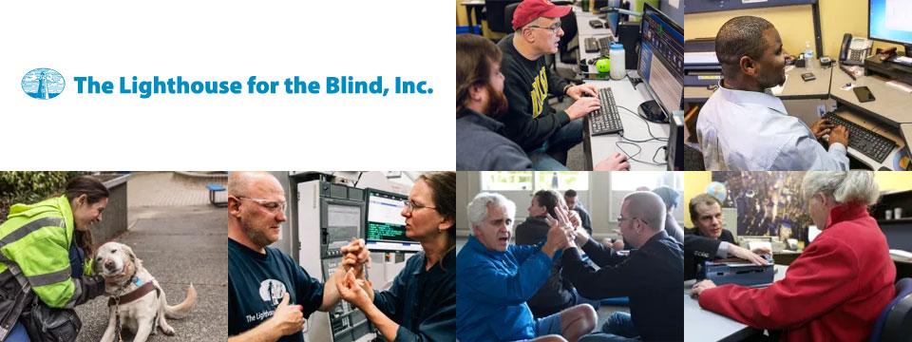
Sponsor Since: December 29, 2022 📅️
Website: https://lhblind.org/ 🌐️
Phone: (800) 914-7307 📱️
Fax: (206) 329-3397 ░
Contact Us: https://lhblind.org/contact-us/
About: The Lighthouse for the Blind, Inc. is a private, not-for-profit social enterprise providing employment, support, and training opportunities for people who are blind, deafblind, and blind with other disabilities. The Lighthouse has provided employment and support to people who are blind in our community since 1918.
The Lighthouse for the Blind, Inc. is a successful manufacturing organization with over 60 years of experience in precision machining. We produce an array of machined parts and plastic injection molding for various aerospace manufacturers, as well as a host of office products and hydration equipment sold to the Federal Government and the U.S. Military. We also own and operate stores on military bases along the West Coast. Our products and services include:
• Manufacturing: We are a successful manufacturing organization committed to making jobs accessible to individuals who are blind. Our manufacturing operations center on making quality products for the Federal Government under the AbilityOne Program and producing parts for aerospace manufacturers.
• Managed Services: The Lighthouse for the Blind, Inc. offers a variety of services to our commercial, federal, and military customers. These include Contract Management Support (CMS) services for government contracting offices.
• Base Supply Centers: We operate 12 AbilityOne Base Supply Centers (BSCs) that offer easy customer access to Lighthouse products, direct feedback and communication with customers, and employment opportunities for individuals who are blind in geographic areas not served by larger nonprofit agencies.

⬆︎ 8.) Sponsor: Wayaround

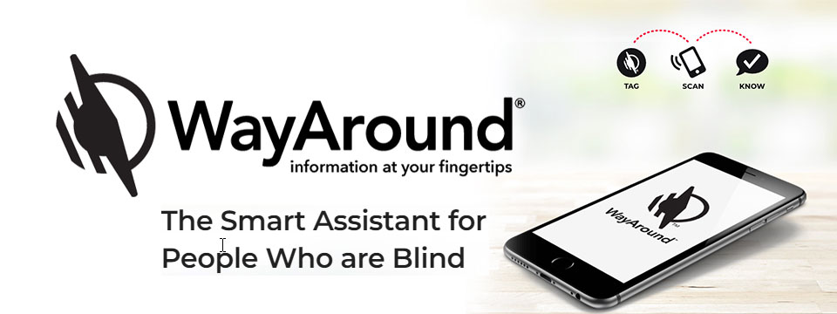
👉️ Classified Advertisement: FREE Sampler Pack with a Purchase of Any 25-pack of WayTags | Wayaround
WayAround is a smartphone-based labeling app that works with your preferred accessibility settings. You just need the free mobile app and some WayTags ® to label items in the kitchen, garden, closet, office & more.
If you want to label something that's inside, outside, wet, dry, hot, or cold, there's a WayTag that will attach securely. WayTags come as stickers, buttons, magnets, and clips. Each of the different styles of WayTags work exactly the same. Simply choose the WayTag that's best for what you want to label.
Purchase a 25-pack of any style of WayTag and get a free Sampler Pack so you can try all seven different WayTags. Enter the coupon code SAMPLE at checkout and the Sampler Pack will automatically be added to your cart. This is a $14.99 value! Limit one Sample pack per order.
Sponsor Since: January 5, 2023 📅️
Website: https://www.wayaround.com/ 🌐️
General Sales & Support: (888) 898-4465 📱️
Business Sales & Support: (888) 898-4465 📱️
Email: connect@wayaround.com 📧️
About: WayAround is the app for your smart device that provides on-demand details about everyday things. The simple tag-and-scan approach lets you quickly and easily identify things around you. It also provides extra details, like how something works or when it expires. The result? Doing more of the things you want, with more confidence and more independence.
All the information you want with just a tap of your phone. No more waiting around to ask someone. You need just two things to get started: The free mobile app for iOS or Android and some of our smart WayTags®.
Accessible labels for the blind, deafblind, and anyone with vision loss. Your biggest problem isn't poor eyesight. It's that so much of the information in the world is visual. But you shouldn't have to wait around for someone else to get the information you need. Or carry around a bulky, outdated device. There is a better way to get accurate and complete information every time. So you can reduce stress and gain independence.
Download The App (Apple): https://itunes.apple.com/us/app/wayaround-tag-and-scan/id1294361140?mt=8
Download The App (Android): https://play.google.com/store/apps/details?id=com.wayaround.wayaround

⬆︎ 7.) Sponsor: Aira

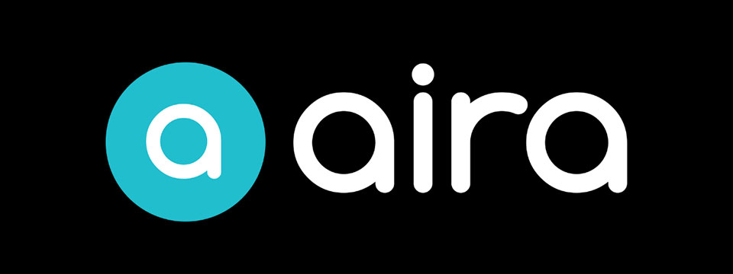
Sponsor Since: August 4, 2022 📅️
Website: https://aira.io/ 🌐️
Download the App: Apple App Store | Google Play Store
Plans and Pricing: https://aira.io/pricing/
Phone: NA: +1.800.835.1934 📱️ | AU: +1.800.765.096 📱️ | UK: +0.800.046.5668 📱️ | NZ: +1.800.425.451 📱️
Text Message: NA: +1.858.242.4457 📱️ | AU: +61.488.839.767 📱️ | UK: +44.149.320.2474 📱️
Email: support@aira.io 📧️
About: At Aira, we believe access to information is a human right. Aira breaks down accessibility barriers by providing on-demand video remote interpreting for both the blind and low-vision community, and the Deaf Community. People can download the Aira Explorer app or the Aira ASL app, and be instantly connected to a professional interpreter. Available 24/7/365, interpreters work with callers to facilitate more efficient communication and accomplish tasks together. Aira is proud to lead the way in delivering secure, on-demand, inclusive services that transform lives and open doors to new opportunities for all.
Contact Us | Access Partners | Plans and Pricing
Step One: Subscribe and Download. Pick the plan that lets you explore on your terms and on your time, sign up in a few minutes, and download the Aira app to your smartphone. Plans shown are for the United States, Canada, Australia, New Zealand and the United Kingdom. Add or cancel at any time.
Step Two: Connect with an Aira Agent. On the first call, connect with one of our certified, specially-trained Agents and learn how everything works.
Step Three: Real-time Assistance. At the touch of a button, Aira delivers instant access to visual information, when and where you want it.
Social: Twitter | Facebook | LinkedIn | YouTube | Instagram

⬆︎ 6.) Sponsor: Fable Tech Labs

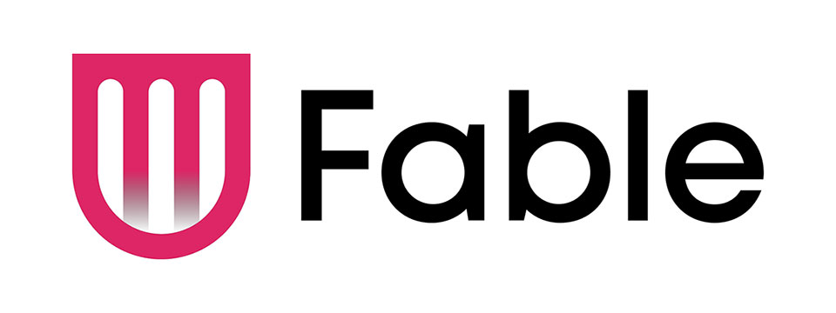
👉️ Classified Advertisement: Learn Management Skills For Free. Get The Job You Want | Fable
Everyone deserves equal access to the internet which is why Fable works with people with disabilities who use assistive technologies like switch controls to improve the accessibility of websites and apps. Fable Pathways, a free, accessible, and on-demand skill-building program, is an extension of Fable's mission. Fable Pathways provides new opportunities for people with disabilities to gain the skills they need, from experts like Judy Heumann and Kelly Ford, to contribute to improving digital accessibility.
Sponsor Since: June 30, 2022 📅️
Website: https://makeitfable.com/ 🌐️
Email: community@makeitfable.com 📧️
About: Fable is an accessibility platform powered by people with disabilities, connecting them to accessibility managers, user researchers, designers, and developers to build accessible user experiences.
Opportunities:
➜ Accessibility Tester: Testers drive meaningful change in digital accessibility by sharing feedback on the websites and apps of the companies that care. As a Tester, earn a competitive tech industry wage, learn valuable transferrable skills, and grow your career. Fable is looking for assistive technology users in the US or Canada to work the hours that they want, completely from home. No experience or resume required.
➜ Survey Respondent: Survey Respondents enjoy a remote, low-commitment income opportunity, all while contributing to accessibility research. Surveys are typically sent out once a month, and you can earn $5 to $50 per survey. Apply today if you identify as having a disability and live in the US or Canada. You do not need to use assistive technology to apply.

⬆︎ 5.) Sponsor: SelvasBLV

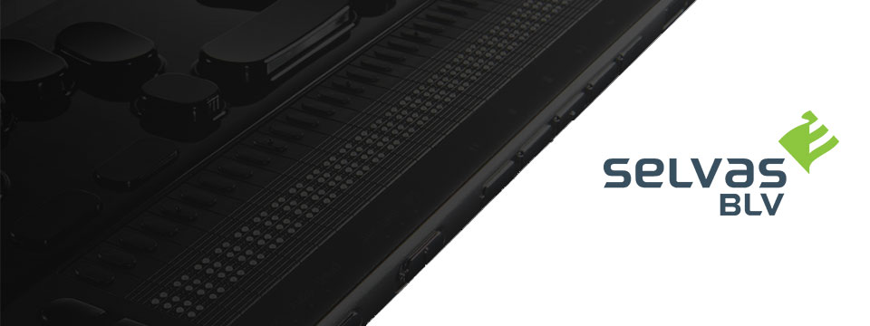
👉️ Classified Advertisement: Join SELVAS BLV At These Upcoming Webinars!
Please join Earle Harrison from SELVAS BLV, the proud North America distributors of HIMS blindness and low vision products, and Jenny Axler from HIMS the manufacturer, as they share new and innovative developments as they relate to the BrailleSense 6 Android tablet and the Braille eMotion Smart Braille display.
The presentation will take place on Monday, August 25th from 8:00 until 9:00 PM Eastern time in the Pat Price Training Room found at:
https://us02web.zoom.us/j/839935813?pwd=eXFMRHpxNnhFZlRiMHAzRWNWYXM3Zz09
You may also join Earle Harrison for a general webinar taking place Thursday, August 28th at 5PM-6PM Eastern Time as he shares new and innovative developments as they relate to the BrailleSense 6 Android tablet.
The presentation link can be found at: https://us02web.zoom.us/j/81211089088
We look forward to seeing you!
Sponsor Since: September 30, 2021 📅️
Website: https://selvasblv.com/ 🌐️
Shop All Products: https://selvasblv.com/shop-all-products/ 🛒️
Phone: (512) 837-2000 📱️
YouTube: https://www.youtube.com/watch?v=5R9NjA1nfWo
Sales: sales@selvasblv.com 📧️
Support: support@selvasblv.com 📧️
About: SelvasBLV is a global manufacturer and distributor that has provided braille, magnification and accessible healthcare devices since 1999.

⬆︎ 4.) Sponsor: Carroll Center for the Blind


👉️ Classified Advertisement: Attend the Screen Reader User Tester Training Program at the Carroll Center for the Blind | Carroll Center for the Blind
Launch your career in the digital accessibility field! The Carroll Center for the Blind's new 7-week intensive Screen Reader User Tester Training program allows participants to learn and grow their ability to professionally explore, test, and report findings regarding the accessibility of websites, mobile applications, and digital document files using screen readers. Want to learn more? Start your journey to becoming a Screen Reader User Tester today.
Sponsor Since: August 5, 2021 📅️
Website: https://carroll.org/ 🌐️
Phone: (617) 969-6200 📱️
Fax: (617) 969-6204 ░️
Shop: https://carroll.org/store/ 🛒️
Donate: https://carroll.org/donate ❤️
Social: Facebook | Twitter | YouTube | LinkedIn | Instagram
About: The Carroll Center for the Blind is the foremost leader in vision rehabilitation services for individuals confronted by the challenges of vision loss. Our mission is to empower those who are blind or visually impaired to achieve independence and to lead a fulfilling life. Established in 1936, the renowned Carroll Center for the Blind has been serving those with vision impairment for over eight decades; we are known nationally as a premier Vision Rehabilitation Center. Located just outside of Boston on a sprawling campus in Newton, Massachusetts, we proudly serve ALL ages and ALL stages of vision loss. With the ongoing promise of improving the lives of people with vision-related problems, The Carroll Center for the Blind has pioneered many innovative services allowing people who are blind or have low vision to learn the skills to be independent in their homes, in class settings, and in their work places. Our services include vision rehabilitation, vocational and transition programs, assistive technology training, educational support, and recreation opportunities for individuals who are visually impaired of all ages. For over 80 years, the expertise of Carroll Center staff has provided help for thousands of blind and visually impaired persons with diverse opportunities for success and independent living.

⬆︎ 3.) Sponsor: Pneuma Solutions

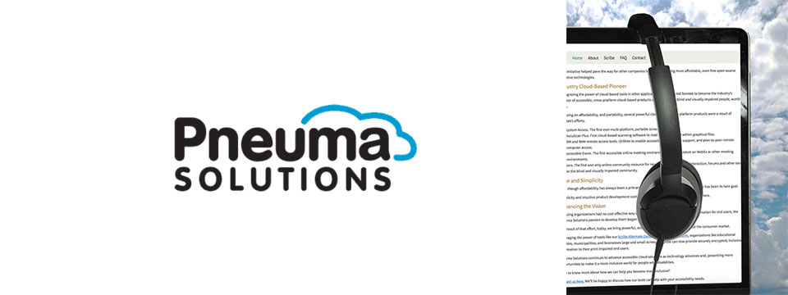
👉️ Classified Advertisement: Take Your Accessibility To The Next Level With Pneuma Solutions: Providing The Best In Cloud-Based Accessibility Solutions | Pneuma Solutions
When it comes to people's lives and their disabilities, access to information is not a privilege…It's a right. Pneuma Solutions believes organizations like yours have the right to provide the best tools for your consumers, students, employees, and citizens. We also believe, since you are here, that you're interested in joining us in making this a more inclusive world. The solutions we provide allow you or your organization to do just that. From near-perfect document remediation, to accessible realtime teleconference slides, to unparalleled remote desktop access, Pneuma Solutions is here to bring you the best in quality, reliability, and accessibility.
Sponsor Since: June 3, 2021 📅️
Website: https://pneumasolutions.com/ 🌐️
Email Newsletter: Click here to receive periodic news via email concerning Pneuma Solutions products for business, consumers and education.
Sales: (866) 202-0520 📱️
Support: (650) 249-1000 📱️
About: Backed by two decades of creating award-winning accessible cloud technologies for people with visual impairments, Pneuma Solutions is the global leader in accessible cloud-based solutions. Pneuma Solutions was founded by long-time accessibility developers Mike Calvo and Matt Campbell. For more information on their individual profiles, click on their respective bio pages. We're proud to be the first company to develop cloud-based accessibility at the network level. Our tools provide organizations, like yours, a way to deliver secure, accessible information right from your network or from our secure servers. You can provide your print disabled consumers, students, employees, and citizens with a multitude of accessible options. Additionally, we offer a suite of cloud-based applications to blind and print disabled consumers directly from our website. Our consumer products are designed to make the day-to-day lives of blind and print disabled individuals more accessible and simpler to manage. Access to information is not a privilege, it's a right. It's also your right to obtain affordable, accessible cloud solutions to serve your end user. When organizations like yours implement our tools, together we help make it a more inclusive world for people with disabilities. Want to know more about how we can help you become more inclusive?
Contact us here. We'll be happy to discuss how our tools can help with your accessibility needs.

⬆︎ 20.) Sponsor: Your Name Here

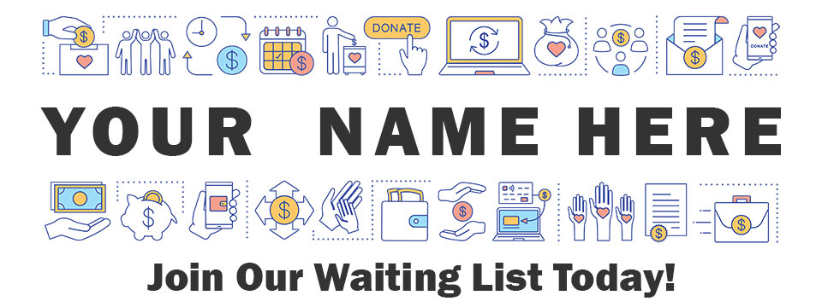
Join: Waiting List 📋️
Sponsor Since: Today 📅️
Website: https://toptechtidbits.com/sponsor 🌐️
Phone: (855) 578-6660 📱️
Email: enews@toptechtidbits.com 📧️
About: Founded in 2004, Top Tech Tidbits is the world's leading not-for-profit access technology publication that reaches over 40,000 blind, low vision, deaf, hard of hearing, deafblind, neurodivergent and/or disabled professionals, educators and enthusiasts, all over the world, each week. Subscribe here. Review the most recent issues here.

Top Tech Tidbits Supporters 🤝️
We couldn't do it without you! Thank you for your support!
Why: Top Tech Tidbits Supporters donate an amount of their choosing either one time or annually in order to assist with the ongoing distribution of the Top Tech Tidbits publication.
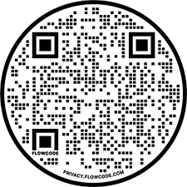
Benefits: All Top Tech Tidbits Supporters receive a listing within the "Our Supporters" section of each weekly newsletter, as well as a listing within the "Our Supporters" section of the Top Tech Tidbits website.
In addition, all Top Tech Tidbits Supporters automatically become Premium Subscribers as well, and therefore enjoy all of the benefits that a Premium Subscription has to offer.
One Time Donation: If you would like to become a Top Tech Tidbits Supporter by making a one time donation in an amount of your choosing to assist with the ongoing distribution of the Top Tech Tidbits publication, you may utilize this donate link, or scan the QR code to the right.
Annual Donation: If you would like to become a Top Tech Tidbits Supporter by making a small donation to assist with the ongoing distribution of the Top Tech Tidbits publication, we also offer the following options, all with our sincerest thanks, and most heartfelt gratitude for your ongoing support.
Support: In tandem with Our Sponsors, these are the people that make the ongoing distribution of Top Tech Tidbits possible.

Platinum Supporters:

Become a Top Tech Tidbits Platinum Supporter today.
1.) Gary Lee
Platinum Supporter since June 25, 2020
2.) Anonymous Donation
Platinum Supporter since July 9, 2020
3.) Pshon Barrett
Platinum Supporter since January 28, 2021
4.) Robin Millar
Platinum Supporter since April 6, 2023

Gold Supporters:

Become a Top Tech Tidbits Gold Supporter today.
1.) Howard Goldstein
Gold Supporter since June 4, 2020
2.) David Goldstein
Gold Supporter since June 12, 2020
3.) Katherine Crohan
Gold Supporter since January 14, 2021
4.) Neil Jarvis
Gold Supporter since April 28, 2022

Silver Supporters:

Become a Top Tech Tidbits Silver Supporter today.
1.) Timothy Gorbold
Silver Supporter since July 19, 2023
2.) Vojtech Polasek
Silver Supporter since December 29, 2023

Bronze Supporters:

Become a Top Tech Tidbits Bronze Supporter today.
1.) Steven Wettlaufer
Bronze Supporter since July 16, 2020
2.) Lions Clubs International
Bronze Supporter since July 13, 2020

One Time Supporters:
One Time Supporters donate an amount of their choosing — one time to assist with the ongoing distribution of the Top Tech Tidbits Publication.
Become a Top Tech Tidbits One Time Supporter today.
1.) Beth Wright
One Time Supporter on November 28, 2023
2.) Your name here.
One Time Supporter on ...

Top Tech Tidbits News Team 🗞️

Distribution: Sponsors, Supporters, Advertisers and Mind Vault Solutions, Ltd.

Distribution Since: 2004
As of June 4, 2020 the distribution of Top Tech Tidbits is made possible by our Sponsors, our Supporters, our Advertisers and Mind Vault Solutions, Ltd., a leading international provider of professionally outsourced marketing administration and consultation services.
Any time the Top Tech Tidbits Publication carries less than its Sponsor limit, Mind Vault Solutions, Ltd. donates the remaining dollars necessary to keep the publication running.
Please help us to support the ongoing distribution of this publication. Learn more about the benefits of Sponsorship today.

Publisher: Aaron Di Blasi

Publisher Since: June 4, 2020
Location: Cleveland, Ohio
Time Zone: Eastern Standard Time (EST/EDT) (GMT-5/GMT-4)
In addition to serving as Publisher for Top Tech Tidbits Aaron also serves as Publisher for the Access Information News and AI-Weekly newsletters, PR-Director for the AT-Newswire Press Release News Distribution Service, and President and Senior Project Management Professional for Mind Vault Solutions, Ltd.
As Publisher Aaron oversees the weekly distribution of Top Tech Tidbits on behalf of Mind Vault Solutions, Ltd.
Aaron Di Blasi, PMP
Email: publisher@toptechtidbits.com 📧️
Toll Free: +1 (855) 578-6660 📱️
PR Director (2024-Present)
AT-Newswire 🌐
Access Technology's Digital Newswire
Publisher (2024-Present)
AI-Weekly 🌐
The Week's News in Artificial Intelligence
Publisher (2022-Present)
Access Information News 🌐
The Week's News in Access Information
Publisher (2020-Present)
Top Tech Tidbits 🌐
The Week's News in Access Technology
Sr. Project Management Professional (2006 - Present)
Mind Vault Solutions, Ltd. 🌐
Innovative ideas. Solutions that perform.
Certified:
Digital Marketing Associate
Meta Certified (2022 - Present)
Social Marketing Professional
Hootsuite Certified (2020 - Present)
Email Marketing Professional
Constant Contact Certified (2019 - Present)
Specializing in:
Digital Strategy and Content Marketing
Social Media Advertising
Online Fundraising
ADA, WCAG and Section 508 Compliance

Editor: John Hanlin

Editor Since: June 4, 2020
Location: Boulder, Colorado
Time Zone: Mountain Standard Time (MST/MDT) (GMT-7/GMT-6)
In addition to serving as an Editor to Top Tech Tidbits John also serves as an Editor to the Access Information News and AI-Weekly newsletters and is also an attorney-at-law specializing in long-term disability claims for persons who are blind or low-vision.
John is also a long-time contractor and member of the Board of Trustees at Mind Vault Solutions, Ltd.
John Hanlin, Esq.
Editor (2024-Present)
AI-Weekly 🌐
The Week's News in Artificial Intelligence
Editor (2022-Present)
Access Information News 🌐
The Week's News in Access Information
Editor (2020-Present)
Top Tech Tidbits 🌐
The Week's News in Access Technology
Board of Trustees (2006 - Present)
Mind Vault Solutions, Ltd. 🌐
Innovative ideas. Solutions that perform.

Editor: Jenna Lang

Editor Since: June 4, 2020
Location: Des Moines, Iowa
Time Zone: Central Standard Time (CST/CDT) (GMT-6/GMT-5)
In addition to serving as an Editor to Top Tech Tidbits Jenna also serves as an Editor to the Access Information News and AI-Weekly newsletters and runs her own advocacy foundation.
Jenna also serves as a certified Project Management Professional (PMP) for Mind Vault Solutions, Ltd.
Jenna's son was born blind and she is always seeking new and innovative ways to empower him through technology.
Jenna Lang, PMP
Editor (2024-Present)
AI-Weekly 🌐
The Week's News in Artificial Intelligence
Editor (2022-Present)
Access Information News 🌐
The Week's News in Access Information
Project Management Professional (2022 - Present)
Mind Vault Solutions, Ltd. 🌐
Innovative ideas. Solutions that perform.
Editor (2020-Present)
Top Tech Tidbits 🌐
The Week's News in Access Technology

Editor: Stephen (Alex) Marositz

Editor Since: October 7, 2021
Location: Los Angeles, California
Time Zone: Pacific Standard Time (PST/PDT) (GMT-6/GMT-7)
In addition to serving as an Editor to Top Tech Tidbits Alex is also the Accessible Technology Coordinator for California State University, Dominguez Hills. He has worked in accessibility in higher education since 2005, is certified by the International Association of Accessibility Professionals, and in his spare time plays for the San Gabriel Valley Panthers Beep Baseball Team. He can be reached on twitter at: @samarositz.
Stephen (Alex) Marositz
Editor (2021-Present)
Top Tech Tidbits 🌐
The Week's News in Access Technology
Accessible Technology Coordinator
California State University, Dominguez Hills 🌐

Editor: Ben Moxey

Editor Since: January 1, 2022
Location: Newcastle, Australia
Time Zone: Australia Eastern Standard Time (AEST/AEDT) (GMT+10)
In addition to serving as an Editor to Top Tech Tidbits Ben is also an Access and Technology Advisor for Guide Dogs, New South Wales, Australian Capital Territory (NSW/ACT).
Hi, Tidbits readers, my name's Ben Moxey and I'm based in Newcastle, Australia. I'm really happy to be part of the Tidbits Team and look forward to supporting this valuable publication.
A bit about me and how I came to work in the BVI area. I grew up with very low vision in one eye due to retinal issues and relied on magnification and speech throughout school. They also tried to teach me Braille, but let's just say that I wasn't the best student! I was determined to use my remaining vision, no matter how impractical it was becoming.
When I was 20, the other retina came off and I've now been totally blind for about 21 years. This is when my love for assistive technology, and technology in general, really kicked in. I'll be honest, I was a bit of a computer nerd anyway, but I could quickly see how technology was my key to enhanced independence and lifestyle. I embraced screen readers, early smart phones and mobility aids. I even finally realised the huge value of Braille and finished off the course, though I'm still pretty slow!
Long story short (not one of my strong points), I've worked in the BVI area for 12 years with much of that spent reviewing, recommending and teaching assistive technology that suits the individual. I'm currently a proud employee of Guide Dogs NSW/ACT where I was the Practice Lead for the assistive technology service, and I've now moved into an Access and Technology Advisor role. Basically, this involves a strong focus on accessibility and technology innovation.
Feel free to look me up on LinkedIn, but I'll warn you in advance that I haven't given my profile the recommended attention!
All the best and happy reading!
Ben Moxey
Editor (2022-Present)
Top Tech Tidbits 🌐
The Week's News in Access Technology
Access and Technology Advisor
Guide Dogs, New South Wales, Australian Capital Territory (NSW/ACT) 🌐

Editor: David Woodbridge

Editor Since: February 6, 2023
Location: Central Coast, New South Wales, Australia
Time Zone: Australia Eastern Standard Time (AEST/AEDT) (GMT+10)
In addition to serving as an Editor to Top Tech Tidbits David also serves as an Editor to the Access Information News publication and is also the National Commercial Assistive Technology Advisor for Vision Australia where he has worked since 1990. Over this time he has assisted people who are blind or vision impaired in their home, education, and work settings to take advantage of the benefits of using assistive and main stream technology.
In the last seventeen years, he has also been involved with evaluating technology for use by people who are blind or vision impaired covering both low and high tech equipment (including Microsoft, Samsung, Google, Amazon, and Apple). David is also one of the key spokespersons for Vision Australia relating to technology.
He has been an Apple Ambassador for Apple Australia since 2009 with a group of other Ambassadors / Apple Distinguished Educators (ADE)'s covering the range of Apple's Accessibility solutions throughout Australia.
David produces a range of podcasts (since 2011) covering Apple and other technologies which are distributed on his own podcast (http://davidwoodbr.podbean.com). In addition, he also has a regular Talking Tech program (since 2013) which can be heard every Tuesday at 4:30 Eastern Summer Time on Vision Australia Radio Melbourne (available online) or via https://omny.fm/shows/talking-tech-vision-australia-radio
David also runs a weekly Tech Monday where people can chat about assistive and main stream technology, share information, and any tips and tricks.
David lost his sight when he was 8 years old and had to learn Braille. Since then, he completed high school, went to Sydney University receiving a Social Work degree, spent 4 years drug and alcohol counselling, and then moved into his current job.
As a person who is blind, David believes that as a user of the technology that he recommends to others, that he is well situated to look at the strengths and shortcomings of the assistive technology that he comes across in both his professional and personal life, in particular, mainstream technology that is accessible.
In addition to his weekly contributions to Top Tech Tidbits and Access Information News, David's regularly occurring activities are his weekly tech radio show, bi-monthly exploring tech webinars for Vision Australia, his iSee podcast when something of note grabs his attention, and the weekly Tech Monday chat sessions.
David Woodbridge
X (Formerly Twitter): @dwoodbridge
Mastodon: woody@dragonscave.space
iSee Podcast: https://davidwoodbr.podbean.com
Vision Australia Radio Talking Tech: https://omny.fm/shows/talking-tech-vision-australia-radio
Editor (2023-Present)
Top Tech Tidbits 🌐
The Week's News in Access Technology
Editor (2023-Present)
Access Information News 🌐
The Week's News in Access Information
National Commercial Assistive Technology Advisor
(1990 - Present)
Vision Australia 🌐
Live the life you choose. We're here to support all Australians who are blind or have low vision.

Editor: Vicki Walton

Editor Since: January 9, 2024
Location: Benton City, WA
Time Zone: Pacific Standard Time (PST/PDT) (GMT-6/GMT-7)
IIn addition to serving as an Editor to Top Tech Tidbits Vicki also serves as an Editor to the Access Information News publication and works as a Web Accessibility Specialist / IT Quality Assurance Tester at Washington State Board for Community and Technical Colleges.
Vicki Walton
Editor (2024-Present)
Top Tech Tidbits 🌐
The Week's News in Access Technology
Editor (2024-Present)
Access Information News 🌐
The Week's News in Access Information
Web Accessibility Specialist / IT Quality Assurance Tester
Washington State Board for Community and Technical Colleges 🌐
Better Jobs, Brighter Futures, a Stronger Washington

Subscription Information 📰️
ABOUT ♿️
Founded in 2004, Top Tech Tidbits is the world's leading not-for-profit access technology publication that reaches over 40,000 blind, low vision, deaf, hard of hearing, deafblind, neurodivergent and/or disabled professionals, educators and enthusiasts, all over the world, each week. Subscribe here. Review the most recent issues here. Access Technology broadly encompasses technologies that enable access to information and communication systems for persons with disabilities. Adaptive Technology is a subset of Access Technology designed to assist individuals in performing tasks that might otherwise be challenging due to their particular disabilities. Assistive Technology includes any device, software, or equipment that helps people work around their challenges. Top Tech Tidbits is a Mind Vault Solutions, Ltd. Publication. Publisher: Aaron Di Blasi. Editors: John Hanlin, Jenna Lang, Stephen (Alex) Marositz, Ben Moxey, David Woodbridge and Vicki Walton. Top Tech Tidbits is a sponsor, reader and advertiser supported publication.
RELEASE SCHEDULE 📅️
Top Tech Tidbits is released every Thursday morning at 6:00 AM ET.
SUBSCRIBE 📧️
Do you, a friend, or colleague wish to receive the Top Tech Tidbits newsletter? If so, please use or pass along our CAPTCHA-free sign-up link. You can also subscribe to receive the Top Tech Tidbits newsletter on the Top Tech Tidbits Website. Either of these methods will provide you with an accessibly friendly and secure medium through which you can subscribe to our mailing list. Just enter your email address, click send, and begin receiving the Top Tech Tidbits newsletter. It's that easy.
WEBSITE 🌐️
Visit the Top Tech Tidbits website online at: https://toptechtidbits.com.
PREMIUM SUBSCRIBER 💸️
Only Top Tech Tidbits Premium Subscribers receive our special quarterly issue listing the Top 60 Most Clicked News Articles of the Last 3 Months. Just $12 USD per year. This special quarterly issue is provided to Premium Subscribers as a native Microsoft Word document with full headings, links and abstracts to all 60 articles. There are no restrictions placed on these documents. Complete list of all back issues available. Premium Subscribers are entitled to all back issues, anytime they sign up. Join us today and begin receiving this incredibly informative issue every 3 months.
SPONSOR 🏅️
If you would like to become 1 of only 24 Top Tech Tidbits Sponsors whose ongoing support makes the distribution of Top Tech Tidbits possible, we offer you the following advertising benefits, with our sincerest thanks, and most heartfelt gratitude for your ongoing support.
ADVERTISE 🎯️
Top Tech Tidbits offers a variety of one-time advertising options to both Sponsors and non-Sponsors alike. Here we offer a sample newsletter that provides a breakdown of exactly what those one-time advertising options are, where they appear, and what they cost per publication.
DONATE ❤️
If you would like to become a Top Tech Tidbits Supporter by making a small donation to assist with the ongoing distribution of the Top Tech Tidbits publication, we offer the following options, with our sincerest thanks, and most heartfelt gratitude for your support.
STORE 🛒️
Are you blind or do you live with low vision? Are you deaf, hard of hearing or deafblind? Do you require a wheelchair for mobility? Do you consider yourself to be neurodivergent or otherwise disabled? The Top Tech Tidbits Online Store For Digital Downloads specializes in information that can improve your quality of life. Learn more today.
FACEBOOK 💬️
Are you on Facebook? Follow Top Tech Tidbits on Facebook to begin receiving current news and trends in Access Information as part of your Facebook News Feed.
X (FORMERLY TWITTER) 💬️
Are you on X? Follow Top Tech Tidbits on X to begin receiving current news and trends in Access Information as part of your X News Feed.
MASTODON 💬️
Are you on Mastodon? Follow Top Tech Tidbits on Mastodon to begin receiving current news and trends in Access Information as part of your Mastodon News Feed or by searching for @news@mastodon.toptechtidbits.com on your server today.
LINKEDIN 💬️
Are you on LinkedIn? Follow Top Tech Tidbits on LinkedIn to begin receiving current news and trends in Access Information as part of your LinkedIn News Feed.
YOUTUBE ▶️
Are you on YouTube? Follow Top Tech Tidbits on YouTube to begin receiving current news and trends in Access Information as part of your YouTube Video Feed.
RSS 📡️
Do you prefer RSS? Follow Top Tech Tidbits via RSS today to begin receiving current news and trends in Access Information using your choice of news aggregator.
QUESTIONS ❓️
Tidbits are intentionally concise. As a result we know that some readers may not always understand all of the items listed because little explanation is given. If a particular Tidbit brings up a question in your mind, feel free to ask, and we will try to answer as time and knowledge permit.
ARCHIVE 🗄️
Read the most recently released issues of Top Tech Tidbits online here. Visit the Top Tech Tidbits Archive here, where you can read back issues.
CONTENT CONTRIBUTORS ✍️
Any information for future issues of Top Tech Tidbits may be submitted online via our News Item Submission Form or directed to our Editors via email.
THANK YOU 🙏️
Thank you for reading. On behalf of all of us here at Top Tech Tidbits we look forward to keeping you informed.
Information provided by:
Top Tech Tidbits
https://toptechtidbits.com/ 🌐
A Mind Vault Solutions, Ltd. Publication
1284 SOM Center Road, PMB 194,
Mayfield Heights, Ohio 44124
+1 (855) 578-6660 📱️

