How to Read Blind: https://toptechtidbits.com/read
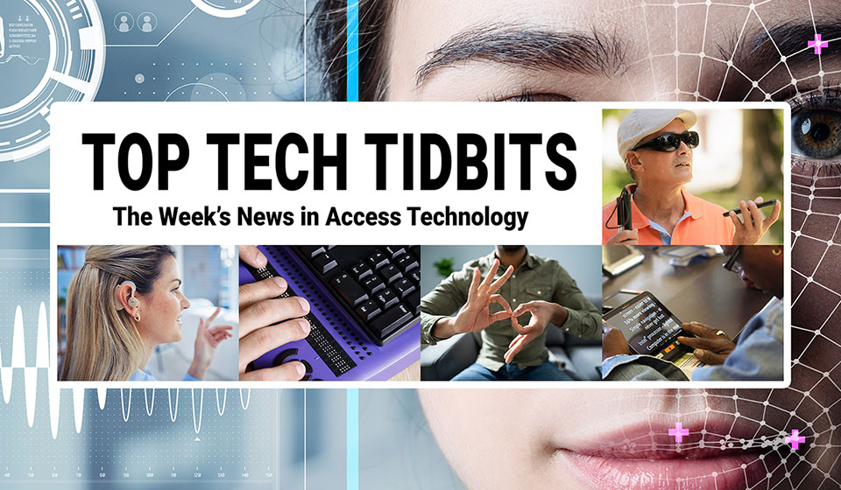
 |  |  |  |  |  |  |  |  |  |  |  | 
Top Tech Tidbits for Thursday, September 18, 2025 - Volume 1033
♿️ The Week's News in Access Technology
Top Tech Tidbits. The world's #1 online resource for current news and trends in access technology.
A Mind Vault Solutions, Ltd. Publication
Subscribers: 41,858 🔢️ opt-in subscribers were sent this issue via email.

Sponsors 🏅️
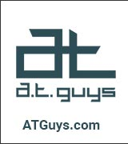 |  |  |  | 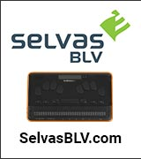 | 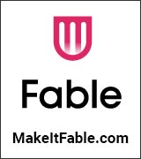
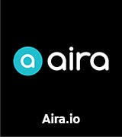 | 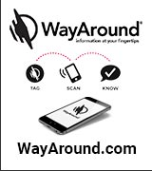 | 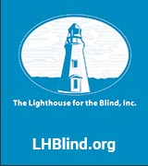 | 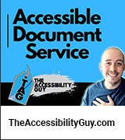 |  | 
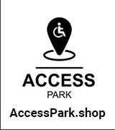 | 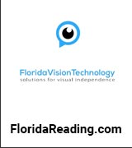 |  | 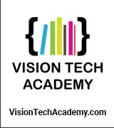 | 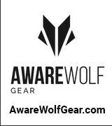 | 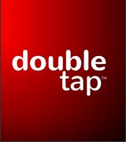
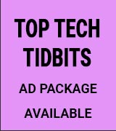 | 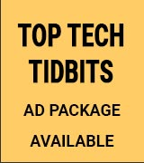 | 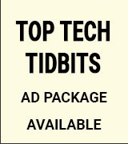 | 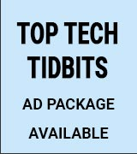 | 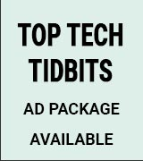 | 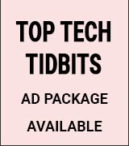

Access Awareness: Updates That Matter ♿️
Meta Smart Glasses Leak, AirPods Pro 3 & Double Demos | Double Tap | September 17, 2025
Discover the latest in accessible smart tech as Steven Scott and Shaun Preece explore the new Meta smart glasses leaks, Apple's iOS 26 update, and the AirPods Pro 3 reviews. Plus, listeners share hands-on demos of Studio Recorder and the Tapo D235 video doorbell, proving accessibility and innovation can go hand in hand.

This Week's Featured Advertisement 🎯️
Sponsorship Packages Currently Available. Support Free Access Technology News For Disabled Readers All Over The World While Increasing Traffic To Your Properties Each Week. Advertise in every issue. Or just one.
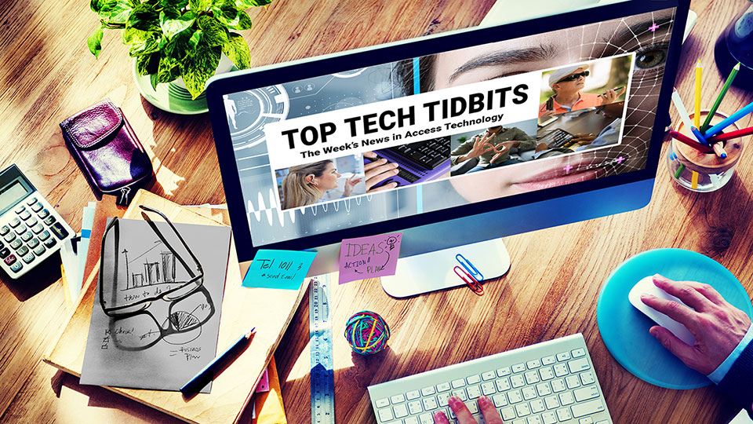
Join Top Tech Tidbits as a Sponsor today and begin reaching over 40,000 access technology subscribers each week, all while supporting the ongoing distribution of Top Tech Tidbits for those very same readers. Only $200 / month.
Key Newsletter Statistics:
- Subscribers: 40,000 + per week and growing.
- Open Rate: 46% (Average. Last 12 months.)
- Click Rate: 42% (Average. Last 12 months.)
- Bounce Rate: 1.1% (Average. Last 12 months.)
- Ad CTRs: 2-12% (Average. Last 12 months.)
Benefits All Sponsors Receive:
- One (1) Sponsor Profile on the Top Tech Tidbits website.
- One (1) Sponsor Profile in each weekly newsletter.
- One (1) Sponsor Wall Brand Advertisement on the Top Tech Tidbits home page.
- One (1) Sponsor Wall Brand Advertisement in each weekly newsletter.
- One (1) Classified Advertisement in each weekly newsletter.
- 50% Discount on all Sponsored Tidbit Advertisements.
- Free link tracking.
- Permanent SEO benefits.
- Gratitude from over 40,000 access technology subscribers for keeping Top Tech Tidbits free to read.
With additional benefits for Sponsors that pay quarterly or annually. Learn more today.

News 📰️
👉 Submit a Tidbit for free here, with timing and placement determined by our editors.
👉 Submit a Sponsored Tidbit here, with timing and placement determined by you.

1.) Top 5 Most Clicked Tidbits From Last Week 📊️
A.) Apple Event 2025: iPhone Air, Apple Watches, and More | Double Tap | YouTube.com | September 10, 2025
Apple's 2025 event unveiled groundbreaking new products, including the iPhone Air and Apple Watch Series 11. Experts discuss innovative features such as blood pressure sensing, advanced noise cancellation in AirPods Pro 3, and the implications of a potential folding iPhone, weighing the promises of accessibility against the reality of their applications.
B.) Podcast: Hadley Presents: Artificial Intelligence And Vision Loss | HadleyHelps.org | September 10, 2025
In this episode of the Hadley Presents podcast, host Ricky Enger and guests explore four AI-driven tools — Be My Eyes, Seeing AI, Aira, and Meta Glasses — highlighting how each can support daily tasks for people with vision loss, from reading mail to navigating a grocery store.
C.) AI1y (AI And A11y) — Part III: Can I Trust AI To Be Right 100% Of The Time For Accessibility? | Nira11y.com | September 7, 2025
AI tools for accessibility audits are not 100% reliable but have the potential to greatly improve website accessibility. Despite AI's imperfections, it offers scalability and continuous improvements that can reach a larger audience compared to time-consuming manual audits. The focus should shift to enhancing AI's capabilities to address the accessibility challenges of the vast internet.
D.) Apple 2025 Accessibility Updates: Vision Pro, Braille Access, and More | Double Tap | YouTube.com | September 9, 2025
Apple's 2025 accessibility updates are set to revolutionize tech inclusivity for low vision, blind, and deaf-blind users. Vision Pro's new Zoom features, advanced Braille access tools, and the innovative Magnifier for Mac provide greater independence and functionality, while updated App Store labels ensure users can easily identify accessible apps.
E.) How Be My Eyes And InnoSearch Are Making Shopping And Travel More Accessible Than Ever | BeMyEyes.com | September 9, 2025
The integration of InnoSearch into the Be My Eyes app enhances accessibility for blind and low-vision users, offering features like simplified shopping and travel booking. This AI-driven platform provides users with easier access to a wide range of products and services, significantly promoting independence in their daily lives.
2.) Sponsorship Packages Currently Available | TopTechTidbits.com | September 18, 2025
There are Six (6) Sponsorship Packages currently available. Would your product, service or message benefit from reaching over 40,000 access technology subscribers each week? For just $200 / month? If you're thinking yes, we invite you to try a Sponsorship Package with Top Tech Tidbits. The benefits are amazing and the traffic delivered to your properties each week is measurable. No obligation. Cancel anytime. When there are no Sponsorship Packages available, you can join the waiting list here.
3.) One Time Advertisements Available | TopTechTidbits.com | September 18, 2025
One time advertisements are available to anyone, with or without a Sponsorship. Would your product, service or message benefit from reaching over 40,000 access technology subscribers? If you're thinking yes, we invite you to check out our one time advertising options. They are cost-effective, targeted and measurable. Scheduling is optional. Learn more today.
4.) Premium Subscribers | TopTechTidbits.com | September 18, 2025
Next Issue: Premium Subscribers will receive their 14th issue of the Top 60 Most Clicked News Articles for April, May and June of 2025 on Monday, October 6, 2025. Back Issues: There are currently 13 back issues available. Premium Subscribers are entitled to all back issues, anytime they sign up. All available back issues will be sent to you via email within 24 hours of purchasing your subscription. Please Join Us: If you would like to receive a perfectly formatted and searchable Word Document with each of the Top 60 Most Clicked News Articles of the last 3 months listed neatly within it, please consider joining us today for just $1 a month.
5.) Sponsored Tidbits | TopTechTidbits.com | September 18, 2025
Use Sponsored Tidbits to reach the access technology community when you need to. Whether you are a current Sponsor or not. Drive traffic to your access product and service announcements, events, updates or fundraisers using this incredibly cost-effective and easy-to-use advertisement tool. Learn more today.
6.) Do You Have A Link In This Issue? Learn How To Track It For Free | TopTechTidbits.com | September 18, 2025
This article outlines, step-by-step, how you can get free website traffic reporting on any link to your domain (AKA domain name, website or web address) that has been published by Top Tech Tidbits since January 18, 2024, when we launched this feature.

7.) Apple Updates 🍎️
Skip this Tidbit to skip all updates on Apple.

A.) iOS 26 And iPadOS 26: A Summary Of VoiceOver And Braille Issues And Improvements | AppleVis.com | September 15, 2025
The post outlines significant bugs and improvements regarding VoiceOver and Braille functionality in iOS 26 and iPadOS 26, including issues with Live Captions, Message Actions in WhatsApp, and recommendations for various user types. The authors urge users to read through the post and community feedback before deciding to upgrade.
B.) MacOS Tahoe: New Features, Changes, Improvements, And Bugs For Blind, Deaf Blind, And Low Vision Users | AppleVis.com | September 15, 2025
macOS 26 Tahoe introduces various enhancements aimed at blind, deaf blind, and low vision users, including new VoiceOver functionalities like remote control via Screen Sharing, Braille Keyboard Input, and improved toolbar customization. Despite the upgrades, several new bugs have emerged, raising concerns about accessibility and user experience.
C.) What's New In iOS 26 Accessibility For Blind And DeafBlind Users | AppleVis.com | September 13, 2025
iOS 26 introduces important accessibility features for blind and DeafBlind users, including temporary sharing of accessibility settings, Nutrition Labels for app developers, and significant updates to VoiceOver and braille functionalities. The update focuses on enhancing the usability of iOS devices for users with varying accessibility needs.

8.) AI Updates 🤖️
Skip this Tidbit to skip all updates on AI.

A.) These Halo Smart Glasses Just Got A Major Memory Boost, Thanks To Liquid AI | ZDNet.com | September 15, 2025
Brilliant Labs has partnered with Liquid AI to enhance its Halo smart glasses by integrating advanced vision-language foundation models. This improvement enables the glasses to provide a more detailed and accurate interpretation of the user's surroundings, which is essential for their agentic experience and memory capabilities.
B.) Screen Readers Do Not Need To Be Saved By AI | CraigAbbott.co.uk | September 14, 2025
The article addresses the misconception that artificial intelligence can fix issues related to screen reader accessibility, particularly the misuse of emojis. It emphasizes that the responsibility for accessibility lies with content creators and advocates for teaching inclusive writing practices instead of relying on advanced technology that could complicate screen readers and increase costs for users.
C.) AI Can Spot Which Patients Need Treatment To Prevent Vision Loss In Young Adults | MedicalXpress.com | September 13, 2025
Researchers have developed an artificial intelligence algorithm capable of predicting which young adults with keratoconus require early treatment to prevent vision loss. The algorithm uses optical coherence tomography images and patient data from initial visits to effectively identify high-risk patients, potentially reducing unnecessary monitoring and enabling timely interventions.
D.) Oakley Meta HSTN Review: AI Glasses With Style and Substance | PCMag.com | September 12, 2025
The Oakley Meta HSTN smart glasses provide an engaging way to capture 3K videos and receive real-time information through an AI assistant. While they may not replace traditional devices for audio and photography, they offer a longer battery life and enhanced audio quality compared to competitors like Ray-Ban Meta glasses.
E.) Microsoft's Next AI Experiment — A Shopping Assistant That Never Clocks Out | WindowsCentral.com | September 11, 2025
Microsoft has unveiled a preview of its AI-powered Personal Shopping Agent, which promises a personalized product discovery experience for consumers. The tool can be embedded into retail apps and websites, aiming to improve customer interactions and streamline the shopping process.
F.) Everyone Is Making Smart Glasses Now | UploadVR.com | September 11, 2025
The landscape of smart glasses is increasingly crowded, with many tech giants and startups launching their own products. Noteworthy entries include Google's Gemini AI collaboration and Apple's anticipated smart glasses, highlighting the competition among established brands and innovative newcomers in the smart eyewear market.
G.) Can AI Help You Showcase Your Skills Better In Job Applications? We Put It To The Test | Technical.ly | September 8, 2025
A study indicates that a majority of hiring managers support the use of AI tools in resume creation, although they also express the need for human oversight. While AI can generate tailored resumes quickly, it's essential for applicants to review and refine the outputs to ensure accuracy and relevancy.
H.) AI in the Workplace: Assisting Blind and Low Vision Professionals | Tiffany Kim | APH ConnectCenter | August 20, 2025
For many people, artificial intelligence (AI) only entered the spotlight with the public release of ChatGPT in late 2022. But for blind and low vision professionals, AI has been quietly transforming accessibility and independence for years through tools like optical character recognition apps, screen-reading assistants, and automated description services.

Tips, Tutorials, Guides, Reviews, Walk-Throughs and How-To's 📚️

9.) JAWS Power Tip: How To Create a New Sheet in Google Sheets | Freedom Scientific | TopTechTidbits.com | September 18, 2025
Google Sheets is a part of the Google Workspace suite of applications, and is widely used in schools and in the workplace to organize data. You can navigate, format, and analyze data in Sheets with JAWS using the keyboard.
10.) Accessible Slide Transitions For Microsoft PowerPoint | The Accessibility Guy | YouTube.com | September 17, 2025
Learn to implement accessible slide transitions in PowerPoint, offering an intuitive experience for all users. This tutorial proposes effective alternatives to traditional transitions, enhancing content clarity and user engagement.

News, Trends, Updates and Opinion Editorials 📰️

11.) Top Tech Tidbits Publisher Updates for September 18, 2025: Top Tech Tidbits Website Redesign Currently Underway | Aaron Di Blasi | TopTechTidbits.com | September 18, 2025
I am incredibly excited to report that a complete redesign of the Top Tech Tidbits website is currentrly underway. Learn more today.
12.) Meta Smart Glasses Leak, AirPods Pro 3 & Double Demos | Double Tap | YouTube.com | September 17, 2025
Steven Scott and Shaun Preece expose exciting developments in accessible technology, discussing leaks of Meta's smart glasses, the new iOS 26 update, and details on AirPods Pro 3. Insightful demos from listeners showcase the Studio Recorder app and Tapo D235 doorbell, demonstrating how innovation remains deeply intertwined with accessibility.
13.) Eyes on Success Episode 2538: Encore of 1741 Together Again - Leaders Who Made a Difference (Part 2 of 2) | September 17, 2025
Hosts Nancy and Peter Torpey continue the conversation with three leaders in the field of assistive technology: Deane Blazie, Jim Fruchterman, and Ted Henter. They made pioneering contributions to the development of refreshable Braille displays, OCR, and screen readers, respectively. Learn about their visions for the future in this informative round table discussion.
14.) NVDA 2025.3 Released | NVAccess.org | September 17, 2025
NVDA 2025.3 has been officially released, offering significant improvements in Remote Access, SAPI5 voices, braille functionality, and the Add-on Store. Key updates include the addition of command functions, smarter braille features, and various bug fixes, enhancing overall software stability and user experience.
15.) Glide Rollout, Meta Glasses Bugs, And The Reality Of Blind Gaming | Double Tap | YouTube.com | September 16, 2025
Glide's phased rollout has ignited discussions within the blind tech community, as Steven Scott and Shaun Preece delve into listener feedback about accessibility challenges and tech frustrations. The episode explores diverse perspectives on Glide's funding and rollout strategy, the intricacies of AI-powered glasses, and the pressing need for more immersive accessible gaming experiences for blind users.
16.) Vibe Fixing: How To Validate AI-Generated Code And Achieve Accessibility At The Speed Of AI | Deque.com | September 16, 2025
Here Jeremy Rivera presents “vibe fixing” as a workflow to pair AI-powered code generation (“vibe coding”) with accessibility validation using tools like the axe MCP Server, enabling developers to quickly detect, remediate, and re-verify accessibility issues directly in their existing development environment.
17.) Terminal Mode Goes Live With JAWS On Monarch | APH.org | September 16, 2025
Monarch's terminal mode app enhances the integration of screen readers with multi-line braille displays, providing an advanced reading experience. The updated application supports both JAWS and NVDA with features like wrapped mode for better text adjustment, cropped mode for efficient data display, and split display functionality for simultaneous content interaction.
18.) Improved Accessibility In Firefox 143 For Windows: Support For Windows UI Automation | Firefox.com | September 16, 2025
Firefox 143 introduces support for Windows UI Automation, enhancing compatibility with assistive technologies like Windows Voice Access, Text Cursor Indicator, and Narrator as part of a phased rollout.
19.) Ally Solo First Impressions & Monarch Braille Experiences | Double Tap | YouTube.com | September 15, 2025
In this insightful discussion, Steven Scott and Shaun Preece examine the functionality of Ally Solo smart glasses, focusing on their performance in object recognition for blind users. The episode also covers the practicality of wearable AI tools compared to real-world expectations, alongside the exploration of the Monarch Braille display and its impact on user independence.
20.) Skool.com Is Not Accessible | The Accessibility Guy | YouTube.com | September 15, 2025
The transition from skool.com to a custom-built Learning Management System marks a significant shift for the accessibility community. Insights gained from this journey highlight the importance of creating truly accessible digital spaces for all users.
21.) NVDA 2025.3 Released | NVAccess.org | September 15, 2025
Version 2025.3 of NVDA, the free screen reader for Microsoft Windows, is now available for download. This update features enhancements to Remote Access, SAPI5 voices, braille, and the Add-on Store, along with several bug fixes and performance improvements.
22.) JAWS Tip: Camera Positioning in JAWS | EastersealsTech.com | September 15, 2025
Belva Smith, an Assistive Technology Specialist, demonstrates features in JAWS that assist users in positioning their faces effectively for video calls and meetings. This includes insights on utilizing the Face in View and Picture Smart AI features.
23.) Musescore Studio Tips And Tricks For Musicians With Print Disabilities | SoundWithoutSight.org | September 15, 2025
This session covers accessibility features and tools in MuseScore Studio designed for low vision and neurodivergent musicians, including screen reader navigation, braille support, and tips for customizing UI for better accessibility. It showcases the potential of digital scores to enhance music literacy for individuals with print disabilities.
24.) Sound Without Sight Wins Top Honours At International Sound Awards 2025 | SoundWithoutSight.org | September 15, 2025
Sound Without Sight has been awarded the Grand Prix at the International Sound Awards 2025, recognizing its significant impact in empowering blind and partially sighted musicians. The award ceremony was held in Berlin, with Project Manager Jay Pocknell representing the initiative, which aims to enhance access, community, and innovation for musicians with visual impairments.
25.) Technology Guides For Blind Users | National Braille Press via Tech-VI List | September 15, 2025
National Braille Press offers an extensive range of accessible technology guides for blind users, covering Microsoft Windows, iOS, Android, Google applications, and other practical tech topics such as online safety, remote meetings, and accessible photography.
26.) Braille Buddy Review: Affordable Braille Embosser With Tactile Graphics! | The Blind Life | YouTube.com | September 13, 2025
Explore the innovative Braille Buddy embosser, a compact and cost-effective solution that produces Braille and tactile graphics. Ideal for educators and organizations serving individuals with visual impairments, it enhances accessibility and learning opportunities for students and teachers alike.
27.) How Groundbreaking Tech Enables The Visually Impaired To See Photographs At World Unseen Exhibit On At Iziko Museum | Primediaplus.com | September 13, 2025
Innovative technology is showcased at the World Unseen Exhibit, allowing visually impaired individuals to experience photographs through tactile and auditory feedback. This initiative aims to enhance accessibility and inclusivity in art perception, emphasizing the importance of sensory engagement.
28.) Want To Master Windows 11? Start With These 73 Keyboard Shortcuts | CNet.com | September 13, 2025
Windows 11 is filled with a vast array of keyboard shortcuts designed to improve user efficiency. Mastering these shortcuts, which include basic commands and lesser-known combos, can greatly enhance productivity in navigating the operating system.
29.) Why iPhone Upgrades And Assistive Tech Costs Spark Debate | Double Tap | YouTube.com | September 12, 2025
Stephen Scott and Shaun Preece delve into the complexities of assistive technology pricing and Apple's iPhone upgrades, fueled by listener feedback and current debates. With insights on UK pricing controversies around JAWS and discussions about the sustainability of assistive tech, they also highlight emerging alternatives and tools aimed at enhancing accessibility for blind users.
30.) September Digital Accessibility Roundup | Disability:IN | September 12, 2025
A roundup of digital accessibility news items for September 2025 by Disability: IN.
31.) Announcing Windows 11 Insider Preview Build 26120.6682 (Beta Channel) | Blogs.Windows.com | September 12, 2025
Microsoft has released Windows 11 Insider Preview Build 26120.6682 to the Beta Channel, introducing new features and improvements such as an updated Copilot prompt box and enhancements to Narrator. Additionally, this build addresses several bugs and provides new emojis as part of the update.
32.) Podcast: Tech Tools for Vision Loss, From Low to High Tech | Hadley Presents: A Conversation with the Experts | September 12, 2025
Ever wonder which tools professionals with vision loss use in their daily lives? Wonder no more! Join Sam Seavey, creator of The Blind Life YouTube channel, as he shares the tools he loves.
33.) Perspective AT Beta Now Available | Substack.com | September 12, 2025
Taylor Arndt announces the launch of Perspective AT, an iPhone app designed to provide assistance with assistive technology commands while prioritizing user privacy by processing all data on-device. The app is dedicated to the memory of Arndt's late friend Rachel Pavone, emphasizing the importance of empowering individuals with disabilities.
34.) Navigating The World Of Web Accessibility With Sara Soueidan | SaraSoueidan.com | September 11, 2025
In a lively discussion, Sara Soueidan and Kevin Powell explore web accessibility and its significance. They delve into personal experiences, common misconceptions, HTML semantics, ARIA, and the impact of CSS on accessibility, all while sharing a bit about their culinary interests.
35.) Exclusive TalkBack Features For Google TTS Are Doing More Harm Than Good | AccessibleAndroid.com | September 11, 2025
The integration of exclusive features between TalkBack and Google Text-to-Speech creates accessibility barriers for users who do not rely on Google TTS. This trend raises concerns about freedom of choice and equal functionality for all text-to-speech engines, particularly affecting multilingual users.
36.) Maintenance Contracts Explained: Protecting Your BT Speak | BlazieTech.com | September 11, 2025
Blazie Technologies offers maintenance contracts for the BT Speak, ensuring rapid exchanges, regular software updates, and flexible payment options to keep the device functioning optimally. The service provides peace of mind through dependable customer support and ongoing product enhancements.
37.) Browse Menus Like Menus4ALL — On InnoSearch Food | Tech-VI List | Septmember 11, 2025
Quick tip for Food lovers: you can use InnoSearch Food & Grocery to find restaurants and read their menus — just like MENUS4ALL — with the same focus on great accessibility. Even better, the built-in CoBrowse AI lets you talk to the menu to explore dishes hands-free.
38.) State Of The Thunder: Mozilla Connect Updates | Thunderbird.net | September 11, 2025
The latest episode of State of the Thunder explores community feedback and updates on Thunderbird projects. It addresses user concerns about message sorting, keyboard shortcuts, and potential simplified versions of Thunderbird, alongside the status of top Mozilla Connect suggestions for feature improvements.
39.) Video: Thunderbird Accessibility Study | Thunderbird.net | September 5, 2025
This edition of Community Office Hours focuses on accessibility improvements for Thunderbird's desktop and mobile apps, revealing key insights from a recent study conducted with user participation. Findings highlight various accessibility challenges and outline next steps for enhancing inclusivity for all users.
40.) You Don't Have to Be Blind to Use a Screen Reader | PedalPoint.com | August 18, 2025
Screen readers are useful assistive technology not just for blind users, but also for those with low vision, dyslexia, or anyone who prefers audio for flexibility. They provide a way to interact with devices comfortably, enhance productivity, and cater to a variety of needs across different user groups.

Featured Events 📅️
👉 Submit your event for consideration within this section here.

September 18, 2025 | Ten Tips For Boosting Productivity When Using Google Sheets With JAWS | Freedom Scientific
9:00 AM PT, 10:00 AM MT, 11:00 AM CT, 12:00 PM ET, 4:00 PM GMT
In this free, one-hour webinar, Freedom Scientific shares ten practical tips for increasing productivity when using Google Sheets with JAWS. Learn how to navigate, format, and organize data more efficiently with guidance on enabling accessibility settings, applying cell formatting, using functions, managing multiple sheets, and leveraging keyboard shortcuts and menus.
September 18, 2025 | Ally Solos Smart Glasses Workshop | Florida Outreach Center For The Blind
11:00 AM PT, 12:00 PM MT, 1:00 PM CT, 2:00 PM ET, 6:00 PM GMT
In this free Zoom workshop, the Florida Outreach Center for the Blind hosts Co-Founder and CEO of Envision, Karthik Mahadevan, for a deep dive into Ally Solos smart glasses. Built on Solos' award-winning platform, the glasses combine comfort and durability with AI-powered features such as text reading, document scanning, scene description, translation, web search, and more to enhance independence and accessibility.
September 20, 2025 | Disability Strong Virtual Conference: Building Change | Disability Strong Virtual Conference
1:00 PM PT, 2:00 PM MT, 3:00 PM CT, 4:00 PM ET, 8:00 PM GMT
Disability advocate and civic leader Nico Meyering shares his lived experience with orphan disease and navigating inaccessible systems toward impactful leadership. Drawing from his work in reshaping civic institutions, Nico offers practical insights on building power, forging coalitions, and creating inclusive spaces where Disabled people lead, thrive, and belong.
September 21, 2025 | Disability Strong Virtual Conference: From Trauma To Healing & Intersectionality Of Race And Disability | Disability Strong Virtual Conference
9:00 AM PT, 10:00 AM MT, 11:00 AM CT, 12:00 PM ET, 4:00 PM GMT & 1:00 PM PT, 2:00 PM MT, 3:00 PM CT, 4:00 PM ET, 8:00 PM GMT
Nicole Demos shares her personal journey of trauma and healing in Finland, highlighting the importance of self-care, advocacy, and safe spaces. Later, Nancy Williams-Nettles examines how racism and ableism intersect, creating unique challenges for people of color with disabilities, and explores ways to foster inclusive, justice-driven approaches.
September 22, 2025 | Disability Strong Virtual Conference: Civic Engagement, Policymaking, And Advocacy Panel | Disability Strong Virtual Conference
4:00 PM PT, 5:00 PM MT, 6:00 PM CT, 7:00 PM ET, 11:00 PM GMT
Panelists Nico Meyering, Nancy Williams-Nettles, and Jesse Schwartzman discuss practical ways to engage in community advocacy, both politically and non-politically. They share strategies for using personal experiences to drive change and highlight the power of active participation in shaping more inclusive communities.
September 22, 2025 | Twenty-Sixth Audio Description Institute | American Council Of The Blind
1:00 PM PT, 2:00 PM MT, 3:00 PM CT, 4:00 PM ET, 8:00 PM GMT
Led by Dr. Joel Snyder, this five-day virtual training from the American Council of the Blind offers an in-depth introduction to the theory, techniques, and applications of audio description. Attendees will gain practical skills through lectures, discussions, and collaborative sessions, and receive a certificate of completion along with a training manual.
September 23, 2025 | Disability Strong Virtual Conference: Using Inclusive Language / How To Be An Ally | Disability Strong Virtual Conference
5:00 PM PT, 6:00 PM MT, 7:00 PM CT, 8:00 PM ET, 12:00 AM GMT
Nicole Demos guides participants through strategies for fostering belonging, equity, and empathy by using inclusive language and practicing genuine allyship. Attendees will explore how words and actions can work together to make accessibility and inclusivity an everyday reality.
September 23, 2024 | Webinar — Project Tacticos: Promoting Literacy And Inclusion For Visually Impaired Children Through Innovative Illustrated Tactile Books | Enviter
1:30 AM PT, 2:30 AM MT, 3:30 AM CT, 4:30 AM ET, 8:30 AM GMT
This free webinar from Enviter introduces Project TACTICOS, an Erasmus+ initiative that promotes literacy and inclusion for visually impaired children through innovative tactile books. Attendees will explore practical guidelines, hands-on examples, and support tips for educators, parents, and professionals involved in accessible learning.
September 24, 2025 | Disability Strong Virtual Conference: How Violence And Disability Converge | Disability Strong Virtual Conference
5:00 PM PT, 6:00 PM MT, 7:00 PM CT, 8:00 PM ET, 12:00 AM GMT
Margaux Sorenson examines how violence disproportionately impacts people with disabilities, the systemic barriers to reporting, and the historical roots of ableism. The session highlights advocacy efforts centering disabled survivors and explores ways to promote safety, equity, and justice for all.
September 27, 2025 | NJCB Virtual Convention: The Grassroots Revival | New Jersey Council Of The Blind
9:00 AM PT, 10:00 AM MT, 11:00 AM CT, 12:00 PM ET, 4:00 PM GMT
The New Jersey Council of the Blind presents its 2025 Virtual Convention, The Grassroots Revival, bringing together expert speakers, live Q&A sessions, assistive technology demonstrations, and community engagement. Running for the first time in over 15 years, this online gathering highlights advocacy, access, and connection with presentations on adaptive living, accessible technology, healthcare, and independent living resources.
September 27, 2024 | What To Expect With The New Iphone Operating System Update iOS 26 | Maryland State Library For The Blind And Print Disabled Technology User Group
10:00 AM PT, 11:00 AM MT, 12:00 PM CT, 1:00 PM ET, 5:00 PM GMT
The Technology User Group (TUG) reveals the latest changes coming to the iPhone's operating system, iOS 26, and explores whether these updates will enhance accessibility or fall short of expectations.
October 1, 2025 | Agile And Accessible User Experiences With At User Flow Testing | TPGi
9:00 AM PT, 10:00 AM MT, 11:00 AM CT, 12:00 PM ET, 4:00 PM GMT
In this webinar from TPGi, David Sloan, Chief Accessibility Officer at Vispero, and Isabel Holdsworth, Senior Accessibility Engineer and JAWS user, demonstrate how AT user flow testing complements technical accessibility evaluations. They share strategies for integrating usability insights into fast-paced development cycles, uncovering business-critical issues, and validating accessibility remediation through real-world assistive technology user experiences.
October 1, 2025 | Part 1: Web Accessibility Basics - Manual Testing: Color Contrast, Keyboard Access, And Reflow (Digital Accessibility Webinar) | Michael Parker | Access Ingenuity
10 AM PT, 11 AM MT, 12 PM CT, 1 PM ET, 5 PM GMT
This session covers the basics of manual testing techniques that form the foundation of a web accessibility evaluation. Learn to verify color contrast ratios, conduct keyboard accessibility analysis, and assess reflow and responsive design. Tools like WAVE and axe will be demonstrated.
October 8, 2025 | Navigating Powerpoint With JAWS (Assistive Technology Webinar) | Marisa Church And Michael Vitagliano | Access Ingenuity
10 AM PT, 11 AM MT, 12 PM CT, 1 PM ET, 5 PM GMT
Techniques for navigating PowerPoint with JAWS, including editing text within slides and constructing presentations. Designed for both new and experienced JAWS users.
October 14, 2025 and October 15, 2025| Virtual Web Accessibility Training | WebAIM
9:00 AM PT, 10:00 AM MT, 11:00 AM CT, 12:00 PM ET, 4:00 PM GMT
In this two-day, expert-led online program from WebAIM, participants will learn essential and advanced web accessibility practices to ensure compliance with international guidelines and legal requirements. Designed for developers, designers, and accessibility professionals, the training covers WCAG principles, assistive technology use, inclusive design for various disabilities, evaluation techniques, and offers a complimentary document accessibility course.
October 15, 2025 | Basics Of Creating Accessible Powerpoint Presentations - Remediation And Testing (Digital Accessibility Webinar) | Rachel Reeves | Access Ingenuity
10 AM PT, 11 AM MT, 12 PM CT, 1 PM ET, 5 PM GMT
Learn the basics of structuring PowerPoint for accessibility, adding alternate text (especially for complex images like flowcharts), and best practices for screen reader compatibility.
October 22, 2025 | Monarch Meets JAWS: Unlocking The Future Of Multiline Braille | Vispero And Humanware
9:00 AM PT, 10:00 AM MT, 11:00 AM CT, 12:00 PM ET, 4:00 PM GMT
In this exclusive webinar, Vispero and HumanWare showcase how Monarch and JAWS together unlock new possibilities for multiline and split braille, enhancing education, productivity, and independence. The session highlights intuitive navigation with multiline cursor routing and the seamless integration between JAWS and Monarch for braille users at every level.
October 22, 2025 | JAWS For Windows: Quick Ways To Get Help & Beginner Resources (Assistive Technology Webinar) | Mark Schafer | Access Ingenuity
10 AM PT, 11 AM MT, 12 PM CT, 1 PM ET, 5 PM GMT
Explore JAWS help tools such as Keyboard Help, Screen Sensitive Help, and other resources for beginners. Interactive session with Q&A.
October 29, 2025 | Part 2: Web Accessibility Basics - Manual Screen Reader (Digital Accessibility Webinar) | Michael Parker And Marisa Church | Access Ingenuity
10 AM PT, 11 AM MT, 12 PM CT, 1 PM ET, 5 PM GMT
Focused on desktop screen reader testing using JAWS and NVDA with Chrome on Windows 11. Covers navigation, form labeling, error handling, and accessibility barriers. Mapped to WCAG 2.2 Level AA.
November 5, 2025 | Jaws, Zoomtext & Fusion 2026: Latest Features (Assistive Technology Webinar) | Ian Ramos And Marisa Church | Access Ingenuity
10 AM PT, 11 AM MT, 12 PM CT, 1 PM ET, 5 PM GMT
Explore updates and new features in the 2026 versions of JAWS, ZoomText, and Fusion.
November 12, 2025 | Part 3: Web Accessibility Basics - Manual Mobile Testing (Digital Accessibility Webinar) | Michael Parker And Marisa Church | Access Ingenuity
10 AM PT, 11 AM MT, 12 PM CT, 1 PM ET, 5 PM GMT
Covers mobile testing challenges, including use of VoiceOver (iOS) and TalkBack (Android). Learn gestures, navigation, testing touch targets, and reflow issues.
November 13, 2025 and November 14, 2025 | Blind Travel Summit | Blind Travel Foundation
Led by Paralympian and accessibility trailblazer Mike May, the Blind Travel Summit at the Texas School for the Blind in Austin features interactive, solutions-focused sessions designed to foster real connection among blind travelers, tech users, and advocates. Each session combines concise presentations with facilitated discussions to co-create better travel solutions.
November 14, 2025 | Deadline to Invest in Doppler Labs' At-Home Hearing | Dr. Kirk Adams
Doppler Labs offers audiologist-grade hearing aids and a patented at-home fitting platform designed to deliver fast, accessible hearing care at scale. The Netcapital raise aims to fund expansion, production, and a nonprofit arm targeting underserved regions, with clinical trials completed and pricing locked in for sustainable impact and global reach.
November 15, 2025 | International Neurology Conference 2025 | PubScholars Group
12:00 AM PT, 1:00 AM MT, 2:00 AM CT, 3:00 AM ET, 8:00 AM GMT
The International Neurology Conference 2025 is a flagship hybrid event hosted by PubScholars Group on November 15-16, 2025, at the Hard Rock Hotel at Universal Orlando (5800 Universal Blvd, Orlando, FL) and streamed online. The conference explores "Mind-Brain Connection: Understanding Neuroscience through Mental Health," aiming to integrate cutting-edge science with clinical relevance. Who Should Attend: Neurologists, neurosurgeons, neuroscientists, psychologists, rehabilitation professionals, engineers, industry leaders, students, and allied health practitioners. Important Dates & times: Abstract Submission Deadline: September 15, 2025. Registration Deadline: September 30, 2025. Event Timing: November 15, 2025 (8 AM start) - November 16, 2025 (6 PM close). Format: Hybrid Event (In-person & Virtual.) Contact Person: Richard A. Email: info@pubscholars.org 📧️. Phone: +91 7042134266 📱️. Venue: Hard Rock Hotel at Universal Orlando, 5800 Universal Blvd, Orlando, FL 32819, USA.
November 19, 2025 | Portable OCR Solutions - Easily Access Text Again (Assistive Technology Webinar - ACVREP CE Approved) | Ian Ramos (Access Ingenuity) And Joseph Mcdaniel (Vispero)
10 AM PT, 11 AM MT, 12 PM CT, 1 PM ET, 5 PM GMT
Presentation on OCR technology for the visually impaired. Open to all participants; TVIs can earn ACVREP continuing education credit.
December 9, 2025 and December 19, 2025 | 6th Annual Sight Tech Global | SightTechGlobal.com
Sight Tech Global returns for its sixth year as a free, virtual conference spotlighting how AI and emerging technologies are reshaping assistive tech and accessibility worldwide. Featuring expert panels, demos, and discussions with leaders from Google, Meta, and Microsoft, the conference explores innovations that empower independence and drive digital equity.
May 21, 2026 | Tech Blitz 2026: Assistive Technology Showcase Brings Together Blind, Deafblind, And Low Vision Community For Innovation, Discovery, And Connection. | Helen Keller Services
3:00 PM PT, 4:00 PM MT, 5:00 PM CT, 6:00 PM ET, 11:00 PM GMT
In this in-person showcase hosted by Helen Keller Services, assistive technology vendors, innovators, and users come together for a day of interactive demonstrations, in-depth discussions, and community connection focused on advancing access and independence for the blind, DeafBlind, and low vision communities.

Directories 📝️
1) Top Tech Tidbits App Directory | Submit
2) Top Tech Tidbits Game Directory | Submit
3) Top Tech Tidbits Listserv Directory | Submit
4) Top Tech Tidbits Podcast Directory | Submit
5) Top Tech Tidbits YouTube Directory | Submit

Surveys 📝️
👉 Submit your survey for consideration within this section here.

1.) Service Gaps & Solutions: A Survey For Vision And Mental Health Professionals | Google.com | Deadline: September 19, 2025
This doctoral capstone project in Occupational Therapy seeks input from vision and mental health professionals to identify resources, service gaps, and opportunities for improving access to mental health support for individuals who are blind or visually impaired. All responses will remain confidential and will contribute to advancing solutions in this critical area.
2.) Exploring Artificial Intelligence Use by People With and Without Disabilities | AFB.org | Deadline: September 30, 2025
As artificial intelligence (AI) chatbots and apps become more commonplace, we want to hear from you! We invite you to fill out our survey to tell us whether or not you've been using AI, what you use it for, what you think about AI, and any problems you have had with AI systems. We want to learn how AI experiences differ between people with and without disabilities. We'll use what we learn to inform AI companies and policymakers, so they can make AI as accessible as possible to everyone. Anyone in the United States who is at least 18 years old can fill out the survey. You do not have to have a disability to take the survey. The survey should take about 30-45 minutes to complete. You can take breaks while completing the survey. We invite people with any type of disability to take the survey. The survey is screen reader accessible. We offer a Certified Deaf Interpreter or a scribe who can record your spoken answers if you wish. You can also take the survey with your own ASL interpreter or communication assistant.
3.) Important Survey For Users Of The Mantis, Chameleon, Monarch, Pageblaster/Picsblaster, Polly And Other Braille Products From APH | SurveyMonkey.com | Deadline: October 10, 2025
APH invites users of its braille products to participate in the 2025 GPRA Satisfaction Survey, aimed at gathering feedback to enhance product development and meet federal performance standards. Responses are confidential, and the deadline to complete the survey is Friday, October 10.
4.) Invitation To Participate In Research On Wearable Technology For The Visually Impaired | Seekr in Partnership with indare | November 8, 2025
We are a wearable technology company, working in partnership with a design consultancy to develop a new product for the visually impaired. As part of our research, we are reaching out to individuals who may be interested in sharing their experiences and needs, helping us design a product that truly supports daily life. We would like to invite participants who meet the following criteria to take part in a relaxed 1.5-hour conversation. Each session'll be compensated at USD 100 per participant: Elderlies aged 65+ with dry AMD conditions. Children aged 3-18 with no usable residual vision (parents'll be the primary interviewees). To protect privacy, detailed participant criteria will be shared only via email. If you are interested, please leave your email address, and we will provide the information directly. All details will remain strictly confidential and used exclusively for research purposes. We look forward to hearing from you and hope to collaborate on this meaningful project.

Buy, Sell or Trade 📝️
👉 List your new, gently-used or refurbished item in FOUR (4) consecutive issues of Top Tech Tidbits for just $5 USD.

1.) FOR SALE: One Buy, Sell or Trade Advertisement (Just like this one.)
Price: $5.00 USD | Description: List your new, gently-used or refurbished item in FOUR (4) consecutive issues of Top Tech Tidbits for just $5 USD.

Sponsor Classified Ads 🎯️

⬆︎ 6.) Sponsor: Fable Tech Labs

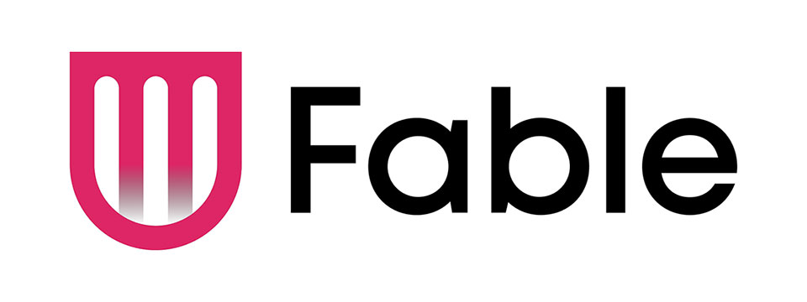
👉️ Classified Advertisement: Learn Management Skills For Free. Get The Job You Want | Fable
Everyone deserves equal access to the internet which is why Fable works with people with disabilities who use assistive technologies like switch controls to improve the accessibility of websites and apps. Fable Pathways, a free, accessible, and on-demand skill-building program, is an extension of Fable's mission. Fable Pathways provides new opportunities for people with disabilities to gain the skills they need, from experts like Judy Heumann and Kelly Ford, to contribute to improving digital accessibility.
Sponsor Since: June 30, 2022 📅️
Website: https://makeitfable.com/ 🌐️
Email: community@makeitfable.com 📧️
About: Fable is an accessibility platform powered by people with disabilities, connecting them to accessibility managers, user researchers, designers, and developers to build accessible user experiences.
Opportunities:
➜ Accessibility Tester: Testers drive meaningful change in digital accessibility by sharing feedback on the websites and apps of the companies that care. As a Tester, earn a competitive tech industry wage, learn valuable transferrable skills, and grow your career. Fable is looking for assistive technology users in the US or Canada to work the hours that they want, completely from home. No experience or resume required.
➜ Survey Respondent: Survey Respondents enjoy a remote, low-commitment income opportunity, all while contributing to accessibility research. Surveys are typically sent out once a month, and you can earn $5 to $50 per survey. Apply today if you identify as having a disability and live in the US or Canada. You do not need to use assistive technology to apply.

⬆︎ 5.) Sponsor: SelvasBLV

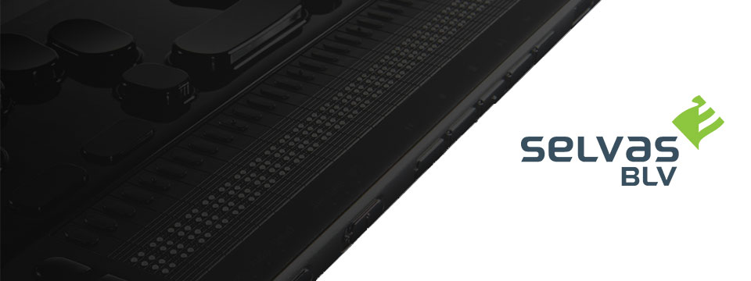
👉️ Classified Advertisement: Thank You For Attending Our Webinar!
Thank you all who attended our webinar on 9/16 to discuss the upcoming BrailleSense 6 firmware upgrade! If you missed the webinar, you may find it on our website by next week under our Tutorials and Webinars page!
Sponsor Since: September 30, 2021 📅️
Website: https://selvasblv.com/ 🌐️
Shop All Products: https://selvasblv.com/shop-all-products/ 🛒️
Phone: (512) 837-2000 📱️
YouTube: https://www.youtube.com/watch?v=5R9NjA1nfWo
Sales: sales@selvasblv.com 📧️
Support: support@selvasblv.com 📧️
About: SelvasBLV is a global manufacturer and distributor that has provided braille, magnification and accessible healthcare devices since 1999.

⬆︎ 4.) Sponsor: Carroll Center for the Blind


👉️ Classified Advertisement: Attend the Screen Reader User Tester Training Program at the Carroll Center for the Blind | Carroll Center for the Blind
Launch your career in the digital accessibility field! The Carroll Center for the Blind's new 7-week intensive Screen Reader User Tester Training program allows participants to learn and grow their ability to professionally explore, test, and report findings regarding the accessibility of websites, mobile applications, and digital document files using screen readers. Want to learn more? Start your journey to becoming a Screen Reader User Tester today.
Sponsor Since: August 5, 2021 📅️
Website: https://carroll.org/ 🌐️
Phone: (617) 969-6200 📱️
Fax: (617) 969-6204 ░️
Shop: https://carroll.org/store/ 🛒️
Donate: https://carroll.org/donate ❤️
Social: Facebook | Twitter | YouTube | LinkedIn | Instagram
About: The Carroll Center for the Blind is the foremost leader in vision rehabilitation services for individuals confronted by the challenges of vision loss. Our mission is to empower those who are blind or visually impaired to achieve independence and to lead a fulfilling life. Established in 1936, the renowned Carroll Center for the Blind has been serving those with vision impairment for over eight decades; we are known nationally as a premier Vision Rehabilitation Center. Located just outside of Boston on a sprawling campus in Newton, Massachusetts, we proudly serve ALL ages and ALL stages of vision loss. With the ongoing promise of improving the lives of people with vision-related problems, The Carroll Center for the Blind has pioneered many innovative services allowing people who are blind or have low vision to learn the skills to be independent in their homes, in class settings, and in their work places. Our services include vision rehabilitation, vocational and transition programs, assistive technology training, educational support, and recreation opportunities for individuals who are visually impaired of all ages. For over 80 years, the expertise of Carroll Center staff has provided help for thousands of blind and visually impaired persons with diverse opportunities for success and independent living.

⬆︎ 3.) Sponsor: Pneuma Solutions

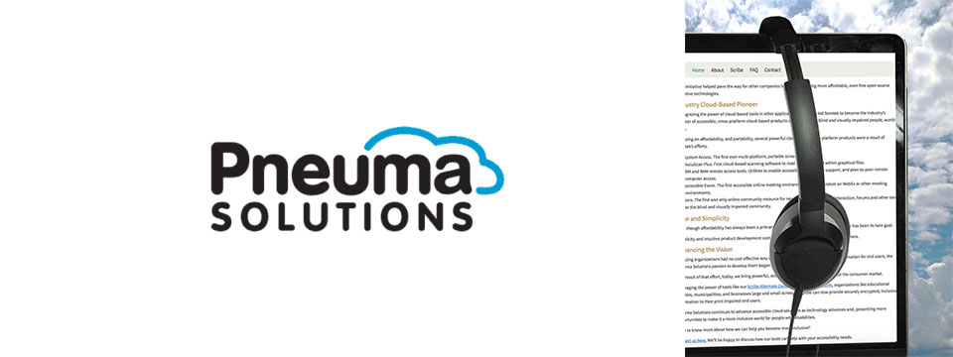
👉️ Classified Advertisement: Accessible Archive: Scalable, On-Demand Accessibility for Large Document Repositories | Pneuma Solutions
Organizations with large digital libraries, such as universities, government agencies, publishers, museums, and corporations, are under increasing pressure to provide accessible versions of their content to meet global disability and inclusion laws. But full-scale remediation of millions of documents is rarely practical or budget-friendly.
The Accessible Archive offers a scalable, just-in-time approach to document accessibility. Instead of converting every document in advance, this system makes archived content instantly available in accessible formats only when requested. The result is lower costs, faster deployment, and compliant, user-friendly output across a range of needs, including for blind, low-vision, and other print-impaired users. The Accessible Archive is designed to handle the scale and complexity of institutional digital libraries without requiring full pre-processing or re-engineering.
Sponsor Since: June 3, 2021 📅️
Website: https://pneumasolutions.com/ 🌐️
Email Newsletter: Click here to receive periodic news via email concerning Pneuma Solutions products for business, consumers and education.
Sales: (866) 202-0520 📱️
Support: (650) 249-1000 📱️
About: Backed by two decades of creating award-winning accessible cloud technologies for people with visual impairments, Pneuma Solutions is the global leader in accessible cloud-based solutions. Pneuma Solutions was founded by long-time accessibility developers Mike Calvo and Matt Campbell. For more information on their individual profiles, click on their respective bio pages. We're proud to be the first company to develop cloud-based accessibility at the network level. Our tools provide organizations, like yours, a way to deliver secure, accessible information right from your network or from our secure servers. You can provide your print disabled consumers, students, employees, and citizens with a multitude of accessible options. Additionally, we offer a suite of cloud-based applications to blind and print disabled consumers directly from our website. Our consumer products are designed to make the day-to-day lives of blind and print disabled individuals more accessible and simpler to manage. Access to information is not a privilege, it's a right. It's also your right to obtain affordable, accessible cloud solutions to serve your end user. When organizations like yours implement our tools, together we help make it a more inclusive world for people with disabilities. Want to know more about how we can help you become more inclusive?
Contact us here. We'll be happy to discuss how our tools can help with your accessibility needs.

⬆︎ 2.) Sponsor: Freedom Scientific

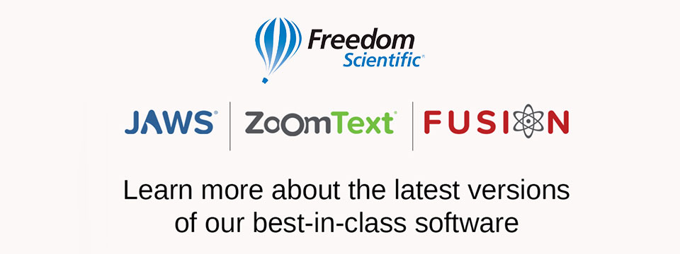
👉️ Classified Advertisement: Freedom Scientific Focus Blue 5th Generation Refreshable Braille Displays | Freedom Scientific
Our world-class refreshable Braille displays deliver efficient Braille input and outstanding output for your PC or mobile device. The robust Bluetooth® connectivity provides seamless use with Windows®, Mac®, iPhones®, iPads®, and Android TM smartphones and tablets. Ergonomic navigation features allow quick, natural hand movements for greater productivity. When used with JAWS® screen reading software, they support our popular Braille Study Mode, an interactive tool for teaching and learning Braille. Learn more today.
Sponsor Since: April 15, 2021 📅️
Website: https://www.freedomscientific.com/ 🌐️
Email: info@vispero.com 📧️
Phone: (800) 444-4443 📱️
Facebook | Twitter | YouTube (Training)
About: Freedom Scientific, a Vispero brand, is a leading worldwide brand of assistive technology products for those with vision impairments. We offer products designed to promote independence, allowing blind and low vision individuals the same access to information as their sighted peers. World-renowned JAWS (Job Access With Speech) screen reading software and ZoomText screen magnification software provide users the independence and ability to seek education and obtain or maintain a career after vision loss. Our expansive product line includes both low vision and blindness technology for all aspects of daily living. The wide range of RUBY, TOPAZ, and ONYX desktop and portable video magnifiers are designed for their ease of use and assist with daily activities. Our impressive line of blindness hardware products include refreshable Braille displays and scanning and reading devices, offering many options tailored to fit individual needs.

⬆︎ 1.) Sponsor: A. T. Guys

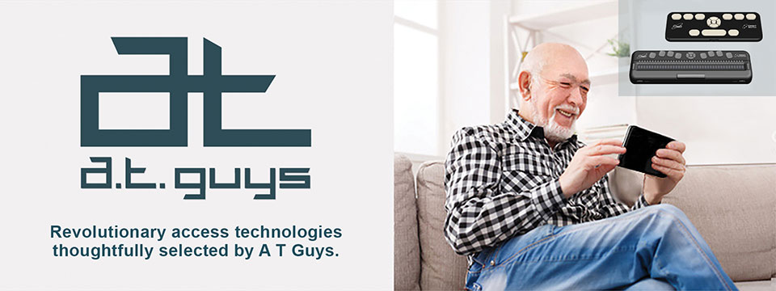
👉️ Classified Advertisement: Pluggable USB-C 7-in-1 Hub | A. T. Guys
If you're like me, you probably have more things to plug into your computer than available ports. That's why we've now added the Pluggable USB-C 7-in-1 Hub. Plug it into your laptop and you will get 3 USB ports, SD and Micro SD card slots, a USBC charging port, and an HDMI video port. It's available now for just $29.95.
Sponsor Since: June 11, 2020 📅️
Website: https://www.atguys.com/ 🌐️
Phone: (269) 216-4798 📱️
Email: support@atguys.com 📧️
Skype: atguys 💬️
X (Formerly Twitter): https://twitter.com/atguys (@atguys) 💬️
Facebook: https://facebook.com/atguys 💬️
About: ATGuys.com. Your access technology experts, home for cool gadgets, accessories, and more. Our products are all tested to work great for blind and visually impaired users but also work just as well for anyone. If there's an item you're looking for, or if you have a question, please don't hesitate to send us a message or call (269) 216-4798 📱️.

⬆︎ 18.) Sponsor: Double Tap

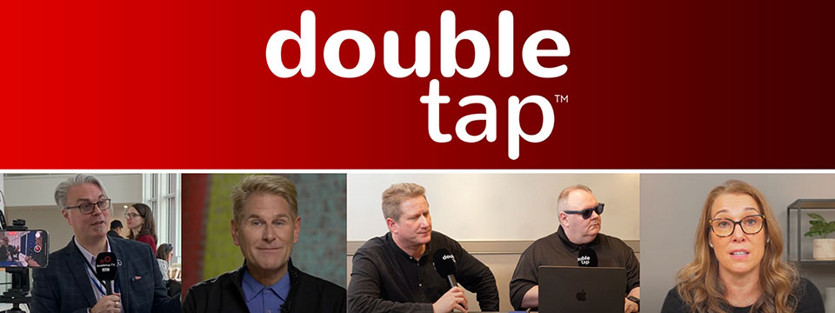

Sponsor Since: March 15, 2025 📅️
Website: https://doubletaponair.com/ 🌐️
About: Founded in 2017 as “Double Tap Canada” on AMI-audio, Double Tap has grown into a weekday podcast, radio show and YouTube series whose tagline proudly declares it "The Podcast Where Blind People Talk Tech." Its Glasgow-based creator Steven Scott, Manchester-based producer-co-host Shaun Preece and Canadian executive producer Marc Aflalo now helm more than 600 episodes that drop every weekday at noon ET, alongside written articles and video clips on DoubleTapOnAir.com.
Each episode blends mainstream gadget news with deep dives into assistive tools, all filtered through the lived experience of blind hosts. Listener emails, voicemails and WhatsApp messages are woven into the conversation, while spin-offs such as Shaun of the Shed (beginner tutorials) and past TV projects like Access Tech Live extend the brand across platforms in partnership with Accessible Media Inc. The result is a vibrant, multi-platform ecosystem that reaches audiences via AMI-audio, every major podcast app, YouTube and even specialist players like the Victor Reader Stream.
The community's enthusiasm shows: Double Tap recently surpassed one million cumulative downloads and, in March 2025 alone, attracted nearly 27K listeners generating 38K downloads; Apple Podcasts users rate it around 4.8 / 5. Authentic insights, daily consistency and professional production continue to position Double Tap as an essential, trusted voice at the intersection of mainstream tech and accessibility.
Newsletter (Double Tap Digest) | Facebook | Instagram | LinkedIn | TikTok | X (Formerly Twitter) | YouTube

⬆︎ 17.) Sponsor: Awarewolf Gear

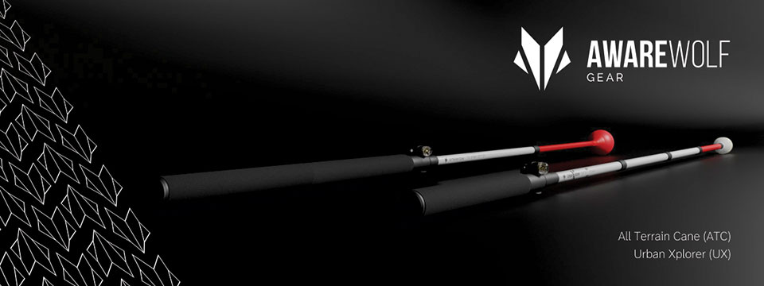

Sponsor Since: February 28, 2025 📅️
Website: https://awarewolfgear.com/ 🌐️
About: Awarewolf Gear is built on innovation, resilience, and a passion for adventure — especially for those in the blind and low vision community.
Awarewolf Gear is dedicated to redefining mobility through high-performance, thoughtfully engineered canes.
With the core belief that everyone deserves to explore confidently, our mission is encapsulated in our tagline, "Power for Life's Adventure."
Our product line, community initiatives, and inspirational storytelling all work in tandem to empower users to navigate diverse terrains with ease and independence.
Product Line
⚫️ All Terrain Cane (ATC)
Design & Purpose: The All Terrain Cane was originally engineered for the rugged trails of Sedona, Arizona. Made from durable titanium alloy, it is built to handle everything from sandy beaches to rocky mountain paths. Its adjustable 16-inch handle and high-performance roller ball tip provide stability and versatility across varied surfaces.
⚫️ Urban Xplorer Cane (UX)
Innovation & Versatility: Merging the rugged design of the ATC with enhancements for urban mobility, the Urban Xplorer Cane features an adjustable handle and a specially designed "Dome" cane tip. Available in multiple sizes (small, medium, large and extra-large), this lightweight, robust cane is ideal for navigating busy city streets as well as more challenging environments.
⚫️ Cane Tips
Customization & Performance: Awarewolf Gear's Cane Tips are designed to elevate your mobility experience by ensuring smooth, reliable navigation across all terrains. Crafted for both durability and style, these premium replacement tips allow users to personalize their canes while enhancing performance.
⚫️ Accessories and Apparel
Customization & Expression: Beyond canes, Awarewolf Gear offers a range of accessories — such as colorful replacement cane tips designed for visibility and personal expression — and apparel that carry the brand's adventurous spirit.
Instagram | Facebook | LinkedIn | YouTube

⬆︎ 16.) Sponsor: Vision Tech Academy

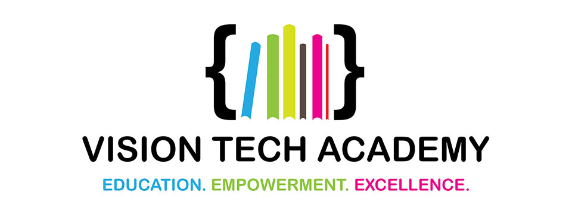

Sponsor Since: January 15, 2025 📅️
Website: https://visiontechacademy.com/ 🌐️
About: Vision Tech Academy is a website, platform and online directory dedicated to empowering blind and low-vision individuals by connecting them with trusted assistive technology educators for free.
Vision Tech Academy is the home of the free, access-technology specific, Online Directory of Educators (ODE).
Inspired by the legacy of John Panarese, the Academy website serves as a hub for accessible learning, offering a free directory of access educators, live and recorded courses, and resources to foster learning independence and success.
With an ongoing mission to provide high-quality, trusted, personalized training on tools like VoiceOver, JAWS, NVDA and Braille technology, Vision Tech Academy bridges the gap between technology and accessibility, ensuring inclusive and accessible education for all.
📖️ Free Directory for Students
📖️ Free General Profiles for All Access Educators
🏅️ Premium Profiles for Access Educators Who Want More Reach

⬆︎ 15.) Sponsor: Elegant Insights Braille Creations

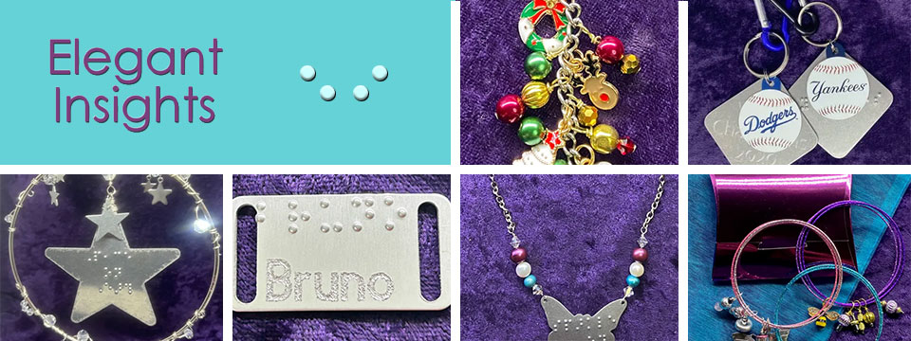
👉️ Classified Advertisement: Elegant Insights Has Halloween's Most Haunted Jewelry And Accessories!
Greetings, ghouls, goblins, and ghosts with the most! We're headed into spooky season, which means Elegant Insights has a truly terrifying collection of jewelry and accessories perfect for fright night. Dress up your white cane for Halloween with our choice of either a creepy copper bat braille-embossed with "boo!" or an orange and green enamel pumpkin jingle bell in our Charmed by the Holidays Halloween Mobility Cane Charm. Decorate your handbag, tote, or trick or treat bag with one of our Halloween theme Charmed by the Holidays purse charms. Halloween's Most Haunted earrings are a frightfully fun way to dress up for Halloween without committing to a costume! If you've got it, haunt it! Shop with Elegant Insights for all your fab fall fashion, gifts, and accessories. Check out our showstopping Falling In Leaf collection if you love all things autumn, or give us a call if you have a custom design in mind. Call +1 (702) 605-1265 or shop online at https://elegantinsightsjewelry.com.
x (Formerly Twitter) | Facebook | Instagram

Sponsor Since: November 22, 2024 📅️
Website: https://elegantinsightsjewelry.com/ 🌐️
About: Elegant Insights Braille Creations, founded by Laura Legendary, offers a distinctive collection of handcrafted jewelry and accessories embossed with crisp, readable braille.
Inspired by a personal experience, Laura, who is blind, established the brand to merge style with accessibility, providing beautiful and inclusive products. Each piece is made in the USA and can often be personalized or custom-designed to meet individual preferences.
Beyond her work with Elegant Insights, Laura co-founded The Fashionability Channel podcast, which provides beauty, fashion, and lifestyle information for people with disabilities. She also maintains two blogs: the Accessible Insights Blog, offering information on products and services for individuals with low or no vision, and the Sparkle On Blog, which provides jewelry education, design trends, and style information.
Laura's dedication to accessibility and advocacy extends to her role as a speaker, author, and educator specializing in these areas. Her multifaceted efforts aim to empower individuals with disabilities, ensuring they have access to stylish, functional, and meaningful products and information.
Home | About Elegant Insights | Ordering, Shipping and FAQs | My Account | Checkout | Cart | Shop The Boutique | Wish List | Testimonials | Subscribe

⬆︎ 14.) Sponsor: Florida Vision Technology

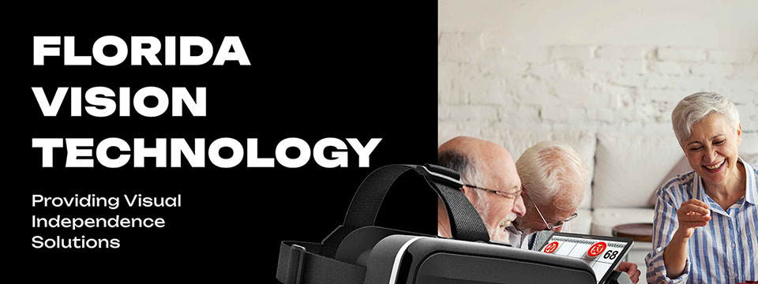

Sponsor Since: October 13, 2024 📅️
Website: https://floridareading.com/ 🌐️
About: Florida Vision Technology is officially celebrating its 20th anniversary. When I started in February 2000, the assistive technology industry was young, and there were just a handful of manufacturers.
Opening the business felt right, and I was ready to jump in. The biggest challenge, in the beginning, was getting a used bulky desk into the shed in my backyard, which my daughters named "Lesa Berg Kretschmer World Headquarters."
Three years later, in June of 2003, we moved into our first offsite location and opened a low vision superstore!
Home | Shop | Blogs | About Us | Contact Us

⬆︎ 13.) Sponsor: Access Park

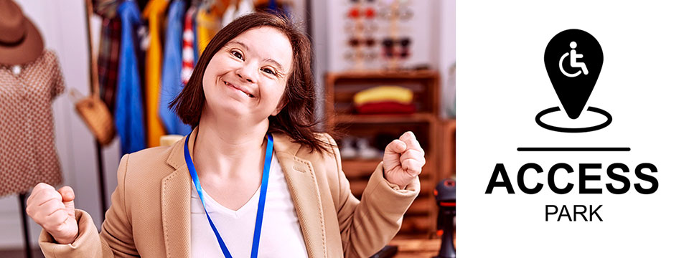
👉️ Classified Advertisement: Donna J. Jodhan's Pottery - Piece By Piece! Building Blocks For Inspiration And Creation! | Access Park
My pottery pieces are designed to inspire your creativity and imagination! Each piece is crafted with care, offering a unique touch to your home and dining experience. Whether you're looking for elegant dinnerware, functional art, or custom pieces, I can help you bring your vision to life. From rustic charm to modern elegance, I specialize in creating pottery that fits your personal style and elevates your dining table. Let me customize a one-of-a-kind creation that reflects your taste and enhances your space, adding beauty and warmth to every meal. And check out the highlight of the month.
A Perspective from World-Renowned Advocate Donna J. Jodhan - How Some Canadian Government Departments Are Using Work Arounds

Sponsor Since: September 20, 2024 📅️
Website: https://accesspark.shop 🌐️
About: Access Park is your premier destination for accessible shopping.
At Access Park, we offer a curated selection of products aimed at enhancing the daily lives of persons with disabilities.
Whether you're looking for accessible tech gadgets, specialty assistive devices, or just everyday essentials, you'll find them here.
Access Park provides a shopping experience that prioritizes keyboard navigability, screen reader compatibility, and high-contrast visuals for those with visual impairments, in addition to other enhancements that provide an elevated shopping experience to users of various assistive technologies.
Access Park. Where inclusivity is always in stock. ^{(TM)}

⬆︎ 12.) Sponsor: The Apex Program

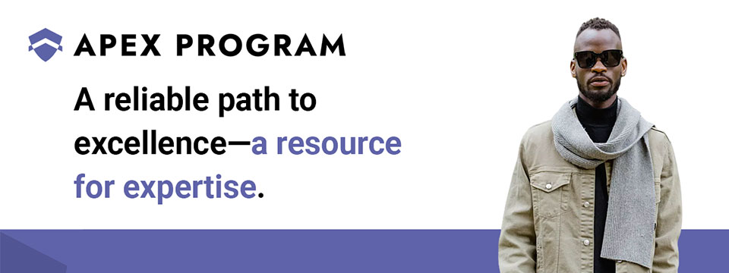
👉️ Classified Advertisement: Jumpstart Your Cybersecurity Career with the Apex Program! | The Apex Program
Are you ready to advance your career in cybersecurity? The Apex Program offers a comprehensive 12-week training course designed to prepare you for the CompTIA Network+ and Security+ certification exams. Tailored for the blind, visually impaired, disabled, and veteran communities, our program combines informative lectures, video tutorials, and quizzes, with expert instructor support every step of the way.
Get started today — Classes start on the first Monday of every month!
Don't miss this opportunity to join a diverse and inclusive workforce in the cybersecurity sector. Visit https://TheApexProgram.com to learn more and secure your spot today!
Sponsor Since: July 16, 2024 📅️
Website: https://theapexprogram.com 🌐️
About: Unlocking Abilities, Securing Futures. Founded on the principles of inclusivity and opportunity, the Apex Program is a pioneering educational initiative in cybersecurity, tailored for the blind, visually impaired, disabled, and veteran communities. Created by a Novacoast employee and inspired by his own journey from disability to Security Operations Center manager, the curriculum is designed to create a strong foundation of IT security knowledge, while instilling confidence and ensuring competence in the IT talent pool. Our ten-week program culminates in industry-recognized CompTIA certifications and a guaranteed pathway to employment, courtesy of Novacoast's dedicated IT Staffing division. At Apex, we don't just teach cybersecurity; we transform lives by unlocking potential and advocating for diversity in the IT security workforce.
Mission: The Apex Program is committed to bridging the gap in cybersecurity talent by empowering the blind, visually impaired, disabled, and veteran communities through inclusive, accessible, and comprehensive training. Our mission is to nurture a diverse workforce equipped with the necessary IT security skills and certifications to thrive in the cybersecurity sector. In partnership with Novacoast, we ensure a solid educational foundation and job placement in the industry, further fostering a future where every individual can focus their distinct abilities on building a more secure digital world.
Novacoast: Novacoast is a cybersecurity and IT services company that helps organizations enhance their security posture. They offer a range of services, including cybersecurity advisory, security engineering, identity and access management, development and integration, penetration testing, managed security services, and incident response. Their managed services include co-managed SIEM, DLP, EDR, vulnerability and patch management, phishing monitoring, and threat operations. Novacoast also provides specialized services for different industries such as finance, healthcare, and gaming. Additionally, they offer staffing solutions and training programs. Learn more today.
Home | A Division of Novacoast | Novacoast Federal | The Program | About Us | Partnerships | Media | Contact

⬆︎ 11.) Sponsor: Innosearch.ai

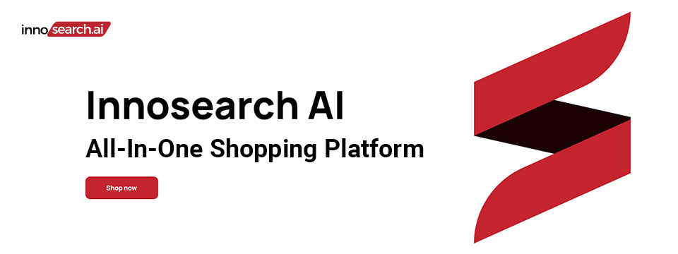
👉️ Classified Advertisement: Shop by Phone — No Screens, Just Your Voice!
Call 1-855-SHOP-GPT (1-855-746-7478)
Shopping online can be hard if you're blind, visually impaired, or not tech-savvy. That's why Innosearch AI created Shop by Phone — a 100% free, voice-only service.
Just call and say what you need:
👉 “Find me a phone charger.”
👉 “Add it to my cart.”
👉 “Check out.”
No apps, no websites — just easy, hands-free shopping from over 500,000 stores.
- ✔ Free to use
- ✔ Works anywhere, anytime
- ✔ Perfect for seniors, blind, and low-vision users
Available in:
- 🇬🇧 UK: +44 7727 247467 📱️
- 🇨🇦 Canada: +1 782 222 7467 📱️
- 🇦🇺 Australia: +61 489 267 467 📱️
- 🇺🇸 USA: 1-855-SHOP-GPT 📱️ (1-855-746-7478 📱️)
Call now and shop with ease!
Sponsor Since: June 7, 2024 📅️
Website: https://www.innosearch.ai 🌐️
Email: info@innosearch.ai 📧️
About: Innosearch is an all-in-one shopping platform augmented with a cutting-edge AI-powered shopping assistant. This innovative feature mimics the experience of shopping in real life by allowing you to interact with the assistant using natural language. It aggregates millions of products from top US online retailers, bringing them directly to you. With this advanced generative AI, Innosearch offers personalized product recommendations, highlights the best deals, and provides comprehensive information including reviews, total prices, shipping options, and more. Innosearch delivers a seamless end-to-end shopping experience, eliminating the need to search and browse in multiple tabs across retailers.
YouTube Review By Sam Seavey: https://youtube.com/watch?v=-rjL-HAwaZY.
Key Features: Key Features of the Innosearch All-in-One AI Shopping Platform include:
➜ Research Products: Easily compare products across retailers, or weigh pros and cons of similar products to make informed decisions.
➜ Uncover the Best Deals: Never miss a door buster, coupon, or clearance sale again. Get notified about the best prices and offers.
➜ AI Summarized Trusted Reviews: See what others are saying and make confident purchases.
➜ All in One: Innosearch brings millions of products from top online retailers directly to you, allowing you to shop the best deals with easy checkout and personalized AI assistance.
➜ Shop with Confidence: Rest assured, Innosearch has you covered with free shipping and returns on every purchase.
➜ Know Before You Buy: Innosearch equips you with expert buying guides, empowering you to make well-informed decisions.
How To Shop: Simply create a free account and start shopping today!

⬆︎ 10.) Sponsor: The Accessibility Guy

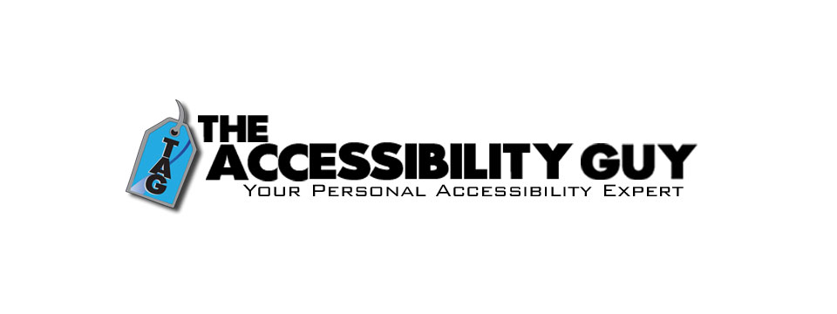
👉️ Classified Advertisement: How to Tag Multiple Languages in a PDF | The Accessibility Guy
More Adobe Acrobat accessibility tips!
My latest post explains how to properly tag individual language sections in a multilingual PDF. Adobe Acrobat offers tools to assign language codes to specific sections, allowing screen readers to interpret and vocalize the content accurately.
Check out The Accessibility Guy's full suite of Accessibility services.
Sponsor Since: August 3, 2023 📅️
Website: https://theaccessibilityguy.com/ 🌐️
YouTube: https://youtube.com/@TheAccessibilityGuy 📹
About: My name is Shawn Jordison and I love helping others learn the ins and outs of digital accessibility.
I have made over 100 thousand documents accessible, provided hundreds of trainings in the areas of accessibility and document remediation, and reviewed many websites and mobile applications for accessibility.
I have developed and reviewed VPATs, LMS courses, and other pieces of training. I am the accessibility Swiss army knife. Let me be your personal accessibility expert.
➜ Over 13 years of experience in the field of accessibility.
➜ Passionate about providing equal access to information for everyone.
➜ Wide range of project experience, including document accessibility, training, and more.
➜ Expertise in captioning, assistive technology, and accessibility best practices. I'm here to help you create a more accessible world.
The Blog: This blog covers topics like making Word, PDF & PowerPoint files accessible, Closed Captioning, assistive technology, and other important accessibility topics.
Training and Consulting: Offering customized training and consulting for implementing accessibility best practices.
Accessible Document Service: Providing top-tier document remediation services for all types of files, ensuring compliance with WCAG, 508, and PDF UA standards.

⬆︎ 9.) Sponsor: The Lighthouse for the Blind, Inc.

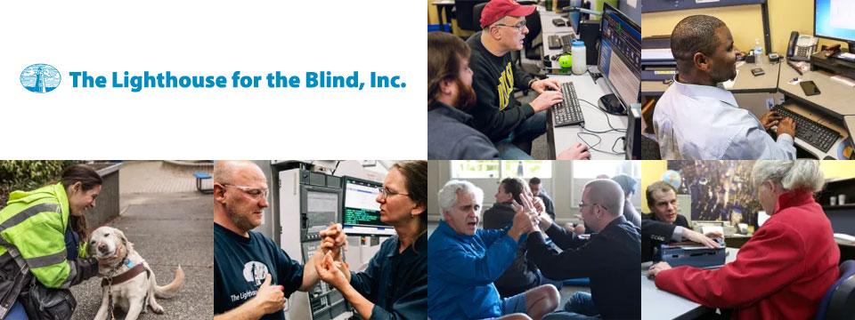
Sponsor Since: December 29, 2022 📅️
Website: https://lhblind.org/ 🌐️
Phone: (800) 914-7307 📱️
Fax: (206) 329-3397 ░
Contact Us: https://lhblind.org/contact-us/
About: The Lighthouse for the Blind, Inc. is a private, not-for-profit social enterprise providing employment, support, and training opportunities for people who are blind, deafblind, and blind with other disabilities. The Lighthouse has provided employment and support to people who are blind in our community since 1918.
The Lighthouse for the Blind, Inc. is a successful manufacturing organization with over 60 years of experience in precision machining. We produce an array of machined parts and plastic injection molding for various aerospace manufacturers, as well as a host of office products and hydration equipment sold to the Federal Government and the U.S. Military. We also own and operate stores on military bases along the West Coast. Our products and services include:
• Manufacturing: We are a successful manufacturing organization committed to making jobs accessible to individuals who are blind. Our manufacturing operations center on making quality products for the Federal Government under the AbilityOne Program and producing parts for aerospace manufacturers.
• Managed Services: The Lighthouse for the Blind, Inc. offers a variety of services to our commercial, federal, and military customers. These include Contract Management Support (CMS) services for government contracting offices.
• Base Supply Centers: We operate 12 AbilityOne Base Supply Centers (BSCs) that offer easy customer access to Lighthouse products, direct feedback and communication with customers, and employment opportunities for individuals who are blind in geographic areas not served by larger nonprofit agencies.

⬆︎ 8.) Sponsor: Wayaround

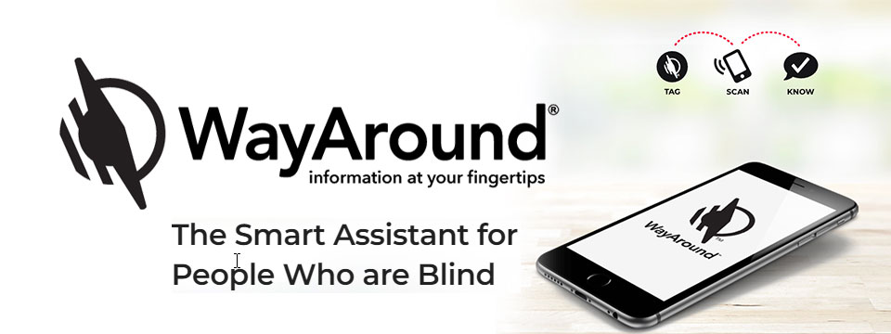
👉️ Classified Advertisement: FREE Sampler Pack with a Purchase of Any 25-pack of WayTags | Wayaround
WayAround is a smartphone-based labeling app that works with your preferred accessibility settings. You just need the free mobile app and some WayTags ® to label items in the kitchen, garden, closet, office & more.
If you want to label something that's inside, outside, wet, dry, hot, or cold, there's a WayTag that will attach securely. WayTags come as stickers, buttons, magnets, and clips. Each of the different styles of WayTags work exactly the same. Simply choose the WayTag that's best for what you want to label.
Purchase a 25-pack of any style of WayTag and get a free Sampler Pack so you can try all seven different WayTags. Enter the coupon code SAMPLE at checkout and the Sampler Pack will automatically be added to your cart. This is a $14.99 value! Limit one Sample pack per order.
Sponsor Since: January 5, 2023 📅️
Website: https://www.wayaround.com/ 🌐️
General Sales & Support: (888) 898-4465 📱️
Business Sales & Support: (888) 898-4465 📱️
Email: connect@wayaround.com 📧️
About: WayAround is the app for your smart device that provides on-demand details about everyday things. The simple tag-and-scan approach lets you quickly and easily identify things around you. It also provides extra details, like how something works or when it expires. The result? Doing more of the things you want, with more confidence and more independence.
All the information you want with just a tap of your phone. No more waiting around to ask someone. You need just two things to get started: The free mobile app for iOS or Android and some of our smart WayTags®.
Accessible labels for the blind, deafblind, and anyone with vision loss. Your biggest problem isn't poor eyesight. It's that so much of the information in the world is visual. But you shouldn't have to wait around for someone else to get the information you need. Or carry around a bulky, outdated device. There is a better way to get accurate and complete information every time. So you can reduce stress and gain independence.
Download The App (Apple): https://itunes.apple.com/us/app/wayaround-tag-and-scan/id1294361140?mt=8
Download The App (Android): https://play.google.com/store/apps/details?id=com.wayaround.wayaround

⬆︎ 7.) Sponsor: Aira

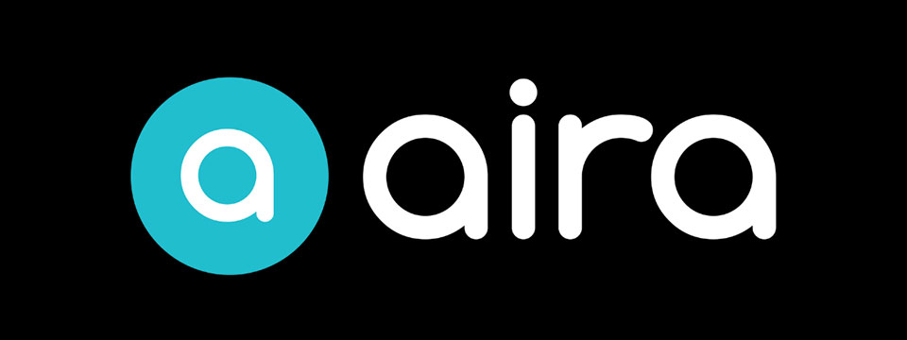
Sponsor Since: August 4, 2022 📅️
Website: https://aira.io/ 🌐️
Download the App: Apple App Store | Google Play Store
Plans and Pricing: https://aira.io/pricing/
Phone: NA: +1.800.835.1934 📱️ | AU: +1.800.765.096 📱️ | UK: +0.800.046.5668 📱️ | NZ: +1.800.425.451 📱️
Text Message: NA: +1.858.242.4457 📱️ | AU: +61.488.839.767 📱️ | UK: +44.149.320.2474 📱️
Email: support@aira.io 📧️
About: At Aira, we believe access to information is a human right. Aira breaks down accessibility barriers by providing on-demand video remote interpreting for both the blind and low-vision community, and the Deaf Community. People can download the Aira Explorer app or the Aira ASL app, and be instantly connected to a professional interpreter. Available 24/7/365, interpreters work with callers to facilitate more efficient communication and accomplish tasks together. Aira is proud to lead the way in delivering secure, on-demand, inclusive services that transform lives and open doors to new opportunities for all.
Contact Us | Access Partners | Plans and Pricing
Step One: Subscribe and Download. Pick the plan that lets you explore on your terms and on your time, sign up in a few minutes, and download the Aira app to your smartphone. Plans shown are for the United States, Canada, Australia, New Zealand and the United Kingdom. Add or cancel at any time.
Step Two: Connect with an Aira Agent. On the first call, connect with one of our certified, specially-trained Agents and learn how everything works.
Step Three: Real-time Assistance. At the touch of a button, Aira delivers instant access to visual information, when and where you want it.
Social: Twitter | Facebook | LinkedIn | YouTube | Instagram

⬆︎ 19.) Sponsor: Your Name Here

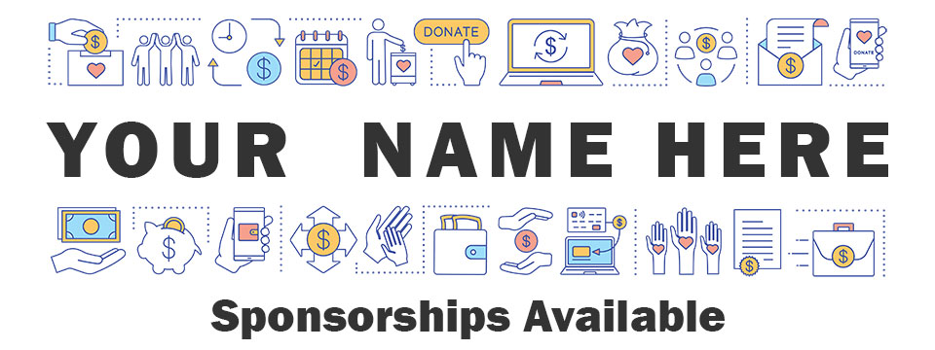
Purchase: Sponsorship Package 💸️ (Packages currently available.)
Join: Waiting List 📋️ (When there are no sponsorship packages available.)
Sponsor Since: Today 📅️
Website: https://toptechtidbits.com/sponsor 🌐️
Phone: (855) 578-6660 📱️
Email: enews@toptechtidbits.com 📧️
About: Founded in 2004, Top Tech Tidbits is the world's leading not-for-profit access technology publication that reaches over 40,000 blind, low vision, deaf, hard of hearing, deafblind, neurodivergent and/or disabled professionals, educators and enthusiasts, all over the world, each week. Subscribe here. Review the most recent issues here.

Top Tech Tidbits Supporters 🤝️
We couldn't do it without you! Thank you for your support!
Why: Top Tech Tidbits Supporters donate an amount of their choosing either one time or annually in order to assist with the ongoing distribution of the Top Tech Tidbits publication.
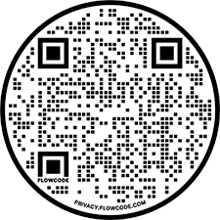
Benefits: All Top Tech Tidbits Supporters receive a listing within the "Our Supporters" section of each weekly newsletter, as well as a listing within the "Our Supporters" section of the Top Tech Tidbits website.
In addition, all Top Tech Tidbits Supporters automatically become Premium Subscribers as well, and therefore enjoy all of the benefits that a Premium Subscription has to offer.
One Time Donation: If you would like to become a Top Tech Tidbits Supporter by making a one time donation in an amount of your choosing to assist with the ongoing distribution of the Top Tech Tidbits publication, you may utilize this donate link, or scan the QR code to the right.
Annual Donation: If you would like to become a Top Tech Tidbits Supporter by making a small donation to assist with the ongoing distribution of the Top Tech Tidbits publication, we also offer the following options, all with our sincerest thanks, and most heartfelt gratitude for your ongoing support.
Support: In tandem with Our Sponsors, these are the people that make the ongoing distribution of Top Tech Tidbits possible.

Platinum Supporters:

Become a Top Tech Tidbits Platinum Supporter today.
1.) Gary Lee
Platinum Supporter since June 25, 2020
2.) Anonymous Donation
Platinum Supporter since July 9, 2020
3.) Pshon Barrett
Platinum Supporter since January 28, 2021
4.) Robin Millar
Platinum Supporter since April 6, 2023

Gold Supporters:

Become a Top Tech Tidbits Gold Supporter today.
1.) Howard Goldstein
Gold Supporter since June 4, 2020
2.) David Goldstein
Gold Supporter since June 12, 2020
3.) Katherine Crohan
Gold Supporter since January 14, 2021
4.) Neil Jarvis
Gold Supporter since April 28, 2022

Silver Supporters:

Become a Top Tech Tidbits Silver Supporter today.
1.) Timothy Gorbold
Silver Supporter since July 19, 2023
2.) Vojtech Polasek
Silver Supporter since December 29, 2023

Bronze Supporters:

Become a Top Tech Tidbits Bronze Supporter today.
1.) Steven Wettlaufer
Bronze Supporter since July 16, 2020
2.) Lions Clubs International
Bronze Supporter since July 13, 2020

One Time Supporters:
One Time Supporters donate an amount of their choosing — one time to assist with the ongoing distribution of the Top Tech Tidbits Publication.
Become a Top Tech Tidbits One Time Supporter today.
1.) Beth Wright
One Time Supporter on November 28, 2023
2.) Your name here.
One Time Supporter on ...

Top Tech Tidbits News Team 🗞️

Distribution: Sponsors, Supporters, Advertisers and Mind Vault Solutions, Ltd.

Distribution Since: 2004
As of June 4, 2020 the distribution of Top Tech Tidbits is made possible by our Sponsors, our Supporters, our Advertisers and Mind Vault Solutions, Ltd., a leading international provider of professionally outsourced marketing administration and consultation services.
Any time the Top Tech Tidbits Publication carries less than its Sponsor limit, Mind Vault Solutions, Ltd. donates the remaining dollars necessary to keep the publication running.
Please help us to support the ongoing distribution of this publication. Learn more about the benefits of Sponsorship today.

Publisher: Aaron Di Blasi

Publisher Since: June 4, 2020
Location: Cleveland, Ohio
Time Zone: Eastern Standard Time (EST/EDT) (GMT-5/GMT-4)
In addition to serving as Publisher for Top Tech Tidbits Aaron also serves as Publisher for the Access Information News and AI-Weekly newsletters, PR-Director for the AT-Newswire Press Release News Distribution Service, and President and Senior Project Management Professional for Mind Vault Solutions, Ltd.
As Publisher Aaron oversees the weekly distribution of Top Tech Tidbits on behalf of Mind Vault Solutions, Ltd.
Aaron Di Blasi, PMP
Email: publisher@toptechtidbits.com 📧️
Toll Free: +1 (855) 578-6660 📱️
PR Director (2024-Present)
AT-Newswire 🌐
Access Technology's Digital Newswire
Publisher (2024-Present)
AI-Weekly 🌐
The Week's News in Artificial Intelligence
Publisher (2022-Present)
Access Information News 🌐
The Week's News in Access Information
Publisher (2020-Present)
Top Tech Tidbits 🌐
The Week's News in Access Technology
Sr. Project Management Professional (2006 - Present)
Mind Vault Solutions, Ltd. 🌐
Innovative ideas. Solutions that perform.
Certified:
Digital Marketing Associate
Meta Certified (2022 - Present)
Social Marketing Professional
Hootsuite Certified (2020 - Present)
Email Marketing Professional
Constant Contact Certified (2019 - Present)
Specializing in:
Digital Strategy and Content Marketing
Social Media Advertising
Online Fundraising
ADA, WCAG and Section 508 Compliance

Editor: John Hanlin

Editor Since: June 4, 2020
Location: Boulder, Colorado
Time Zone: Mountain Standard Time (MST/MDT) (GMT-7/GMT-6)
In addition to serving as an Editor to Top Tech Tidbits John also serves as an Editor to the Access Information News and AI-Weekly newsletters and is also an attorney-at-law specializing in long-term disability claims for persons who are blind or low-vision.
John is also a long-time contractor and member of the Board of Trustees at Mind Vault Solutions, Ltd.
John Hanlin, Esq.
Editor (2024-Present)
AI-Weekly 🌐
The Week's News in Artificial Intelligence
Editor (2022-Present)
Access Information News 🌐
The Week's News in Access Information
Editor (2020-Present)
Top Tech Tidbits 🌐
The Week's News in Access Technology
Board of Trustees (2006 - Present)
Mind Vault Solutions, Ltd. 🌐
Innovative ideas. Solutions that perform.

Editor: Jenna Lang

Editor Since: June 4, 2020
Location: Des Moines, Iowa
Time Zone: Central Standard Time (CST/CDT) (GMT-6/GMT-5)
In addition to serving as an Editor to Top Tech Tidbits Jenna also serves as an Editor to the Access Information News and AI-Weekly newsletters and runs her own advocacy foundation.
Jenna also serves as a certified Project Management Professional (PMP) for Mind Vault Solutions, Ltd.
Jenna's son was born blind and she is always seeking new and innovative ways to empower him through technology.
Jenna Lang, PMP
Editor (2024-Present)
AI-Weekly 🌐
The Week's News in Artificial Intelligence
Editor (2022-Present)
Access Information News 🌐
The Week's News in Access Information
Project Management Professional (2022 - Present)
Mind Vault Solutions, Ltd. 🌐
Innovative ideas. Solutions that perform.
Editor (2020-Present)
Top Tech Tidbits 🌐
The Week's News in Access Technology

Editor: Stephen (Alex) Marositz

Editor Since: October 7, 2021
Location: Los Angeles, California
Time Zone: Pacific Standard Time (PST/PDT) (GMT-6/GMT-7)
In addition to serving as an Editor to Top Tech Tidbits Alex is also the Accessible Technology Coordinator for California State University, Dominguez Hills. He has worked in accessibility in higher education since 2005, is certified by the International Association of Accessibility Professionals, and in his spare time plays for the San Gabriel Valley Panthers Beep Baseball Team. He can be reached on twitter at: @samarositz.
Stephen (Alex) Marositz
Editor (2021-Present)
Top Tech Tidbits 🌐
The Week's News in Access Technology
Accessible Technology Coordinator
California State University, Dominguez Hills 🌐

Editor: Ben Moxey

Editor Since: January 1, 2022
Location: Newcastle, Australia
Time Zone: Australia Eastern Standard Time (AEST/AEDT) (GMT+10)
In addition to serving as an Editor to Top Tech Tidbits Ben is also an Access and Technology Advisor for Guide Dogs, New South Wales, Australian Capital Territory (NSW/ACT).
Hi, Tidbits readers, my name's Ben Moxey and I'm based in Newcastle, Australia. I'm really happy to be part of the Tidbits Team and look forward to supporting this valuable publication.
A bit about me and how I came to work in the BVI area. I grew up with very low vision in one eye due to retinal issues and relied on magnification and speech throughout school. They also tried to teach me Braille, but let's just say that I wasn't the best student! I was determined to use my remaining vision, no matter how impractical it was becoming.
When I was 20, the other retina came off and I've now been totally blind for about 21 years. This is when my love for assistive technology, and technology in general, really kicked in. I'll be honest, I was a bit of a computer nerd anyway, but I could quickly see how technology was my key to enhanced independence and lifestyle. I embraced screen readers, early smart phones and mobility aids. I even finally realised the huge value of Braille and finished off the course, though I'm still pretty slow!
Long story short (not one of my strong points), I've worked in the BVI area for 12 years with much of that spent reviewing, recommending and teaching assistive technology that suits the individual. I'm currently a proud employee of Guide Dogs NSW/ACT where I was the Practice Lead for the assistive technology service, and I've now moved into an Access and Technology Advisor role. Basically, this involves a strong focus on accessibility and technology innovation.
Feel free to look me up on LinkedIn, but I'll warn you in advance that I haven't given my profile the recommended attention!
All the best and happy reading!
Ben Moxey
Editor (2022-Present)
Top Tech Tidbits 🌐
The Week's News in Access Technology
Access and Technology Advisor
Guide Dogs, New South Wales, Australian Capital Territory (NSW/ACT) 🌐

Editor: David Woodbridge

Editor Since: February 6, 2023
Location: Central Coast, New South Wales, Australia
Time Zone: Australia Eastern Standard Time (AEST/AEDT) (GMT+10)
In addition to serving as an Editor to Top Tech Tidbits David also serves as an Editor to the Access Information News publication and is also the National Commercial Assistive Technology Advisor for Vision Australia where he has worked since 1990. Over this time he has assisted people who are blind or vision impaired in their home, education, and work settings to take advantage of the benefits of using assistive and main stream technology.
In the last seventeen years, he has also been involved with evaluating technology for use by people who are blind or vision impaired covering both low and high tech equipment (including Microsoft, Samsung, Google, Amazon, and Apple). David is also one of the key spokespersons for Vision Australia relating to technology.
He has been an Apple Ambassador for Apple Australia since 2009 with a group of other Ambassadors / Apple Distinguished Educators (ADE)'s covering the range of Apple's Accessibility solutions throughout Australia.
David produces a range of podcasts (since 2011) covering Apple and other technologies which are distributed on his own podcast (http://davidwoodbr.podbean.com). In addition, he also has a regular Talking Tech program (since 2013) which can be heard every Tuesday at 4:30 Eastern Summer Time on Vision Australia Radio Melbourne (available online) or via https://omny.fm/shows/talking-tech-vision-australia-radio
David also runs a weekly Tech Monday where people can chat about assistive and main stream technology, share information, and any tips and tricks.
David lost his sight when he was 8 years old and had to learn Braille. Since then, he completed high school, went to Sydney University receiving a Social Work degree, spent 4 years drug and alcohol counselling, and then moved into his current job.
As a person who is blind, David believes that as a user of the technology that he recommends to others, that he is well situated to look at the strengths and shortcomings of the assistive technology that he comes across in both his professional and personal life, in particular, mainstream technology that is accessible.
In addition to his weekly contributions to Top Tech Tidbits and Access Information News, David's regularly occurring activities are his weekly tech radio show, bi-monthly exploring tech webinars for Vision Australia, his iSee podcast when something of note grabs his attention, and the weekly Tech Monday chat sessions.
David Woodbridge
X (Formerly Twitter): @dwoodbridge
Mastodon: woody@dragonscave.space
iSee Podcast: https://davidwoodbr.podbean.com
Vision Australia Radio Talking Tech: https://omny.fm/shows/talking-tech-vision-australia-radio
Editor (2023-Present)
Top Tech Tidbits 🌐
The Week's News in Access Technology
Editor (2023-Present)
Access Information News 🌐
The Week's News in Access Information
National Commercial Assistive Technology Advisor
(1990 - Present)
Vision Australia 🌐
Live the life you choose. We're here to support all Australians who are blind or have low vision.

Editor: Vicki Walton

Editor Since: January 9, 2024
Location: Benton City, WA
Time Zone: Pacific Standard Time (PST/PDT) (GMT-6/GMT-7)
IIn addition to serving as an Editor to Top Tech Tidbits Vicki also serves as an Editor to the Access Information News publication and works as a Web Accessibility Specialist / IT Quality Assurance Tester at Washington State Board for Community and Technical Colleges.
Vicki Walton
Editor (2024-Present)
Top Tech Tidbits 🌐
The Week's News in Access Technology
Editor (2024-Present)
Access Information News 🌐
The Week's News in Access Information
Web Accessibility Specialist / IT Quality Assurance Tester
Washington State Board for Community and Technical Colleges 🌐
Better Jobs, Brighter Futures, a Stronger Washington

Subscription Information 📰️
ABOUT ♿️
Founded in 2004, Top Tech Tidbits is the world's leading not-for-profit access technology publication that reaches over 40,000 blind, low vision, deaf, hard of hearing, deafblind, neurodivergent and/or disabled professionals, educators and enthusiasts, all over the world, each week. Subscribe here. Review the most recent issues here. Access Technology broadly encompasses technologies that enable access to information and communication systems for persons with disabilities. Adaptive Technology is a subset of Access Technology designed to assist individuals in performing tasks that might otherwise be challenging due to their particular disabilities. Assistive Technology includes any device, software, or equipment that helps people work around their challenges. Top Tech Tidbits is a Mind Vault Solutions, Ltd. Publication. Publisher: Aaron Di Blasi. Editors: John Hanlin, Jenna Lang, Stephen (Alex) Marositz, Ben Moxey, David Woodbridge and Vicki Walton. Top Tech Tidbits is a sponsor, reader and advertiser supported publication.
RELEASE SCHEDULE 📅️
Top Tech Tidbits is released every Thursday morning at 6:00 AM ET.
SUBSCRIBE 📧️
Do you, a friend, or colleague wish to receive the Top Tech Tidbits newsletter? If so, please use or pass along our CAPTCHA-free sign-up link. You can also subscribe to receive the Top Tech Tidbits newsletter on the Top Tech Tidbits Website. Either of these methods will provide you with an accessibly friendly and secure medium through which you can subscribe to our mailing list. Just enter your email address, click send, and begin receiving the Top Tech Tidbits newsletter. It's that easy.
WEBSITE 🌐️
Visit the Top Tech Tidbits website online at: https://toptechtidbits.com.
PREMIUM SUBSCRIBER 💸️
Only Top Tech Tidbits Premium Subscribers receive our special quarterly issue listing the Top 60 Most Clicked News Articles of the Last 3 Months. Just $12 USD per year. This special quarterly issue is provided to Premium Subscribers as a native Microsoft Word document with full headings, links and abstracts to all 60 articles. There are no restrictions placed on these documents. Complete list of all back issues available. Premium Subscribers are entitled to all back issues, anytime they sign up. Join us today and begin receiving this incredibly informative issue every 3 months.
SPONSOR 🏅️
If you would like to become 1 of only 24 Top Tech Tidbits Sponsors whose ongoing support makes the distribution of Top Tech Tidbits possible, we offer you the following advertising benefits, with our sincerest thanks, and most heartfelt gratitude for your ongoing support.
ADVERTISE 🎯️
Top Tech Tidbits offers a variety of one-time advertising options to both Sponsors and non-Sponsors alike. Here we offer a sample newsletter that provides a breakdown of exactly what those one-time advertising options are, where they appear, and what they cost per publication.
DONATE ❤️
If you would like to become a Top Tech Tidbits Supporter by making a small donation to assist with the ongoing distribution of the Top Tech Tidbits publication, we offer the following options, with our sincerest thanks, and most heartfelt gratitude for your support.
STORE 🛒️
Are you blind or do you live with low vision? Are you deaf, hard of hearing or deafblind? Do you require a wheelchair for mobility? Do you consider yourself to be neurodivergent or otherwise disabled? The Top Tech Tidbits Online Store For Digital Downloads specializes in information that can improve your quality of life. Learn more today.
FACEBOOK 💬️
Are you on Facebook? Follow Top Tech Tidbits on Facebook to begin receiving current news and trends in Access Information as part of your Facebook News Feed.
X (FORMERLY TWITTER) 💬️
Are you on X? Follow Top Tech Tidbits on X to begin receiving current news and trends in Access Information as part of your X News Feed.
MASTODON 💬️
Are you on Mastodon? Follow Top Tech Tidbits on Mastodon to begin receiving current news and trends in Access Information as part of your Mastodon News Feed or by searching for @news@mastodon.toptechtidbits.com on your server today.
LINKEDIN 💬️
Are you on LinkedIn? Follow Top Tech Tidbits on LinkedIn to begin receiving current news and trends in Access Information as part of your LinkedIn News Feed.
YOUTUBE ▶️
Are you on YouTube? Follow Top Tech Tidbits on YouTube to begin receiving current news and trends in Access Information as part of your YouTube Video Feed.
RSS 📡️
Do you prefer RSS? Follow Top Tech Tidbits via RSS today to begin receiving current news and trends in Access Information using your choice of news aggregator.
QUESTIONS ❓️
Tidbits are intentionally concise. As a result we know that some readers may not always understand all of the items listed because little explanation is given. If a particular Tidbit brings up a question in your mind, feel free to ask, and we will try to answer as time and knowledge permit.
ARCHIVE 🗄️
Read the most recently released issues of Top Tech Tidbits online here. Visit the Top Tech Tidbits Archive here, where you can read back issues.
CONTENT CONTRIBUTORS ✍️
Any information for future issues of Top Tech Tidbits may be submitted online via our News Item Submission Form or directed to our Editors via email.
THANK YOU 🙏️
Thank you for reading. On behalf of all of us here at Top Tech Tidbits we look forward to keeping you informed.
Information provided by:
Top Tech Tidbits
https://toptechtidbits.com/ 🌐
A Mind Vault Solutions, Ltd. Publication
1284 SOM Center Road, PMB 194,
Mayfield Heights, Ohio 44124
+1 (855) 578-6660 📱️

