How to Read Blind: https://toptechtidbits.com/read
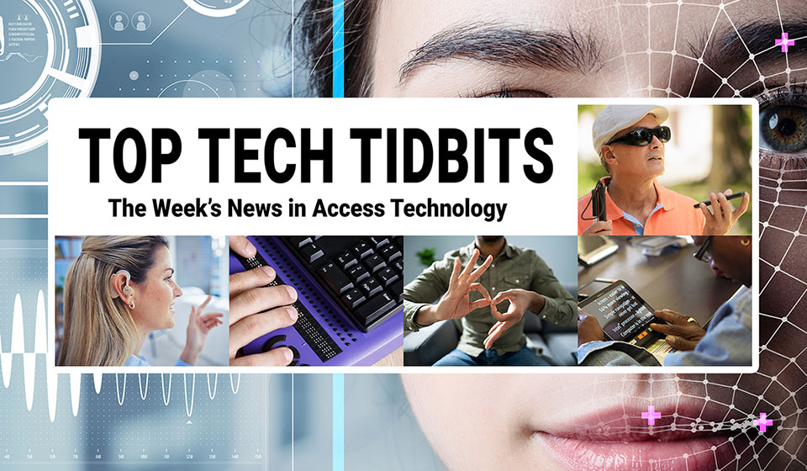
 |  |  |  |  |  |  |  |  |  |  |  | 
Top Tech Tidbits for Thursday, September 25, 2025 - Volume 1034
♿️ The Week's News in Access Technology
Top Tech Tidbits. The world's #1 online resource for current news and trends in access technology.
A Mind Vault Solutions, Ltd. Publication
Subscribers: 42,005 🔢️ opt-in subscribers were sent this issue via email.

Sponsors 🏅️
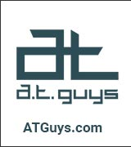 |  |  |  | 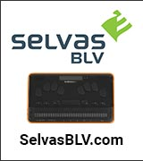 | 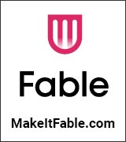
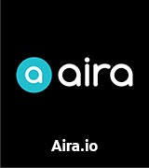 | 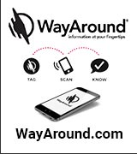 | 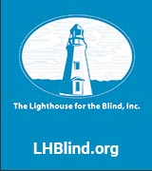 | 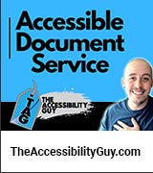 |  | 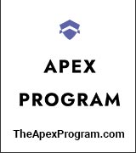
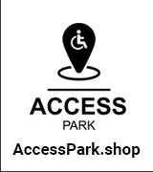 | 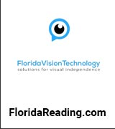 |  | 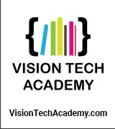 | 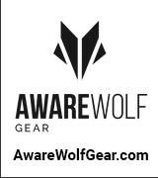 | 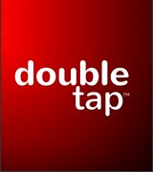
 | 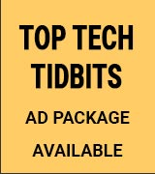 | 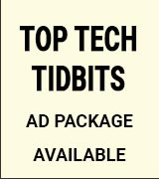 | 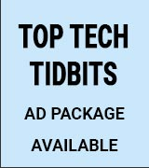 | 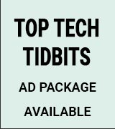 | 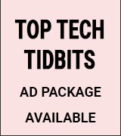

Access Awareness: Updates That Matter ♿️
How To Install SELECT TO SPEAK On Android | The Blind Life | YouTube.com | September 23, 2025
If you're blind or visually impaired and can't find the Select to Speak option on your Android phone, this video walks you step-by-step through how to install the app and get it running. Select to Speak is an on-demand screen reader that makes Android devices more accessible, giving you the flexibility to hear text read aloud whenever you need it. Whether you're exploring assistive technology for the first time, helping a friend or family member living with vision loss, or working as a professional supporting the blind and visually impaired community, this tutorial highlights the value of accessible software, adaptive equipment, and low vision tools. Discover practical tips for making your phone more usable and for living with vision loss more independently.

This Week's Featured Advertisement 🎯️
Sponsorship Packages Currently Available. Support Free Access Technology News For Disabled Readers All Over The World While Increasing Traffic To Your Properties Each Week. Advertise in every issue. Or just one.
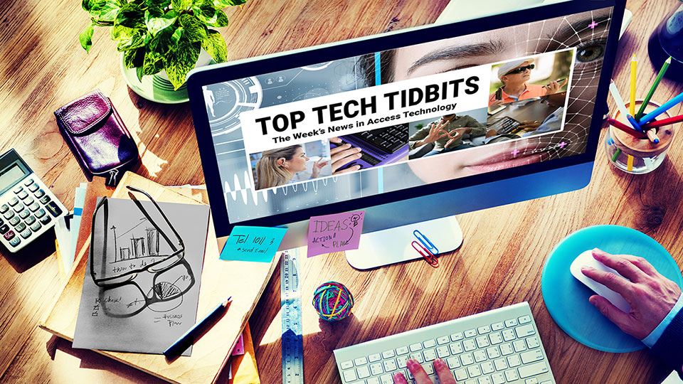
Join Top Tech Tidbits as a Sponsor today and begin reaching over 42,000 access technology subscribers each week, all while supporting the ongoing distribution of Top Tech Tidbits for those very same readers. Only $200 / month.
Key Newsletter Statistics:
- Subscribers: 42,000 + per week and growing.
- Open Rate: 46% (Average. Last 12 months.)
- Click Rate: 42% (Average. Last 12 months.)
- Bounce Rate: 1.1% (Average. Last 12 months.)
- Ad CTRs: 2-12% (Average. Last 12 months.)
Benefits All Sponsors Receive:
- One (1) Sponsor Profile on the Top Tech Tidbits website.
- One (1) Sponsor Profile in each weekly newsletter.
- One (1) Sponsor Wall Brand Advertisement on the Top Tech Tidbits home page.
- One (1) Sponsor Wall Brand Advertisement in each weekly newsletter.
- One (1) Classified Advertisement in each weekly newsletter.
- 50% Discount on all Sponsored Tidbit Advertisements.
- Free link tracking.
- Permanent SEO benefits.
- Gratitude from over 42,000 access technology subscribers for keeping Top Tech Tidbits free to read.
With additional benefits for Sponsors that pay quarterly or annually. Learn more today.

News 📰️
👉 Submit a Tidbit for free here, with timing and placement determined by our editors.
👉 Submit a Sponsored Tidbit here, with timing and placement determined by you.

1.) Top 5 Most Clicked Tidbits From Last Week 📊️
A.) AI in the Workplace: Assisting Blind and Low Vision Professionals | Tiffany Kim | APH ConnectCenter | August 20, 2025
For many people, artificial intelligence (AI) only entered the spotlight with the public release of ChatGPT in late 2022. But for blind and low vision professionals, AI has been quietly transforming accessibility and independence for years through tools like optical character recognition apps, screen-reading assistants, and automated description services.
B.) iOS 26 And iPadOS 26: A Summary Of VoiceOver And Braille Issues And Improvements | AppleVis.com | September 15, 2025
The post outlines significant bugs and improvements regarding VoiceOver and Braille functionality in iOS 26 and iPadOS 26, including issues with Live Captions, Message Actions in WhatsApp, and recommendations for various user types. The authors urge users to read through the post and community feedback before deciding to upgrade.
C.) What's New In iOS 26 Accessibility For Blind And DeafBlind Users | AppleVis.com | September 13, 2025
iOS 26 introduces important accessibility features for blind and DeafBlind users, including temporary sharing of accessibility settings, Nutrition Labels for app developers, and significant updates to VoiceOver and braille functionalities. The update focuses on enhancing the usability of iOS devices for users with varying accessibility needs.
D.) Microsoft's Next AI Experiment — A Shopping Assistant That Never Clocks Out | WindowsCentral.com | September 11, 2025
Microsoft has unveiled a preview of its AI-powered Personal Shopping Agent, which promises a personalized product discovery experience for consumers. The tool can be embedded into retail apps and websites, aiming to improve customer interactions and streamline the shopping process.
E.) Top Tech Tidbits Publisher Updates for September 18, 2025: Top Tech Tidbits Website Redesign Currently Underway | Aaron Di Blasi | TopTechTidbits.com | September 18, 2025
I am incredibly excited to report that a complete redesign of the Top Tech Tidbits website is currentrly underway. Learn more today.
2.) Sponsorship Packages Currently Available | TopTechTidbits.com | September 25, 2025
There are Six (6) Sponsorship Packages currently available. Would your product, service or message benefit from reaching over 42,000 access technology subscribers each week? For just $200 / month? If you're thinking yes, we invite you to try a Sponsorship Package with Top Tech Tidbits. The benefits are amazing and the traffic delivered to your properties each week is measurable. No obligation. Cancel anytime. When there are no Sponsorship Packages available, you can join the waiting list here.
3.) One Time Advertisements Available | TopTechTidbits.com | September 25, 2025
One time advertisements are available to anyone, with or without a Sponsorship. Would your product, service or message benefit from reaching over 42,000 access technology subscribers? If you're thinking yes, we invite you to check out our one time advertising options. They are cost-effective, targeted and measurable. Scheduling is optional. Learn more today.
4.) Premium Subscribers | TopTechTidbits.com | September 25, 2025
Next Issue: Premium Subscribers will receive their 14th issue of the Top 60 Most Clicked News Articles for April, May and June of 2025 on Monday, October 6, 2025. Back Issues: There are currently 13 back issues available. Premium Subscribers are entitled to all back issues, anytime they sign up. All available back issues will be sent to you via email within 24 hours of purchasing your subscription. Please Join Us: If you would like to receive a perfectly formatted and searchable Word Document with each of the Top 60 Most Clicked News Articles of the last 3 months listed neatly within it, please consider joining us today for just $1 a month.
5.) Sponsored Tidbits | TopTechTidbits.com | September 25, 2025
Use Sponsored Tidbits to reach the access technology community when you need to. Whether you are a current Sponsor or not. Drive traffic to your access product and service announcements, events, updates or fundraisers using this incredibly cost-effective and easy-to-use advertisement tool. Learn more today.
6.) Do You Have A Link In This Issue? Learn How To Track It For Free | TopTechTidbits.com | September 25, 2025
This article outlines, step-by-step, how you can get free website traffic reporting on any link to your domain (AKA domain name, website or web address) that has been published by Top Tech Tidbits since January 18, 2024, when we launched this feature.
7.) Top Tech Tidbits Welcomes ConnectAlt | Aaron Di Blasi | TopTechTidbits.com | September 25, 2025
Please join me in giving a warm Tidbits welcome to ConnectAlt, who has so very graciously agreed to support the ongoing distribution of Top Tech Tidbits as a Sponsor. If you enjoy reading Top Tech Tidbits for free each week, it is Sponsors like ConnectAlt that make it possible. ConnectAlt is a free, centralized, accessible hub that brings together BLV events, programs, and resources into one searchable calendar you can filter by keyword, date, organization, and location — including virtual offerings. Created by Lucie Courtois (who is blind) with co-founders Carol Trapani and Ella Deshautreaux, ConnectAlt is solving the “where do I find it?” problem our community raises every week. Their support helps keep Tidbits not-for-profit, independent, and landing in your inbox every Thursday morning. Please join me in thanking them by visiting ConnectAlt.com and sharing it with someone who could use it.

8.) Apple Updates 🍎️
Skip this Tidbit to skip all updates on Apple.

A.) Recap: Apple Releases Software Version 26 For iPhone, iPad, Mac, Apple Watch, And Apple TV | AppleVis.com | September 13, 2025
Apple has launched operating system version 26 across its key platforms, including iPhone, iPad, Mac, Apple Watch, and Apple TV, while addressing a significant VoiceOver issue in iOS and iPadOS 26. A fix for this issue is anticipated, and users are advised to delay the update until it is available. The newsletter includes links to resources detailing the features and improvements of the new operating systems.
B.) Instructional: This Is How You Install Windows 11 On Mac Using Parallels. V2.0 | AppleVis.com | September 4, 2025
This guide provides a step-by-step process for blind users to install and run Windows 11 on macOS using Parallels as a virtual machine. It includes specific instructions for utilizing accessibility tools like VOCR, Karabiner-Elements, and SharpKeys to enhance the experience for users who rely on screen readers.

9.) AI Updates 🤖️
Skip this Tidbit to skip all updates on AI.

A.) Smart Glasses Boom Creates A New Opportunity For Radio | RadioInk.com | September 23, 2025
The increasing popularity of smart glasses presents radio operators with a chance to engage younger demographics in innovative ways. Data reveals a significant interest in smart glasses, especially among individuals under 35, which could lead to new advertising strategies within this emerging market.
B.) Meta's AI Glasses Could Mean More Independence For The Blind Community | CBSNews.com | September 22, 2025
Meta's latest AI glasses enhance independence for visually impaired users, allowing them to stream video, interact with the environment, and utilize apps like "Be My Eyes" for real-time assistance. The glasses feature optical character recognition to read text aloud, though their effectiveness varies, showcasing the need for ongoing development in assistive technologies for the blind.
C.) Meta's Ray-Ban Glasses: The New Standard For Accessibility? | TimDixon.net | September 22, 2025
Tim Dixon reviews Meta's Ray-Ban smart glasses, highlighting their hands-free camera and the Be My Eyes integration that enhances accessibility for blind and low-vision users. The article discusses improvements in the latest Gen 2 model, including better battery life and camera quality, while emphasizing the importance of mainstream tech making strides in accessibility.
D.) Meta Connect 2025 Roundup: Everything Announced, And What We Tested | UploadVR.com | September 21, 2025
Meta Connect 2025 showcased new hardware and significant software updates, including the Meta Ray-Ban Display smart glasses priced at $800, which incorporate the Meta Neural Band for gesture control. Additional announcements included enhancements to existing devices and new integrations aimed at expanding usability within the Meta ecosystem.
E.) Meta Ray-Ban Display Vs. Rokid Glasses: Who's Winning The Smart Glasses War? | PCMag.com | September 21, 2025
Comparing Meta's latest smart glasses featuring a full-color monocular display and a unique wristband controller against Rokid's polished pair with a green binocular waveguide display, this article analyzes their functionalities, performance, and potential impact on wearable tech.
F.) Meta Opens Up Smart Glasses To Developers, Accessibility At The Forefront | DoubleTapOnAir.com | September 19, 2025
Meta's new Access SDK will allow third-party developers to utilize the camera, microphone, and speakers of its smart glasses, enhancing accessibility features. Microsoft will be among the first partners, integrating its Seeing AI app for improved object recognition and text reading, marking a significant advancement in wearable technology for the visually impaired.
G.) How To Stand Out When Anyone Can Build Anything | Antonsten.com | August 19, 2025
In an era where AI tools and no-code platforms have democratized product creation, the challenge has shifted from building functionality to identifying actual user needs. The article emphasizes that companies must focus on genuine understanding, effective communication, and thoughtful execution to differentiate themselves in a saturated market.
H.) The New Oakley Meta Glasses Are What Athletes Actually Want | TheVerge.com | September 18, 2025
The Oakley Meta Vanguard glasses feature significant upgrades for outdoor athletes, including an IP67 water resistance rating, a 12MP camera with multiple recording modes, and integration with Garmin devices for enhanced performance tracking. The glasses are designed for durability and comfort, appealing to serious athletes and recreational users alike.
I.) Best Buy To Carry The New Meta Ray-Ban Display Glasses Under Exclusive Retail Partnership | SeekingAlpha.com | September 18, 2025
Best Buy has been designated as the exclusive big box retailer for the upcoming Meta Ray-Ban Display glasses. Starting October 3, customers will be able to see demonstrations of the glasses in-store and explore their features.
J.) This AI Voice Recorder Is the End of Typing Notes | Pcmag.com | September 18, 2025
An innovative AI voice recorder simplifies note-taking by transcribing speech and summarizing discussions in real-time. It operates smartly with features like voice activation and noise reduction to deliver clear audio and actionable summaries without the need for manual note-taking.
K.) Meta Ray-Ban Gen 2 Smart Glasses Are Official — Here Are 5 Key Upgrades You Need To Know About | TechRadar.com | September 18, 2025
The new Meta Ray-Ban Gen 2 smart glasses boast improved battery life, doubling the previous capacity to eight hours. Upgrades include faster charging times and enhanced video resolution, now featuring options for 3K Ultra HD video recording at 30 frames per second, among other capabilities. The glasses will also introduce new shooting modes and software improvements shortly.
L.) Ray-Ban Meta Gen 2 Now Available: AI Glasses With Extended Battery Life And 3K Video | Meta.com | September 17, 2025
The latest iteration of Ray-Ban Meta glasses introduces significant upgrades, including enhanced AI capabilities, a longer-lasting battery, and improved camera resolution delivering 3K video quality. These advancements aim to enhance user experience and expand the functionalities of smart eyewear.

Tips, Tutorials, Guides, Reviews, Walk-Throughs and How-To's 📚️

10.) JAWS Power Tip: How To Spellcheck an Email in the New Outlook | Freedom Scientific | TopTechTidbits.com | September 25, 2025
The new Outlook desktop app has a new design that differs from that of Outlook Classic, and can be navigated with JAWS using keyboard commands. In Outlook Classic, you can check spelling by pressing F7; however, this keyboard command does not work in the new Outlook. Instead, to check spelling and grammar in the new Outlook, take these steps.
11.) JAWS Tips: Using PictureSmart With PowerPoints | EastersealsTech.com | September 22, 2025
Belva Smith, an Assistive Technology Specialist at Easterseals Crossroads, demonstrates the Picture Smart feature of the JAWS screen reader, showcasing how to utilize it effectively in PowerPoint presentations. This guidance helps improve accessibility for users with visual impairments.
12.) Build Your Braille Skills With New Advanced Lessons On Braille Brain | APHConnectCenter.org | September 22, 2025
Braille Brain is an innovative learning tool from the American Printing House for the Blind (APH) designed to support individuals in learning Unified English Braille (UEB) through step-by-step lessons. The new advanced lessons cover technical subjects like math and science, provide built-in assessments for tracking progress, and offer a certificate of completion to celebrate milestones in braille literacy.

News, Trends, Updates and Opinion Editorials 📰️

13.) Audio Description In The UK: Why We Still Struggle | Double Tap | YouTube.com | September 24, 2025
Exploring the complexities of audio description availability in the UK, major challenges with streaming platforms, and pressing accessibility concerns faced by blind users. Insights into the advancements in assistive technology, such as the WeWALK smart cane, and reviews of the latest Apple products add depth to the discussion.
14.) Podcast: Eyes on Success Episode 2539 A Lifelong Journey with Assistive Tech as it Evolves | September 24, 2025
How have assistive technologies evolved for blind users over the decades? Hosts Nancy and Peter Torpey discuss the variety of assistive technologies Peter used over the years as his vision declined. They talk about the tools he used as a child, student, and scientist, as well as modern devices that he uses in retirement and what may be coming next.
15.) How To Install Select To Speak On Android | The Blind Life | YouTube.com | September 23, 2025
Step-by-step guidance is provided for installing the Select to Speak app on Android devices, enhancing accessibility for blind and visually impaired users. Viewers will learn about the benefits of this on-demand screen reader, which allows for text to be heard aloud at the user's convenience, and discover practical tips to improve phone usability and independence when living with vision loss.
16.) HumanWare And Meta Smart Glasses: AI Accessibility For Blind Users | Double Tap | YouTube.com | September 23, 2025
HumanWare is pioneering advancements in accessibility through the integration of AI-powered navigation and object recognition into Ray-Ban Meta smart glasses for blind users. In a revealing discussion, the team delves into the implications of these developments while addressing broader issues surrounding accessibility in online gambling apps.
17.) Podcast: Tech Abilities: Apple Picks Meta Tricks And A Bug Fix... But, Is That It? | BlindAbilities.com | September 23, 2025
The Tech Abilities crew is back with Serina, Seyoon, Sree, Cheryl, and Jeff stirring up plenty of laughs and tech talk. Did anyone score a sweet deal at the Apple Orchard sale Well the iPhone 17 might just be the pick of the crop. The team dishes on the first round of iOS and Mac updates, including that sneaky VoiceOver bug that Apple promises to squash soon. Then the spotlight shifts to wearables. Oakleys new wrap around Meta Glasses come with a front centered camera above the nose bridge, Meta drops a second generation model with double the juice and sharper views, and there is even a sneak peek at display glasses with a screen reader in the works. To top it all off the gang debates trying on AirPods at the Apple Store as long as they are not too crusty.
18.) Uber Revs Up New Discounts With Prepaid Ride Passes, Uber Eats Meal Deals | CNet.com | September 23, 2025
Uber is introducing new features to provide discounts for rides and meals, including meal deals priced at $15 or less and prepaid ride passes that offer savings of up to 20% on bundled rides. These initiatives cater to daily commuters and families, making transportation and dining more affordable as routines shift back to normal.
19.) How Meta's Glasses Could Be The iPhone Moment For Blind Users | Double Tap | YouTube.com | September 22, 2025
Meta's new Ray-Ban Display smart glasses are set to revolutionize accessibility for blind and low-vision users, featuring built-in screen reader capabilities and AI integrations. Saqib Shaikh from Microsoft shares insights on how these advancements could mark a significant moment akin to the launch of the iPhone in the realm of assistive technology.
20.) How To Add A Table Summary To A PDF In Adobe Acrobat Pro DC | The Accessibility Guy | YouTube.com | September 22, 2025
Learn how to effectively integrate a table summary into your PDF documents using Adobe Acrobat Pro DC, enhancing accessibility and user comprehension for all readers. Step-by-step guidance is provided along with actionable tips for seamless implementation.
21.) Introducing The PWD Media Distribution Co-op: A One-of-a-Kind Business Resource For Consistently Reaching The Largest Audience of Persons With Disabilities In The World Today | Aaron Di Blasi | AT-Newswire.com | September 22, 2025
Greetings everyone. I am very excited to announce to you today the official launch of the PWD Media Distribution Cooperative. Why and how is it a “cooperative”? Well, that is precisely what I hope to explain in the following paragraphs. Let's open with a bit of background as to how this cooperative got started, and then I'll explain what it is, what it does, how it works, and finally, how you can reach out for consideration if you're interested.
22.) Podcast: The Blind Drive: PiccyBot, Precision, And Being Present | BlindAbilities.com | September 22, 2025
The Blind Drive dives into PiccyBot — an AI that can describe not just photos but video. Tim Schwartz shares how it's changing the way he explores the world, while Jeff Thompson zooms out to ask where this AI wave is taking us. Jeff also puts a new Wixey Bluetooth angle gauge to work in the woodshop, with VoiceOver calling out precise blade angles right from his iPhone. The bigger conversation? How to let helpful tech enhance a moment without stealing it. If you're out to dinner with friends and family, should screen time go up — or stay out of the way? Join Tim and Jeff for a lively, practical chat about using AI with intention.
23.) MacOS Tahoe Vs. Windows 11: Who Wins The Battle For Your Desktop? | PCMag.com | September 22, 2025
This comparison evaluates the latest operating systems from Apple and Microsoft, focusing on compatibility, security, and other critical factors. Windows 11 is favored for its superior usability and gaming capabilities, while macOS Tahoe stands out for its design and stability.
24.) I Replaced Windows Clipboard With This Micro-Productivity Tool, And I'm Not Going Back | XDA-Developers.com | September 21, 2025
This article highlights the benefits of using Ditto, an open-source clipboard manager, which transforms productivity by offering enhanced clipboard management features such as saving every copied item, searching past items, and syncing clipboard across devices. It emphasizes the practical improvements in workflow and efficiency, illustrating how Ditto enables users to manage their clipboard with ease.
25.) Using The Meta Ray-Ban Smartglasses Audio Describe A Comic Book! | The Blind Life | YouTube.com | September 20, 2025
Experience a unique blend of technology and storytelling as the Meta Ray-Ban Smartglasses offer an innovative way to describe a comic book. This engaging content showcases the potential of assistive technology in enhancing accessibility for visually impaired individuals.
26.) Touch Beyond Vision: Bringing Photographs To Life Through Touch And AI | Double Tap | YouTube.com | September 19, 2025
Carveco's tactile art technology is reshaping how blind and visually impaired individuals interact with imagery, bringing emotional connections through tactile experiences. This episode showcases a London exhibition featuring 3D-printed photographs and engaging discussions on the profound impact of touchable art.
27.) BrailleSense 6 Firmware 3.0 Review | Selvas BLV | September 19, 2025
Join Earle and Jenny as they discuss the upcoming BrailleSense 6 Firmware 3.0 release! This major update delivers a redesigned Main Menu and Settings dialog, an enhanced Word Processor, a new Braille Practice app for teaching and learning Braille, the highly anticipated new Web Browser, and more.
28.) Samsung's One UI 8.0 Update All But Bricks Phones For TalkBack Users | AccessibleAndroid.com | September 19, 2025
Samsung's One UI 8.0 update introduces a critical bug in TalkBack 16.0, affecting users who utilize the "Hide Screen" feature, rendering it nearly unusable. The issue complicates accessing devices if the screen is hidden during the update, with outlined workarounds to temporarily regain accessibility.
29.) Amazon Is Focusing On Accessibility For Kindle Books | GoodEReader.com | September 19, 2025
Amazon is enhancing accessibility features for Kindle books, including a new tab on book descriptions highlighting accessibility metadata. This initiative responds to legal pressures and aims to support readers with visual impairments by featuring compliant e-books from major publishers, particularly Simon & Schuster, which has committed to 100% accessibility in 2025.
30.) The Radio Tuner — Your Global Passport To 50,000 Stations | BlazieTech.com | September 18, 2025
The Radio Tuner application on BT Speak and BT Braille offers users access to over 50,000 radio stations worldwide. This community-driven tool enhances exploration with features like searching by name, browsing by location, and saving favorite stations, all within a simplified user interface designed for ease of use.
31.) How “Personal Power” Empowers Blind iPhone Users | Double Tap | YouTube.com | September 18, 2025
Michael shares his inspiring journey in creating a comprehensive accessibility guide for blind iPhone users, backed by the support of the blind community and a dedicated fundraiser. He discusses how innovative technology enhances everyday experiences and emphasizes the importance of creating user-friendly resources that resonate with learners.
32.) Inside Meta's Connect 2025 Event With Robert Scoble | Double Tap | YouTube.com | September 18, 2025
Robert Scoble joins Steven Scott to unveil the pioneering technology behind Meta's latest AI-powered smart glasses and neural armband. The conversation delves into the evolution of wearable devices, the capabilities of brain-sensing technology, and what the future of spatial computing could hold over the next decade.
33.) How to Clone Your Voice in Seconds with Chatterbox TTS | Double Tap | YouTube.com | September 18, 2025
Robin Christopherson reveals the capabilities of Chatterbox TTS, a dynamic voice cloning tool from Hugging Face. Demonstrating its ability to generate natural-sounding speech from brief samples, he illustrates features such as voice adjustment and downloadable outputs, showcasing its value for content creators needing quick, high-quality voiceovers.
34.) Meta Connect 2025: Meta Ray-Ban Gen 2, Oakley Vanguard & Display Glasses | Double Tap | YouTube.com | September 18, 2025
Meta Connect 2025 unveils cutting-edge wearables including the Meta Ray-Ban Gen 2 smart glasses and the Oakley Vanguard. Experts discuss battery enhancements, camera upgrades, and accessibility features for low-vision users, while analyzing the potential and future implications of smart eyewear technology.
35.) Tactile Colouring For Blind Adults: Creativity You Can Feel | Double Tap | YouTube.com | September 18, 2025
Illustrator Kirsty McAllister presents her innovative tactile adult colouring sheets designed specifically for blind and visually impaired individuals. The conversation delves into the thoughtful features of these raised-line sheets that enhance the colouring experience while promoting relaxation and independent creativity among users.
36.) Tapo D235 Video Doorbell: Accessible Smart Home Security Review | Double Tap | YouTube.com | September 18, 2025
Kelvin Marsh from Taunton, Somerset, shares his comprehensive evaluation of the Tapo D235 video doorbell, highlighting its user-friendly app and robust security features. Describing its seamless integration with accessibility tools, he emphasizes its effective AI detection capabilities, flexible storage options, and clear communication through the app, making it an ideal choice for accessible smart home security.
37.) Why Studio Recorder Is Still a Go-To for Spoken Word Audio | Double Tap | YouTube.com | September 18, 2025
Stan Warren Littrell shares insights into why Studio Recorder is a preferred tool for spoken word audio recording and editing. He highlights crucial features, keyboard shortcuts, and the newest effects menu update that enhances audio creativity while reflecting on the software's evolution over time.
38.) CSS To Speech: Alternative Text For CSS-Generated Content | SaraSoueidan.com | September 17, 2025
This article provides a detailed overview of using the slash syntax in CSS to integrate alternative text for content generated via CSS. It examines the implications for accessibility considering browser support and best practices, emphasizing that meaningful content should reside in HTML, while decorative content can utilize CSS with appropriate alt text.
39.) YNAB Adds A Home Screen To Its iOS Mobile App; But Is It Accessible? | RachelEditullio.com | September 17, 2025
Rachele DiTullio evaluates the accessibility of the newly introduced home screen feature in the YNAB iOS app. While some improvements have been made, critical accessibility issues remain for users of assistive technologies, particularly concerning navigation within the app's context menu, thus highlighting areas that need further attention.
40.) Where To Start Learning About Accessibility | Laura Wissiak | Substack.com | September 17, 2025
My Masterpost of Web Accessibility Resources for Developers, Designers, and Editors.
41.) Kindle Unlimited Is Now Free For 3 Months | GoodEReader.com | September 17, 2025
Amazon is offering a promotion for Kindle Unlimited, allowing users to subscribe for three months at no cost as part of an early Prime Day deal. This subscription provides access to over 4 million eBooks, audiobooks, comics, and magazines, available on various Kindle devices and apps.
42.) Georgia Tech Team Designs Robot Guide Dog To Assist The Visually Impaired | RoboticsAndAutomationNews.com | September 17, 2025
Researchers at Georgia Tech are developing a robotic guide dog to provide an alternative for visually impaired individuals who are unable to care for traditional service dogs. The design focuses not only on functionality but also on aesthetics, addressing public perceptions and user interaction for better integration into society.
43.) Podcast: Unlock Your Future With Cybersecurity Through The Apex Program | BlindAbilities.com | September 16, 2025
The Apex Program is opening doors to careers in cybersecurity for blind and visually impaired students across the country. With over 750,000 unfilled cybersecurity jobs, this program offers a life-changing opportunity. In just 12 weeks of accessible online training, students can earn Network+ and Security+ certifications that employers value more than a college degree. Designed by David Mayne of Novacoast and championed by Dr. Kirk Adams, the Apex Program partners with vocational rehabilitation agencies in more than 20 states. Students gain hands-on training, mentoring, and job placement support, with many securing remote positions that provide both financial stability and professional growth. This program isn't about just finding a job — it's about building a career path in an exciting and growing field. If you're ready to step into a future with real opportunity, the Apex Program may be your key to success.
44.) Accessible By Design: Improving Command Line Interfaces For All Users | Afixt.com | September 16, 2025
This article emphasizes the importance of accessibility in command line interfaces (CLIs) for users with disabilities, particularly those who are blind or visually impaired. It provides best practices for developers to improve CLI usability by simplifying visual formatting, avoiding dynamic content, and structuring output for clarity.
45.) Accessible Time Format | OZeWAI.org | September 15, 2025
This article presents a study assessing how different time formats (colon vs. period) are read by screen readers. Findings reveal that time formatted with a colon is consistently read correctly, while the period format causes confusion, underscoring the importance of using the colon format in web content.
46.) Aria-Label Or Title? Screen Reader Behaviour Explained | A11y-Collective.com | September 15, 2025
This article clarifies the differences between the aria-label and title attributes, emphasizing their varied roles in web accessibility. It warns against over-reliance on aria-labels, advocating for more robust solutions to improve accessibility for users with visual impairments.
47.) How To Make Complex Data Accessible For Users With Disabilities | Pope.tech | September 15, 2025
Effective presentation of complex data is crucial for ensuring accessibility for users with disabilities. The article emphasizes three key steps: understanding the purpose of the data, recognizing the diversity of the audience, and designing information for multiple pathways to enhance comprehension and usability.
48.) Threats And Opportunities For Mature Design Systems | ErinWhite.com | September 14, 2025
As design systems mature, several patterns can inhibit their effectiveness, including 'design by number' and 'first-solution inertia.' It explores ways to enhance designer engagement and ensure systems evolve in alignment with user needs, emphasizing the importance of mentorship, user-centered focus, and collaborative contributions to design systems.
49.) How Blind People Navigate The World, On And Offline | A11yNews.substack.com | September 12, 2025
This article explores the navigation techniques used by blind individuals both online and offline, emphasizing the differences between them. It examines the tools available, such as screen readers and Braille, and highlights the importance of accessibility in user interface design.
50.) Baby Steps Accessibility — Page Titles | DennisDeacon.com | September 10, 2025
This article emphasizes the significance of effective page titles for accessibility and search engine optimization. It outlines common issues with page titles that can confuse users, especially those using screen readers, and provides best practices for creating unique, descriptive, and meaningful titles for each web page.
51.) Screenreader HTML Support Look Up App | Html5Accessibility.com | September 8, 2025
This app allows users to view and compare HTML support for different screen readers, utilizing data from JAWS, NVDA, and VoiceOver. It functions as a proof of concept for contrasting screen reader capabilities based on HTML elements, enhancing accessibility support for developers.
52.) Understanding Focus Indicators For Web Accessibility | A11Y-Collective.com | September 8, 2025
Focus indicators are crucial for accessible web design, providing visual cues for keyboard navigation. They ensure compliance with WCAG standards and enhance usability for individuals with disabilities who rely on keyboard input for navigation.
53.) WCAG 3 September 2025 Update | WhollyAccessible.org | September 4, 2025
The Accessibility Guidelines Working Group has released an updated draft of the WCAG 3 guidelines, marking a significant step towards its final publication. This draft transitions many components to Developing status, while others remain in the exploratory phase. It highlights a commitment to eventual completion, with a timeline to be announced soon.
54.) No IEP Required: How To Get Accessible Reading Tools For Your Student NOW | BookShare.org | September 3, 2025
Students with learning disabilities can access reading accommodations without needing a formal IEP, contrary to common belief. The Chafee Amendment allows individuals with disabilities to access published works in formats they can use, facilitating immediate support through services like Bookshare.
55.) An Accessible Guide To WCAG 3.3.8: Authentication Without Frustration | Auth0.com | September 3, 2025
This article emphasizes the importance of accessible authentication methods in aligning with WCAG guidelines, particularly focusing on Success Criterion 3.3.8. It suggests strategies like passwordless login, utilizing WebAuthn, and eliminating cognitive tests in authentication processes to improve user accessibility and reduce barriers for individuals with cognitive disabilities.
56.) Why You Should Test Your Page Without JavaScript | SitePoint.com | September 2, 2025
This article emphasizes the importance of considering how websites function without JavaScript, highlighting potential failures due to network issues, browser settings, or assistive technology limitations. It advocates for using progressive enhancement in web design to ensure accessibility and resilience for all users.
57.) Introducing Baby Steps Accessibility | DennisDeacon.com | August 31, 2025
This article initiates a series focused on practical steps to enhance digital accessibility, emphasizing that progress can begin without full support or resources. It aims to guide newcomers in digital accessibility through manageable tasks that promote immediate improvements.
58.) A (Not So Swift) Rant… | LaurenSherrard.com | August 26, 2023
The blog post critiques Taylor Swift's new website for its lack of accessibility features despite its high-profile design. It highlights multiple accessibility issues and emphasizes the importance of inclusive design practices, urging designers and developers to prioritize accessibility from the beginning of their projects.
59.) Why Does Big Tech Not Run Accessibility Bug Bounties? | ChrisYoong.com | August 23, 2025
The article argues that big tech companies should implement accessibility bug bounty programs similar to those for security bugs, ensuring proactive identification and resolution of accessibility issues. This approach could enhance inclusivity, improve user experience, and acknowledge the ethical responsibility these companies have towards all users.
60.) Assistive Technology Device Communicates Facial Expressions To People Who Are Blind | Accessibility.org.au | August 14, 2025
HapWare is launching a groundbreaking pair of glasses that translate facial expressions into vibrations on a wristband, allowing users to experience emotions like smiles and waves. Set to release in early 2026, the device emphasizes empowerment and independence without relying on internet connectivity.

Featured Events 📅️
👉 Submit your event for consideration within this section here.

September 25, 2025 | Supercharge Your Bottom Line Through Disability Inclusion: Interview with Kathy West-Evans, Executive Director, CSAVR National Employment Team (NET) | Dr. Kirk Adams | LinkedIn Live Event
11:00 AM PT, 12:00 PM MT, 1:00 PM CT, 2:00 PM ET, 6:00 PM GMT
Here Dr. Kirk Adams frames disability inclusion as a hiring advantage powered by one national door and local execution. He spotlights CSAVR's National Employment Team (NET), led by Kathleen West-Evans, as a single gateway into every state and territorial public VR agency, with TAP (the Talent Acquisition Portal) and on-the-ground VR specialists turning postings into interviews, OJT, accommodations, and retention. The article walks leaders through why inclusion breaks at the national-to-local seam, how the NET's “one company” model fixes it, and where the ROI shows up—shorter time-to-fill, stronger 90/180-day retention, and reduced compliance risk. Case patterns from Hyatt (1,000+ trainees), Microsoft (dozens of hires), CVS Health (hundreds of hires), and Kwik Trip (300+ hires across 600+ stores) demonstrate repeatable designs: employer-built curricula, alternative assessments, role redesign, and national agreements executed locally.
September 27, 2025 | NJCB Virtual Convention: The Grassroots Revival | New Jersey Council Of The Blind
9:00 AM PT, 10:00 AM MT, 11:00 AM CT, 12:00 PM ET, 4:00 PM GMT
The New Jersey Council of the Blind presents its 2025 Virtual Convention, The Grassroots Revival, bringing together expert speakers, live Q&A sessions, assistive technology demonstrations, and community engagement. Running for the first time in over 15 years, this online gathering highlights advocacy, access, and connection with presentations on adaptive living, accessible technology, healthcare, and independent living resources.
September 27, 2024 | What To Expect With The New Iphone Operating System Update iOS 26 | Maryland State Library For The Blind And Print Disabled Technology User Group
10:00 AM PT, 11:00 AM MT, 12:00 PM CT, 1:00 PM ET, 5:00 PM GMT
The Technology User Group (TUG) reveals the latest changes coming to the iPhone's operating system, iOS 26, and explores whether these updates will enhance accessibility or fall short of expectations.
October 1, 2025 | Agile And Accessible User Experiences With At User Flow Testing | TPGi
9:00 AM PT, 10:00 AM MT, 11:00 AM CT, 12:00 PM ET, 4:00 PM GMT
In this webinar from TPGi, David Sloan, Chief Accessibility Officer at Vispero, and Isabel Holdsworth, Senior Accessibility Engineer and JAWS user, demonstrate how AT user flow testing complements technical accessibility evaluations. They share strategies for integrating usability insights into fast-paced development cycles, uncovering business-critical issues, and validating accessibility remediation through real-world assistive technology user experiences.
October 1, 2025 | Part 1: Web Accessibility Basics - Manual Testing: Color Contrast, Keyboard Access, And Reflow (Digital Accessibility Webinar) | Michael Parker | Access Ingenuity
10 AM PT, 11 AM MT, 12 PM CT, 1 PM ET, 5 PM GMT
This session covers the basics of manual testing techniques that form the foundation of a web accessibility evaluation. Learn to verify color contrast ratios, conduct keyboard accessibility analysis, and assess reflow and responsive design. Tools like WAVE and axe will be demonstrated.
October 2, 2025 | An Introduction To ChatGPT: Conversations, Creativity, And Clarity | Freedom Scientific
9:00 AM PT, 10:00 AM MT, 11:00 AM CT, 12:00 PM ET, 4:00 PM GMT
In this hands-on webinar, participants will explore how ChatGPT can enhance efficiency with JAWS, ZoomText, and Fusion by drafting emails, summarizing documents, tailoring content, and organizing data. Ideal for those new to AI, the session explains how ChatGPT works, outlines its versions, and demonstrates how to integrate it into daily workflows.
October 6, 2025 through October 8, 2025 | M-Enabling Summit | Promoting Accessible Technologies and Environments
Ready for a Transformative Journey into Digital Accessibility? Embark on a transformational journey by participating in the 2025 M-Enabling Summit, where we will delve into "Digital Accessibility Innovation — A Deep Dive into Next-Generation User Experiences" from the perspective of the latest tech trends for organizational inclusion. Gain insights and network discussions with business executives, disability advocates, developers, and policy experts across various sectors, including private, public, nonprofit, and education. A key feature of the Summit is the Accessibility Professionals Forum, which will focus on accessibility within organizations at the intersection of physical and digital environments. Unable to make it to Washington, D.C.? No worries! You can still be part of the Summit by joining us online. Access a curated selection of streamed sessions, interact with leading industry experts through our app, or catch up with post-event recordings.
October 8, 2025 | Navigating Powerpoint With JAWS (Assistive Technology Webinar) | Marisa Church And Michael Vitagliano | Access Ingenuity
10 AM PT, 11 AM MT, 12 PM CT, 1 PM ET, 5 PM GMT
Techniques for navigating PowerPoint with JAWS, including editing text within slides and constructing presentations. Designed for both new and experienced JAWS users.
October 14, 2025 and October 15, 2025| Virtual Web Accessibility Training | WebAIM
9:00 AM PT, 10:00 AM MT, 11:00 AM CT, 12:00 PM ET, 4:00 PM GMT
In this two-day, expert-led online program from WebAIM, participants will learn essential and advanced web accessibility practices to ensure compliance with international guidelines and legal requirements. Designed for developers, designers, and accessibility professionals, the training covers WCAG principles, assistive technology use, inclusive design for various disabilities, evaluation techniques, and offers a complimentary document accessibility course.
October 15, 2025 | Basics Of Creating Accessible Powerpoint Presentations - Remediation And Testing (Digital Accessibility Webinar) | Rachel Reeves | Access Ingenuity
10 AM PT, 11 AM MT, 12 PM CT, 1 PM ET, 5 PM GMT
Learn the basics of structuring PowerPoint for accessibility, adding alternate text (especially for complex images like flowcharts), and best practices for screen reader compatibility.
October 21, 2025 | Pathways To Disability Empowerment: Navigating On-Line Credentials To Boost Your Skills | The Lighthouse For The Blind, Inc.
4:00 PM PT, 5:00 PM MT, 6:00 PM CT, 7:00 PM ET, 11:00 PM GMT
In this monthly career webinar from The Lighthouse for the Blind, Inc., job seekers who are blind, low vision, DeafBlind, or blind with other disabilities will explore how platforms like EdX and Udemy can help close skill gaps and earn certifications across industries. Topics include writing, communication, interpersonal development, artificial intelligence, marketing, and project management.
October 22, 2025 | Monarch Meets JAWS: Unlocking The Future Of Multiline Braille | Vispero And Humanware
9:00 AM PT, 10:00 AM MT, 11:00 AM CT, 12:00 PM ET, 4:00 PM GMT
In this exclusive webinar, Vispero and HumanWare showcase how Monarch and JAWS together unlock new possibilities for multiline and split braille, enhancing education, productivity, and independence. The session highlights intuitive navigation with multiline cursor routing and the seamless integration between JAWS and Monarch for braille users at every level.
October 22, 2025 | JAWS For Windows: Quick Ways To Get Help & Beginner Resources (Assistive Technology Webinar) | Mark Schafer | Access Ingenuity
10 AM PT, 11 AM MT, 12 PM CT, 1 PM ET, 5 PM GMT
Explore JAWS help tools such as Keyboard Help, Screen Sensitive Help, and other resources for beginners. Interactive session with Q&A.
October 29, 2025 | Part 2: Web Accessibility Basics - Manual Screen Reader (Digital Accessibility Webinar) | Michael Parker And Marisa Church | Access Ingenuity
10 AM PT, 11 AM MT, 12 PM CT, 1 PM ET, 5 PM GMT
Focused on desktop screen reader testing using JAWS and NVDA with Chrome on Windows 11. Covers navigation, form labeling, error handling, and accessibility barriers. Mapped to WCAG 2.2 Level AA.
November 5, 2025 | Jaws, Zoomtext & Fusion 2026: Latest Features (Assistive Technology Webinar) | Ian Ramos And Marisa Church | Access Ingenuity
10 AM PT, 11 AM MT, 12 PM CT, 1 PM ET, 5 PM GMT
Explore updates and new features in the 2026 versions of JAWS, ZoomText, and Fusion.
November 12, 2025 | Part 3: Web Accessibility Basics - Manual Mobile Testing (Digital Accessibility Webinar) | Michael Parker And Marisa Church | Access Ingenuity
10 AM PT, 11 AM MT, 12 PM CT, 1 PM ET, 5 PM GMT
Covers mobile testing challenges, including use of VoiceOver (iOS) and TalkBack (Android). Learn gestures, navigation, testing touch targets, and reflow issues.
November 13, 2025 and November 14, 2025 | Blind Travel Summit | Blind Travel Foundation
Led by Paralympian and accessibility trailblazer Mike May, the Blind Travel Summit at the Texas School for the Blind in Austin features interactive, solutions-focused sessions designed to foster real connection among blind travelers, tech users, and advocates. Each session combines concise presentations with facilitated discussions to co-create better travel solutions.
November 14, 2025 | Deadline to Invest in Doppler Labs' At-Home Hearing | Dr. Kirk Adams
Doppler Labs offers audiologist-grade hearing aids and a patented at-home fitting platform designed to deliver fast, accessible hearing care at scale. The Netcapital raise aims to fund expansion, production, and a nonprofit arm targeting underserved regions, with clinical trials completed and pricing locked in for sustainable impact and global reach.
November 15, 2025 | International Neurology Conference 2025 | PubScholars Group
12:00 AM PT, 1:00 AM MT, 2:00 AM CT, 3:00 AM ET, 8:00 AM GMT
The International Neurology Conference 2025 is a flagship hybrid event hosted by PubScholars Group on November 15-16, 2025, at the Hard Rock Hotel at Universal Orlando (5800 Universal Blvd, Orlando, FL) and streamed online. The conference explores "Mind-Brain Connection: Understanding Neuroscience through Mental Health," aiming to integrate cutting-edge science with clinical relevance. Who Should Attend: Neurologists, neurosurgeons, neuroscientists, psychologists, rehabilitation professionals, engineers, industry leaders, students, and allied health practitioners. Important Dates & times: Abstract Submission Deadline: September 15, 2025. Registration Deadline: September 30, 2025. Event Timing: November 15, 2025 (8 AM start) - November 16, 2025 (6 PM close). Format: Hybrid Event (In-person & Virtual.) Contact Person: Richard A. Email: info@pubscholars.org 📧️. Phone: +91 7042134266 📱️. Venue: Hard Rock Hotel at Universal Orlando, 5800 Universal Blvd, Orlando, FL 32819, USA.
November 19, 2025 | Portable OCR Solutions - Easily Access Text Again (Assistive Technology Webinar - ACVREP CE Approved) | Ian Ramos (Access Ingenuity) And Joseph Mcdaniel (Vispero)
10 AM PT, 11 AM MT, 12 PM CT, 1 PM ET, 5 PM GMT
Presentation on OCR technology for the visually impaired. Open to all participants; TVIs can earn ACVREP continuing education credit.
December 9, 2025 and December 19, 2025 | 6th Annual Sight Tech Global | SightTechGlobal.com
Sight Tech Global returns for its sixth year as a free, virtual conference spotlighting how AI and emerging technologies are reshaping assistive tech and accessibility worldwide. Featuring expert panels, demos, and discussions with leaders from Google, Meta, and Microsoft, the conference explores innovations that empower independence and drive digital equity.
May 21, 2026 | Tech Blitz 2026: Assistive Technology Showcase Brings Together Blind, Deafblind, And Low Vision Community For Innovation, Discovery, And Connection. | Helen Keller Services
3:00 PM PT, 4:00 PM MT, 5:00 PM CT, 6:00 PM ET, 11:00 PM GMT
In this in-person showcase hosted by Helen Keller Services, assistive technology vendors, innovators, and users come together for a day of interactive demonstrations, in-depth discussions, and community connection focused on advancing access and independence for the blind, DeafBlind, and low vision communities.

Directories 📝️
1) Top Tech Tidbits App Directory | Submit
2) Top Tech Tidbits Game Directory | Submit
3) Top Tech Tidbits Listserv Directory | Submit
4) Top Tech Tidbits Podcast Directory | Submit
5) Top Tech Tidbits YouTube Directory | Submit

Surveys 📝️
👉 Submit your survey for consideration within this section here.

1.) Exploring Artificial Intelligence Use by People With and Without Disabilities | AFB.org | Deadline: September 30, 2025
As artificial intelligence (AI) chatbots and apps become more commonplace, we want to hear from you! We invite you to fill out our survey to tell us whether or not you've been using AI, what you use it for, what you think about AI, and any problems you have had with AI systems. We want to learn how AI experiences differ between people with and without disabilities. We'll use what we learn to inform AI companies and policymakers, so they can make AI as accessible as possible to everyone. Anyone in the United States who is at least 18 years old can fill out the survey. You do not have to have a disability to take the survey. The survey should take about 30-45 minutes to complete. You can take breaks while completing the survey. We invite people with any type of disability to take the survey. The survey is screen reader accessible. We offer a Certified Deaf Interpreter or a scribe who can record your spoken answers if you wish. You can also take the survey with your own ASL interpreter or communication assistant.
2.) Important Survey For Users Of The Mantis, Chameleon, Monarch, Pageblaster/Picsblaster, Polly And Other Braille Products From APH | SurveyMonkey.com | Deadline: October 10, 2025
APH invites users of its braille products to participate in the 2025 GPRA Satisfaction Survey, aimed at gathering feedback to enhance product development and meet federal performance standards. Responses are confidential, and the deadline to complete the survey is Friday, October 10.
3.) Invitation To Participate In Research On Wearable Technology For The Visually Impaired | Seekr in Partnership with indare | November 8, 2025
We are a wearable technology company, working in partnership with a design consultancy to develop a new product for the visually impaired. As part of our research, we are reaching out to individuals who may be interested in sharing their experiences and needs, helping us design a product that truly supports daily life. We would like to invite participants who meet the following criteria to take part in a relaxed 1.5-hour conversation. Each session'll be compensated at USD 100 per participant: Elderlies aged 65+ with dry AMD conditions. Children aged 3-18 with no usable residual vision (parents'll be the primary interviewees). To protect privacy, detailed participant criteria will be shared only via email. If you are interested, please leave your email address, and we will provide the information directly. All details will remain strictly confidential and used exclusively for research purposes. We look forward to hearing from you and hope to collaborate on this meaningful project.

Buy, Sell or Trade 📝️
👉 List your new, gently-used or refurbished item in FOUR (4) consecutive issues of Top Tech Tidbits for just $5 USD.

1.) FOR SALE: One Buy, Sell or Trade Advertisement (Just like this one.)
Price: $5.00 USD | Description: List your new, gently-used or refurbished item in FOUR (4) consecutive issues of Top Tech Tidbits for just $5 USD.

Sponsor Classified Ads 🎯️

⬆︎ 7.) Sponsor: Aira

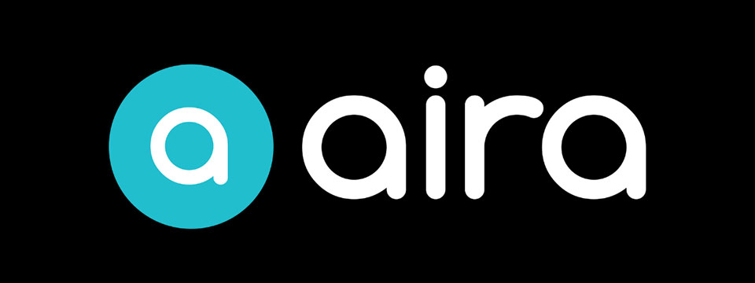
Sponsor Since: August 4, 2022 📅️
Website: https://aira.io/ 🌐️
Download the App: Apple App Store | Google Play Store
Plans and Pricing: https://aira.io/pricing/
Phone: NA: +1.800.835.1934 📱️ | AU: +1.800.765.096 📱️ | UK: +0.800.046.5668 📱️ | NZ: +1.800.425.451 📱️
Text Message: NA: +1.858.242.4457 📱️ | AU: +61.488.839.767 📱️ | UK: +44.149.320.2474 📱️
Email: support@aira.io 📧️
About: At Aira, we believe access to information is a human right. Aira breaks down accessibility barriers by providing on-demand video remote interpreting for both the blind and low-vision community, and the Deaf Community. People can download the Aira Explorer app or the Aira ASL app, and be instantly connected to a professional interpreter. Available 24/7/365, interpreters work with callers to facilitate more efficient communication and accomplish tasks together. Aira is proud to lead the way in delivering secure, on-demand, inclusive services that transform lives and open doors to new opportunities for all.
Contact Us | Access Partners | Plans and Pricing
Step One: Subscribe and Download. Pick the plan that lets you explore on your terms and on your time, sign up in a few minutes, and download the Aira app to your smartphone. Plans shown are for the United States, Canada, Australia, New Zealand and the United Kingdom. Add or cancel at any time.
Step Two: Connect with an Aira Agent. On the first call, connect with one of our certified, specially-trained Agents and learn how everything works.
Step Three: Real-time Assistance. At the touch of a button, Aira delivers instant access to visual information, when and where you want it.
Social: Twitter | Facebook | LinkedIn | YouTube | Instagram

⬆︎ 6.) Sponsor: Fable Tech Labs

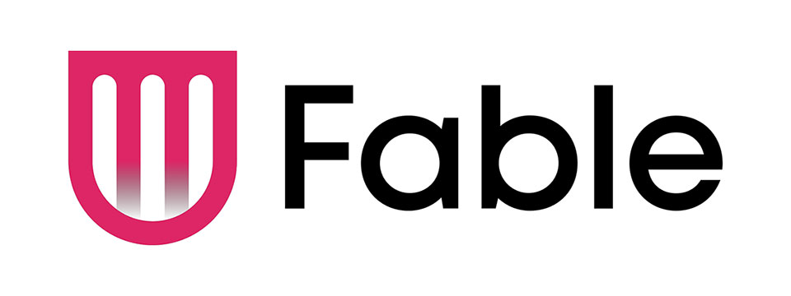
👉️ Classified Advertisement: Learn Management Skills For Free. Get The Job You Want | Fable
Everyone deserves equal access to the internet which is why Fable works with people with disabilities who use assistive technologies like switch controls to improve the accessibility of websites and apps. Fable Pathways, a free, accessible, and on-demand skill-building program, is an extension of Fable's mission. Fable Pathways provides new opportunities for people with disabilities to gain the skills they need, from experts like Judy Heumann and Kelly Ford, to contribute to improving digital accessibility.
Sponsor Since: June 30, 2022 📅️
Website: https://makeitfable.com/ 🌐️
Email: community@makeitfable.com 📧️
About: Fable is an accessibility platform powered by people with disabilities, connecting them to accessibility managers, user researchers, designers, and developers to build accessible user experiences.
Opportunities:
➜ Accessibility Tester: Testers drive meaningful change in digital accessibility by sharing feedback on the websites and apps of the companies that care. As a Tester, earn a competitive tech industry wage, learn valuable transferrable skills, and grow your career. Fable is looking for assistive technology users in the US or Canada to work the hours that they want, completely from home. No experience or resume required.
➜ Survey Respondent: Survey Respondents enjoy a remote, low-commitment income opportunity, all while contributing to accessibility research. Surveys are typically sent out once a month, and you can earn $5 to $50 per survey. Apply today if you identify as having a disability and live in the US or Canada. You do not need to use assistive technology to apply.

⬆︎ 5.) Sponsor: SelvasBLV

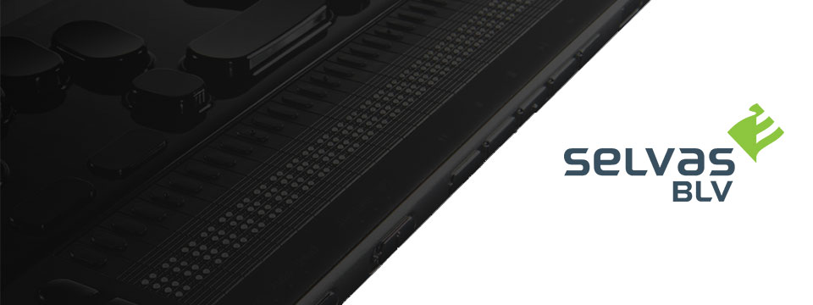
👉️ Classified Advertisement: Missed Our Recent Webinar Reviewing The Upcoming Braillesense 6 Firmware 3.0 Release? Watch It Here!
The recording of the webinar reviewing the BrailleSense 6 Firmware 3.0 release is now on our YouTube! Check it out with this link, and let us know what you think!
Sponsor Since: September 30, 2021 📅️
Website: https://selvasblv.com/ 🌐️
Shop All Products: https://selvasblv.com/shop-all-products/ 🛒️
Phone: (512) 837-2000 📱️
YouTube: https://www.youtube.com/watch?v=5R9NjA1nfWo
Sales: sales@selvasblv.com 📧️
Support: support@selvasblv.com 📧️
About: SelvasBLV is a global manufacturer and distributor that has provided braille, magnification and accessible healthcare devices since 1999.

⬆︎ 4.) Sponsor: Carroll Center for the Blind


👉️ Classified Advertisement: Attend the Screen Reader User Tester Training Program at the Carroll Center for the Blind | Carroll Center for the Blind
Launch your career in the digital accessibility field! The Carroll Center for the Blind's new 7-week intensive Screen Reader User Tester Training program allows participants to learn and grow their ability to professionally explore, test, and report findings regarding the accessibility of websites, mobile applications, and digital document files using screen readers. Want to learn more? Start your journey to becoming a Screen Reader User Tester today.
Sponsor Since: August 5, 2021 📅️
Website: https://carroll.org/ 🌐️
Phone: (617) 969-6200 📱️
Fax: (617) 969-6204 ░️
Shop: https://carroll.org/store/ 🛒️
Donate: https://carroll.org/donate ❤️
Social: Facebook | Twitter | YouTube | LinkedIn | Instagram
About: The Carroll Center for the Blind is the foremost leader in vision rehabilitation services for individuals confronted by the challenges of vision loss. Our mission is to empower those who are blind or visually impaired to achieve independence and to lead a fulfilling life. Established in 1936, the renowned Carroll Center for the Blind has been serving those with vision impairment for over eight decades; we are known nationally as a premier Vision Rehabilitation Center. Located just outside of Boston on a sprawling campus in Newton, Massachusetts, we proudly serve ALL ages and ALL stages of vision loss. With the ongoing promise of improving the lives of people with vision-related problems, The Carroll Center for the Blind has pioneered many innovative services allowing people who are blind or have low vision to learn the skills to be independent in their homes, in class settings, and in their work places. Our services include vision rehabilitation, vocational and transition programs, assistive technology training, educational support, and recreation opportunities for individuals who are visually impaired of all ages. For over 80 years, the expertise of Carroll Center staff has provided help for thousands of blind and visually impaired persons with diverse opportunities for success and independent living.

⬆︎ 3.) Sponsor: Pneuma Solutions

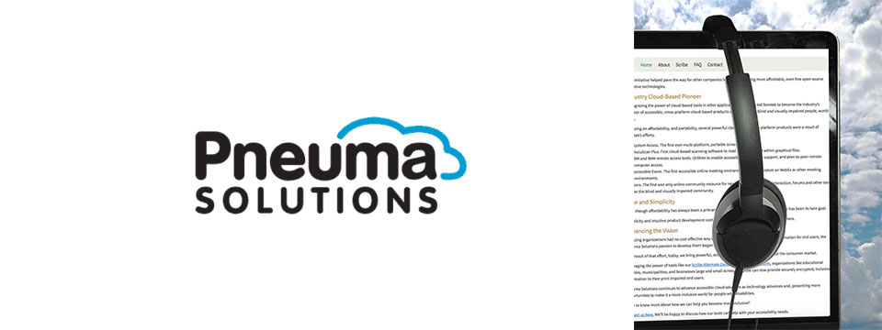
👉️ Classified Advertisement: Accessible Archive: Scalable, On-Demand Accessibility for Large Document Repositories | Pneuma Solutions
Organizations with large digital libraries, such as universities, government agencies, publishers, museums, and corporations, are under increasing pressure to provide accessible versions of their content to meet global disability and inclusion laws. But full-scale remediation of millions of documents is rarely practical or budget-friendly.
The Accessible Archive offers a scalable, just-in-time approach to document accessibility. Instead of converting every document in advance, this system makes archived content instantly available in accessible formats only when requested. The result is lower costs, faster deployment, and compliant, user-friendly output across a range of needs, including for blind, low-vision, and other print-impaired users. The Accessible Archive is designed to handle the scale and complexity of institutional digital libraries without requiring full pre-processing or re-engineering.
Sponsor Since: June 3, 2021 📅️
Website: https://pneumasolutions.com/ 🌐️
Email Newsletter: Click here to receive periodic news via email concerning Pneuma Solutions products for business, consumers and education.
Sales: (866) 202-0520 📱️
Support: (650) 249-1000 📱️
About: Backed by two decades of creating award-winning accessible cloud technologies for people with visual impairments, Pneuma Solutions is the global leader in accessible cloud-based solutions. Pneuma Solutions was founded by long-time accessibility developers Mike Calvo and Matt Campbell. For more information on their individual profiles, click on their respective bio pages. We're proud to be the first company to develop cloud-based accessibility at the network level. Our tools provide organizations, like yours, a way to deliver secure, accessible information right from your network or from our secure servers. You can provide your print disabled consumers, students, employees, and citizens with a multitude of accessible options. Additionally, we offer a suite of cloud-based applications to blind and print disabled consumers directly from our website. Our consumer products are designed to make the day-to-day lives of blind and print disabled individuals more accessible and simpler to manage. Access to information is not a privilege, it's a right. It's also your right to obtain affordable, accessible cloud solutions to serve your end user. When organizations like yours implement our tools, together we help make it a more inclusive world for people with disabilities. Want to know more about how we can help you become more inclusive?
Contact us here. We'll be happy to discuss how our tools can help with your accessibility needs.

⬆︎ 2.) Sponsor: Freedom Scientific

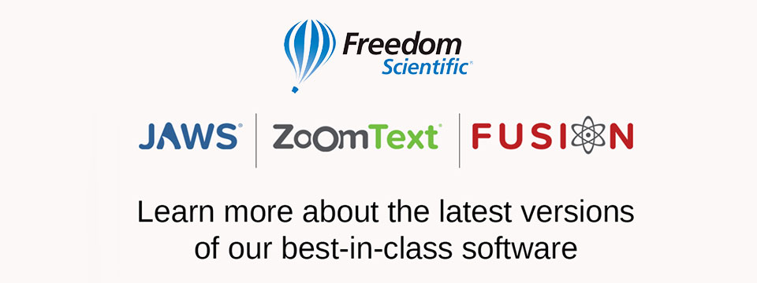
👉️ Classified Advertisement: Freedom Scientific Focus Blue 5th Generation Refreshable Braille Displays | Freedom Scientific
Our world-class refreshable Braille displays deliver efficient Braille input and outstanding output for your PC or mobile device. The robust Bluetooth® connectivity provides seamless use with Windows®, Mac®, iPhones®, iPads®, and Android TM smartphones and tablets. Ergonomic navigation features allow quick, natural hand movements for greater productivity. When used with JAWS® screen reading software, they support our popular Braille Study Mode, an interactive tool for teaching and learning Braille. Learn more today.
Sponsor Since: April 15, 2021 📅️
Website: https://www.freedomscientific.com/ 🌐️
Email: info@vispero.com 📧️
Phone: (800) 444-4443 📱️
Facebook | Twitter | YouTube (Training)
About: Freedom Scientific, a Vispero brand, is a leading worldwide brand of assistive technology products for those with vision impairments. We offer products designed to promote independence, allowing blind and low vision individuals the same access to information as their sighted peers. World-renowned JAWS (Job Access With Speech) screen reading software and ZoomText screen magnification software provide users the independence and ability to seek education and obtain or maintain a career after vision loss. Our expansive product line includes both low vision and blindness technology for all aspects of daily living. The wide range of RUBY, TOPAZ, and ONYX desktop and portable video magnifiers are designed for their ease of use and assist with daily activities. Our impressive line of blindness hardware products include refreshable Braille displays and scanning and reading devices, offering many options tailored to fit individual needs.

⬆︎ 1.) Sponsor: A. T. Guys

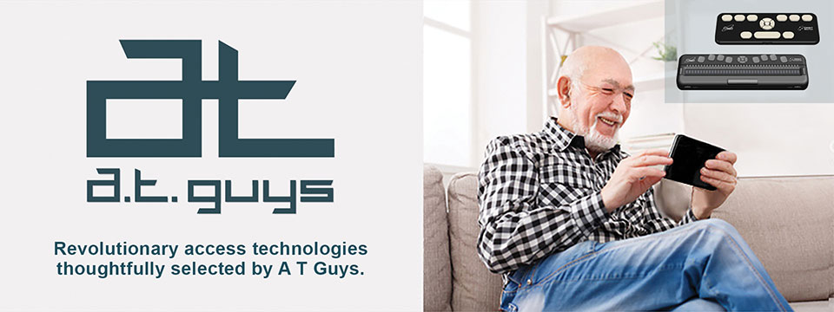
👉️ Classified Advertisement: Pluggable USB-C 7-in-1 Hub | A. T. Guys
If you're like me, you probably have more things to plug into your computer than available ports. That's why we've now added the Pluggable USB-C 7-in-1 Hub. Plug it into your laptop and you will get 3 USB ports, SD and Micro SD card slots, a USBC charging port, and an HDMI video port. It's available now for just $29.95.
Sponsor Since: June 11, 2020 📅️
Website: https://www.atguys.com/ 🌐️
Phone: (269) 216-4798 📱️
Email: support@atguys.com 📧️
Skype: atguys 💬️
X (Formerly Twitter): https://twitter.com/atguys (@atguys) 💬️
Facebook: https://facebook.com/atguys 💬️
About: ATGuys.com. Your access technology experts, home for cool gadgets, accessories, and more. Our products are all tested to work great for blind and visually impaired users but also work just as well for anyone. If there's an item you're looking for, or if you have a question, please don't hesitate to send us a message or call (269) 216-4798 📱️.

⬆︎ 19.) Sponsor: ConnectAlt

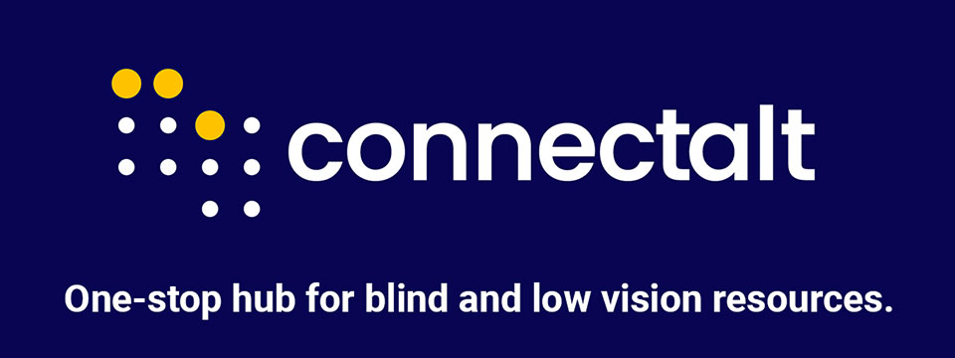

Sponsor Since: September 25, 2025 📅️
Website: https://connectalt.com/ 🌐️
About: ConnectAlt is a free, accessible hub that centralizes events, programs, and resources for the blind and low-vision (BLV) community. Built by creator/co-founder Lucie Courtois (who is blind) with Carol Trapani and Ella Deshautreaux, ConnectAlt solves the discovery problem by making it easy to find what's happening by date, topic, organization, and location including virtual offerings. The team is active across BLV networks and national convenings (e.g., exhibitor at NFB 2025) and partners with nonprofits, service providers, and assistive-tech leaders to help people quickly connect with opportunities that improve daily life, education, mobility, and employment.
Sponsoring ConnectAlt aligns your brand with tangible access and inclusion while reaching an engaged audience of BLV individuals and families, educators, VR counselors, nonprofits, employers, and assistive-tech users. Packages can include high-visibility placement alongside relevant listings and resources, partner spotlights, community giveaways, and event activations around key gatherings such as the Blind Travel Summit (Austin, Nov 13-14, 2025) — all while keeping the core platform free to users. Let's tailor a sponsorship that advances your goals and measurably expands access for the BLV community.
Social: Follow us on Instagram.

⬆︎ 18.) Sponsor: Double Tap

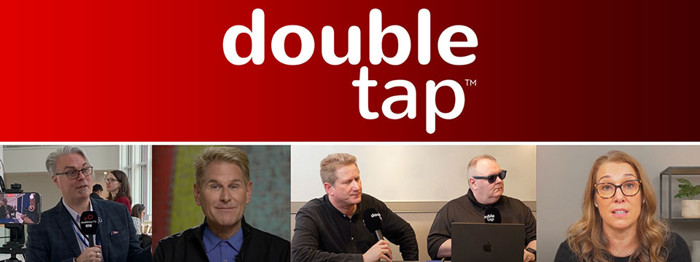

Sponsor Since: March 15, 2025 📅️
Website: https://doubletaponair.com/ 🌐️
About: Founded in 2017 as “Double Tap Canada” on AMI-audio, Double Tap has grown into a weekday podcast, radio show and YouTube series whose tagline proudly declares it "The Podcast Where Blind People Talk Tech." Its Glasgow-based creator Steven Scott, Manchester-based producer-co-host Shaun Preece and Canadian executive producer Marc Aflalo now helm more than 600 episodes that drop every weekday at noon ET, alongside written articles and video clips on DoubleTapOnAir.com.
Each episode blends mainstream gadget news with deep dives into assistive tools, all filtered through the lived experience of blind hosts. Listener emails, voicemails and WhatsApp messages are woven into the conversation, while spin-offs such as Shaun of the Shed (beginner tutorials) and past TV projects like Access Tech Live extend the brand across platforms in partnership with Accessible Media Inc. The result is a vibrant, multi-platform ecosystem that reaches audiences via AMI-audio, every major podcast app, YouTube and even specialist players like the Victor Reader Stream.
The community's enthusiasm shows: Double Tap recently surpassed one million cumulative downloads and, in March 2025 alone, attracted nearly 27K listeners generating 38K downloads; Apple Podcasts users rate it around 4.8 / 5. Authentic insights, daily consistency and professional production continue to position Double Tap as an essential, trusted voice at the intersection of mainstream tech and accessibility.
Newsletter (Double Tap Digest) | Facebook | Instagram | LinkedIn | TikTok | X (Formerly Twitter) | YouTube

⬆︎ 17.) Sponsor: Awarewolf Gear

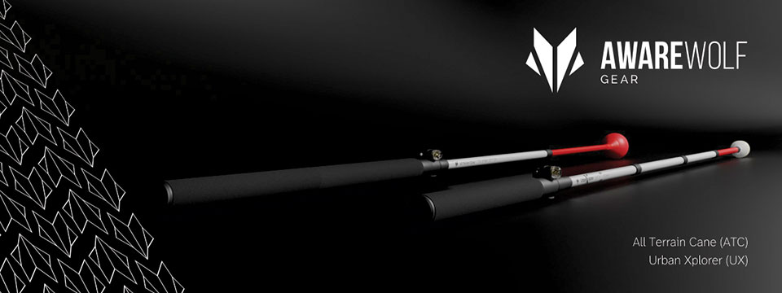

Sponsor Since: February 28, 2025 📅️
Website: https://awarewolfgear.com/ 🌐️
About: Awarewolf Gear is built on innovation, resilience, and a passion for adventure — especially for those in the blind and low vision community.
Awarewolf Gear is dedicated to redefining mobility through high-performance, thoughtfully engineered canes.
With the core belief that everyone deserves to explore confidently, our mission is encapsulated in our tagline, "Power for Life's Adventure."
Our product line, community initiatives, and inspirational storytelling all work in tandem to empower users to navigate diverse terrains with ease and independence.
Product Line
⚫️ All Terrain Cane (ATC)
Design & Purpose: The All Terrain Cane was originally engineered for the rugged trails of Sedona, Arizona. Made from durable titanium alloy, it is built to handle everything from sandy beaches to rocky mountain paths. Its adjustable 16-inch handle and high-performance roller ball tip provide stability and versatility across varied surfaces.
⚫️ Urban Xplorer Cane (UX)
Innovation & Versatility: Merging the rugged design of the ATC with enhancements for urban mobility, the Urban Xplorer Cane features an adjustable handle and a specially designed "Dome" cane tip. Available in multiple sizes (small, medium, large and extra-large), this lightweight, robust cane is ideal for navigating busy city streets as well as more challenging environments.
⚫️ Cane Tips
Customization & Performance: Awarewolf Gear's Cane Tips are designed to elevate your mobility experience by ensuring smooth, reliable navigation across all terrains. Crafted for both durability and style, these premium replacement tips allow users to personalize their canes while enhancing performance.
⚫️ Accessories and Apparel
Customization & Expression: Beyond canes, Awarewolf Gear offers a range of accessories — such as colorful replacement cane tips designed for visibility and personal expression — and apparel that carry the brand's adventurous spirit.
Instagram | Facebook | LinkedIn | YouTube

⬆︎ 16.) Sponsor: Vision Tech Academy

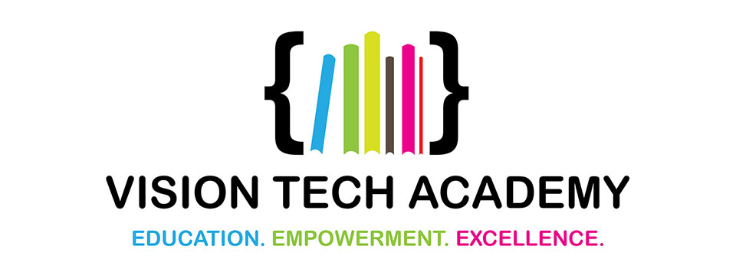

Sponsor Since: January 15, 2025 📅️
Website: https://visiontechacademy.com/ 🌐️
About: Vision Tech Academy is a website, platform and online directory dedicated to empowering blind and low-vision individuals by connecting them with trusted assistive technology educators for free.
Vision Tech Academy is the home of the free, access-technology specific, Online Directory of Educators (ODE).
Inspired by the legacy of John Panarese, the Academy website serves as a hub for accessible learning, offering a free directory of access educators, live and recorded courses, and resources to foster learning independence and success.
With an ongoing mission to provide high-quality, trusted, personalized training on tools like VoiceOver, JAWS, NVDA and Braille technology, Vision Tech Academy bridges the gap between technology and accessibility, ensuring inclusive and accessible education for all.
📖️ Free Directory for Students
📖️ Free General Profiles for All Access Educators
🏅️ Premium Profiles for Access Educators Who Want More Reach

⬆︎ 15.) Sponsor: Elegant Insights Braille Creations

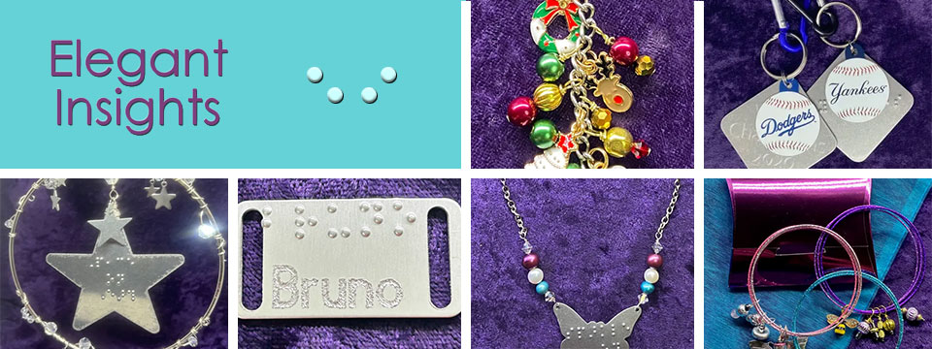
👉️ Classified Advertisement: Elegant Insights Has Halloween's Most Haunted Jewelry And Accessories!
Greetings, ghouls, goblins, and ghosts with the most! We're headed into spooky season, which means Elegant Insights has a truly terrifying collection of jewelry and accessories perfect for fright night. Dress up your white cane for Halloween with our choice of either a creepy copper bat braille-embossed with "boo!" or an orange and green enamel pumpkin jingle bell in our Charmed by the Holidays Halloween Mobility Cane Charm. Decorate your handbag, tote, or trick or treat bag with one of our Halloween theme Charmed by the Holidays purse charms. Halloween's Most Haunted earrings are a frightfully fun way to dress up for Halloween without committing to a costume! If you've got it, haunt it! Shop with Elegant Insights for all your fab fall fashion, gifts, and accessories. Check out our showstopping Falling In Leaf collection if you love all things autumn, or give us a call if you have a custom design in mind. Call +1 (702) 605-1265 or shop online at https://elegantinsightsjewelry.com.
x (Formerly Twitter) | Facebook | Instagram

Sponsor Since: November 22, 2024 📅️
Website: https://elegantinsightsjewelry.com/ 🌐️
About: Elegant Insights Braille Creations, founded by Laura Legendary, offers a distinctive collection of handcrafted jewelry and accessories embossed with crisp, readable braille.
Inspired by a personal experience, Laura, who is blind, established the brand to merge style with accessibility, providing beautiful and inclusive products. Each piece is made in the USA and can often be personalized or custom-designed to meet individual preferences.
Beyond her work with Elegant Insights, Laura co-founded The Fashionability Channel podcast, which provides beauty, fashion, and lifestyle information for people with disabilities. She also maintains two blogs: the Accessible Insights Blog, offering information on products and services for individuals with low or no vision, and the Sparkle On Blog, which provides jewelry education, design trends, and style information.
Laura's dedication to accessibility and advocacy extends to her role as a speaker, author, and educator specializing in these areas. Her multifaceted efforts aim to empower individuals with disabilities, ensuring they have access to stylish, functional, and meaningful products and information.
Home | About Elegant Insights | Ordering, Shipping and FAQs | My Account | Checkout | Cart | Shop The Boutique | Wish List | Testimonials | Subscribe

⬆︎ 14.) Sponsor: Florida Vision Technology

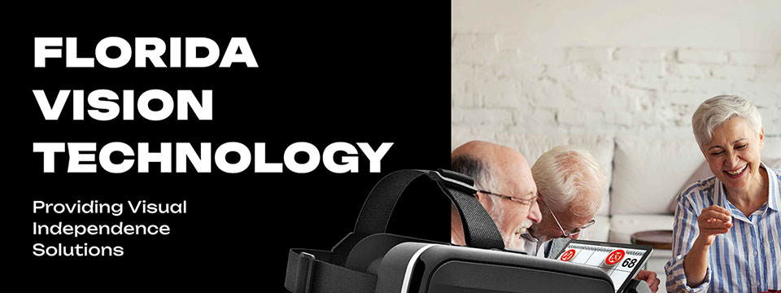

Sponsor Since: October 13, 2024 📅️
Website: https://floridareading.com/ 🌐️
About: Florida Vision Technology is officially celebrating its 20th anniversary. When I started in February 2000, the assistive technology industry was young, and there were just a handful of manufacturers.
Opening the business felt right, and I was ready to jump in. The biggest challenge, in the beginning, was getting a used bulky desk into the shed in my backyard, which my daughters named "Lesa Berg Kretschmer World Headquarters."
Three years later, in June of 2003, we moved into our first offsite location and opened a low vision superstore!
Home | Shop | Blogs | About Us | Contact Us

⬆︎ 13.) Sponsor: Access Park

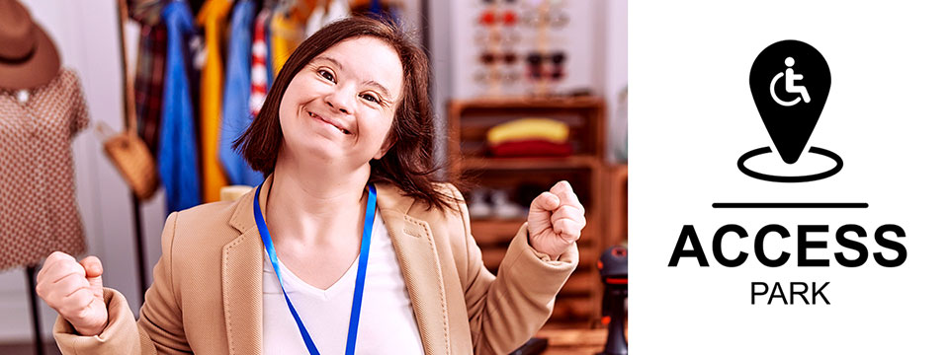
👉️ Classified Advertisement: Donna J. Jodhan's Pottery - Piece By Piece! Building Blocks For Inspiration And Creation! | Access Park
My pottery pieces are designed to inspire your creativity and imagination! Each piece is crafted with care, offering a unique touch to your home and dining experience. Whether you're looking for elegant dinnerware, functional art, or custom pieces, I can help you bring your vision to life. From rustic charm to modern elegance, I specialize in creating pottery that fits your personal style and elevates your dining table. Let me customize a one-of-a-kind creation that reflects your taste and enhances your space, adding beauty and warmth to every meal. And check out the highlight of the month.
A Perspective from World-Renowned Advocate Donna J. Jodhan - How Some Canadian Government Departments Are Using Work Arounds

Sponsor Since: September 20, 2024 📅️
Website: https://accesspark.shop 🌐️
About: Access Park is your premier destination for accessible shopping.
At Access Park, we offer a curated selection of products aimed at enhancing the daily lives of persons with disabilities.
Whether you're looking for accessible tech gadgets, specialty assistive devices, or just everyday essentials, you'll find them here.
Access Park provides a shopping experience that prioritizes keyboard navigability, screen reader compatibility, and high-contrast visuals for those with visual impairments, in addition to other enhancements that provide an elevated shopping experience to users of various assistive technologies.
Access Park. Where inclusivity is always in stock. ^{(TM)}

⬆︎ 12.) Sponsor: The Apex Program

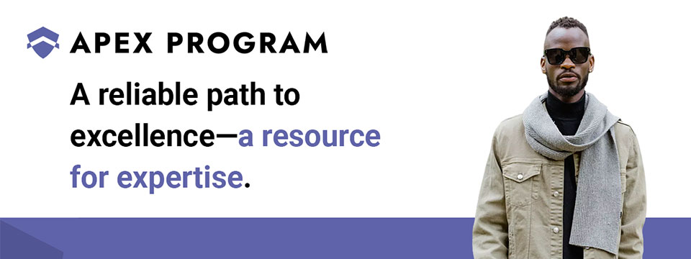
👉️ Classified Advertisement: Jumpstart Your Cybersecurity Career with the Apex Program! | The Apex Program
Are you ready to advance your career in cybersecurity? The Apex Program offers a comprehensive 12-week training course designed to prepare you for the CompTIA Network+ and Security+ certification exams. Tailored for the blind, visually impaired, disabled, and veteran communities, our program combines informative lectures, video tutorials, and quizzes, with expert instructor support every step of the way.
Get started today — Classes start on the first Monday of every month!
Don't miss this opportunity to join a diverse and inclusive workforce in the cybersecurity sector. Visit https://TheApexProgram.com to learn more and secure your spot today!
Sponsor Since: July 16, 2024 📅️
Website: https://theapexprogram.com 🌐️
About: Unlocking Abilities, Securing Futures. Founded on the principles of inclusivity and opportunity, the Apex Program is a pioneering educational initiative in cybersecurity, tailored for the blind, visually impaired, disabled, and veteran communities. Created by a Novacoast employee and inspired by his own journey from disability to Security Operations Center manager, the curriculum is designed to create a strong foundation of IT security knowledge, while instilling confidence and ensuring competence in the IT talent pool. Our ten-week program culminates in industry-recognized CompTIA certifications and a guaranteed pathway to employment, courtesy of Novacoast's dedicated IT Staffing division. At Apex, we don't just teach cybersecurity; we transform lives by unlocking potential and advocating for diversity in the IT security workforce.
Mission: The Apex Program is committed to bridging the gap in cybersecurity talent by empowering the blind, visually impaired, disabled, and veteran communities through inclusive, accessible, and comprehensive training. Our mission is to nurture a diverse workforce equipped with the necessary IT security skills and certifications to thrive in the cybersecurity sector. In partnership with Novacoast, we ensure a solid educational foundation and job placement in the industry, further fostering a future where every individual can focus their distinct abilities on building a more secure digital world.
Novacoast: Novacoast is a cybersecurity and IT services company that helps organizations enhance their security posture. They offer a range of services, including cybersecurity advisory, security engineering, identity and access management, development and integration, penetration testing, managed security services, and incident response. Their managed services include co-managed SIEM, DLP, EDR, vulnerability and patch management, phishing monitoring, and threat operations. Novacoast also provides specialized services for different industries such as finance, healthcare, and gaming. Additionally, they offer staffing solutions and training programs. Learn more today.
Home | A Division of Novacoast | Novacoast Federal | The Program | About Us | Partnerships | Media | Contact

⬆︎ 11.) Sponsor: Innosearch.ai

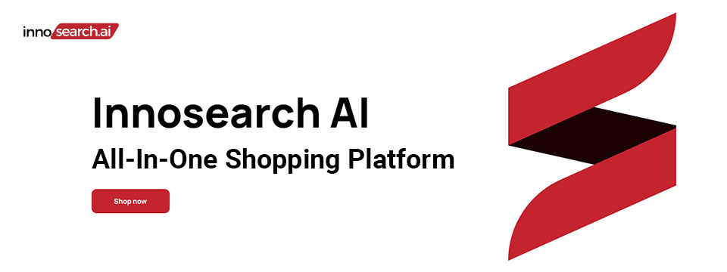
👉️ Classified Advertisement: Shop by Phone — No Screens, Just Your Voice!
Call 1-855-SHOP-GPT (1-855-746-7478)
Shopping online can be hard if you're blind, visually impaired, or not tech-savvy. That's why Innosearch AI created Shop by Phone — a 100% free, voice-only service.
Just call and say what you need:
👉 “Find me a phone charger.”
👉 “Add it to my cart.”
👉 “Check out.”
No apps, no websites — just easy, hands-free shopping from over 500,000 stores.
- ✔ Free to use
- ✔ Works anywhere, anytime
- ✔ Perfect for seniors, blind, and low-vision users
Available in:
- 🇬🇧 UK: +44 7727 247467 📱️
- 🇨🇦 Canada: +1 782 222 7467 📱️
- 🇦🇺 Australia: +61 489 267 467 📱️
- 🇺🇸 USA: 1-855-SHOP-GPT 📱️ (1-855-746-7478 📱️)
Call now and shop with ease!
Sponsor Since: June 7, 2024 📅️
Website: https://www.innosearch.ai 🌐️
Email: info@innosearch.ai 📧️
About: Innosearch is an all-in-one shopping platform augmented with a cutting-edge AI-powered shopping assistant. This innovative feature mimics the experience of shopping in real life by allowing you to interact with the assistant using natural language. It aggregates millions of products from top US online retailers, bringing them directly to you. With this advanced generative AI, Innosearch offers personalized product recommendations, highlights the best deals, and provides comprehensive information including reviews, total prices, shipping options, and more. Innosearch delivers a seamless end-to-end shopping experience, eliminating the need to search and browse in multiple tabs across retailers.
YouTube Review By Sam Seavey: https://youtube.com/watch?v=-rjL-HAwaZY.
Key Features: Key Features of the Innosearch All-in-One AI Shopping Platform include:
➜ Research Products: Easily compare products across retailers, or weigh pros and cons of similar products to make informed decisions.
➜ Uncover the Best Deals: Never miss a door buster, coupon, or clearance sale again. Get notified about the best prices and offers.
➜ AI Summarized Trusted Reviews: See what others are saying and make confident purchases.
➜ All in One: Innosearch brings millions of products from top online retailers directly to you, allowing you to shop the best deals with easy checkout and personalized AI assistance.
➜ Shop with Confidence: Rest assured, Innosearch has you covered with free shipping and returns on every purchase.
➜ Know Before You Buy: Innosearch equips you with expert buying guides, empowering you to make well-informed decisions.
How To Shop: Simply create a free account and start shopping today!

⬆︎ 10.) Sponsor: The Accessibility Guy

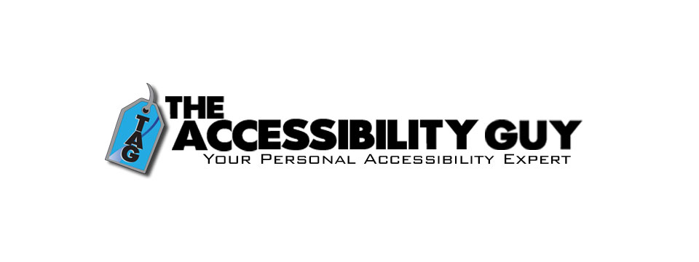
👉️ Classified Advertisement: How to Tag Multiple Languages in a PDF | The Accessibility Guy
More Adobe Acrobat accessibility tips!
My latest post explains how to properly tag individual language sections in a multilingual PDF. Adobe Acrobat offers tools to assign language codes to specific sections, allowing screen readers to interpret and vocalize the content accurately.
Check out The Accessibility Guy's full suite of Accessibility services.
Sponsor Since: August 3, 2023 📅️
Website: https://theaccessibilityguy.com/ 🌐️
YouTube: https://youtube.com/@TheAccessibilityGuy 📹
About: My name is Shawn Jordison and I love helping others learn the ins and outs of digital accessibility.
I have made over 100 thousand documents accessible, provided hundreds of trainings in the areas of accessibility and document remediation, and reviewed many websites and mobile applications for accessibility.
I have developed and reviewed VPATs, LMS courses, and other pieces of training. I am the accessibility Swiss army knife. Let me be your personal accessibility expert.
➜ Over 13 years of experience in the field of accessibility.
➜ Passionate about providing equal access to information for everyone.
➜ Wide range of project experience, including document accessibility, training, and more.
➜ Expertise in captioning, assistive technology, and accessibility best practices. I'm here to help you create a more accessible world.
The Blog: This blog covers topics like making Word, PDF & PowerPoint files accessible, Closed Captioning, assistive technology, and other important accessibility topics.
Training and Consulting: Offering customized training and consulting for implementing accessibility best practices.
Accessible Document Service: Providing top-tier document remediation services for all types of files, ensuring compliance with WCAG, 508, and PDF UA standards.

⬆︎ 9.) Sponsor: The Lighthouse for the Blind, Inc.

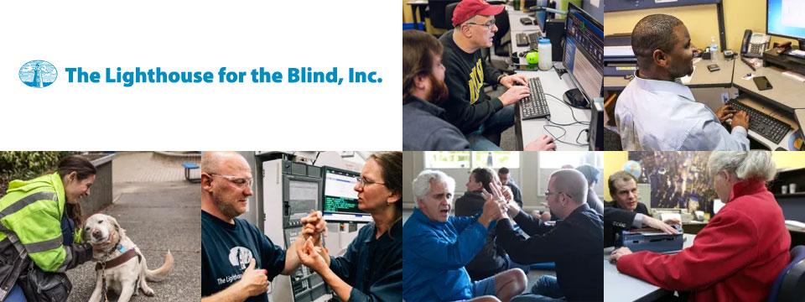
Sponsor Since: December 29, 2022 📅️
Website: https://lhblind.org/ 🌐️
Phone: (800) 914-7307 📱️
Fax: (206) 329-3397 ░
Contact Us: https://lhblind.org/contact-us/
About: The Lighthouse for the Blind, Inc. is a private, not-for-profit social enterprise providing employment, support, and training opportunities for people who are blind, deafblind, and blind with other disabilities. The Lighthouse has provided employment and support to people who are blind in our community since 1918.
The Lighthouse for the Blind, Inc. is a successful manufacturing organization with over 60 years of experience in precision machining. We produce an array of machined parts and plastic injection molding for various aerospace manufacturers, as well as a host of office products and hydration equipment sold to the Federal Government and the U.S. Military. We also own and operate stores on military bases along the West Coast. Our products and services include:
• Manufacturing: We are a successful manufacturing organization committed to making jobs accessible to individuals who are blind. Our manufacturing operations center on making quality products for the Federal Government under the AbilityOne Program and producing parts for aerospace manufacturers.
• Managed Services: The Lighthouse for the Blind, Inc. offers a variety of services to our commercial, federal, and military customers. These include Contract Management Support (CMS) services for government contracting offices.
• Base Supply Centers: We operate 12 AbilityOne Base Supply Centers (BSCs) that offer easy customer access to Lighthouse products, direct feedback and communication with customers, and employment opportunities for individuals who are blind in geographic areas not served by larger nonprofit agencies.

⬆︎ 8.) Sponsor: Wayaround

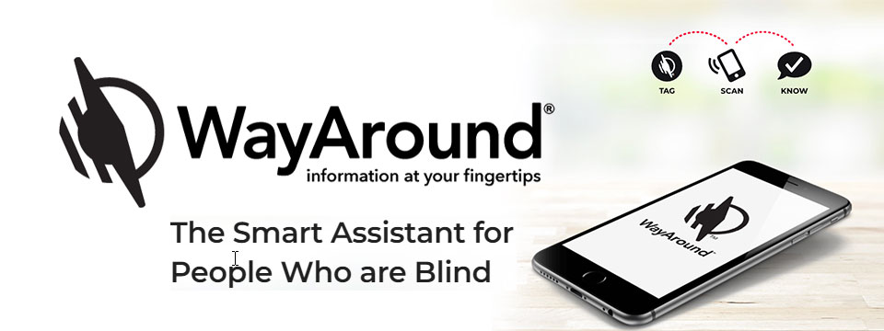
👉️ Classified Advertisement: FREE Sampler Pack with a Purchase of Any 25-pack of WayTags | Wayaround
WayAround is a smartphone-based labeling app that works with your preferred accessibility settings. You just need the free mobile app and some WayTags ® to label items in the kitchen, garden, closet, office & more.
If you want to label something that's inside, outside, wet, dry, hot, or cold, there's a WayTag that will attach securely. WayTags come as stickers, buttons, magnets, and clips. Each of the different styles of WayTags work exactly the same. Simply choose the WayTag that's best for what you want to label.
Purchase a 25-pack of any style of WayTag and get a free Sampler Pack so you can try all seven different WayTags. Enter the coupon code SAMPLE at checkout and the Sampler Pack will automatically be added to your cart. This is a $14.99 value! Limit one Sample pack per order.
Sponsor Since: January 5, 2023 📅️
Website: https://www.wayaround.com/ 🌐️
General Sales & Support: (888) 898-4465 📱️
Business Sales & Support: (888) 898-4465 📱️
Email: connect@wayaround.com 📧️
About: WayAround is the app for your smart device that provides on-demand details about everyday things. The simple tag-and-scan approach lets you quickly and easily identify things around you. It also provides extra details, like how something works or when it expires. The result? Doing more of the things you want, with more confidence and more independence.
All the information you want with just a tap of your phone. No more waiting around to ask someone. You need just two things to get started: The free mobile app for iOS or Android and some of our smart WayTags®.
Accessible labels for the blind, deafblind, and anyone with vision loss. Your biggest problem isn't poor eyesight. It's that so much of the information in the world is visual. But you shouldn't have to wait around for someone else to get the information you need. Or carry around a bulky, outdated device. There is a better way to get accurate and complete information every time. So you can reduce stress and gain independence.
Download The App (Apple): https://itunes.apple.com/us/app/wayaround-tag-and-scan/id1294361140?mt=8
Download The App (Android): https://play.google.com/store/apps/details?id=com.wayaround.wayaround

⬆︎ 19.) Sponsor: Your Name Here

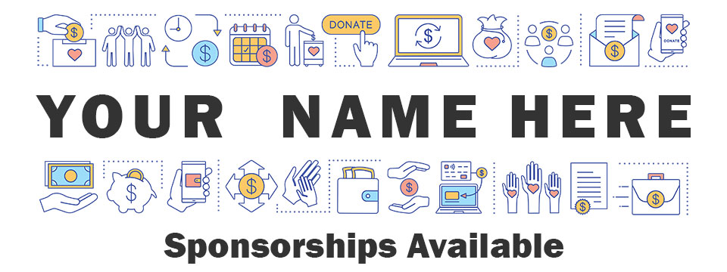
Purchase: Sponsorship Package 💸️ (Packages currently available.)
Join: Waiting List 📋️ (When there are no sponsorship packages available.)
Sponsor Since: Today 📅️
Website: https://toptechtidbits.com/sponsor 🌐️
Phone: (855) 578-6660 📱️
Email: enews@toptechtidbits.com 📧️
About: Founded in 2004, Top Tech Tidbits is the world's leading not-for-profit access technology publication that reaches over 42,000 blind, low vision, deaf, hard of hearing, deafblind, neurodivergent and/or disabled professionals, educators and enthusiasts, all over the world, each week. Subscribe here. Review the most recent issues here.

Top Tech Tidbits Supporters 🤝️
We couldn't do it without you! Thank you for your support!
Why: Top Tech Tidbits Supporters donate an amount of their choosing either one time or annually in order to assist with the ongoing distribution of the Top Tech Tidbits publication.
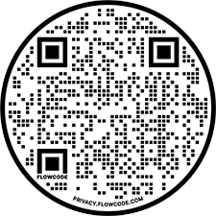
Benefits: All Top Tech Tidbits Supporters receive a listing within the "Our Supporters" section of each weekly newsletter, as well as a listing within the "Our Supporters" section of the Top Tech Tidbits website.
In addition, all Top Tech Tidbits Supporters automatically become Premium Subscribers as well, and therefore enjoy all of the benefits that a Premium Subscription has to offer.
One Time Donation: If you would like to become a Top Tech Tidbits Supporter by making a one time donation in an amount of your choosing to assist with the ongoing distribution of the Top Tech Tidbits publication, you may utilize this donate link, or scan the QR code to the right.
Annual Donation: If you would like to become a Top Tech Tidbits Supporter by making a small donation to assist with the ongoing distribution of the Top Tech Tidbits publication, we also offer the following options, all with our sincerest thanks, and most heartfelt gratitude for your ongoing support.
Support: In tandem with Our Sponsors, these are the people that make the ongoing distribution of Top Tech Tidbits possible.

Platinum Supporters:

Become a Top Tech Tidbits Platinum Supporter today.
1.) Gary Lee
Platinum Supporter since June 25, 2020
2.) Anonymous Donation
Platinum Supporter since July 9, 2020
3.) Pshon Barrett
Platinum Supporter since January 28, 2021
4.) Robin Millar
Platinum Supporter since April 6, 2023

Gold Supporters:

Become a Top Tech Tidbits Gold Supporter today.
1.) Howard Goldstein
Gold Supporter since June 4, 2020
2.) David Goldstein
Gold Supporter since June 12, 2020
3.) Katherine Crohan
Gold Supporter since January 14, 2021
4.) Neil Jarvis
Gold Supporter since April 28, 2022

Silver Supporters:

Become a Top Tech Tidbits Silver Supporter today.
1.) Timothy Gorbold
Silver Supporter since July 19, 2023
2.) Vojtech Polasek
Silver Supporter since December 29, 2023

Bronze Supporters:

Become a Top Tech Tidbits Bronze Supporter today.
1.) Steven Wettlaufer
Bronze Supporter since July 16, 2020
2.) Lions Clubs International
Bronze Supporter since July 13, 2020

One Time Supporters:
One Time Supporters donate an amount of their choosing — one time to assist with the ongoing distribution of the Top Tech Tidbits Publication.
Become a Top Tech Tidbits One Time Supporter today.
1.) Beth Wright
One Time Supporter on November 28, 2023
2.) Your name here.
One Time Supporter on ...

Top Tech Tidbits News Team 🗞️

Distribution: Sponsors, Supporters, Advertisers and Mind Vault Solutions, Ltd.

Distribution Since: 2004
As of June 4, 2020 the distribution of Top Tech Tidbits is made possible by our Sponsors, our Supporters, our Advertisers and Mind Vault Solutions, Ltd., a leading international provider of professionally outsourced marketing administration and consultation services.
Any time the Top Tech Tidbits Publication carries less than its Sponsor limit, Mind Vault Solutions, Ltd. donates the remaining dollars necessary to keep the publication running.
Please help us to support the ongoing distribution of this publication. Learn more about the benefits of Sponsorship today.

Publisher: Aaron Di Blasi

Publisher Since: June 4, 2020
Location: Cleveland, Ohio
Time Zone: Eastern Standard Time (EST/EDT) (GMT-5/GMT-4)
In addition to serving as Publisher for Top Tech Tidbits Aaron also serves as Publisher for the Access Information News and AI-Weekly newsletters, PR-Director for the AT-Newswire Press Release News Distribution Service, and President and Senior Project Management Professional for Mind Vault Solutions, Ltd.
As Publisher Aaron oversees the weekly distribution of Top Tech Tidbits on behalf of Mind Vault Solutions, Ltd.
Aaron Di Blasi, PMP
Email: publisher@toptechtidbits.com 📧️
Toll Free: +1 (855) 578-6660 📱️
PR Director (2024-Present)
AT-Newswire 🌐
Access Technology's Digital Newswire
Publisher (2024-Present)
AI-Weekly 🌐
The Week's News in Artificial Intelligence
Publisher (2022-Present)
Access Information News 🌐
The Week's News in Access Information
Publisher (2020-Present)
Top Tech Tidbits 🌐
The Week's News in Access Technology
Sr. Project Management Professional (2006 - Present)
Mind Vault Solutions, Ltd. 🌐
Innovative ideas. Solutions that perform.
Certified:
Digital Marketing Associate
Meta Certified (2022 - Present)
Social Marketing Professional
Hootsuite Certified (2020 - Present)
Email Marketing Professional
Constant Contact Certified (2019 - Present)
Specializing in:
Digital Strategy and Content Marketing
Social Media Advertising
Online Fundraising
ADA, WCAG and Section 508 Compliance

Editor: John Hanlin

Editor Since: June 4, 2020
Location: Boulder, Colorado
Time Zone: Mountain Standard Time (MST/MDT) (GMT-7/GMT-6)
In addition to serving as an Editor to Top Tech Tidbits John also serves as an Editor to the Access Information News and AI-Weekly newsletters and is also an attorney-at-law specializing in long-term disability claims for persons who are blind or low-vision.
John is also a long-time contractor and member of the Board of Trustees at Mind Vault Solutions, Ltd.
John Hanlin, Esq.
Editor (2024-Present)
AI-Weekly 🌐
The Week's News in Artificial Intelligence
Editor (2022-Present)
Access Information News 🌐
The Week's News in Access Information
Editor (2020-Present)
Top Tech Tidbits 🌐
The Week's News in Access Technology
Board of Trustees (2006 - Present)
Mind Vault Solutions, Ltd. 🌐
Innovative ideas. Solutions that perform.

Editor: Jenna Lang

Editor Since: June 4, 2020
Location: Des Moines, Iowa
Time Zone: Central Standard Time (CST/CDT) (GMT-6/GMT-5)
In addition to serving as an Editor to Top Tech Tidbits Jenna also serves as an Editor to the Access Information News and AI-Weekly newsletters and runs her own advocacy foundation.
Jenna also serves as a certified Project Management Professional (PMP) for Mind Vault Solutions, Ltd.
Jenna's son was born blind and she is always seeking new and innovative ways to empower him through technology.
Jenna Lang, PMP
Editor (2024-Present)
AI-Weekly 🌐
The Week's News in Artificial Intelligence
Editor (2022-Present)
Access Information News 🌐
The Week's News in Access Information
Project Management Professional (2022 - Present)
Mind Vault Solutions, Ltd. 🌐
Innovative ideas. Solutions that perform.
Editor (2020-Present)
Top Tech Tidbits 🌐
The Week's News in Access Technology

Editor: Stephen (Alex) Marositz

Editor Since: October 7, 2021
Location: Los Angeles, California
Time Zone: Pacific Standard Time (PST/PDT) (GMT-6/GMT-7)
In addition to serving as an Editor to Top Tech Tidbits Alex is also the Accessible Technology Coordinator for California State University, Dominguez Hills. He has worked in accessibility in higher education since 2005, is certified by the International Association of Accessibility Professionals, and in his spare time plays for the San Gabriel Valley Panthers Beep Baseball Team. He can be reached on twitter at: @samarositz.
Stephen (Alex) Marositz
Editor (2021-Present)
Top Tech Tidbits 🌐
The Week's News in Access Technology
Accessible Technology Coordinator
California State University, Dominguez Hills 🌐

Editor: Ben Moxey

Editor Since: January 1, 2022
Location: Newcastle, Australia
Time Zone: Australia Eastern Standard Time (AEST/AEDT) (GMT+10)
In addition to serving as an Editor to Top Tech Tidbits Ben is also an Access and Technology Advisor for Guide Dogs, New South Wales, Australian Capital Territory (NSW/ACT).
Hi, Tidbits readers, my name's Ben Moxey and I'm based in Newcastle, Australia. I'm really happy to be part of the Tidbits Team and look forward to supporting this valuable publication.
A bit about me and how I came to work in the BVI area. I grew up with very low vision in one eye due to retinal issues and relied on magnification and speech throughout school. They also tried to teach me Braille, but let's just say that I wasn't the best student! I was determined to use my remaining vision, no matter how impractical it was becoming.
When I was 20, the other retina came off and I've now been totally blind for about 21 years. This is when my love for assistive technology, and technology in general, really kicked in. I'll be honest, I was a bit of a computer nerd anyway, but I could quickly see how technology was my key to enhanced independence and lifestyle. I embraced screen readers, early smart phones and mobility aids. I even finally realised the huge value of Braille and finished off the course, though I'm still pretty slow!
Long story short (not one of my strong points), I've worked in the BVI area for 12 years with much of that spent reviewing, recommending and teaching assistive technology that suits the individual. I'm currently a proud employee of Guide Dogs NSW/ACT where I was the Practice Lead for the assistive technology service, and I've now moved into an Access and Technology Advisor role. Basically, this involves a strong focus on accessibility and technology innovation.
Feel free to look me up on LinkedIn, but I'll warn you in advance that I haven't given my profile the recommended attention!
All the best and happy reading!
Ben Moxey
Editor (2022-Present)
Top Tech Tidbits 🌐
The Week's News in Access Technology
Access and Technology Advisor
Guide Dogs, New South Wales, Australian Capital Territory (NSW/ACT) 🌐

Editor: David Woodbridge

Editor Since: February 6, 2023
Location: Central Coast, New South Wales, Australia
Time Zone: Australia Eastern Standard Time (AEST/AEDT) (GMT+10)
In addition to serving as an Editor to Top Tech Tidbits David also serves as an Editor to the Access Information News publication and is also the National Commercial Assistive Technology Advisor for Vision Australia where he has worked since 1990. Over this time he has assisted people who are blind or vision impaired in their home, education, and work settings to take advantage of the benefits of using assistive and main stream technology.
In the last seventeen years, he has also been involved with evaluating technology for use by people who are blind or vision impaired covering both low and high tech equipment (including Microsoft, Samsung, Google, Amazon, and Apple). David is also one of the key spokespersons for Vision Australia relating to technology.
He has been an Apple Ambassador for Apple Australia since 2009 with a group of other Ambassadors / Apple Distinguished Educators (ADE)'s covering the range of Apple's Accessibility solutions throughout Australia.
David produces a range of podcasts (since 2011) covering Apple and other technologies which are distributed on his own podcast (http://davidwoodbr.podbean.com). In addition, he also has a regular Talking Tech program (since 2013) which can be heard every Tuesday at 4:30 Eastern Summer Time on Vision Australia Radio Melbourne (available online) or via https://omny.fm/shows/talking-tech-vision-australia-radio
David also runs a weekly Tech Monday where people can chat about assistive and main stream technology, share information, and any tips and tricks.
David lost his sight when he was 8 years old and had to learn Braille. Since then, he completed high school, went to Sydney University receiving a Social Work degree, spent 4 years drug and alcohol counselling, and then moved into his current job.
As a person who is blind, David believes that as a user of the technology that he recommends to others, that he is well situated to look at the strengths and shortcomings of the assistive technology that he comes across in both his professional and personal life, in particular, mainstream technology that is accessible.
In addition to his weekly contributions to Top Tech Tidbits and Access Information News, David's regularly occurring activities are his weekly tech radio show, bi-monthly exploring tech webinars for Vision Australia, his iSee podcast when something of note grabs his attention, and the weekly Tech Monday chat sessions.
David Woodbridge
X (Formerly Twitter): @dwoodbridge
Mastodon: woody@dragonscave.space
iSee Podcast: https://davidwoodbr.podbean.com
Vision Australia Radio Talking Tech: https://omny.fm/shows/talking-tech-vision-australia-radio
Editor (2023-Present)
Top Tech Tidbits 🌐
The Week's News in Access Technology
Editor (2023-Present)
Access Information News 🌐
The Week's News in Access Information
National Commercial Assistive Technology Advisor
(1990 - Present)
Vision Australia 🌐
Live the life you choose. We're here to support all Australians who are blind or have low vision.

Editor: Vicki Walton

Editor Since: January 9, 2024
Location: Benton City, WA
Time Zone: Pacific Standard Time (PST/PDT) (GMT-6/GMT-7)
IIn addition to serving as an Editor to Top Tech Tidbits Vicki also serves as an Editor to the Access Information News publication and works as a Web Accessibility Specialist / IT Quality Assurance Tester at Washington State Board for Community and Technical Colleges.
Vicki Walton
Editor (2024-Present)
Top Tech Tidbits 🌐
The Week's News in Access Technology
Editor (2024-Present)
Access Information News 🌐
The Week's News in Access Information
Web Accessibility Specialist / IT Quality Assurance Tester
Washington State Board for Community and Technical Colleges 🌐
Better Jobs, Brighter Futures, a Stronger Washington

Subscription Information 📰️
ABOUT ♿️
Founded in 2004, Top Tech Tidbits is the world's leading not-for-profit access technology publication that reaches over 42,000 blind, low vision, deaf, hard of hearing, deafblind, neurodivergent and/or disabled professionals, educators and enthusiasts, all over the world, each week. Subscribe here. Review the most recent issues here. Access Technology broadly encompasses technologies that enable access to information and communication systems for persons with disabilities. Adaptive Technology is a subset of Access Technology designed to assist individuals in performing tasks that might otherwise be challenging due to their particular disabilities. Assistive Technology includes any device, software, or equipment that helps people work around their challenges. Top Tech Tidbits is a Mind Vault Solutions, Ltd. Publication. Publisher: Aaron Di Blasi. Editors: John Hanlin, Jenna Lang, Stephen (Alex) Marositz, Ben Moxey, David Woodbridge and Vicki Walton. Top Tech Tidbits is a sponsor, reader and advertiser supported publication.
RELEASE SCHEDULE 📅️
Top Tech Tidbits is released every Thursday morning at 6:00 AM ET.
SUBSCRIBE 📧️
Do you, a friend, or colleague wish to receive the Top Tech Tidbits newsletter? If so, please use or pass along our CAPTCHA-free sign-up link. You can also subscribe to receive the Top Tech Tidbits newsletter on the Top Tech Tidbits Website. Either of these methods will provide you with an accessibly friendly and secure medium through which you can subscribe to our mailing list. Just enter your email address, click send, and begin receiving the Top Tech Tidbits newsletter. It's that easy.
WEBSITE 🌐️
Visit the Top Tech Tidbits website online at: https://toptechtidbits.com.
PREMIUM SUBSCRIBER 💸️
Only Top Tech Tidbits Premium Subscribers receive our special quarterly issue listing the Top 60 Most Clicked News Articles of the Last 3 Months. Just $12 USD per year. This special quarterly issue is provided to Premium Subscribers as a native Microsoft Word document with full headings, links and abstracts to all 60 articles. There are no restrictions placed on these documents. Complete list of all back issues available. Premium Subscribers are entitled to all back issues, anytime they sign up. Join us today and begin receiving this incredibly informative issue every 3 months.
SPONSOR 🏅️
If you would like to become 1 of only 24 Top Tech Tidbits Sponsors whose ongoing support makes the distribution of Top Tech Tidbits possible, we offer you the following advertising benefits, with our sincerest thanks, and most heartfelt gratitude for your ongoing support.
ADVERTISE 🎯️
Top Tech Tidbits offers a variety of one-time advertising options to both Sponsors and non-Sponsors alike. Here we offer a sample newsletter that provides a breakdown of exactly what those one-time advertising options are, where they appear, and what they cost per publication.
DONATE ❤️
If you would like to become a Top Tech Tidbits Supporter by making a small donation to assist with the ongoing distribution of the Top Tech Tidbits publication, we offer the following options, with our sincerest thanks, and most heartfelt gratitude for your support.
STORE 🛒️
Are you blind or do you live with low vision? Are you deaf, hard of hearing or deafblind? Do you require a wheelchair for mobility? Do you consider yourself to be neurodivergent or otherwise disabled? The Top Tech Tidbits Online Store For Digital Downloads specializes in information that can improve your quality of life. Learn more today.
FACEBOOK 💬️
Are you on Facebook? Follow Top Tech Tidbits on Facebook to begin receiving current news and trends in Access Information as part of your Facebook News Feed.
X (FORMERLY TWITTER) 💬️
Are you on X? Follow Top Tech Tidbits on X to begin receiving current news and trends in Access Information as part of your X News Feed.
MASTODON 💬️
Are you on Mastodon? Follow Top Tech Tidbits on Mastodon to begin receiving current news and trends in Access Information as part of your Mastodon News Feed or by searching for @news@mastodon.toptechtidbits.com on your server today.
LINKEDIN 💬️
Are you on LinkedIn? Follow Top Tech Tidbits on LinkedIn to begin receiving current news and trends in Access Information as part of your LinkedIn News Feed.
YOUTUBE ▶️
Are you on YouTube? Follow Top Tech Tidbits on YouTube to begin receiving current news and trends in Access Information as part of your YouTube Video Feed.
RSS 📡️
Do you prefer RSS? Follow Top Tech Tidbits via RSS today to begin receiving current news and trends in Access Information using your choice of news aggregator.
QUESTIONS ❓️
Tidbits are intentionally concise. As a result we know that some readers may not always understand all of the items listed because little explanation is given. If a particular Tidbit brings up a question in your mind, feel free to ask, and we will try to answer as time and knowledge permit.
ARCHIVE 🗄️
Read the most recently released issues of Top Tech Tidbits online here. Visit the Top Tech Tidbits Archive here, where you can read back issues.
CONTENT CONTRIBUTORS ✍️
Any information for future issues of Top Tech Tidbits may be submitted online via our News Item Submission Form or directed to our Editors via email.
THANK YOU 🙏️
Thank you for reading. On behalf of all of us here at Top Tech Tidbits we look forward to keeping you informed.
Information provided by:
Top Tech Tidbits
https://toptechtidbits.com/ 🌐
A Mind Vault Solutions, Ltd. Publication
1284 SOM Center Road, PMB 194,
Mayfield Heights, Ohio 44124
+1 (855) 578-6660 📱️

