How to Read Blind: https://toptechtidbits.com/read
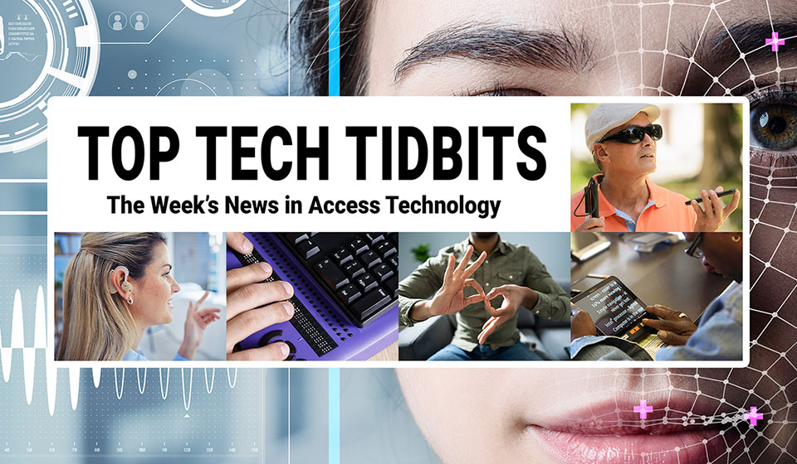
 |  |  |  |  |  |  |  |  |  |  |  | 
Top Tech Tidbits for Thursday, October 16, 2025 - Volume 1037
♿️ The Week's News in Access Technology
Top Tech Tidbits. The world's #1 online resource for current news and trends in access technology.
A Mind Vault Solutions, Ltd. Publication
Subscribers: 42,242 🔢️ opt-in subscribers were sent this issue via email.

Sponsors 🏅️
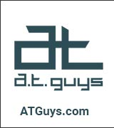 |  |  |  | 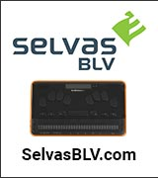 | 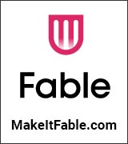
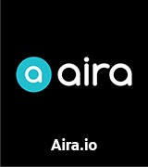 | 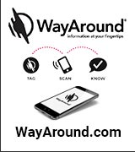 | 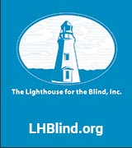 | 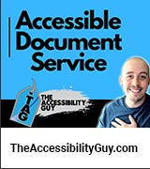 |  | 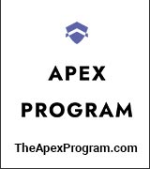
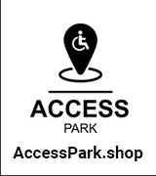 | 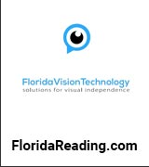 |  | 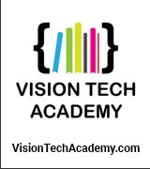 | 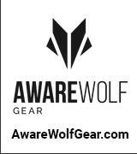 | 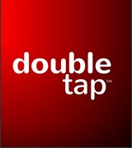
 | 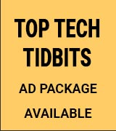 | 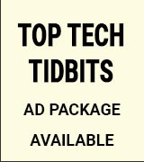 | 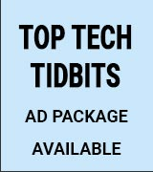 | 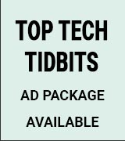 | 

Access Awareness: Updates That Matter ♿️
Why 90% of Blind People Don't Use a White Cane... (Free Cane Giveaway!) | Legally Blind No Limits | YouTube.com | October 9, 2025
Over 90% of people who are blind or visually impaired don't use a cane… even when they need one. I used to be one of them, and actually, hiding my blindness almost killed me. I don't want that to happen to anyone else. That's why I've partnered with @AwarewolfGear to give away 3 FREE white canes this Blindness Awareness Month. This isn't just a giveaway. it's part of my mission to help people get the support, tools, and confidence they need to live life NO limits. If you've been too afraid, too unsure, or just didn't know where to start, this one's for you.

This Week's Featured Advertisement 🎯️
Sponsorship Packages Currently Available. Support Free Access Technology News For Disabled Readers All Over The World While Increasing Traffic To Your Properties Each Week. Advertise in every issue. Or just one.
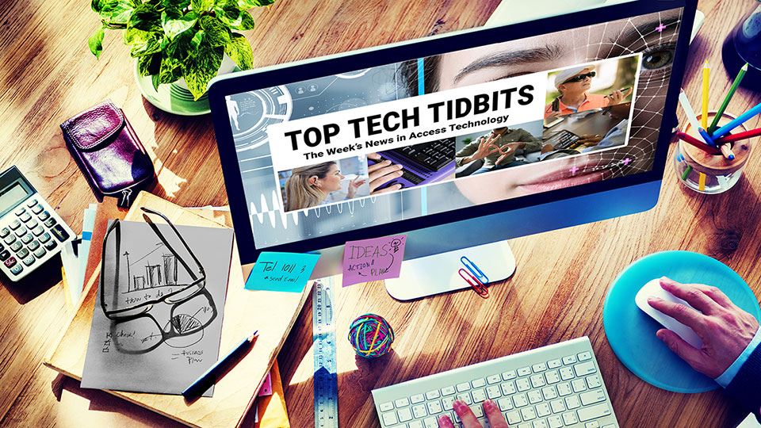
Join Top Tech Tidbits as a Sponsor today and begin reaching over 42,000 access technology subscribers each week, all while supporting the ongoing distribution of Top Tech Tidbits for those very same readers. Only $200 / month.
Key Newsletter Statistics:
- Subscribers: 42,000 + per week and growing.
- Open Rate: 46% (Average. Last 12 months.)
- Click Rate: 42% (Average. Last 12 months.)
- Bounce Rate: 1.1% (Average. Last 12 months.)
- Ad CTRs: 2-12% (Average. Last 12 months.)
Benefits All Sponsors Receive:
- One (1) Sponsor Profile on the Top Tech Tidbits website.
- One (1) Sponsor Profile in each weekly newsletter.
- One (1) Sponsor Wall Brand Advertisement on the Top Tech Tidbits home page.
- One (1) Sponsor Wall Brand Advertisement in each weekly newsletter.
- One (1) Classified Advertisement in each weekly newsletter.
- 50% Discount on all Sponsored Tidbit Advertisements.
- Free link tracking.
- Permanent SEO benefits.
- Gratitude from over 42,000 access technology subscribers for keeping Top Tech Tidbits free to read.
With additional benefits for Sponsors that pay quarterly or annually. Learn more today.

News 📰️
👉 Submit a Tidbit for free here, with timing and placement determined by our editors.
👉 Submit a Sponsored Tidbit here, with timing and placement determined by you.

1.) Top 5 Most Clicked Tidbits From Last Week 📊️
A.) Fire TVs Have A New Machine Learning Dialogue Boost Option That Works In Real Time On All Videos | AFTVnews.com | October 8, 2025
Amazon has introduced an advanced dialogue boost feature for Fire TVs which utilizes machine learning to enhance dialogue clarity in real time across all videos. This feature allows users to select from multiple levels of boost, improving the listening experience significantly compared to previous options available in Dolby audio settings.
B.) Eyes on Success Episode 2541: CoBrowse AI Agent Makes Web Interactions More Accessible | October 8, 2025
Now AI can simplify online shopping for people with vision loss. Hosts Nancy and Peter Torpey talk with Patrick Long, co-founder of the accessible InnoSearch AI shopping service, about their new CoBrowse AI agent, which uses interactive voice-controlled commands and reasoning to make e-commerce sites and other online experiences more accessible for everyone.
C.) Why Accessibility Might Be AI's Biggest Breakthrough | ArsTechnica.com | September 9, 2025
A UK government study reveals that neurodiverse employees benefit significantly from AI tools, particularly chatbots, reporting higher satisfaction and likelihood to recommend these tools compared to neurotypical workers. The study suggests AI may help bridge accessibility gaps in the workplace, transforming the work experience for those with various disabilities.
D.) Meta Ray-Bans: Blind User's Experience With Smart Glasses | AbilityMagazine.com | October 2, 2025
The article explores the functionality of the Meta Ray-Ban smart glasses from the perspective of a blind user who shares her transformative experience with the technology. Key features discussed include the glasses' ability to read text aloud, provide descriptions of the surroundings, and assist with everyday tasks, significantly enhancing independence and quality of life for visually impaired individuals.
E.) Pushing Apple's On-Device AI to Its Limits | Taylor Arndt | Substack.com | October 7, 2025
Introducing Perspective AI, an innovative on-device AI similar to ChatGPT that allows users to engage in natural conversation, ask questions, and enable memory functions. With daily updates and a focus on privacy through local data handling, this AI marks the future of personal technology.
2.) Sponsorship Packages Currently Available | TopTechTidbits.com | October 16, 2025
There are Five (5) Sponsorship Packages currently available. Would your product, service or message benefit from reaching over 42,000 access technology subscribers each week? For just $200 / month? If you're thinking yes, we invite you to try a Sponsorship Package with Top Tech Tidbits. The benefits are amazing and the traffic delivered to your properties each week is measurable. No obligation. Cancel anytime. When there are no Sponsorship Packages available, you can join the waiting list here.
3.) One Time Advertisements Available | TopTechTidbits.com | October 16, 2025
One time advertisements are available to anyone, with or without a Sponsorship. Would your product, service or message benefit from reaching over 42,000 access technology subscribers? If you're thinking yes, we invite you to check out our one time advertising options. They are cost-effective, targeted and measurable. Scheduling is optional. Learn more today.
4.) Premium Subscribers | TopTechTidbits.com | October 16, 2025
Next Issue: Premium Subscribers will receive their 14th issue of the Top 60 Most Clicked News Articles for April, May and June of 2025 on Monday, October 6, 2025. Back Issues: There are currently 13 back issues available. Premium Subscribers are entitled to all back issues, anytime they sign up. All available back issues will be sent to you via email within 24 hours of purchasing your subscription. Please Join Us: If you would like to receive a perfectly formatted and searchable Word Document with each of the Top 60 Most Clicked News Articles of the last 3 months listed neatly within it, please consider joining us today for just $1 a month.
5.) Sponsored Tidbits | TopTechTidbits.com | October 16, 2025
Use Sponsored Tidbits to reach the access technology community when you need to. Whether you are a current Sponsor or not. Drive traffic to your access product and service announcements, events, updates or fundraisers using this incredibly cost-effective and easy-to-use advertisement tool. Learn more today.
6.) Do You Have A Link In This Issue? Learn How To Track It For Free | TopTechTidbits.com | October 16, 2025
This article outlines, step-by-step, how you can get free website traffic reporting on any link to your domain (AKA domain name, website or web address) that has been published by Top Tech Tidbits since January 18, 2024, when we launched this feature.

7.) Apple Updates 🍎️
Skip this Tidbit to skip all updates on Apple.

A.) Apple Updates MacBook Pro, iPad Pro, And Apple Vision Pro With M5 Chip And More | AppleVis.com | October 15, 2025
Apple has introduced updates to the 14-inch MacBook Pro, iPad Pro, and Apple Vision Pro, featuring the new M5 chip, which enhances AI performance and processing speeds significantly compared to previous models. Additionally, these devices incorporate higher memory bandwidth, improved battery performance, and a commitment to carbon neutrality through the use of recycled materials.
B.) iPhone 17 Pro Max Review: Fast Performance, Better Speakers, A Centered Face, And Average Battery Life | AppleVis.com | October 13, 2025
The review details the features of the iPhone 17 Pro Max, highlighting improvements in speaker quality and performance, with VoiceOver responsiveness noted as a key benefit for blind users. Despite high expectations, the battery life is rated as average compared to previous models, falling short of the anticipated enhancements touted by Apple.
C.) Using a Braille Display on iOS: An Introduction | AppleVis.com | October 10, 2025
This guide provides essential information on connecting and using braille displays with iOS devices including supported models, commands, connection instructions, and troubleshooting tips. It highlights features and functionalities that enhance the accessibility experience for braille users on Apple devices.

8.) AI Updates 🤖️
Skip this Tidbit to skip all updates on AI.

A.) Figure AI's New Humanoid Robot Can Fold Your Clothes, Do The Dishes | PCMag.com | October 9, 2025
Figure AI has introduced the Figure 03, a next-generation humanoid robot designed to perform household chores autonomously, such as folding clothes and washing dishes. The robot utilizes advanced AI technology to navigate complex home environments, aiming for broader applications in both residential and commercial settings.
B.) These $600 Display Glasses Do Some Things Meta's New $800 Glasses Can't | CNet.com | October 9, 2025
Rokid Glasses offer a unique solution with magnetic prescription lens inserts that cater to a wider range of vision corrections compared to other smart glasses. With features like music playback, live translations, and a teleprompter, these glasses demonstrate promising advancements in augmented reality, though they still face challenges in design and functionality compared to competitors like Meta.
C.) A Guide To BrailleAccess | AccessInterrupted.substack.com | October 8, 2025
Apple's new BrailleAccess feature embedded in iOS 26 allows users to utilize Braille capabilities without needing an external Braille notetaker. It includes functionalities like Braille Notes for secure personal data storage, a Nemeth calculator, and Live Captions for reading spoken content, marking a significant advancement in accessibility for blind and deafblind users.
D.) Inmo Air 3 Vs Rokid: Can These Smart Glasses Replace Your Smartphone? | Geeky-Gadgets.com | October 8, 2025
The Inmo Air 3 and Rokid Smart Glasses showcase advanced augmented reality features, catering to different user preferences. Rokid stands out with its lightweight design, superior usability, and longer battery life, while Inmo Air 3 offers robust processing power for multitasking but suffers from usability issues. Ultimately, Rokid is recommended for a seamless AR experience.
E.) Do Meta AI Glasses Support Prescription Lenses? | AndroidCentral.com | October 7, 2025
Most Meta AI glasses, including Ray-Ban Meta and Oakley Meta HSTN, support prescription lenses with a range from -6.0 to +4.0. Users can order their glasses with specific prescriptions at the time of purchase or opt for aftermarket options.
F.) Xiaomi AI Smart Glasses: Affordable AI Smart Glasses | Geeky-Gadgets.com | October 7, 2025
Xiaomi's AI Smart Glasses feature a lightweight design and offer hands-free 2K video recording, music playback through bone conduction audio, and real-time text translation. Priced at approximately $280, they strike a balance between practicality and affordability, though they lack advanced AR display capabilities and have some inconsistencies in AI performance for non-Chinese languages.
G.) Over 1,500 Preorders For .lumen Glasses In Just 10 Days | DotLumen.com | October 5, 2023
In Romania, over 1,500 blind and visually impaired individuals have preordered .lumen glasses within ten days, supported by a government program. This initiative marks Romania as the first country to provide widespread access to glasses designed to assist the visually impaired, aiming to enhance their independence and quality of life.
H.) Ray-Ban Meta Tips And Tricks: Key AI Features For Ray-Ban, Oakley, And Meta Display Glasses | AndroidCentral.com | October 5, 2025
Meta smart glasses, including Ray-Ban and Oakley models, offer a range of innovative AI features that enhance user experience. This guide highlights key functionalities such as live translation, connected apps, and AI assistance for users, ensuring they make the most of their devices.

Tips, Tutorials, Guides, Reviews, Walk-Throughs and How-To's 📚️

9.) JAWS Power Tip: How To Display A List Of Misspelled Words In A Word Document | Freedom Scientific | TopTechTidbits.com | October 16, 2025
When using Microsoft Word with JAWS, you can display a list of misspelled words in the JAWS Virtual Viewer. This allows you to quickly review and correct spelling errors. You must enable the setting Check spelling as you Type in Word for this list to be available. If you try to access the list and this setting is not enabled, a message will be displayed telling you to enable it.
10.) How to Make Tables Accessible | The Accessibility Guy | YouTube.com | October 13, 2025
Learn effective strategies for enhancing table accessibility in Adobe Acrobat Pro DC, covering essential tagging techniques and best practices. The tutorial includes step-by-step guidance for converting and tagging tables from various Microsoft applications, along with insights into remediating complex table structures.

News, Trends, Updates and Opinion Editorials 📰️

11.) The Best Fingernail Clippers For The Blind? Edjy Accessible Nail Cutter Review | The Blind Life | YouTube.com | October 15, 2025
The EDJY Fingernail Clippers offer an innovative solution for those who are blind or visually impaired, featuring a smart finger stop that enhances the nail trimming experience. Experience a review that evaluates their design, comfort, and cutting effectiveness, demonstrating how thoughtful accessibility can simplify daily grooming.
12.) Human Vs AI: The Future Of Audio Description With Eric Wickstrom | Double Tap | YouTube.com | October 15, 2025
Steven Scott and Shaun Preece engage with Eric Wickstrom to delve into the evolving landscape of audio description, weighing the pros and cons of human versus AI narration. Key discussions include the emotional depth provided by human narrators, the rising trend of text-to-speech technology, and the ongoing debate about cost versus quality in accessibility.
13.) Android's Accessibility Settings Give Access to Phones Like Never Before | ConsumerReports.org | October 15, 2025
This article highlights the new accessibility features for Android, such as Expressive Captions and TalkBack, which enhance smartphone usability for individuals with disabilities. Designed to increase interaction and control, these innovations aim to improve the overall user experience and help mitigate the challenges faced by those with various accessibility needs.
14.) Podcast: Eyes on Success Episode 2542 Business Enterprise Competition for Blind Entrepreneurs | October 15, 2025
Applications are now open for the 2025 Business Enterprise Competition that supports blind entrepreneurs with scholarships and cash awards. Hosts Nancy and Peter Torpey talk with Colleen Wunderlich of The Chicago Lighthouse about the application process and eligibility requirements, Miami University of Ohio's mentorship program for winners, and the $25,000 top prize.
15.) OSERS Advocacy And Funding Newsletter | National Deaf Center | YouTube.com | October 14, 2025
Key insights into the latest developments in advocacy and funding for OSERS initiatives are shared, focusing on strategies to enhance support for deaf youth and improve their postsecondary outcomes. Viewers are encouraged to engage with the content and share it within their communities.
16.) Be My Eyes Gets New Partners, .Lumen Starts Shipping & Steven Swaps His Apple Watch | Double Tap | YouTube.com | October 14, 2025
Steven Scott and Shaun Preece tackle the pressing tech challenges of remote troubleshooting and sluggish Windows 11 performance, while highlighting Be My Eyes' impactful partnerships with major brands. The discussion also covers the innovative Dot Lumen mobility glasses, Apple's rebranding efforts, and Steven's new Apple Watch Ultra 3, illustrating the ongoing advancements in accessibility technology.
17.) For Vintage Assistive Technology Enthusiasts: Recordings Of Old Gw Micro Tapes | Tech-VI List | October 14, 2025
Ameer Armaly shares newly digitized recordings of classic GW Micro materials, including tutorials and user guides for Window-Eyes and Vocal-Eyes, offering enthusiasts a chance to stream or download these rare assistive technology audio resources.
18.) For Those Interested In Vintage Assistive Technology: Recordings Of Jaws 3.0 And 3.2 Training Tapes | Tech-VI List | October 14, 2025
Ameer Armaly shares digitized recordings of JAWS 3.0 and 3.2 training materials, including basic training, installation, and features presentation tapes, providing enthusiasts access to rare historical assistive technology resources.
19.) NLS Digital Advanced Player 2 (DA2) User Guide | Loc.gov | October 13, 2025
This user guide provides comprehensive instructions on how to operate the NLS Digital Advanced Player 2 (DA2), detailing its features, controls, and settings for reading audio titles. It includes sections on device orientation, inserting cartridges, using the menu, and connecting to Wi-Fi and Bluetooth.
20.) NVDA 2025.3.1rc1 Available For Testing | NVAccess.org | October 13, 2025
The Release Candidate (RC) of NVDA 2025.3.1 is now available for download and testing, encouraging user feedback. This patch release addresses a security issue and bugs, with the last RC mirroring the final stable release, ensuring users can stay updated with the latest NVDA versions.
21.) Our Favorite Smart Displays For Controlling Your Home | Wired.com | October 13, 2025
This guide reviews the top smart displays available for home automation, highlighting their capabilities such as video streaming, digital photo framing, and voice assistant integration. Key products include the Google Nest Hub Max and the Amazon Echo Show 8, along with details about their features and pricing.
22.) 30 Days With Dolphin Screen Reader: Day 0; Introduction | DavidGoldfield.wordpress.com | October 13, 2025
David Goldfield introduces his series on evaluating the Dolphin Screen Reader after learning about a promotional discount for users switching from other screen readers. He outlines his experience with Dolphin, the setup process, and his long-term use of JAWS screen reader, emphasizing his goal to give a fair evaluation despite not planning to purchase Dolphin.
23.) The End of an OS: Reflections on Windows 10 and How I Got Started with Computers | WesleyMartin.net | October 13, 2025
Reflecting on the transition from Windows 10 to newer operating systems, the author shares personal insights on their early experiences with Windows, including the challenges and discoveries while learning to use a screen reader. They highlight the ongoing use of Windows 10 in various contexts while reminiscing about significant moments from their journey with computers.
24.) Sofirn ST1 Rechargeable Flashlight Review | The Blind Life | YouTube.com | October 11, 2025
Explore the impressive capabilities of the Sofirn ST1, a stylish flashlight that delivers a maximum output of 1500 lumens and a beam distance of 226 meters. Designed for ease of use with five brightness levels and built from durable aluminum alloy, the ST1 is ideal for outdoor adventures, work, and emergencies, making it a perfect gift for anyone seeking reliable illumination.
25.) Chromebook Text-to-Speech App Optimized for Education | SpeechCentral.net | October 11, 2025
Speech Central has been redesigned to enhance the reading and accessibility experience for students and educators using Chromebooks. It is free in school-managed environments, supports multiple file formats, and is optimized for performance, making it a leading text-to-speech solution in education.
26.) Podcast: From Screen Readers To Self-Reliance: Cheryl's Journey To Becoming A Certified Assistive Technology Instructional Specialist | BlindAbilities.com | October 11, 2025
Cheryl McIntosh shares her journey toward becoming a Certified Assistive Technology Instructional Specialist, or CATIS, and how she empowers others to build independence through technology. Cheryl teaches screen reader users—primarily JAWS and VoiceOver, through personalized virtual training. She explains that success starts with fundamentals like keyboard familiarity, navigating Windows, and understanding screen reader terminology. Cheryl emphasizes that each learner has unique goals, so she tailors lessons based on personal needs, whether that means mastering email for work, browsing the web, or simply staying connected with family. She also highlights the power of community and mentorship, crediting World Services for the Blind for launching her career path and praising the growing network of accessible training resources. Cheryl finds fulfillment in seeing progress firsthand: students who once doubted themselves now secure jobs and promotions thanks to new tech skills.
27.) Windows 10 End-Of-Life, Braille Access, And The Power Of BITS | Double Tap | YouTube.com | October 10, 2025
Tech experts Steven Scott, Michael Babcock, and Jeff Bishop offer valuable insights on transitioning from Windows 10 as it nears its end-of-life, exploring essential tools and screen readers that can facilitate upgrades. They delve into Apple's Braille Access features and the benefits of engaging with the BITS community for mentorship and skill enhancement in accessible technology.
28.) How to Use Omni Describer to Create Audio Descriptions | Alliance for Equality of Blind Canadians | October 10, 2025
Omni Describer is a free program for windows or Mac that will allow you to create intelligent audio descriptions for videos. The software uses AI to analyze complex scenes in seconds, producing narrations that make your content accessible.
29.) Happy 5th Anniversary to the Tech-VI List and David Goldfield | Aaron Di Blasi | TopTechTidbits.com | October 10, 2025
Today is the 5th anniversary of the Tech-VI List, founded by David Goldfield. The Tech-VI list is not a discussion list, but it is still one of the very best sources of access information in the world today. David is and always has been a primary news source for Top Tech Tidbits and we sincerely appreciate the time and effort that he dedicates to curating this high quality access information news resource each day. Happy anniversary David. From all of us here at Top Tech Tidbits, we sincerely appreciate the good work that you continue to do.
30.) Accessibility Of Apps, Apple Ultra Watch 3 & Sky TV Audio Description | Double Tap | YouTube.com | October 9, 2025
David Redmond from Vision Ireland highlights advancements in accessible technology, covering the WeWalk Smart Cane's WeAssist service, the Apple Watch Ultra 3's features, and Sky TV's new on-demand audio description for improved entertainment access. Insights include LinkedIn's iOS accessibility fixes and the rise of AI navigation tools, enhancing the landscape for blind and visually impaired users.
31.) Guide Me, The Feature That Turns Walking Into Independence | DotLumen.com | October 9, 2025
The .lumen glasses aim to enhance mobility for visually impaired individuals by providing a guiding system through real-time analysis of surroundings. The innovative Guide Me feature uses haptic feedback to help users navigate obstacles intuitively, mimicking the guidance of a service dog.
32.) Release Of LibreOffice 25.8.2 | Blog.DocumentFoundation.org | October 9, 2025
LibreOffice 25.8.2 has been released, featuring over 60 bug fixes and improvements to enhance stability and user experience. This version aims to solve interoperability issues with Microsoft Office formats, making it a robust choice for personal productivity.
33.) Restaurant App Accessibility: A Screen Reader Experience When Menus Won't Scroll | Blog.UsableNet.com | October 9, 2025
The author shares a personal experience highlighting significant accessibility issues in a restaurant app's digital menu, particularly the inability to scroll through the menu using a screen reader. Despite initial impressions of a well-structured menu, critical scrolling functionality failure ultimately rendered the menu unusable, underscoring the importance of accessibility in digital platforms.
34.) Accessible Reading And Assistive Tech For Visually Impaired Readers | A 2025 Guide | IamHable.com | October 8, 2025
The guide emphasizes the importance of accessible reading for individuals with visual impairments, highlighting the advancements in assistive technology such as screen readers, OCR, and AI-powered smart glasses. It also discusses different reading formats and technologies aimed at improving independence in reading and learning experiences for visually impaired individuals.
35.) Yes, BT Speak Can Do That Now! | BlazieTech.com | October 8, 2025
The latest update for BT Speak enhances functionality with features such as seamless email composition from the File Browser, improved USB file transfers, Wi-Fi connection diagnostics, and revamped keyboard shortcuts. These improvements aim to provide a more connected and user-friendly experience for BT Speak users.
36.) Important: A Heartfelt Thank You And Farewell From AT Today | ATToday.co.uk | October 1, 2025
AT Today has announced it will cease publication and will no longer produce new articles or coordinate social media updates as of October 1, 2025. The decision follows a review of performance indicating that readership growth has not met expectations, prompting a difficult farewell to the platform that has served professionals in assistive technology.

Featured Events 📅️
👉 Submit your event for consideration within this section here.

October 16, 2024 | Proof Word Documents More Proficiently Using The Microsoft Editor And JAWS | Freedom Scientific
9:00 AM PT, 10:00 AM MT, 11:00 AM CT, 12:00 PM ET, 4:00 PM GMT
In this free webinar from Freedom Scientific, Elizabeth Whitaker and Rachel Buchanan demonstrate how to use Microsoft Editor in Word with JAWS to proof documents more effectively. Topics include accessing Editor with keyboard commands, reviewing and selecting suggested edits, and improving writing clarity and conciseness.
October 15, 2025 | Basics Of Creating Accessible Powerpoint Presentations - Remediation And Testing (Digital Accessibility Webinar) | Rachel Reeves | Access Ingenuity
10 AM PT, 11 AM MT, 12 PM CT, 1 PM ET, 5 PM GMT
Learn the basics of structuring PowerPoint for accessibility, adding alternate text (especially for complex images like flowcharts), and best practices for screen reader compatibility.
October 20, 2025 | This Is Your Brain On Birds Programming: A Conversation About Pain With Dr. Rachel Zoffness | Birdability
In this conversation, Birdability's Jayme Boucher and Dr. Rachel Zoffness explore how chronic pain intersects with birding, and how scientific insight can help people live more connected, flourishing lives.
October 21, 2025 | Pathways To Disability Empowerment: Navigating On-Line Credentials To Boost Your Skills | The Lighthouse For The Blind, Inc.
4:00 PM PT, 5:00 PM MT, 6:00 PM CT, 7:00 PM ET, 11:00 PM GMT
In this monthly career webinar from The Lighthouse for the Blind, Inc., job seekers who are blind, low vision, DeafBlind, or blind with other disabilities will explore how platforms like EdX and Udemy can help close skill gaps and earn certifications across industries. Topics include writing, communication, interpersonal development, artificial intelligence, marketing, and project management.
October 21, 2025 | Accessibility In Conservation Panel | Birdability
Birdability Captains working in conservation will share stories, challenges, and successes in making outdoor spaces more accessible and inclusive for disabled visitors and colleagues.
October 21, 2025 | Car Birding In Rhode Island And Beyond | Birdability
This webinar reviews car birding techniques, useful equipment and software, and examples from Rhode Island and other states to help participants take their car-birding to the next level.
October 22, 2025 | Monarch Meets JAWS: Unlocking The Future Of Multiline Braille | Vispero And Humanware
9:00 AM PT, 10:00 AM MT, 11:00 AM CT, 12:00 PM ET, 4:00 PM GMT
In this exclusive webinar, Vispero and HumanWare showcase how Monarch and JAWS together unlock new possibilities for multiline and split braille, enhancing education, productivity, and independence. The session highlights intuitive navigation with multiline cursor routing and the seamless integration between JAWS and Monarch for braille users at every level.
October 22, 2025 | JAWS For Windows: Quick Ways To Get Help & Beginner Resources (Assistive Technology Webinar) | Mark Schafer | Access Ingenuity
10 AM PT, 11 AM MT, 12 PM CT, 1 PM ET, 5 PM GMT
Explore JAWS help tools such as Keyboard Help, Screen Sensitive Help, and other resources for beginners. Interactive session with Q&A.
October 22, 2025 | Birding And Belonging: A Panel About Accessible Birding While Using A Wheelchair | Birdability
Birdability's founder and geographically diverse Captains will discuss how to make birding accessible from a wheelchair, share barriers they've faced, and highlight creative solutions for inclusive participation.
October 23, 2025 | Social Field Safety Workshop By Field Inclusive | Birdability
This workshop raises awareness of social risks in outdoor fieldwork faced by marginalized individuals and offers strategies for creating safer, more inclusive field environments.
October 23, 2025 | Bird-a-Thons And Belonging: Stories From The Blind Birder Community | Birdability
Organizers and participants in the Blind Birder Bird-a-Thon will share stories of inclusion, community, and the impact of birding while blind, and discuss plans for future events.
October 24, 2025 | Accessible Nature Journaling Workshop | Birdability
Birdability Captains Emily Nichols and Cassandra Dean lead a one-hour journaling session, offering prompts and accessible tools so participants of all abilities can connect with nature through journaling.
October 25, 2025 | You Belong Here: Joy, Belonging & Community Through Birding With Dexter Patterson | Birdability
Dexter Patterson (the Wisco Birder) leads a keynote celebrating the connections, joy, and shared belonging that birding can foster among diverse participants.
October 26, 2025 | Birdability Week Celebration + Photo/Video Contest Winners Announced | Birdability
Join the Birdability community to celebrate the week, share participant submissions, and announce winners of the Birdability Week Photo & Video Contest.
October 29, 2025 | Part 2: Web Accessibility Basics - Manual Screen Reader (Digital Accessibility Webinar) | Michael Parker And Marisa Church | Access Ingenuity
10 AM PT, 11 AM MT, 12 PM CT, 1 PM ET, 5 PM GMT
Focused on desktop screen reader testing using JAWS and NVDA with Chrome on Windows 11. Covers navigation, form labeling, error handling, and accessibility barriers. Mapped to WCAG 2.2 Level AA.
November 5, 2025 | JAWS, Zoomtext & Fusion 2026: Latest Features (Assistive Technology Webinar) | Ian Ramos And Marisa Church | Access Ingenuity
10 AM PT, 11 AM MT, 12 PM CT, 1 PM ET, 5 PM GMT
Explore updates and new features in the 2026 versions of JAWS, ZoomText, and Fusion.
November 5, 2025 | Disability Owned Convening | National Disability Institute
12:30 PM PT, 1:30 PM MT, 2:30 PM CT, 3:30 PM ET, 7:30 PM GMT
Hosted by the Small Business Hub at National Disability Institute, this fully virtual, national convening empowers entrepreneurs with disabilities through sessions on leveraging AI, financial health, marketing, and accessible business growth. The free two-day event features expert panels and practical resources to help business owners seize opportunities and overcome challenges.
November 12, 2025 | Part 3: Web Accessibility Basics - Manual Mobile Testing (Digital Accessibility Webinar) | Michael Parker And Marisa Church | Access Ingenuity
10 AM PT, 11 AM MT, 12 PM CT, 1 PM ET, 5 PM GMT
Covers mobile testing challenges, including use of VoiceOver (iOS) and TalkBack (Android). Learn gestures, navigation, testing touch targets, and reflow issues.
November 13, 2025 and November 14, 2025 | Blind Travel Summit | Blind Travel Foundation
Led by Paralympian and accessibility trailblazer Mike May, the Blind Travel Summit at the Texas School for the Blind in Austin features interactive, solutions-focused sessions designed to foster real connection among blind travelers, tech users, and advocates. Each session combines concise presentations with facilitated discussions to co-create better travel solutions.
November 14, 2025 | Deadline to Invest in Doppler Labs' At-Home Hearing | Dr. Kirk Adams
Doppler Labs offers audiologist-grade hearing aids and a patented at-home fitting platform designed to deliver fast, accessible hearing care at scale. The Netcapital raise aims to fund expansion, production, and a nonprofit arm targeting underserved regions, with clinical trials completed and pricing locked in for sustainable impact and global reach.
November 15, 2025 | International Neurology Conference 2025 | PubScholars Group
12:00 AM PT, 1:00 AM MT, 2:00 AM CT, 3:00 AM ET, 8:00 AM GMT
The International Neurology Conference 2025 is a flagship hybrid event hosted by PubScholars Group on November 15-16, 2025, at the Hard Rock Hotel at Universal Orlando (5800 Universal Blvd, Orlando, FL) and streamed online. The conference explores "Mind-Brain Connection: Understanding Neuroscience through Mental Health," aiming to integrate cutting-edge science with clinical relevance. Who Should Attend: Neurologists, neurosurgeons, neuroscientists, psychologists, rehabilitation professionals, engineers, industry leaders, students, and allied health practitioners. Important Dates & times: Abstract Submission Deadline: September 15, 2025. Registration Deadline: September 30, 2025. Event Timing: November 15, 2025 (8 AM start) - November 16, 2025 (6 PM close). Format: Hybrid Event (In-person & Virtual.) Contact Person: Richard A. Email: info@pubscholars.org 📧️. Phone: +91 7042134266 📱️. Venue: Hard Rock Hotel at Universal Orlando, 5800 Universal Blvd, Orlando, FL 32819, USA.
November 19, 2025 | Portable OCR Solutions - Easily Access Text Again (Assistive Technology Webinar - ACVREP CE Approved) | Ian Ramos (Access Ingenuity) And Joseph Mcdaniel (Vispero)
10 AM PT, 11 AM MT, 12 PM CT, 1 PM ET, 5 PM GMT
Presentation on OCR technology for the visually impaired. Open to all participants; TVIs can earn ACVREP continuing education credit.
December 9, 2025 and December 19, 2025 | 6th Annual Sight Tech Global | SightTechGlobal.com
Sight Tech Global returns for its sixth year as a free, virtual conference spotlighting how AI and emerging technologies are reshaping assistive tech and accessibility worldwide. Featuring expert panels, demos, and discussions with leaders from Google, Meta, and Microsoft, the conference explores innovations that empower independence and drive digital equity.
May 21, 2026 | Tech Blitz 2026: Assistive Technology Showcase Brings Together Blind, Deafblind, And Low Vision Community For Innovation, Discovery, And Connection. | Helen Keller Services
3:00 PM PT, 4:00 PM MT, 5:00 PM CT, 6:00 PM ET, 11:00 PM GMT
In this in-person showcase hosted by Helen Keller Services, assistive technology vendors, innovators, and users come together for a day of interactive demonstrations, in-depth discussions, and community connection focused on advancing access and independence for the blind, DeafBlind, and low vision communities.

Directories 📝️
1) Top Tech Tidbits App Directory | Submit
2) Top Tech Tidbits Game Directory | Submit
3) Top Tech Tidbits Listserv Directory | Submit
4) Top Tech Tidbits Podcast Directory | Submit
5) Top Tech Tidbits YouTube Directory | Submit

Surveys 📝️
👉 Submit your survey for consideration within this section here.

1.) Invitation To Participate In Research On Wearable Technology For The Visually Impaired | Seekr in Partnership with indare | November 8, 2025
We are a wearable technology company, working in partnership with a design consultancy to develop a new product for the visually impaired. As part of our research, we are reaching out to individuals who may be interested in sharing their experiences and needs, helping us design a product that truly supports daily life. We would like to invite participants who meet the following criteria to take part in a relaxed 1.5-hour conversation. Each session'll be compensated at USD 100 per participant: Elderlies aged 65+ with dry AMD conditions. Children aged 3-18 with no usable residual vision (parents'll be the primary interviewees). To protect privacy, detailed participant criteria will be shared only via email. If you are interested, please leave your email address, and we will provide the information directly. All details will remain strictly confidential and used exclusively for research purposes. We look forward to hearing from you and hope to collaborate on this meaningful project.

Buy, Sell or Trade 📝️
👉 List your new, gently-used or refurbished item in FOUR (4) consecutive issues of Top Tech Tidbits for just $5 USD.

1.) FOR SALE: One Buy, Sell or Trade Advertisement (Just like this one.)
Price: $5.00 USD | Description: List your new, gently-used or refurbished item in FOUR (4) consecutive issues of Top Tech Tidbits for just $5 USD.

Sponsor Classified Ads 🎯️

⬆︎ 10.) Sponsor: The Accessibility Guy

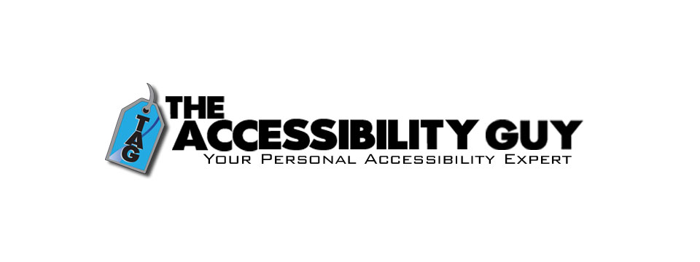
👉️ Classified Advertisement: How to Tag Multiple Languages in a PDF | The Accessibility Guy
More Adobe Acrobat accessibility tips!
My latest post explains how to properly tag individual language sections in a multilingual PDF. Adobe Acrobat offers tools to assign language codes to specific sections, allowing screen readers to interpret and vocalize the content accurately.
Check out The Accessibility Guy's full suite of Accessibility services.
Sponsor Since: August 3, 2023 📅️
Website: https://theaccessibilityguy.com/ 🌐️
YouTube: https://youtube.com/@TheAccessibilityGuy 📹
About: My name is Shawn Jordison and I love helping others learn the ins and outs of digital accessibility.
I have made over 100 thousand documents accessible, provided hundreds of trainings in the areas of accessibility and document remediation, and reviewed many websites and mobile applications for accessibility.
I have developed and reviewed VPATs, LMS courses, and other pieces of training. I am the accessibility Swiss army knife. Let me be your personal accessibility expert.
➜ Over 13 years of experience in the field of accessibility.
➜ Passionate about providing equal access to information for everyone.
➜ Wide range of project experience, including document accessibility, training, and more.
➜ Expertise in captioning, assistive technology, and accessibility best practices. I'm here to help you create a more accessible world.
The Blog: This blog covers topics like making Word, PDF & PowerPoint files accessible, Closed Captioning, assistive technology, and other important accessibility topics.
Training and Consulting: Offering customized training and consulting for implementing accessibility best practices.
Accessible Document Service: Providing top-tier document remediation services for all types of files, ensuring compliance with WCAG, 508, and PDF UA standards.

⬆︎ 9.) Sponsor: The Lighthouse for the Blind, Inc.

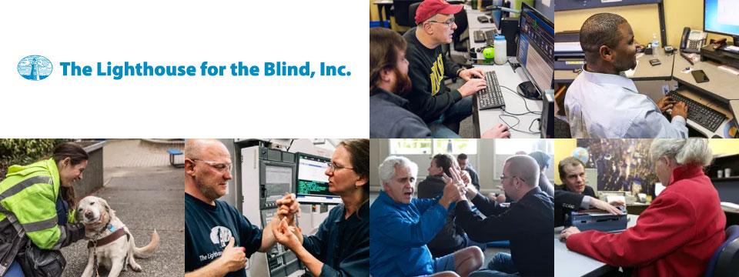
Sponsor Since: December 29, 2022 📅️
Website: https://lhblind.org/ 🌐️
Phone: (800) 914-7307 📱️
Fax: (206) 329-3397 ░
Contact Us: https://lhblind.org/contact-us/
About: The Lighthouse for the Blind, Inc. is a private, not-for-profit social enterprise providing employment, support, and training opportunities for people who are blind, deafblind, and blind with other disabilities. The Lighthouse has provided employment and support to people who are blind in our community since 1918.
The Lighthouse for the Blind, Inc. is a successful manufacturing organization with over 60 years of experience in precision machining. We produce an array of machined parts and plastic injection molding for various aerospace manufacturers, as well as a host of office products and hydration equipment sold to the Federal Government and the U.S. Military. We also own and operate stores on military bases along the West Coast. Our products and services include:
• Manufacturing: We are a successful manufacturing organization committed to making jobs accessible to individuals who are blind. Our manufacturing operations center on making quality products for the Federal Government under the AbilityOne Program and producing parts for aerospace manufacturers.
• Managed Services: The Lighthouse for the Blind, Inc. offers a variety of services to our commercial, federal, and military customers. These include Contract Management Support (CMS) services for government contracting offices.
• Base Supply Centers: We operate 12 AbilityOne Base Supply Centers (BSCs) that offer easy customer access to Lighthouse products, direct feedback and communication with customers, and employment opportunities for individuals who are blind in geographic areas not served by larger nonprofit agencies.

⬆︎ 8.) Sponsor: Wayaround

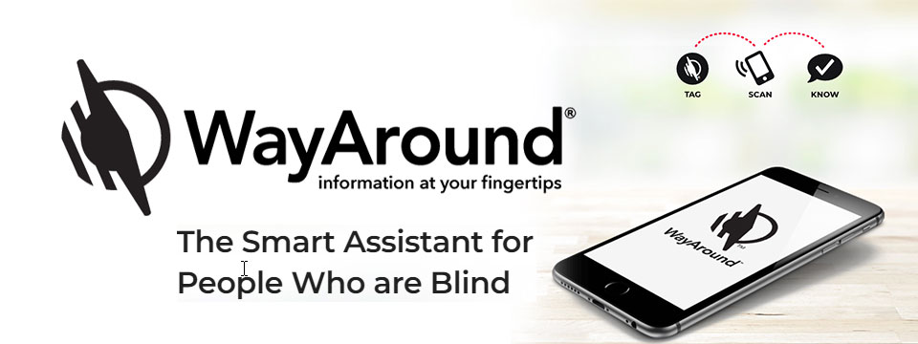
👉️ Classified Advertisement: FREE Sampler Pack with a Purchase of Any 25-pack of WayTags | Wayaround
WayAround is a smartphone-based labeling app that works with your preferred accessibility settings. You just need the free mobile app and some WayTags ® to label items in the kitchen, garden, closet, office & more.
If you want to label something that's inside, outside, wet, dry, hot, or cold, there's a WayTag that will attach securely. WayTags come as stickers, buttons, magnets, and clips. Each of the different styles of WayTags work exactly the same. Simply choose the WayTag that's best for what you want to label.
Purchase a 25-pack of any style of WayTag and get a free Sampler Pack so you can try all seven different WayTags. Enter the coupon code SAMPLE at checkout and the Sampler Pack will automatically be added to your cart. This is a $14.99 value! Limit one Sample pack per order.
Sponsor Since: January 5, 2023 📅️
Website: https://www.wayaround.com/ 🌐️
General Sales & Support: (888) 898-4465 📱️
Business Sales & Support: (888) 898-4465 📱️
Email: connect@wayaround.com 📧️
About: WayAround is the app for your smart device that provides on-demand details about everyday things. The simple tag-and-scan approach lets you quickly and easily identify things around you. It also provides extra details, like how something works or when it expires. The result? Doing more of the things you want, with more confidence and more independence.
All the information you want with just a tap of your phone. No more waiting around to ask someone. You need just two things to get started: The free mobile app for iOS or Android and some of our smart WayTags®.
Accessible labels for the blind, deafblind, and anyone with vision loss. Your biggest problem isn't poor eyesight. It's that so much of the information in the world is visual. But you shouldn't have to wait around for someone else to get the information you need. Or carry around a bulky, outdated device. There is a better way to get accurate and complete information every time. So you can reduce stress and gain independence.
Download The App (Apple): https://itunes.apple.com/us/app/wayaround-tag-and-scan/id1294361140?mt=8
Download The App (Android): https://play.google.com/store/apps/details?id=com.wayaround.wayaround

⬆︎ 7.) Sponsor: Aira

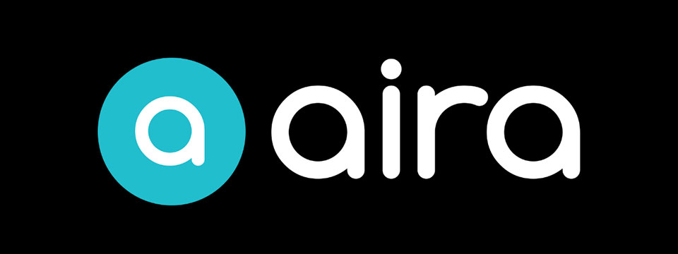
Sponsor Since: August 4, 2022 📅️
Website: https://aira.io/ 🌐️
Download the App: Apple App Store | Google Play Store
Plans and Pricing: https://aira.io/pricing/
Phone: NA: +1.800.835.1934 📱️ | AU: +1.800.765.096 📱️ | UK: +0.800.046.5668 📱️ | NZ: +1.800.425.451 📱️
Text Message: NA: +1.858.242.4457 📱️ | AU: +61.488.839.767 📱️ | UK: +44.149.320.2474 📱️
Email: support@aira.io 📧️
About: At Aira, we believe access to information is a human right. Aira breaks down accessibility barriers by providing on-demand video remote interpreting for both the blind and low-vision community, and the Deaf Community. People can download the Aira Explorer app or the Aira ASL app, and be instantly connected to a professional interpreter. Available 24/7/365, interpreters work with callers to facilitate more efficient communication and accomplish tasks together. Aira is proud to lead the way in delivering secure, on-demand, inclusive services that transform lives and open doors to new opportunities for all.
Contact Us | Access Partners | Plans and Pricing
Step One: Subscribe and Download. Pick the plan that lets you explore on your terms and on your time, sign up in a few minutes, and download the Aira app to your smartphone. Plans shown are for the United States, Canada, Australia, New Zealand and the United Kingdom. Add or cancel at any time.
Step Two: Connect with an Aira Agent. On the first call, connect with one of our certified, specially-trained Agents and learn how everything works.
Step Three: Real-time Assistance. At the touch of a button, Aira delivers instant access to visual information, when and where you want it.
Social: Twitter | Facebook | LinkedIn | YouTube | Instagram

⬆︎ 6.) Sponsor: Fable Tech Labs


👉️ Classified Advertisement: Learn Management Skills For Free. Get The Job You Want | Fable
Everyone deserves equal access to the internet which is why Fable works with people with disabilities who use assistive technologies like switch controls to improve the accessibility of websites and apps. Fable Pathways, a free, accessible, and on-demand skill-building program, is an extension of Fable's mission. Fable Pathways provides new opportunities for people with disabilities to gain the skills they need, from experts like Judy Heumann and Kelly Ford, to contribute to improving digital accessibility.
Sponsor Since: June 30, 2022 📅️
Website: https://makeitfable.com/ 🌐️
Email: community@makeitfable.com 📧️
About: Fable is an accessibility platform powered by people with disabilities, connecting them to accessibility managers, user researchers, designers, and developers to build accessible user experiences.
Opportunities:
➜ Accessibility Tester: Testers drive meaningful change in digital accessibility by sharing feedback on the websites and apps of the companies that care. As a Tester, earn a competitive tech industry wage, learn valuable transferrable skills, and grow your career. Fable is looking for assistive technology users in the US or Canada to work the hours that they want, completely from home. No experience or resume required.
➜ Survey Respondent: Survey Respondents enjoy a remote, low-commitment income opportunity, all while contributing to accessibility research. Surveys are typically sent out once a month, and you can earn $5 to $50 per survey. Apply today if you identify as having a disability and live in the US or Canada. You do not need to use assistive technology to apply.

⬆︎ 5.) Sponsor: SelvasBLV

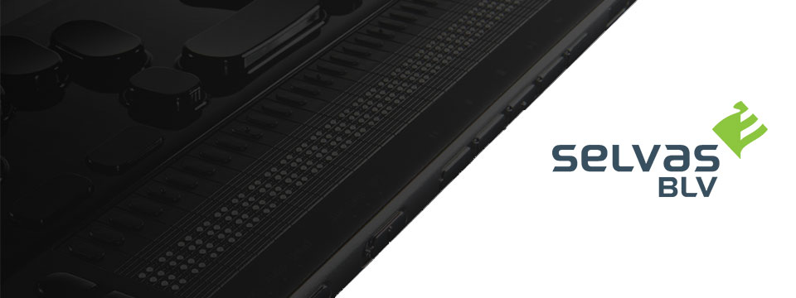
👉️ Classified Advertisement: Braillesense 6 And 6 Mini Firmware 3.0 Is Live!
We are very excited to announce the much-anticipated version 3.0 update for the BrailleSense 6 and BrailleSense 6 mini is now live! This major update delivers a redesigned Main Menu and Settings dialog, an enhanced Word Processor, a new Braille Practice app for teaching and learning Braille, the highly anticipated new Web Browser, and more.
Sponsor Since: September 30, 2021 📅️
Website: https://selvasblv.com/ 🌐️
Shop All Products: https://selvasblv.com/shop-all-products/ 🛒️
Phone: (512) 837-2000 📱️
YouTube: https://www.youtube.com/watch?v=5R9NjA1nfWo
Sales: sales@selvasblv.com 📧️
Support: support@selvasblv.com 📧️
About: SelvasBLV is a global manufacturer and distributor that has provided braille, magnification and accessible healthcare devices since 1999.

⬆︎ 4.) Sponsor: Carroll Center for the Blind


👉️ Classified Advertisement: Attend the Screen Reader User Tester Training Program at the Carroll Center for the Blind | Carroll Center for the Blind
Launch your career in the digital accessibility field! The Carroll Center for the Blind's new 7-week intensive Screen Reader User Tester Training program allows participants to learn and grow their ability to professionally explore, test, and report findings regarding the accessibility of websites, mobile applications, and digital document files using screen readers. Want to learn more? Start your journey to becoming a Screen Reader User Tester today.
Sponsor Since: August 5, 2021 📅️
Website: https://carroll.org/ 🌐️
Phone: (617) 969-6200 📱️
Fax: (617) 969-6204 ░️
Shop: https://carroll.org/store/ 🛒️
Donate: https://carroll.org/donate ❤️
Social: Facebook | Twitter | YouTube | LinkedIn | Instagram
About: The Carroll Center for the Blind is the foremost leader in vision rehabilitation services for individuals confronted by the challenges of vision loss. Our mission is to empower those who are blind or visually impaired to achieve independence and to lead a fulfilling life. Established in 1936, the renowned Carroll Center for the Blind has been serving those with vision impairment for over eight decades; we are known nationally as a premier Vision Rehabilitation Center. Located just outside of Boston on a sprawling campus in Newton, Massachusetts, we proudly serve ALL ages and ALL stages of vision loss. With the ongoing promise of improving the lives of people with vision-related problems, The Carroll Center for the Blind has pioneered many innovative services allowing people who are blind or have low vision to learn the skills to be independent in their homes, in class settings, and in their work places. Our services include vision rehabilitation, vocational and transition programs, assistive technology training, educational support, and recreation opportunities for individuals who are visually impaired of all ages. For over 80 years, the expertise of Carroll Center staff has provided help for thousands of blind and visually impaired persons with diverse opportunities for success and independent living.

⬆︎ 3.) Sponsor: Pneuma Solutions

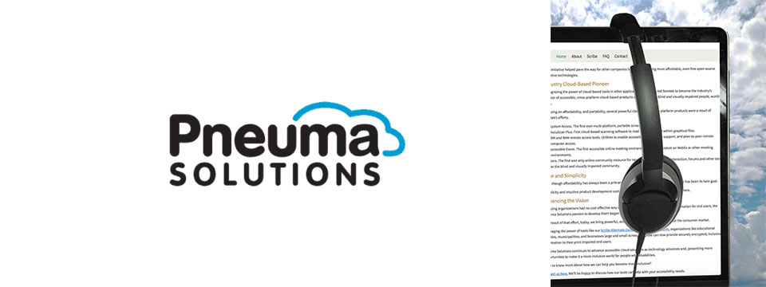
👉️ Classified Advertisement: Accessible Archive: Scalable, On-Demand Accessibility for Large Document Repositories | Pneuma Solutions
Organizations with large digital libraries, such as universities, government agencies, publishers, museums, and corporations, are under increasing pressure to provide accessible versions of their content to meet global disability and inclusion laws. But full-scale remediation of millions of documents is rarely practical or budget-friendly.
The Accessible Archive offers a scalable, just-in-time approach to document accessibility. Instead of converting every document in advance, this system makes archived content instantly available in accessible formats only when requested. The result is lower costs, faster deployment, and compliant, user-friendly output across a range of needs, including for blind, low-vision, and other print-impaired users. The Accessible Archive is designed to handle the scale and complexity of institutional digital libraries without requiring full pre-processing or re-engineering.
Sponsor Since: June 3, 2021 📅️
Website: https://pneumasolutions.com/ 🌐️
Email Newsletter: Click here to receive periodic news via email concerning Pneuma Solutions products for business, consumers and education.
Sales: (866) 202-0520 📱️
Support: (650) 249-1000 📱️
About: Backed by two decades of creating award-winning accessible cloud technologies for people with visual impairments, Pneuma Solutions is the global leader in accessible cloud-based solutions. Pneuma Solutions was founded by long-time accessibility developers Mike Calvo and Matt Campbell. For more information on their individual profiles, click on their respective bio pages. We're proud to be the first company to develop cloud-based accessibility at the network level. Our tools provide organizations, like yours, a way to deliver secure, accessible information right from your network or from our secure servers. You can provide your print disabled consumers, students, employees, and citizens with a multitude of accessible options. Additionally, we offer a suite of cloud-based applications to blind and print disabled consumers directly from our website. Our consumer products are designed to make the day-to-day lives of blind and print disabled individuals more accessible and simpler to manage. Access to information is not a privilege, it's a right. It's also your right to obtain affordable, accessible cloud solutions to serve your end user. When organizations like yours implement our tools, together we help make it a more inclusive world for people with disabilities. Want to know more about how we can help you become more inclusive?
Contact us here. We'll be happy to discuss how our tools can help with your accessibility needs.

⬆︎ 2.) Sponsor: Freedom Scientific

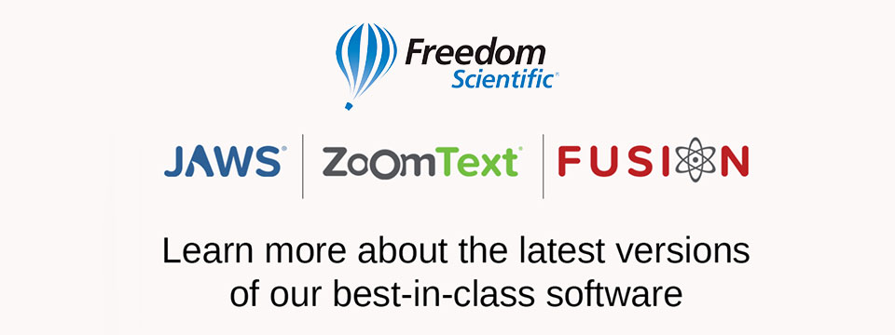
👉️ Classified Advertisement: Freedom Scientific Focus Blue 5th Generation Refreshable Braille Displays | Freedom Scientific
Our world-class refreshable Braille displays deliver efficient Braille input and outstanding output for your PC or mobile device. The robust Bluetooth® connectivity provides seamless use with Windows®, Mac®, iPhones®, iPads®, and Android TM smartphones and tablets. Ergonomic navigation features allow quick, natural hand movements for greater productivity. When used with JAWS® screen reading software, they support our popular Braille Study Mode, an interactive tool for teaching and learning Braille. Learn more today.
Sponsor Since: April 15, 2021 📅️
Website: https://www.freedomscientific.com/ 🌐️
Email: info@vispero.com 📧️
Phone: (800) 444-4443 📱️
Facebook | Twitter | YouTube (Training)
About: Freedom Scientific, a Vispero brand, is a leading worldwide brand of assistive technology products for those with vision impairments. We offer products designed to promote independence, allowing blind and low vision individuals the same access to information as their sighted peers. World-renowned JAWS (Job Access With Speech) screen reading software and ZoomText screen magnification software provide users the independence and ability to seek education and obtain or maintain a career after vision loss. Our expansive product line includes both low vision and blindness technology for all aspects of daily living. The wide range of RUBY, TOPAZ, and ONYX desktop and portable video magnifiers are designed for their ease of use and assist with daily activities. Our impressive line of blindness hardware products include refreshable Braille displays and scanning and reading devices, offering many options tailored to fit individual needs.

⬆︎ 1.) Sponsor: A. T. Guys

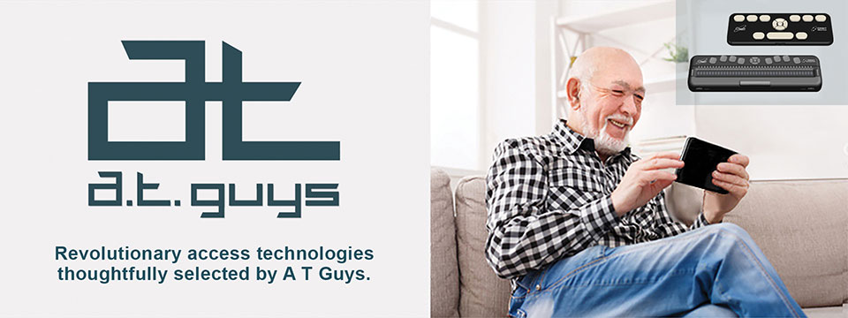
👉️ Classified Advertisement: Pluggable USB-C 7-in-1 Hub | A. T. Guys
If you're like me, you probably have more things to plug into your computer than available ports. That's why we've now added the Pluggable USB-C 7-in-1 Hub. Plug it into your laptop and you will get 3 USB ports, SD and Micro SD card slots, a USBC charging port, and an HDMI video port. It's available now for just $29.95.
Sponsor Since: June 11, 2020 📅️
Website: https://www.atguys.com/ 🌐️
Phone: (269) 216-4798 📱️
Email: support@atguys.com 📧️
Skype: atguys 💬️
X (Formerly Twitter): https://twitter.com/atguys (@atguys) 💬️
Facebook: https://facebook.com/atguys 💬️
About: ATGuys.com. Your access technology experts, home for cool gadgets, accessories, and more. Our products are all tested to work great for blind and visually impaired users but also work just as well for anyone. If there's an item you're looking for, or if you have a question, please don't hesitate to send us a message or call (269) 216-4798 📱️.

⬆︎ 19.) Sponsor: ConnectAlt
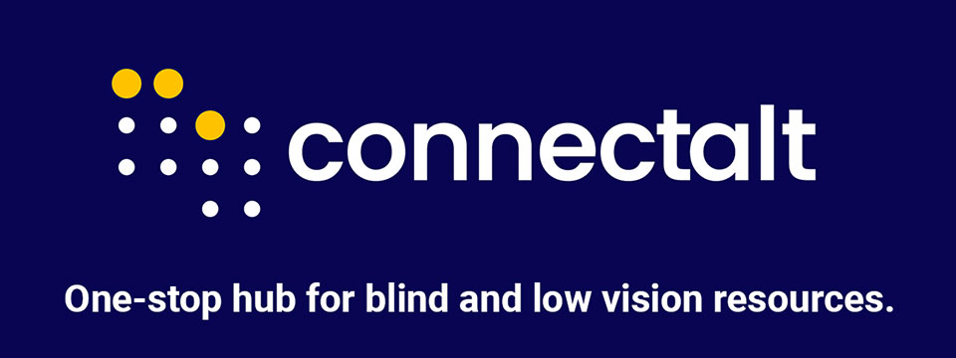

👉️ Classified Advertisement: Connect Alt: Free Accessible Calendar for the BLV Community
Stay connected with Connect Alt, the free, one-stop accessible calendar created by and for the Blind & Low Vision (BLV) community. Find events, programs, and opportunities all in one place — always easy to access and free to use.
Subscribe today and start exploring what's happening in the BLV community!

Sponsor Since: September 25, 2025 📅️
Website: https://connectalt.com/ 🌐️
About: ConnectAlt is a free, accessible hub that centralizes events, programs, and resources for the blind and low-vision (BLV) community. Built by creator/co-founder Lucie Courtois (who is blind) with Carol Trapani and Ella Deshautreaux, ConnectAlt solves the discovery problem by making it easy to find what's happening by date, topic, organization, and location including virtual offerings. The team is active across BLV networks and national convenings (e.g., exhibitor at NFB 2025) and partners with nonprofits, service providers, and assistive-tech leaders to help people quickly connect with opportunities that improve daily life, education, mobility, and employment.
Sponsoring ConnectAlt aligns your brand with tangible access and inclusion while reaching an engaged audience of BLV individuals and families, educators, VR counselors, nonprofits, employers, and assistive-tech users. Packages can include high-visibility placement alongside relevant listings and resources, partner spotlights, community giveaways, and event activations around key gatherings such as the Blind Travel Summit (Austin, Nov 13-14, 2025) — all while keeping the core platform free to users. Let's tailor a sponsorship that advances your goals and measurably expands access for the BLV community.
Social: Follow us on Instagram.

⬆︎ 18.) Sponsor: Double Tap

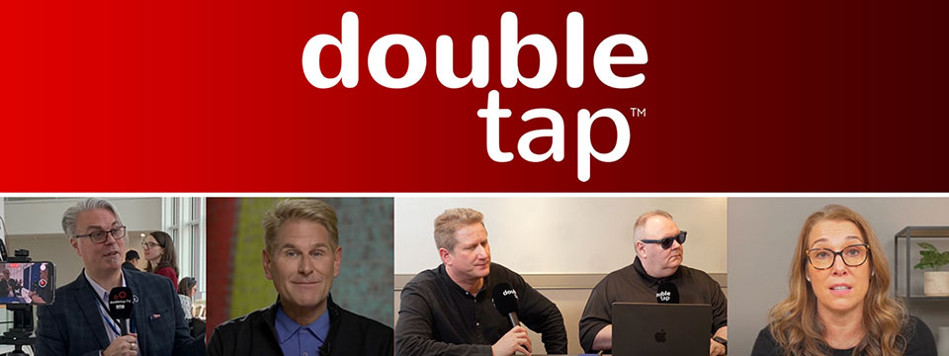

Sponsor Since: March 15, 2025 📅️
Website: https://doubletaponair.com/ 🌐️
About: Founded in 2017 as “Double Tap Canada” on AMI-audio, Double Tap has grown into a weekday podcast, radio show and YouTube series whose tagline proudly declares it "The Podcast Where Blind People Talk Tech." Its Glasgow-based creator Steven Scott, Manchester-based producer-co-host Shaun Preece and Canadian executive producer Marc Aflalo now helm more than 600 episodes that drop every weekday at noon ET, alongside written articles and video clips on DoubleTapOnAir.com.
Each episode blends mainstream gadget news with deep dives into assistive tools, all filtered through the lived experience of blind hosts. Listener emails, voicemails and WhatsApp messages are woven into the conversation, while spin-offs such as Shaun of the Shed (beginner tutorials) and past TV projects like Access Tech Live extend the brand across platforms in partnership with Accessible Media Inc. The result is a vibrant, multi-platform ecosystem that reaches audiences via AMI-audio, every major podcast app, YouTube and even specialist players like the Victor Reader Stream.
The community's enthusiasm shows: Double Tap recently surpassed one million cumulative downloads and, in March 2025 alone, attracted nearly 27K listeners generating 38K downloads; Apple Podcasts users rate it around 4.8 / 5. Authentic insights, daily consistency and professional production continue to position Double Tap as an essential, trusted voice at the intersection of mainstream tech and accessibility.
Newsletter (Double Tap Digest) | Facebook | Instagram | LinkedIn | TikTok | X (Formerly Twitter) | YouTube

⬆︎ 17.) Sponsor: Awarewolf Gear

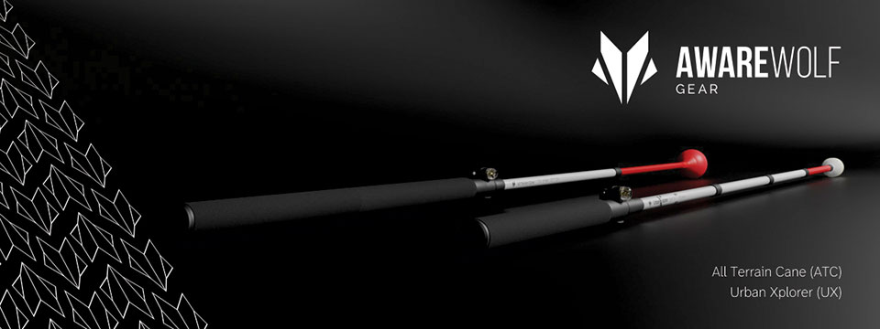

Sponsor Since: February 28, 2025 📅️
Website: https://awarewolfgear.com/ 🌐️
About: Awarewolf Gear is built on innovation, resilience, and a passion for adventure — especially for those in the blind and low vision community.
Awarewolf Gear is dedicated to redefining mobility through high-performance, thoughtfully engineered canes.
With the core belief that everyone deserves to explore confidently, our mission is encapsulated in our tagline, "Power for Life's Adventure."
Our product line, community initiatives, and inspirational storytelling all work in tandem to empower users to navigate diverse terrains with ease and independence.
Product Line
⚫️ All Terrain Cane (ATC)
Design & Purpose: The All Terrain Cane was originally engineered for the rugged trails of Sedona, Arizona. Made from durable titanium alloy, it is built to handle everything from sandy beaches to rocky mountain paths. Its adjustable 16-inch handle and high-performance roller ball tip provide stability and versatility across varied surfaces.
⚫️ Urban Xplorer Cane (UX)
Innovation & Versatility: Merging the rugged design of the ATC with enhancements for urban mobility, the Urban Xplorer Cane features an adjustable handle and a specially designed "Dome" cane tip. Available in multiple sizes (small, medium, large and extra-large), this lightweight, robust cane is ideal for navigating busy city streets as well as more challenging environments.
⚫️ Cane Tips
Customization & Performance: Awarewolf Gear's Cane Tips are designed to elevate your mobility experience by ensuring smooth, reliable navigation across all terrains. Crafted for both durability and style, these premium replacement tips allow users to personalize their canes while enhancing performance.
⚫️ Accessories and Apparel
Customization & Expression: Beyond canes, Awarewolf Gear offers a range of accessories — such as colorful replacement cane tips designed for visibility and personal expression — and apparel that carry the brand's adventurous spirit.
Instagram | Facebook | LinkedIn | YouTube

⬆︎ 16.) Sponsor: Vision Tech Academy

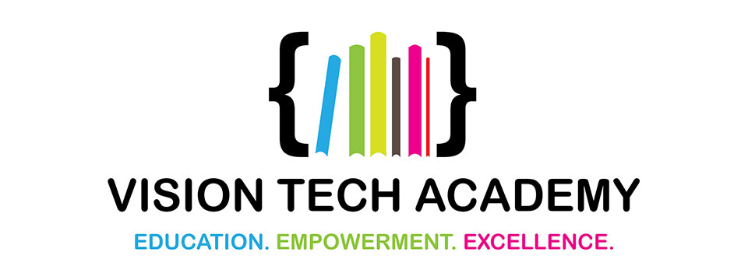

Sponsor Since: January 15, 2025 📅️
Website: https://visiontechacademy.com/ 🌐️
About: Vision Tech Academy is a website, platform and online directory dedicated to empowering blind and low-vision individuals by connecting them with trusted assistive technology educators for free.
Vision Tech Academy is the home of the free, access-technology specific, Online Directory of Educators (ODE).
Inspired by the legacy of John Panarese, the Academy website serves as a hub for accessible learning, offering a free directory of access educators, live and recorded courses, and resources to foster learning independence and success.
With an ongoing mission to provide high-quality, trusted, personalized training on tools like VoiceOver, JAWS, NVDA and Braille technology, Vision Tech Academy bridges the gap between technology and accessibility, ensuring inclusive and accessible education for all.
📖️ Free Directory for Students
📖️ Free General Profiles for All Access Educators
🏅️ Premium Profiles for Access Educators Who Want More Reach

⬆︎ 15.) Sponsor: Elegant Insights Braille Creations

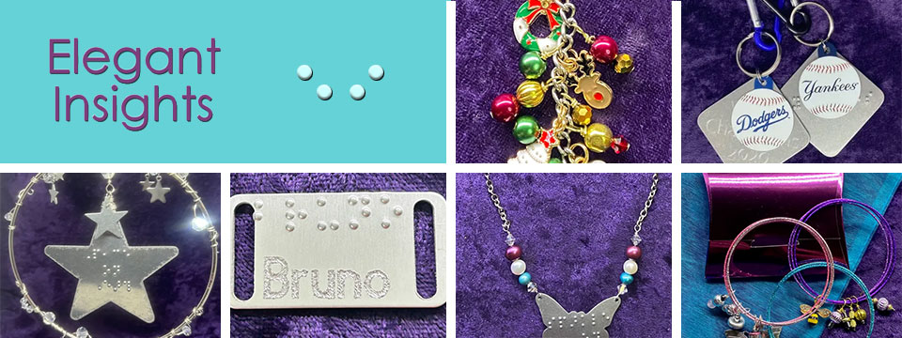
👉️ Classified Advertisement: Join Us For The 10th Edition Of Let's Go Shopping!
Are you an entrepreneur with a disability? Home based business owner? Sole proprietor? A crafter or an artist selling your work? Can you rock an awesome sales pitch? Become a vendor for the 2025 Let's Go Shopping holiday gift extravaganza, set for Saturday, November 1st and Saturday, November 8th. Let's Go Shopping is an online, accessible, virtual mall crawl that connects small businesses with the customers who need them. Discover fashion and fragrance, tech gadgets and small electronics, pet supplies, home decor, jewelry and accessories, and much more. To join the event as a vendor, start at the Let's Go Shopping info page:
https://accessibleinsights.info/blog/lets-go-shopping/
To be added to our Let's Go Shopping groups list for announcements, promotions, coupon codes, the vendor directory and a complete schedule of events, send a blank email to lgs+subscribe@groups.io 📧️ and you will receive all the exciting LGS10 details. For more info, call Laura at +1 (702) 605-1265 📱️.
x (Formerly Twitter) | Facebook | Instagram

Sponsor Since: November 22, 2024 📅️
Website: https://elegantinsightsjewelry.com/ 🌐️
About: Elegant Insights Braille Creations, founded by Laura Legendary, offers a distinctive collection of handcrafted jewelry and accessories embossed with crisp, readable braille.
Inspired by a personal experience, Laura, who is blind, established the brand to merge style with accessibility, providing beautiful and inclusive products. Each piece is made in the USA and can often be personalized or custom-designed to meet individual preferences.
Beyond her work with Elegant Insights, Laura co-founded The Fashionability Channel podcast, which provides beauty, fashion, and lifestyle information for people with disabilities. She also maintains two blogs: the Accessible Insights Blog, offering information on products and services for individuals with low or no vision, and the Sparkle On Blog, which provides jewelry education, design trends, and style information.
Laura's dedication to accessibility and advocacy extends to her role as a speaker, author, and educator specializing in these areas. Her multifaceted efforts aim to empower individuals with disabilities, ensuring they have access to stylish, functional, and meaningful products and information.
Home | About Elegant Insights | Ordering, Shipping and FAQs | My Account | Checkout | Cart | Shop The Boutique | Wish List | Testimonials | Subscribe

⬆︎ 14.) Sponsor: Florida Vision Technology

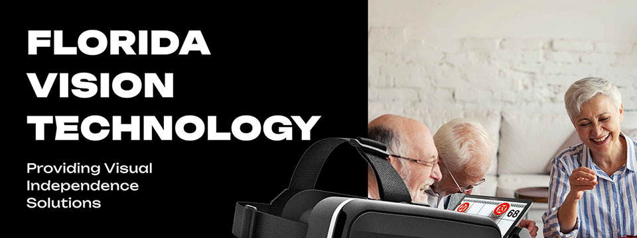

Sponsor Since: October 13, 2024 📅️
Website: https://floridareading.com/ 🌐️
About: Florida Vision Technology is officially celebrating its 20th anniversary. When I started in February 2000, the assistive technology industry was young, and there were just a handful of manufacturers.
Opening the business felt right, and I was ready to jump in. The biggest challenge, in the beginning, was getting a used bulky desk into the shed in my backyard, which my daughters named "Lesa Berg Kretschmer World Headquarters."
Three years later, in June of 2003, we moved into our first offsite location and opened a low vision superstore!
Home | Shop | Blogs | About Us | Contact Us

⬆︎ 13.) Sponsor: Access Park

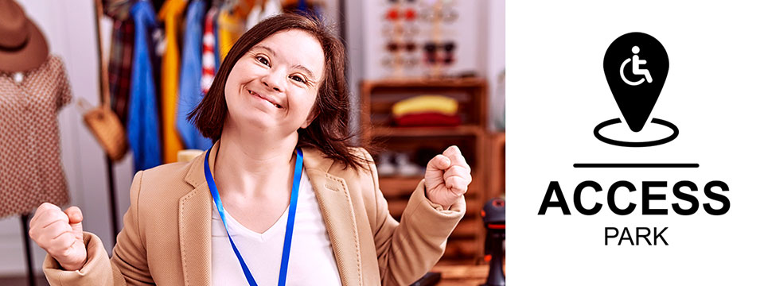
👉️ Classified Advertisement: Donna J. Jodhan's Pottery - Piece By Piece! Building Blocks For Inspiration And Creation! | Access Park
My pottery pieces are designed to inspire your creativity and imagination! Each piece is crafted with care, offering a unique touch to your home and dining experience. Whether you're looking for elegant dinnerware, functional art, or custom pieces, I can help you bring your vision to life. From rustic charm to modern elegance, I specialize in creating pottery that fits your personal style and elevates your dining table. Let me customize a one-of-a-kind creation that reflects your taste and enhances your space, adding beauty and warmth to every meal. And check out the highlight of the month.
A Perspective from World-Renowned Advocate Donna J. Jodhan - How Some Canadian Government Departments Are Using Work Arounds

Sponsor Since: September 20, 2024 📅️
Website: https://accesspark.shop 🌐️
About: Access Park is your premier destination for accessible shopping.
At Access Park, we offer a curated selection of products aimed at enhancing the daily lives of persons with disabilities.
Whether you're looking for accessible tech gadgets, specialty assistive devices, or just everyday essentials, you'll find them here.
Access Park provides a shopping experience that prioritizes keyboard navigability, screen reader compatibility, and high-contrast visuals for those with visual impairments, in addition to other enhancements that provide an elevated shopping experience to users of various assistive technologies.
Access Park. Where inclusivity is always in stock. ^{(TM)}

⬆︎ 12.) Sponsor: The Apex Program

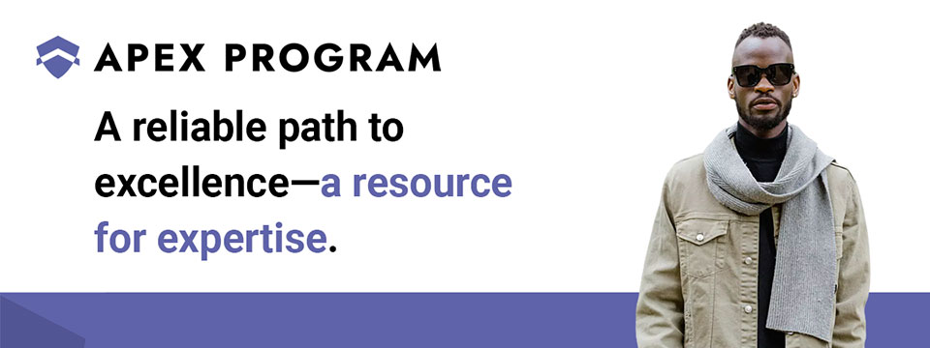
👉️ Classified Advertisement: Jumpstart Your Cybersecurity Career with the Apex Program! | The Apex Program
Are you ready to advance your career in cybersecurity? The Apex Program offers a comprehensive 12-week training course designed to prepare you for the CompTIA Network+ and Security+ certification exams. Tailored for the blind, visually impaired, disabled, and veteran communities, our program combines informative lectures, video tutorials, and quizzes, with expert instructor support every step of the way.
Get started today — Classes start on the first Monday of every month!
Don't miss this opportunity to join a diverse and inclusive workforce in the cybersecurity sector. Visit https://TheApexProgram.com to learn more and secure your spot today!
Sponsor Since: July 16, 2024 📅️
Website: https://theapexprogram.com 🌐️
About: Unlocking Abilities, Securing Futures. Founded on the principles of inclusivity and opportunity, the Apex Program is a pioneering educational initiative in cybersecurity, tailored for the blind, visually impaired, disabled, and veteran communities. Created by a Novacoast employee and inspired by his own journey from disability to Security Operations Center manager, the curriculum is designed to create a strong foundation of IT security knowledge, while instilling confidence and ensuring competence in the IT talent pool. Our ten-week program culminates in industry-recognized CompTIA certifications and a guaranteed pathway to employment, courtesy of Novacoast's dedicated IT Staffing division. At Apex, we don't just teach cybersecurity; we transform lives by unlocking potential and advocating for diversity in the IT security workforce.
Mission: The Apex Program is committed to bridging the gap in cybersecurity talent by empowering the blind, visually impaired, disabled, and veteran communities through inclusive, accessible, and comprehensive training. Our mission is to nurture a diverse workforce equipped with the necessary IT security skills and certifications to thrive in the cybersecurity sector. In partnership with Novacoast, we ensure a solid educational foundation and job placement in the industry, further fostering a future where every individual can focus their distinct abilities on building a more secure digital world.
Novacoast: Novacoast is a cybersecurity and IT services company that helps organizations enhance their security posture. They offer a range of services, including cybersecurity advisory, security engineering, identity and access management, development and integration, penetration testing, managed security services, and incident response. Their managed services include co-managed SIEM, DLP, EDR, vulnerability and patch management, phishing monitoring, and threat operations. Novacoast also provides specialized services for different industries such as finance, healthcare, and gaming. Additionally, they offer staffing solutions and training programs. Learn more today.
Home | A Division of Novacoast | Novacoast Federal | The Program | About Us | Partnerships | Media | Contact

⬆︎ 11.) Sponsor: Innosearch.ai

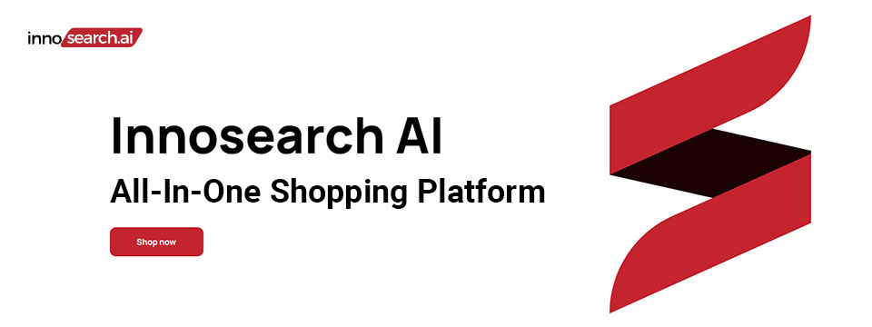
👉️ Classified Advertisement: Shop by Phone — No Screens, Just Your Voice!
Call 1-855-SHOP-GPT (1-855-746-7478)
Shopping online can be hard if you're blind, visually impaired, or not tech-savvy. That's why Innosearch AI created Shop by Phone — a 100% free, voice-only service.
Just call and say what you need:
👉 “Find me a phone charger.”
👉 “Add it to my cart.”
👉 “Check out.”
No apps, no websites — just easy, hands-free shopping from over 500,000 stores.
- ✔ Free to use
- ✔ Works anywhere, anytime
- ✔ Perfect for seniors, blind, and low-vision users
Available in:
- 🇬🇧 UK: +44 7727 247467 📱️
- 🇨🇦 Canada: +1 782 222 7467 📱️
- 🇦🇺 Australia: +61 489 267 467 📱️
- 🇺🇸 USA: 1-855-SHOP-GPT 📱️ (1-855-746-7478 📱️)
Call now and shop with ease!
Sponsor Since: June 7, 2024 📅️
Website: https://www.innosearch.ai 🌐️
Email: info@innosearch.ai 📧️
About: Innosearch is an all-in-one shopping platform augmented with a cutting-edge AI-powered shopping assistant. This innovative feature mimics the experience of shopping in real life by allowing you to interact with the assistant using natural language. It aggregates millions of products from top US online retailers, bringing them directly to you. With this advanced generative AI, Innosearch offers personalized product recommendations, highlights the best deals, and provides comprehensive information including reviews, total prices, shipping options, and more. Innosearch delivers a seamless end-to-end shopping experience, eliminating the need to search and browse in multiple tabs across retailers.
YouTube Review By Sam Seavey: https://youtube.com/watch?v=-rjL-HAwaZY.
Key Features: Key Features of the Innosearch All-in-One AI Shopping Platform include:
➜ Research Products: Easily compare products across retailers, or weigh pros and cons of similar products to make informed decisions.
➜ Uncover the Best Deals: Never miss a door buster, coupon, or clearance sale again. Get notified about the best prices and offers.
➜ AI Summarized Trusted Reviews: See what others are saying and make confident purchases.
➜ All in One: Innosearch brings millions of products from top online retailers directly to you, allowing you to shop the best deals with easy checkout and personalized AI assistance.
➜ Shop with Confidence: Rest assured, Innosearch has you covered with free shipping and returns on every purchase.
➜ Know Before You Buy: Innosearch equips you with expert buying guides, empowering you to make well-informed decisions.
How To Shop: Simply create a free account and start shopping today!

⬆︎ 19.) Sponsor: Your Name Here

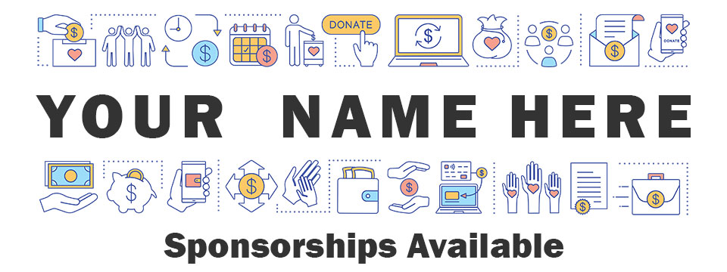
Purchase: Sponsorship Package 💸️ (Packages currently available.)
Join: Waiting List 📋️ (When there are no sponsorship packages available.)
Sponsor Since: Today 📅️
Website: https://toptechtidbits.com/sponsor 🌐️
Phone: (855) 578-6660 📱️
Email: enews@toptechtidbits.com 📧️
About: Founded in 2004, Top Tech Tidbits is the world's leading not-for-profit access technology publication that reaches over 42,000 blind, low vision, deaf, hard of hearing, deafblind, neurodivergent and/or disabled professionals, educators and enthusiasts, all over the world, each week. Subscribe here. Review the most recent issues here.

Top Tech Tidbits Supporters 🤝️
We couldn't do it without you! Thank you for your support!
Why: Top Tech Tidbits Supporters donate an amount of their choosing either one time or annually in order to assist with the ongoing distribution of the Top Tech Tidbits publication.
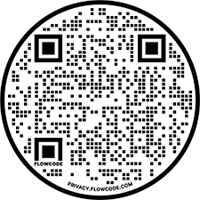
Benefits: All Top Tech Tidbits Supporters receive a listing within the "Our Supporters" section of each weekly newsletter, as well as a listing within the "Our Supporters" section of the Top Tech Tidbits website.
In addition, all Top Tech Tidbits Supporters automatically become Premium Subscribers as well, and therefore enjoy all of the benefits that a Premium Subscription has to offer.
One Time Donation: If you would like to become a Top Tech Tidbits Supporter by making a one time donation in an amount of your choosing to assist with the ongoing distribution of the Top Tech Tidbits publication, you may utilize this donate link, or scan the QR code to the right.
Annual Donation: If you would like to become a Top Tech Tidbits Supporter by making a small donation to assist with the ongoing distribution of the Top Tech Tidbits publication, we also offer the following options, all with our sincerest thanks, and most heartfelt gratitude for your ongoing support.
Support: In tandem with Our Sponsors, these are the people that make the ongoing distribution of Top Tech Tidbits possible.

Platinum Supporters:

Become a Top Tech Tidbits Platinum Supporter today.
1.) Gary Lee
Platinum Supporter since June 25, 2020
2.) Anonymous Donation
Platinum Supporter since July 9, 2020
3.) Pshon Barrett
Platinum Supporter since January 28, 2021
4.) Robin Millar
Platinum Supporter since April 6, 2023

Gold Supporters:

Become a Top Tech Tidbits Gold Supporter today.
1.) Howard Goldstein
Gold Supporter since June 4, 2020
2.) David Goldstein
Gold Supporter since June 12, 2020
3.) Katherine Crohan
Gold Supporter since January 14, 2021
4.) Neil Jarvis
Gold Supporter since April 28, 2022

Silver Supporters:

Become a Top Tech Tidbits Silver Supporter today.
1.) Timothy Gorbold
Silver Supporter since July 19, 2023
2.) Vojtech Polasek
Silver Supporter since December 29, 2023

Bronze Supporters:

Become a Top Tech Tidbits Bronze Supporter today.
1.) Steven Wettlaufer
Bronze Supporter since July 16, 2020
2.) Lions Clubs International
Bronze Supporter since July 13, 2020

One Time Supporters:
One Time Supporters donate an amount of their choosing — one time to assist with the ongoing distribution of the Top Tech Tidbits Publication.
Become a Top Tech Tidbits One Time Supporter today.
1.) Dane Trethowan
One Time Supporter on September 25, 2025
2.) Beth Wright
One Time Supporter on November 28, 2023
3.) Your name here.
One Time Supporter on ...

Top Tech Tidbits News Team 🗞️

Distribution: Sponsors, Supporters, Advertisers and Mind Vault Solutions, Ltd.

Distribution Since: 2004
As of June 4, 2020 the distribution of Top Tech Tidbits is made possible by our Sponsors, our Supporters, our Advertisers and Mind Vault Solutions, Ltd., a leading international provider of professionally outsourced marketing administration and consultation services.
Any time the Top Tech Tidbits Publication carries less than its Sponsor limit, Mind Vault Solutions, Ltd. donates the remaining dollars necessary to keep the publication running.
Please help us to support the ongoing distribution of this publication. Learn more about the benefits of Sponsorship today.

Publisher: Aaron Di Blasi

Publisher Since: June 4, 2020
Location: Cleveland, Ohio
Time Zone: Eastern Standard Time (EST/EDT) (GMT-5/GMT-4)
In addition to serving as Publisher for Top Tech Tidbits Aaron also serves as Publisher for the Access Information News and AI-Weekly newsletters, PR-Director for the AT-Newswire Press Release News Distribution Service, and President and Senior Project Management Professional for Mind Vault Solutions, Ltd.
As Publisher Aaron oversees the weekly distribution of Top Tech Tidbits on behalf of Mind Vault Solutions, Ltd.
Aaron Di Blasi, PMP
Email: publisher@toptechtidbits.com 📧️
Toll Free: +1 (855) 578-6660 📱️
PR Director (2024-Present)
AT-Newswire 🌐
Access Technology's Digital Newswire
Publisher (2024-Present)
AI-Weekly 🌐
The Week's News in Artificial Intelligence
Publisher (2022-Present)
Access Information News 🌐
The Week's News in Access Information
Publisher (2020-Present)
Top Tech Tidbits 🌐
The Week's News in Access Technology
Sr. Project Management Professional (2006 - Present)
Mind Vault Solutions, Ltd. 🌐
Innovative ideas. Solutions that perform.
Certified:
Digital Marketing Associate
Meta Certified (2022 - Present)
Social Marketing Professional
Hootsuite Certified (2020 - Present)
Email Marketing Professional
Constant Contact Certified (2019 - Present)
Specializing in:
Digital Strategy and Content Marketing
Social Media Advertising
Online Fundraising
ADA, WCAG and Section 508 Compliance

Editor: John Hanlin

Editor Since: June 4, 2020
Location: Boulder, Colorado
Time Zone: Mountain Standard Time (MST/MDT) (GMT-7/GMT-6)
In addition to serving as an Editor to Top Tech Tidbits John also serves as an Editor to the Access Information News and AI-Weekly newsletters and is also an attorney-at-law specializing in long-term disability claims for persons who are blind or low-vision.
John is also a long-time contractor and member of the Board of Trustees at Mind Vault Solutions, Ltd.
John Hanlin, Esq.
Editor (2024-Present)
AI-Weekly 🌐
The Week's News in Artificial Intelligence
Editor (2022-Present)
Access Information News 🌐
The Week's News in Access Information
Editor (2020-Present)
Top Tech Tidbits 🌐
The Week's News in Access Technology
Board of Trustees (2006 - Present)
Mind Vault Solutions, Ltd. 🌐
Innovative ideas. Solutions that perform.

Editor: Jenna Lang

Editor Since: June 4, 2020
Location: Des Moines, Iowa
Time Zone: Central Standard Time (CST/CDT) (GMT-6/GMT-5)
In addition to serving as an Editor to Top Tech Tidbits Jenna also serves as an Editor to the Access Information News and AI-Weekly newsletters and runs her own advocacy foundation.
Jenna also serves as a certified Project Management Professional (PMP) for Mind Vault Solutions, Ltd.
Jenna's son was born blind and she is always seeking new and innovative ways to empower him through technology.
Jenna Lang, PMP
Editor (2024-Present)
AI-Weekly 🌐
The Week's News in Artificial Intelligence
Editor (2022-Present)
Access Information News 🌐
The Week's News in Access Information
Project Management Professional (2022 - Present)
Mind Vault Solutions, Ltd. 🌐
Innovative ideas. Solutions that perform.
Editor (2020-Present)
Top Tech Tidbits 🌐
The Week's News in Access Technology

Editor: Stephen (Alex) Marositz

Editor Since: October 7, 2021
Location: Los Angeles, California
Time Zone: Pacific Standard Time (PST/PDT) (GMT-6/GMT-7)
In addition to serving as an Editor to Top Tech Tidbits Alex is also the Accessible Technology Coordinator for California State University, Dominguez Hills. He has worked in accessibility in higher education since 2005, is certified by the International Association of Accessibility Professionals, and in his spare time plays for the San Gabriel Valley Panthers Beep Baseball Team. He can be reached on twitter at: @samarositz.
Stephen (Alex) Marositz
Editor (2021-Present)
Top Tech Tidbits 🌐
The Week's News in Access Technology
Accessible Technology Coordinator
California State University, Dominguez Hills 🌐

Editor: Ben Moxey

Editor Since: January 1, 2022
Location: Newcastle, Australia
Time Zone: Australia Eastern Standard Time (AEST/AEDT) (GMT+10)
In addition to serving as an Editor to Top Tech Tidbits Ben is also an Access and Technology Advisor for Guide Dogs, New South Wales, Australian Capital Territory (NSW/ACT).
Hi, Tidbits readers, my name's Ben Moxey and I'm based in Newcastle, Australia. I'm really happy to be part of the Tidbits Team and look forward to supporting this valuable publication.
A bit about me and how I came to work in the BVI area. I grew up with very low vision in one eye due to retinal issues and relied on magnification and speech throughout school. They also tried to teach me Braille, but let's just say that I wasn't the best student! I was determined to use my remaining vision, no matter how impractical it was becoming.
When I was 20, the other retina came off and I've now been totally blind for about 21 years. This is when my love for assistive technology, and technology in general, really kicked in. I'll be honest, I was a bit of a computer nerd anyway, but I could quickly see how technology was my key to enhanced independence and lifestyle. I embraced screen readers, early smart phones and mobility aids. I even finally realised the huge value of Braille and finished off the course, though I'm still pretty slow!
Long story short (not one of my strong points), I've worked in the BVI area for 12 years with much of that spent reviewing, recommending and teaching assistive technology that suits the individual. I'm currently a proud employee of Guide Dogs NSW/ACT where I was the Practice Lead for the assistive technology service, and I've now moved into an Access and Technology Advisor role. Basically, this involves a strong focus on accessibility and technology innovation.
Feel free to look me up on LinkedIn, but I'll warn you in advance that I haven't given my profile the recommended attention!
All the best and happy reading!
Ben Moxey
Editor (2022-Present)
Top Tech Tidbits 🌐
The Week's News in Access Technology
Access and Technology Advisor
Guide Dogs, New South Wales, Australian Capital Territory (NSW/ACT) 🌐

Editor: David Woodbridge

Editor Since: February 6, 2023
Location: Central Coast, New South Wales, Australia
Time Zone: Australia Eastern Standard Time (AEST/AEDT) (GMT+10)
In addition to serving as an Editor to Top Tech Tidbits David also serves as an Editor to the Access Information News publication and is also the National Commercial Assistive Technology Advisor for Vision Australia where he has worked since 1990. Over this time he has assisted people who are blind or vision impaired in their home, education, and work settings to take advantage of the benefits of using assistive and main stream technology.
In the last seventeen years, he has also been involved with evaluating technology for use by people who are blind or vision impaired covering both low and high tech equipment (including Microsoft, Samsung, Google, Amazon, and Apple). David is also one of the key spokespersons for Vision Australia relating to technology.
He has been an Apple Ambassador for Apple Australia since 2009 with a group of other Ambassadors / Apple Distinguished Educators (ADE)'s covering the range of Apple's Accessibility solutions throughout Australia.
David produces a range of podcasts (since 2011) covering Apple and other technologies which are distributed on his own podcast (http://davidwoodbr.podbean.com). In addition, he also has a regular Talking Tech program (since 2013) which can be heard every Tuesday at 4:30 Eastern Summer Time on Vision Australia Radio Melbourne (available online) or via https://omny.fm/shows/talking-tech-vision-australia-radio
David also runs a weekly Tech Monday where people can chat about assistive and main stream technology, share information, and any tips and tricks.
David lost his sight when he was 8 years old and had to learn Braille. Since then, he completed high school, went to Sydney University receiving a Social Work degree, spent 4 years drug and alcohol counselling, and then moved into his current job.
As a person who is blind, David believes that as a user of the technology that he recommends to others, that he is well situated to look at the strengths and shortcomings of the assistive technology that he comes across in both his professional and personal life, in particular, mainstream technology that is accessible.
In addition to his weekly contributions to Top Tech Tidbits and Access Information News, David's regularly occurring activities are his weekly tech radio show, bi-monthly exploring tech webinars for Vision Australia, his iSee podcast when something of note grabs his attention, and the weekly Tech Monday chat sessions.
David Woodbridge
X (Formerly Twitter): @dwoodbridge
Mastodon: woody@dragonscave.space
iSee Podcast: https://davidwoodbr.podbean.com
Vision Australia Radio Talking Tech: https://omny.fm/shows/talking-tech-vision-australia-radio
Editor (2023-Present)
Top Tech Tidbits 🌐
The Week's News in Access Technology
Editor (2023-Present)
Access Information News 🌐
The Week's News in Access Information
National Commercial Assistive Technology Advisor
(1990 - Present)
Vision Australia 🌐
Live the life you choose. We're here to support all Australians who are blind or have low vision.

Editor: Vicki Walton

Editor Since: January 9, 2024
Location: Benton City, WA
Time Zone: Pacific Standard Time (PST/PDT) (GMT-6/GMT-7)
IIn addition to serving as an Editor to Top Tech Tidbits Vicki also serves as an Editor to the Access Information News publication and works as a Web Accessibility Specialist / IT Quality Assurance Tester at Washington State Board for Community and Technical Colleges.
Vicki Walton
Editor (2024-Present)
Top Tech Tidbits 🌐
The Week's News in Access Technology
Editor (2024-Present)
Access Information News 🌐
The Week's News in Access Information
Web Accessibility Specialist / IT Quality Assurance Tester
Washington State Board for Community and Technical Colleges 🌐
Better Jobs, Brighter Futures, a Stronger Washington

Subscription Information 📰️
ABOUT ♿️
Founded in 2004, Top Tech Tidbits is the world's leading not-for-profit access technology publication that reaches over 42,000 blind, low vision, deaf, hard of hearing, deafblind, neurodivergent and/or disabled professionals, educators and enthusiasts, all over the world, each week. Subscribe here. Review the most recent issues here. Access Technology broadly encompasses technologies that enable access to information and communication systems for persons with disabilities. Adaptive Technology is a subset of Access Technology designed to assist individuals in performing tasks that might otherwise be challenging due to their particular disabilities. Assistive Technology includes any device, software, or equipment that helps people work around their challenges. Top Tech Tidbits is a Mind Vault Solutions, Ltd. Publication. Publisher: Aaron Di Blasi. Editors: John Hanlin, Jenna Lang, Stephen (Alex) Marositz, Ben Moxey, David Woodbridge and Vicki Walton. Top Tech Tidbits is a sponsor, reader and advertiser supported publication.
RELEASE SCHEDULE 📅️
Top Tech Tidbits is released every Thursday morning at 6:00 AM ET.
SUBSCRIBE 📧️
Do you, a friend, or colleague wish to receive the Top Tech Tidbits newsletter? If so, please use or pass along our CAPTCHA-free sign-up link. You can also subscribe to receive the Top Tech Tidbits newsletter on the Top Tech Tidbits Website. Either of these methods will provide you with an accessibly friendly and secure medium through which you can subscribe to our mailing list. Just enter your email address, click send, and begin receiving the Top Tech Tidbits newsletter. It's that easy.
WEBSITE 🌐️
Visit the Top Tech Tidbits website online at: https://toptechtidbits.com.
PREMIUM SUBSCRIBER 💸️
Only Top Tech Tidbits Premium Subscribers receive our special quarterly issue listing the Top 60 Most Clicked News Articles of the Last 3 Months. Just $12 USD per year. This special quarterly issue is provided to Premium Subscribers as a native Microsoft Word document with full headings, links and abstracts to all 60 articles. There are no restrictions placed on these documents. Complete list of all back issues available. Premium Subscribers are entitled to all back issues, anytime they sign up. Join us today and begin receiving this incredibly informative issue every 3 months.
SPONSOR 🏅️
If you would like to become 1 of only 24 Top Tech Tidbits Sponsors whose ongoing support makes the distribution of Top Tech Tidbits possible, we offer you the following advertising benefits, with our sincerest thanks, and most heartfelt gratitude for your ongoing support.
ADVERTISE 🎯️
Top Tech Tidbits offers a variety of one-time advertising options to both Sponsors and non-Sponsors alike. Here we offer a sample newsletter that provides a breakdown of exactly what those one-time advertising options are, where they appear, and what they cost per publication.
DONATE ❤️
If you would like to become a Top Tech Tidbits Supporter by making a small donation to assist with the ongoing distribution of the Top Tech Tidbits publication, we offer the following options, with our sincerest thanks, and most heartfelt gratitude for your support.
STORE 🛒️
Are you blind or do you live with low vision? Are you deaf, hard of hearing or deafblind? Do you require a wheelchair for mobility? Do you consider yourself to be neurodivergent or otherwise disabled? The Top Tech Tidbits Online Store For Digital Downloads specializes in information that can improve your quality of life. Learn more today.
FACEBOOK 💬️
Are you on Facebook? Follow Top Tech Tidbits on Facebook to begin receiving current news and trends in Access Information as part of your Facebook News Feed.
X (FORMERLY TWITTER) 💬️
Are you on X? Follow Top Tech Tidbits on X to begin receiving current news and trends in Access Information as part of your X News Feed.
MASTODON 💬️
Are you on Mastodon? Follow Top Tech Tidbits on Mastodon to begin receiving current news and trends in Access Information as part of your Mastodon News Feed or by searching for @news@mastodon.toptechtidbits.com on your server today.
LINKEDIN 💬️
Are you on LinkedIn? Follow Top Tech Tidbits on LinkedIn to begin receiving current news and trends in Access Information as part of your LinkedIn News Feed.
YOUTUBE ▶️
Are you on YouTube? Follow Top Tech Tidbits on YouTube to begin receiving current news and trends in Access Information as part of your YouTube Video Feed.
RSS 📡️
Do you prefer RSS? Follow Top Tech Tidbits via RSS today to begin receiving current news and trends in Access Information using your choice of news aggregator.
QUESTIONS ❓️
Tidbits are intentionally concise. As a result we know that some readers may not always understand all of the items listed because little explanation is given. If a particular Tidbit brings up a question in your mind, feel free to ask, and we will try to answer as time and knowledge permit.
ARCHIVE 🗄️
Read the most recently released issues of Top Tech Tidbits online here. Visit the Top Tech Tidbits Archive here, where you can read back issues.
CONTENT CONTRIBUTORS ✍️
Any information for future issues of Top Tech Tidbits may be submitted online via our News Item Submission Form or directed to our Editors via email.
THANK YOU 🙏️
Thank you for reading. On behalf of all of us here at Top Tech Tidbits we look forward to keeping you informed.
Information provided by:
Top Tech Tidbits
https://toptechtidbits.com/ 🌐
A Mind Vault Solutions, Ltd. Publication
1284 SOM Center Road, PMB 194,
Mayfield Heights, Ohio 44124
+1 (855) 578-6660 📱️

