How to Read Blind: https://toptechtidbits.com/read
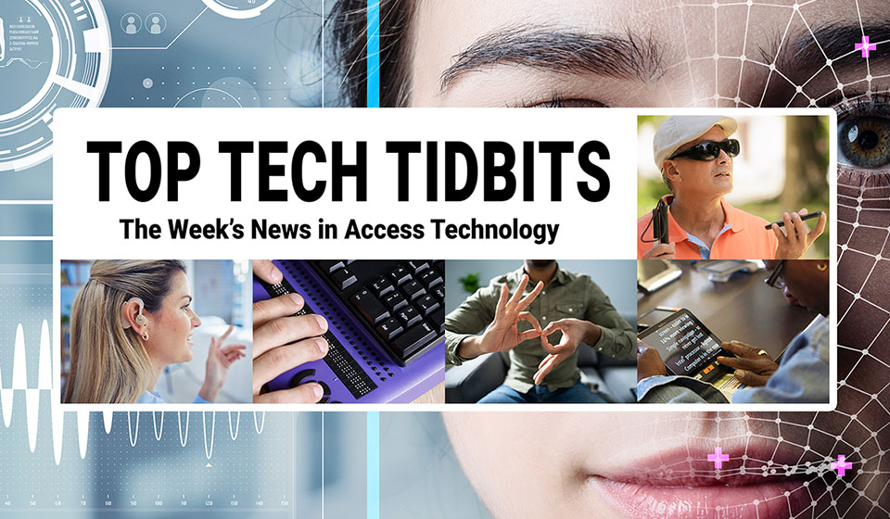
 |  |  |  |  |  |  |  |  |  |  |  | 
Top Tech Tidbits for Thursday, October 23, 2025 - Volume 1038
♿️ The Week's News in Access Technology
Top Tech Tidbits. The world's #1 online resource for current news and trends in access technology.
A Mind Vault Solutions, Ltd. Publication
Subscribers: 42,342 🔢️ opt-in subscribers were sent this issue via email.

Sponsors 🏅️
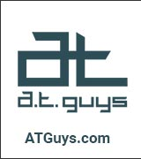 |  |  |  | 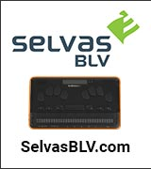 | 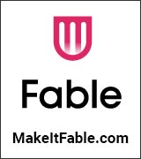
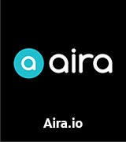 | 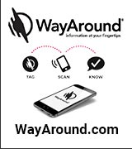 | 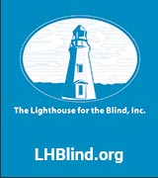 | 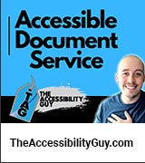 |  | 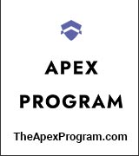
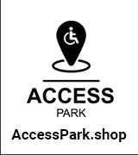 | 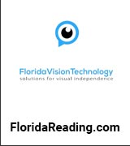 |  | 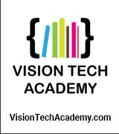 | 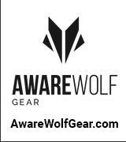 | 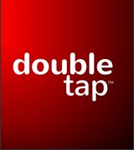
 | 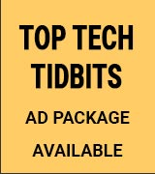 | 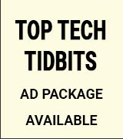 | 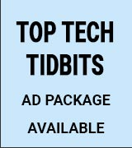 | 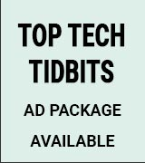 | 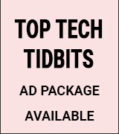

Access Awareness: Updates That Matter ♿️
Samsung Galaxy XR, ChatGPT Atlas & New Zoom Podtrak P4Next | Double Tap | YouTube.com | October 22, 2025
Explore the latest advancements in accessible technology with insights on the Samsung Galaxy XR headset, the innovative ChatGPT Atlas browser, and the Zoom PodTrak P4 Next podcast recorder. By focusing on usability for blind and low vision users, Steven Scott and Shaun Preece highlight progress and challenges in making these tools more accessible.

This Week's Featured Advertisement 🎯️
Sponsorship Packages Currently Available. Support Free Access Technology News For Disabled Readers All Over The World While Increasing Traffic To Your Properties Each Week. Advertise in every issue. Or just one.
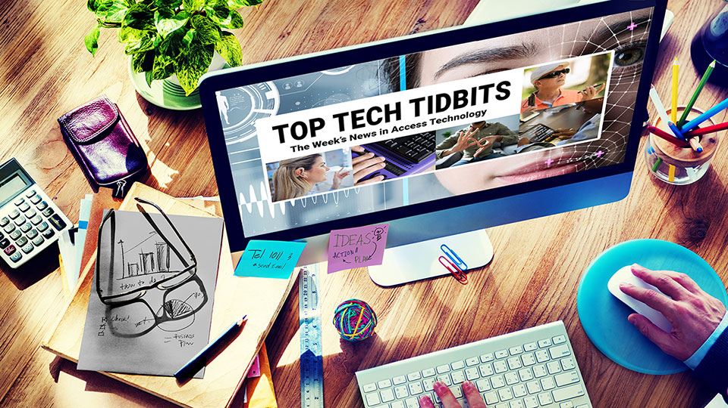
Join Top Tech Tidbits as a Sponsor today and begin reaching over 42,000 access technology subscribers each week, all while supporting the ongoing distribution of Top Tech Tidbits for those very same readers. Only $200 / month.
Key Newsletter Statistics:
- Subscribers: 42,000 + per week and growing.
- Open Rate: 46% (Average. Last 12 months.)
- Click Rate: 42% (Average. Last 12 months.)
- Bounce Rate: 1.1% (Average. Last 12 months.)
- Ad CTRs: 2-12% (Average. Last 12 months.)
Benefits All Sponsors Receive:
- One (1) Sponsor Profile on the Top Tech Tidbits website.
- One (1) Sponsor Profile in each weekly newsletter.
- One (1) Sponsor Wall Brand Advertisement on the Top Tech Tidbits home page.
- One (1) Sponsor Wall Brand Advertisement in each weekly newsletter.
- One (1) Classified Advertisement in each weekly newsletter.
- 50% Discount on all Sponsored Tidbit Advertisements.
- Free link tracking.
- Permanent SEO benefits.
- Gratitude from over 42,000 access technology subscribers for keeping Top Tech Tidbits free to read.
With additional benefits for Sponsors that pay quarterly or annually. Learn more today.

News 📰️
👉 Submit a Tidbit for free here, with timing and placement determined by our editors.
👉 Submit a Sponsored Tidbit here, with timing and placement determined by you.

1.) Top 5 Most Clicked Tidbits From Last Week 📊️
A.) Why 90% of Blind People Don't Use a White Cane... (Free Cane Giveaway!) | Legally Blind No Limits | YouTube.com | October 9, 2025
Over 90% of people who are blind or visually impaired don't use a cane… even when they need one. I used to be one of them, and actually, hiding my blindness almost killed me. I don't want that to happen to anyone else. That's why I've partnered with @AwarewolfGear to give away 3 FREE white canes this Blindness Awareness Month. This isn't just a giveaway. it's part of my mission to help people get the support, tools, and confidence they need to live life NO limits. If you've been too afraid, too unsure, or just didn't know where to start, this one's for you.
B.) Do Meta AI Glasses Support Prescription Lenses? | AndroidCentral.com | October 7, 2025
Most Meta AI glasses, including Ray-Ban Meta and Oakley Meta HSTN, support prescription lenses with a range from -6.0 to +4.0. Users can order their glasses with specific prescriptions at the time of purchase or opt for aftermarket options.
C.) These $600 Display Glasses Do Some Things Meta's New $800 Glasses Can't | CNet.com | October 9, 2025
Rokid Glasses offer a unique solution with magnetic prescription lens inserts that cater to a wider range of vision corrections compared to other smart glasses. With features like music playback, live translations, and a teleprompter, these glasses demonstrate promising advancements in augmented reality, though they still face challenges in design and functionality compared to competitors like Meta.
D.) Using a Braille Display on iOS: An Introduction | AppleVis.com | October 10, 2025
This guide provides essential information on connecting and using braille displays with iOS devices including supported models, commands, connection instructions, and troubleshooting tips. It highlights features and functionalities that enhance the accessibility experience for braille users on Apple devices.
E.) JAWS Power Tip: How To Display A List Of Misspelled Words In A Word Document | Freedom Scientific | TopTechTidbits.com | October 16, 2025
When using Microsoft Word with JAWS, you can display a list of misspelled words in the JAWS Virtual Viewer. This allows you to quickly review and correct spelling errors. You must enable the setting Check spelling as you Type in Word for this list to be available. If you try to access the list and this setting is not enabled, a message will be displayed telling you to enable it.
2.) Sponsorship Packages Currently Available | TopTechTidbits.com | October 23, 2025
There are Five (5) Sponsorship Packages currently available. Would your product, service or message benefit from reaching over 42,000 access technology subscribers each week? For just $200 / month? If you're thinking yes, we invite you to try a Sponsorship Package with Top Tech Tidbits. The benefits are amazing and the traffic delivered to your properties each week is measurable. No obligation. Cancel anytime. When there are no Sponsorship Packages available, you can join the waiting list here.
3.) One Time Advertisements Available | TopTechTidbits.com | October 23, 2025
One time advertisements are available to anyone, with or without a Sponsorship. Would your product, service or message benefit from reaching over 42,000 access technology subscribers? If you're thinking yes, we invite you to check out our one time advertising options. They are cost-effective, targeted and measurable. Scheduling is optional. Learn more today.
4.) Premium Subscribers | TopTechTidbits.com | October 23, 2025
Next Issue: Premium Subscribers will receive their 14th issue of the Top 60 Most Clicked News Articles for April, May and June of 2025 on Monday, October 6, 2025. Back Issues: There are currently 13 back issues available. Premium Subscribers are entitled to all back issues, anytime they sign up. All available back issues will be sent to you via email within 24 hours of purchasing your subscription. Please Join Us: If you would like to receive a perfectly formatted and searchable Word Document with each of the Top 60 Most Clicked News Articles of the last 3 months listed neatly within it, please consider joining us today for just $1 a month.
5.) Sponsored Tidbits | TopTechTidbits.com | October 23, 2025
Use Sponsored Tidbits to reach the access technology community when you need to. Whether you are a current Sponsor or not. Drive traffic to your access product and service announcements, events, updates or fundraisers using this incredibly cost-effective and easy-to-use advertisement tool. Learn more today.
6.) Do You Have A Link In This Issue? Learn How To Track It For Free | TopTechTidbits.com | October 23, 2025
This article outlines, step-by-step, how you can get free website traffic reporting on any link to your domain (AKA domain name, website or web address) that has been published by Top Tech Tidbits since January 18, 2024, when we launched this feature.

7.) Apple Updates 🍎️
Skip this Tidbit to skip all updates on Apple.

A.) Introducing Cobrowse AI Beta On AppleVis And Inviting Community Participation And Feedback | AppleVis.com | October 20, 2025
AppleVis announces the launch of CoBrowse AI, a beta feature enabling voice command navigation for blind and low vision users on their website. The initiative aims to enhance accessibility and gather community feedback for further improvements, particularly through ease of use for new and existing users relying on voice technologies.
B.) New iOS App: SonifEye; An App to Hear Color; Request for Use & Feedback | AppleVis.com | October 17, 2025
SonifEye is a newly released iOS app designed to make color accessible through sound, transforming colors from images into musical notes to aid recognition. The developer seeks feedback from the AppleVis community to refine the app further and has ensured VoiceOver support and haptic guidance for ease of use.

8.) AI Updates 🤖️
Skip this Tidbit to skip all updates on AI.

A.) Google's Gemini AI May Add Mic Lock For Longer Voice Commands | TechBooky.com | October 22, 2025
Google is testing a new feature for its Gemini AI that allows users to long-press the microphone icon to issue longer voice commands without interruption. This enhancement aims to improve conversational capabilities by enabling continuous phone talks without relying on Gemini Live, addressing limitations in current AI voice tools.
B.) The Oakley Meta Vanguard Glasses Had Me Feeling Like An Undercover Superhero | CNet.com | October 21, 2025
The Oakley Meta Vanguard glasses combine sleek design with advanced technology, featuring hands-free video capture and Garmin integration for real-time fitness metrics. Despite some setup challenges and limited mainstream appeal, they demonstrate how wearable tech is evolving with AI capabilities.
C.) Microsoft 365's Accessibility Assistant Gets Smarter at Detecting Tables and Shapes | WindowsReport.com | October 21, 2025
Microsoft has introduced an update to its Accessibility Assistant within Microsoft 365, enhancing its ability to accurately handle tables and shapes in Word, Excel, and PowerPoint. Key improvements include better recognition of valid row and column headers and reduced false alerts for non-compliance, ensuring a more user-friendly experience.
D.) Accessibility Review of OpenAI's New Atlas Browser on Mac | Taylor Arndt | iAccessibility.net | October 21, 2025
OpenAI has introduced a new browser called ChatGPT Atlas, designed to blend artificial intelligence directly into the browsing experience. Unlike traditional browsers that simply display web pages, Atlas integrates ChatGPT so users can ask questions, summarize pages, draft messages, and perform actions right inside the browser. It is currently available only on macOS, with versions for Windows, iOS, and Android expected later.
E.) Tiny AI-Powered Eye Implant Helps the Blind See Again | ScienceDaily.com | October 20, 2025
The PRIMA retinal implant has allowed blind patients with dry AMD to regain the ability to read by transmitting visual data directly to the brain through AR glasses. Clinical trials showed significant improvements in visual recognition and daily navigation for most participants.
F.) Is The AI PC Finally Here? I Think Microsoft's Latest Copilot Updates Bring Us Closer Than Ever | PCMag.com | October 16, 2025
Microsoft's latest updates to Windows 11 introduce advanced Copilot features that significantly transform traditional PCs into AI-enabled machines. These features include voice interaction, task automation, and enhanced usability across various applications, aiming to provide a more intuitive computing experience.
G.) Microsoft Wants You To Talk To Your PC And Let AI Control It | TheVerge.com | October 16, 2025
Microsoft is transforming Windows to enable speech interaction with PCs, aiming for a seamless integration of AI features that allows users to control their computers through voice. The initiative, spearheaded by Copilot, intends to enhance user experience by enabling tasks via natural language commands while also promoting future updates to the Windows operating system.
H.) Beyond Alt Text: Rethinking Visual Description in the Age of AI | AFB.org | October 16, 2025
The integration of AI into image description raises important questions about accessibility for blind and low vision users. While AI-generated alt text can fill gaps where none exists, it often lacks the context and nuance necessary for truly meaningful communication, posing risks of misinformation and inadequate representation. Emphasizing the role of human authorship is essential to ensure that digital content remains genuinely accessible.

Tips, Tutorials, Guides, Reviews, Walk-Throughs and How-To's 📚️

9.) JAWS Power Tip: How To Attach a File to an Email in the New Outlook | Freedom Scientific | TopTechTidbits.com | October 23, 2025
When using the new Outlook with JAWS, you can copy a file, then paste it as an attachment in an email. Here's how to do this using JAWS.

News, Trends, Updates and Opinion Editorials 📰️

10.) Never Run Out Of Power With This Meta Smartglasses Charger - AERIANT Portable Charger Review | The BLind Life | YouTube.com | October 22, 2025
The AERIANT Ultra-Light Portable Charger ensures your Meta Ray-Ban smartglasses remain powered throughout the day. With its rapid charging capabilities and lightweight design, this charger is perfect for users on the go, whether traveling, working, or enjoying outdoor activities.
11.) Samsung Galaxy XR, ChatGPT Atlas & New Zoom Podtrak P4Next | Double Tap | YouTube.com | October 22, 2025
Explore the latest advancements in accessible technology with insights on the Samsung Galaxy XR headset, the innovative ChatGPT Atlas browser, and the Zoom PodTrak P4 Next podcast recorder. By focusing on usability for blind and low vision users, Steven Scott and Shaun Preece highlight progress and challenges in making these tools more accessible.
12.) Samsung Galaxy XR: Everything You Need To Know | Engadget.com | October 22, 2025
Samsung has launched the Galaxy XR, its first Android XR headset, priced at $1,800. The device features an array of 12 cameras, offers multiple functionalities such as real-time video chat while gaming, and includes built-in Gemini AI for enhanced interactivity. The headset is positioned as a competitive alternative to the higher-priced Apple Vision Pro, boasting superior pixel density and affordability.
13.) Podcast: A Comprehensive Review And Demonstration Of Orbit Speak From Orbit Research | Podcasts.Apple.com | October 22, 2025
This episode provides an in-depth review and demonstration of Orbit Speak by Orbit Research, covering features such as the main menu, onboard help, file management, and various utility functions including media playing and internet radio. It serves as a guide for users to navigate and utilize the app effectively.
14.) Podcast: Eyes on Success Episode 2543: Transforming Accessibility Through Aira with AI | October 22, 2025
Aira has transformed from a mostly subscription service into a resource that now offers many free services for visually impaired users. Hosts Nancy and Peter Torpey talk with Jenine Stanley, Director of Customer Success at Aira about navigating public spaces and how collaborations with Google DeepMind and wearable tech promise better visual interpretation tools.
15.) Happy Internet Archive Day! | Blog.Archive.org | October 22, 2025
The San Francisco Board of Supervisors declared October 22, 2025, as Internet Archive Day in recognition of the Archive's achievement of preserving 1 trillion web pages. The celebration includes a rally and street party to honor the collaborative efforts enabling universal access to knowledge.
16.) Upcoming Events For The Blind (Connect Alt) | TheBlindGuide.com | October 22, 2025
Ed Henkler highlights Connect Alt, a new centralized and fully accessible platform designed to list events, programs, and resources for people who are blind or visually impaired. Created by Lucie Courtois, her mother Carol Trapani, and godsister Ella Deshautreaux, the hub offers a searchable, screen-reader-friendly interface that promotes community engagement and accessibility.
17.) Samsung's Android XR Headset: Affordable Alternative to Vision Pro | Double Tap | YouTube.com | October 21, 2025
Samsung's Android XR headset, featuring Snapdragon technology and a customized One UI interface, aims to revolutionize immersive experiences and accessibility for low-vision users. With impressive dual 24K displays and a commitment to support a wide range of Android applications, the headset is positioned as a cost-effective alternative to others in the market, promising robust integration with Google services and a focus on open accessibility.
18.) Tech Turbulence: Outages, Innovations, and Inspiring Journeys | Double Tap | YouTube.com | October 21, 2025
A global internet outage puts a spotlight on our reliance on cloud technology, with significant ramifications for essential services and smart homes. The discussion shifts to Samsung's latest Android XR headset, exploring its implications for low vision users and mainstream acceptance, before concluding with retired U.S. Judge David Tatel's inspiring journey through blindness and the transformative role of technology in overcoming challenges.
19.) Become A Windows 11 Pro With These 73 Keyboard Shortcuts | CNet.com | October 21, 2025
Windows 11 is equipped with numerous keyboard shortcuts designed to enhance productivity and streamline navigation. Learning these shortcuts can significantly reduce time spent navigating through menus, allowing users to maximize their efficiency while working on various tasks.
20.) Life-Changing Eye Implant Helps Blind Patients Read Again | BBC.com | October 21, 2023
An innovative implant has enabled a group of blind patients to regain their reading ability after a trial conducted at Moorfields Eye Hospital. The technology specifically targets those with an advanced form of age-related macular degeneration, offering hope to many who previously had no treatment options.
21.) Canadian Innovator Improves Accessibility Through 3D Printing | 3Dnatives.com | October 21, 2025
Nicolas Vaagen, a maker from Saskatchewan, Canada, is utilizing 3D printing technology to create customized assistive devices that enhance accessibility for individuals with disabilities. His community initiative aims to provide low-cost, tailored solutions, illustrating the transformative potential of additive manufacturing in personal healthcare.
22.) New AT Resources Reveal Real-World Strategies From Blind And Low Vision Workers | NTAC.blind.msstate.edu | October 21, 2025
The National Research and Training Center on Blindness and Low Vision has released two new resources showcasing how blind and low vision professionals use technology to overcome accessibility barriers. The tip sheet and fact sheet highlight real-world strategies involving OCR, AI tools, and cross-training with screen readers, offering practical guidance for navigating inaccessible digital environments.
23.) How To Update Google Docs Heading Styles | The Accessibility Guy | YouTube.com | October 20, 2025
Learn how to customize and apply heading styles in Google Docs, enabling better compatibility with Microsoft Word and PDF formats. Discover techniques to enhance document inclusivity and user-friendliness.
24.) iPhone Air And Apple's M5 Launch: Is It Worth Upgrading? | Double Tap | YouTube.com | October 20, 2025
Steven Scott and Shaun Preece evaluate Apple's latest offerings, including the iPhone Air and M5 devices, while discussing potential accessibility issues for Mac users. The hosts also explore the implications of AI companionship, particularly focusing on new features in ChatGPT that may affect isolated users.
25.) Open And Use Accessibility Settings On Windows 11 | WindowsReport.com | October 20, 2025
Windows 11 offers a range of Ease of Access features that enhance user experience for individuals with varying needs. This guide covers how to access and customize accessibility settings for improved visibility, hearing, and interaction with your device.
26.) Lighthouse Works Shows How JAWS Software Opens Doors For People Who Are Visually Impaired | MyNews13.com | October 20, 2025
Lighthouse Works assists individuals who are blind or visually impaired in securing employment opportunities. Utilizing JAWS software, employees can perform jobs independently, improving their quality of life and establishing financial independence.
27.) Kohler's New Toilet Camera Provides Health Insights Based On Your Bathroom Breaks | TheVerge.com | October 20, 2025
Kohler introduces the Dekoda, a health tracker that analyzes toilet contents to provide insights into hydration and gut health. The device, priced at $599, includes a mobile app for health data but requires a subscription for full access.
28.) Navigating Independently With Indigo | APH.org | October 20, 2025
Indigo is an accessible GPS application designed to support individuals with vision loss in navigating independently. Its features include customizable navigation details, points of interest, virtual mode for trip planning, and breadcrumb mode for creating routes, enhancing location literacy and independence for its users.
29.) Eye Implant Restores Vision To Patients With Incurable Sight Loss | PhysicsWorld.com | October 20, 2025
The PRIMA device, a tiny wireless implant, has demonstrated success in restoring central vision in patients suffering from age-related macular degeneration (AMD). An international clinical trial showed that 27 of 32 participants could read letters and words after using the implant, with considerable improvement in visual acuity over time.
30.) More Flexibility, More Accessibility, And More Ways To Connect With Traktor: Native Instruments Launches Entry-Level Traktor Play DJ Software And Bundles It With Controllers From AlphaTheta | MusicRadar.com | October 20, 2025
Native Instruments has debuted Traktor Play, a beginner-friendly DJ application designed to provide essential DJing functionality without complexity. This software features two decks, a mixer with EQ controls, and access to creative tools, enabling users to start DJing efficiently with integration for streaming services and various hardware controllers.
31.) Blind Patients Read Again With Smart Glasses-Linked Eye Implant | TheVerge.com | October 20, 2025
A groundbreaking study shows that 80% of patients with profound vision loss due to AMD experienced improved vision after receiving a retinal implant linked to smart glasses. This innovative technology allows them to read and engage in daily activities again, though vision remains limited to black and white and somewhat blurry.
32.) For Enthusiasts Of Vintage Assistive Technology: JAWS For DOS 2.3 Tapes In Higher Quality | Tech-VI List | October 20, 2025
Ameer Armaly has uploaded higher-quality recordings of the JAWS for DOS 2.3 training tapes, originally provided by Dan Clark. The collection includes the full Smart Screens tape and several training tapes, with a call for additional rare JAWS for DOS materials such as WordPerfect and macro sets.
33.) Voice Access Vs Voice Typing: Everything You Need To Know To Get Started | WebFriendlyHelp.com | October 19, 2025
This article compares two distinct voice tools in Windows: Voice Typing, a simple speech-to-text feature, and Voice Access, which offers comprehensive control of the computer via voice commands. It outlines how to set up each tool, their specific functionalities, and ideal use cases for users.
34.) Accessibyte: Fun And Accessible Learning Tools For The Blind And Visually Impaired | The Blind Life | YouTube.com | October 18, 2025
Joe Jorgensen, the creator of Accessibyte, reveals how his innovative suite of assistive technology tools empowers the blind and visually impaired community. From engaging typing programs to educational games that enhance learning, his software is designed to foster independence and skill development in various aspects of life.
35.) Advance Notetaking With JamWorks | The Accessibility Guy | YouTube.com | October 17, 2025
Jamworks offers a powerful Enhanced Notetaking feature that transforms recorded lectures, tutorials, or presentations into actionable notes. By initiating a manual query, users can efficiently extract the most pertinent details, streamlining the note-taking process for maximum effectiveness.
36.) Soundscape, Sandwich Shops, And Speaking Up For Blind Communities | Double Tap | YouTube.com | October 17, 2025
A candid exploration of the challenges faced by blind individuals in navigating everyday environments, this episode features Steven Scott and Shaun Preece discussing personal experiences and the role of accessible technology. Insights from listeners highlight the need for authentic representation in blindness organizations and the impact of tools like the Soundscape app, emphasizing the potential for assistance in daily tasks.
37.) Accessibyte: Fun And Accessible Learning Tools For The Blind And Visually Impaired | The Blind Life | YouTube.com | October 17, 2025
In this episode of The Blind Life Podcast, Joe Jorgensen, the creator of Accessibyte, reveals a suite of assistive technology tools crafted to empower the blind and visually impaired community. With features like the Typio typing program and engaging games in Accessibyte Arcade, listeners gain insight into how innovative technology fosters independence and learning in everyday life.
38.) Headers, Headings, And Titles | TemperTemper.net | October 17, 2025
Clarifying the distinctions among 'header', 'heading', and 'title' is crucial for effective communication between designers and developers. Understanding these terms helps prevent confusion and ensures consistent use of HTML and ARIA specifications across teams.
39.) How to Choose Accessible Ebook Devices | IamHable.com | October 17, 2025
This guide provides insights on selecting ebook devices for blind and visually impaired users, detailing key accessibility features such as text-to-speech and Braille support. It emphasizes the importance of testing devices to match individual needs and preferences to enhance the reading experience.
40.) From Braille 'N Speak To BT Speak: A Personal Reflection | BlazieTech.com | October 17, 2023
This blog post reflects on the evolution of Blazie's products, primarily focusing on the Braille 'N Speak's impact on accessibility and its transition to the modern BT Speak. David Goldfield shares personal anecdotes illustrating how these devices revolutionized communication and work for the visually impaired, culminating in the hope that BT Speak will inspire similar experiences.
41.) A Note To Product Vendors: An Invitation To Send Black Friday Specials For Submission To The Tech-VI List | David Goldfield | October 17, 2025
Tech-VI invites product vendors offering Black Friday specials to submit announcements for free distribution to subscribers. Eligible products include items related to blindness or visual impairment, such as Braille devices, accessibility software, and magnifiers, with clear details on pricing, dates, and contact information.
42.) Braille, Screen Readers, And The Guilt Of Doing It Your Way | Double Tap | YouTube.com | October 16, 2025
Explore the ongoing debate around the teaching of Braille and screen readers in educational settings, enriched by listener experiences with various accessibility tools. Steven Scott and Shaun Preece examine the challenges of adapting to vision loss and reflect on the emotional impacts of using technology, all while addressing the balance between independence and practicality in daily life.
43.) Be a Digital Ally: Tools and Techniques of a Blind Accessibility Auditor | Knowbility.org | October 16, 2025
You are tuned in to Knowbility's Be a Digital Ally, and today we are doing a presentation on tools and techniques of a blind accessibility auditor.
44.) Podcast: Learning Blind Tech Episode 29 Narrator Basic Settings and Quick Start Guide | Apple Podcasts | October 15, 2025
This episode covers some basic settings and features of narrator. We will also go over the quick start guide inside of Narrator.
45.) Why Every Search Needs an Announced Empty State | Buttondown.com | October 15, 2025
Announced empty states are crucial for effective search functionality, particularly for screen reader users, who require feedback after a search to understand if results were found or not. Without clear communication, users may become frustrated and lose trust in the system, highlighting a significant accessibility issue that needs addressing.
46.) Page Headings Don't Belong In The Header | TemperTemper.net | October 15, 2025
This article argues for keeping the <h1> heading outside the <header> element to maintain semantic meaning and accessibility. By positioning the <h1> within the <main> element, users, including those relying on screen readers, have a clearer navigation experience, which enhances overall usability.
47.) Common Misconceptions About Screen Readers | Tetralogical.com | October 14, 2025
The article clarifies several prevalent misconceptions about screen readers, emphasizing that they are used not only by blind users but also by those with various visual and cognitive disabilities. It highlights the importance of inclusivity in design, encouraging developers to provide accessible content without assuming the needs of screen reader users.
48.) Tables: Beyond Rows And Columns | TPGI.com | October 13, 2025
This article clarifies the importance of using tables in HTML for presenting structured data, particularly when dealing with complex datasets. It explains best practices for labeling tables and avoiding misuse for layout purposes, emphasizing the significance of semantics in enhancing accessibility for assistive technologies.
49.) HTML Dialog: Getting Accessibility And UX Right | JaredCunha.com | October 13, 2025
The article examines how to effectively use the HTML dialog element to create accessible and user-friendly modal dialogs. It outlines best practices derived from experience with the U.S. Web Design System, emphasizing the importance of focus management, locking background scroll, and adjusting for visual consistency to enhance user interactions.
50.) Todd Libby On Deceptive Patterns | ShopTalkShow.com | October 13, 2025
In this episode, Todd Libby discusses deceptive patterns on the web, what WCAG is and its significance, along with five prevalent deceptive patterns currently in use. The conversation emphasizes the importance of accessibility and responsible web design practices.
51.) .Lumen Wins The 2025 Gitex Global Competition | DotLumen.com | October 13, 2023
The .lumen team participated in GITEX Global in Dubai, showcasing AI-powered glasses for the blind. They won the 2025 Supernova Challenge and emphasized their mission of creating technology that enhances freedom for individuals with visual impairments.
52.) FSCast #262 Enhancing Web Accessibility With JAWS Tools, And A Chat With Kristina Misiunaite | Blog.FreedomScientific.com | October 11, 2025
This episode of FSCast focuses on enhancing website accessibility using the latest tools in JAWS. It features a conversation with tax policy officer Kristina Misiunaite, highlighting the broader impacts of tax law, and previews upcoming training webinars.
53.) Star Raters Are More Challenging To Make Accessible Than You Might Think | ElevenWays.be | October 11, 2025
Star rating systems, though seemingly simple, present significant accessibility challenges for users, especially those with visual or motor impairments. Effective design must ensure intuitive keyboard navigation and prevent accidental submissions, thereby allowing all users to express their opinions reliably.
54.) Stop Inviting Overlay Employees & Bad Actors Into Accessibility Spaces | ChrisYoong.com | October 9, 2025
The presence of overlay companies and their employees in Accessibility spaces poses significant risks, including confusion over genuine and performative work, exploitation of community networks, and deflection of resources away from authentic practitioners. This dynamic undermines trust and integrity within these communities, making meaningful collaboration challenging.
55.) Accessibility Audits: Because Everyone Deserves To Stay In Focus | EqualEntry.com | October 9, 2025
Accessibility audits are crucial for identifying barriers in websites and digital content, ensuring that updates do not hinder usability for users with disabilities. Ongoing commitment to fixing these issues is essential for maintaining credibility and respect for all users.
56.) Why WordPress Themes Require Underlines On Links | JoeDolson.com | October 9, 2025
WordPress themes mandate underlines on links by default to ensure accessibility compliance with WCAG guidelines, simplifying the testing process for theme reviewers. While other design options may exist, they require more complex verification, thereby limiting flexibility in theme development.
57.) How To Conduct User Testing With People With Disabilities | Intopia.digital | October 6, 2025
Effective user testing with individuals with disabilities requires careful participant selection and consideration of their unique circumstances. This guide outlines strategies for recruiting the right participants, using their own devices, and conducting both remote and in-person sessions to ensure inclusive and respectful testing environments.
58.) Essential Visually Hidden CSS Techniques For Web Accessibility | A11Y-Collective.com | October 6, 2025
This guide explores techniques for hiding content visually while keeping it accessible to assistive technologies, addressing common pitfalls such as using 'display: none', which removes content from the accessibility tree. By employing the clip-path technique and ensuring keyboard accessibility, developers can create a more inclusive web experience.

Featured Events 📅️
👉 Submit your event for consideration within this section here.

October 23, 2025 | Social Field Safety Workshop By Field Inclusive | Birdability
This workshop raises awareness of social risks in outdoor fieldwork faced by marginalized individuals and offers strategies for creating safer, more inclusive field environments.
October 23, 2025 | Bird-a-Thons And Belonging: Stories From The Blind Birder Community | Birdability
Organizers and participants in the Blind Birder Bird-a-Thon will share stories of inclusion, community, and the impact of birding while blind, and discuss plans for future events.
October 24, 2025 | Accessible Nature Journaling Workshop | Birdability
Birdability Captains Emily Nichols and Cassandra Dean lead a one-hour journaling session, offering prompts and accessible tools so participants of all abilities can connect with nature through journaling.
October 25, 2025 | You Belong Here: Joy, Belonging & Community Through Birding With Dexter Patterson | Birdability
Dexter Patterson (the Wisco Birder) leads a keynote celebrating the connections, joy, and shared belonging that birding can foster among diverse participants.
October 26, 2025 | Birdability Week Celebration + Photo/Video Contest Winners Announced | Birdability
Join the Birdability community to celebrate the week, share participant submissions, and announce winners of the Birdability Week Photo & Video Contest.
October 29, 2025 | Part 2: Web Accessibility Basics - Manual Screen Reader (Digital Accessibility Webinar) | Michael Parker And Marisa Church | Access Ingenuity
10 AM PT, 11 AM MT, 12 PM CT, 1 PM ET, 5 PM GMT
Focused on desktop screen reader testing using JAWS and NVDA with Chrome on Windows 11. Covers navigation, form labeling, error handling, and accessibility barriers. Mapped to WCAG 2.2 Level AA.
November 5, 2025 | JAWS, Zoomtext & Fusion 2026: Latest Features (Assistive Technology Webinar) | Ian Ramos And Marisa Church | Access Ingenuity
10 AM PT, 11 AM MT, 12 PM CT, 1 PM ET, 5 PM GMT
Explore updates and new features in the 2026 versions of JAWS, ZoomText, and Fusion.
November 5, 2025 | Disability Owned Convening | National Disability Institute
12:30 PM PT, 1:30 PM MT, 2:30 PM CT, 3:30 PM ET, 7:30 PM GMT
Hosted by the Small Business Hub at National Disability Institute, this fully virtual, national convening empowers entrepreneurs with disabilities through sessions on leveraging AI, financial health, marketing, and accessible business growth. The free two-day event features expert panels and practical resources to help business owners seize opportunities and overcome challenges.
November 12, 2025 | Part 3: Web Accessibility Basics - Manual Mobile Testing (Digital Accessibility Webinar) | Michael Parker And Marisa Church | Access Ingenuity
10 AM PT, 11 AM MT, 12 PM CT, 1 PM ET, 5 PM GMT
Covers mobile testing challenges, including use of VoiceOver (iOS) and TalkBack (Android). Learn gestures, navigation, testing touch targets, and reflow issues.
November 13, 2025 and November 14, 2025 | Blind Travel Summit | Blind Travel Foundation
Led by Paralympian and accessibility trailblazer Mike May, the Blind Travel Summit at the Texas School for the Blind in Austin features interactive, solutions-focused sessions designed to foster real connection among blind travelers, tech users, and advocates. Each session combines concise presentations with facilitated discussions to co-create better travel solutions.
November 14, 2025 | Deadline to Invest in Doppler Labs' At-Home Hearing | Dr. Kirk Adams
Doppler Labs offers audiologist-grade hearing aids and a patented at-home fitting platform designed to deliver fast, accessible hearing care at scale. The Netcapital raise aims to fund expansion, production, and a nonprofit arm targeting underserved regions, with clinical trials completed and pricing locked in for sustainable impact and global reach.
November 15, 2025 | International Neurology Conference 2025 | PubScholars Group
12:00 AM PT, 1:00 AM MT, 2:00 AM CT, 3:00 AM ET, 8:00 AM GMT
The International Neurology Conference 2025 is a flagship hybrid event hosted by PubScholars Group on November 15-16, 2025, at the Hard Rock Hotel at Universal Orlando (5800 Universal Blvd, Orlando, FL) and streamed online. The conference explores "Mind-Brain Connection: Understanding Neuroscience through Mental Health," aiming to integrate cutting-edge science with clinical relevance. Who Should Attend: Neurologists, neurosurgeons, neuroscientists, psychologists, rehabilitation professionals, engineers, industry leaders, students, and allied health practitioners. Important Dates & times: Abstract Submission Deadline: September 15, 2025. Registration Deadline: September 30, 2025. Event Timing: November 15, 2025 (8 AM start) - November 16, 2025 (6 PM close). Format: Hybrid Event (In-person & Virtual.) Contact Person: Richard A. Email: info@pubscholars.org 📧️. Phone: +91 7042134266 📱️. Venue: Hard Rock Hotel at Universal Orlando, 5800 Universal Blvd, Orlando, FL 32819, USA.
November 19, 2025 | Portable OCR Solutions - Easily Access Text Again (Assistive Technology Webinar - ACVREP CE Approved) | Ian Ramos (Access Ingenuity) And Joseph Mcdaniel (Vispero)
10 AM PT, 11 AM MT, 12 PM CT, 1 PM ET, 5 PM GMT
Presentation on OCR technology for the visually impaired. Open to all participants; TVIs can earn ACVREP continuing education credit.
December 9, 2025 and December 19, 2025 | 6th Annual Sight Tech Global | SightTechGlobal.com
Sight Tech Global returns for its sixth year as a free, virtual conference spotlighting how AI and emerging technologies are reshaping assistive tech and accessibility worldwide. Featuring expert panels, demos, and discussions with leaders from Google, Meta, and Microsoft, the conference explores innovations that empower independence and drive digital equity.
May 21, 2026 | Tech Blitz 2026: Assistive Technology Showcase Brings Together Blind, Deafblind, And Low Vision Community For Innovation, Discovery, And Connection. | Helen Keller Services
3:00 PM PT, 4:00 PM MT, 5:00 PM CT, 6:00 PM ET, 11:00 PM GMT
In this in-person showcase hosted by Helen Keller Services, assistive technology vendors, innovators, and users come together for a day of interactive demonstrations, in-depth discussions, and community connection focused on advancing access and independence for the blind, DeafBlind, and low vision communities.

Directories 📝️
1) Top Tech Tidbits App Directory | Submit
2) Top Tech Tidbits Game Directory | Submit
3) Top Tech Tidbits Listserv Directory | Submit
4) Top Tech Tidbits Podcast Directory | Submit
5) Top Tech Tidbits YouTube Directory | Submit

Surveys 📝️
👉 Submit your survey for consideration within this section here.

1.) Invitation To Participate In Research On Wearable Technology For The Visually Impaired | Seekr in Partnership with indare | November 8, 2025
We are a wearable technology company, working in partnership with a design consultancy to develop a new product for the visually impaired. As part of our research, we are reaching out to individuals who may be interested in sharing their experiences and needs, helping us design a product that truly supports daily life. We would like to invite participants who meet the following criteria to take part in a relaxed 1.5-hour conversation. Each session'll be compensated at USD 100 per participant: Elderlies aged 65+ with dry AMD conditions. Children aged 3-18 with no usable residual vision (parents'll be the primary interviewees). To protect privacy, detailed participant criteria will be shared only via email. If you are interested, please leave your email address, and we will provide the information directly. All details will remain strictly confidential and used exclusively for research purposes. We look forward to hearing from you and hope to collaborate on this meaningful project.

Buy, Sell or Trade 📝️
👉 List your new, gently-used or refurbished item in FOUR (4) consecutive issues of Top Tech Tidbits for just $5 USD.

1.) FOR SALE: One Buy, Sell or Trade Advertisement (Just like this one.)
Price: $5.00 USD | Description: List your new, gently-used or refurbished item in FOUR (4) consecutive issues of Top Tech Tidbits for just $5 USD.

Sponsor Classified Ads 🎯️

⬆︎ 11.) Sponsor: Innosearch.ai

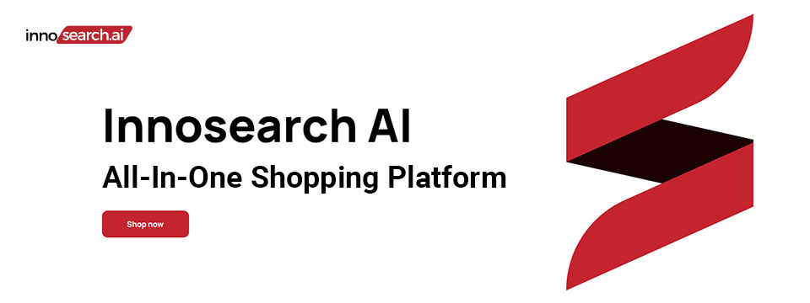
👉️ Classified Advertisement: Shop by Phone — No Screens, Just Your Voice!
Call 1-855-SHOP-GPT (1-855-746-7478)
Shopping online can be hard if you're blind, visually impaired, or not tech-savvy. That's why Innosearch AI created Shop by Phone — a 100% free, voice-only service.
Just call and say what you need:
👉 “Find me a phone charger.”
👉 “Add it to my cart.”
👉 “Check out.”
No apps, no websites — just easy, hands-free shopping from over 500,000 stores.
- ✔ Free to use
- ✔ Works anywhere, anytime
- ✔ Perfect for seniors, blind, and low-vision users
Available in:
- 🇬🇧 UK: +44 7727 247467 📱️
- 🇨🇦 Canada: +1 782 222 7467 📱️
- 🇦🇺 Australia: +61 489 267 467 📱️
- 🇺🇸 USA: 1-855-SHOP-GPT 📱️ (1-855-746-7478 📱️)
Call now and shop with ease!
Sponsor Since: June 7, 2024 📅️
Website: https://www.innosearch.ai 🌐️
Email: info@innosearch.ai 📧️
About: Innosearch is an all-in-one shopping platform augmented with a cutting-edge AI-powered shopping assistant. This innovative feature mimics the experience of shopping in real life by allowing you to interact with the assistant using natural language. It aggregates millions of products from top US online retailers, bringing them directly to you. With this advanced generative AI, Innosearch offers personalized product recommendations, highlights the best deals, and provides comprehensive information including reviews, total prices, shipping options, and more. Innosearch delivers a seamless end-to-end shopping experience, eliminating the need to search and browse in multiple tabs across retailers.
YouTube Review By Sam Seavey: https://youtube.com/watch?v=-rjL-HAwaZY.
Key Features: Key Features of the Innosearch All-in-One AI Shopping Platform include:
➜ Research Products: Easily compare products across retailers, or weigh pros and cons of similar products to make informed decisions.
➜ Uncover the Best Deals: Never miss a door buster, coupon, or clearance sale again. Get notified about the best prices and offers.
➜ AI Summarized Trusted Reviews: See what others are saying and make confident purchases.
➜ All in One: Innosearch brings millions of products from top online retailers directly to you, allowing you to shop the best deals with easy checkout and personalized AI assistance.
➜ Shop with Confidence: Rest assured, Innosearch has you covered with free shipping and returns on every purchase.
➜ Know Before You Buy: Innosearch equips you with expert buying guides, empowering you to make well-informed decisions.
How To Shop: Simply create a free account and start shopping today!

⬆︎ 10.) Sponsor: The Accessibility Guy

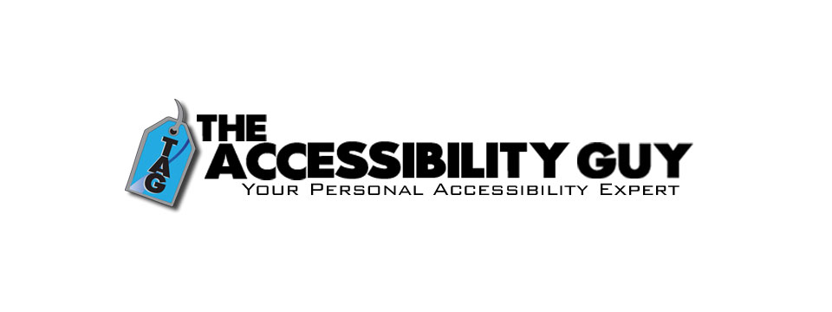
👉️ Classified Advertisement: How to Tag Multiple Languages in a PDF | The Accessibility Guy
More Adobe Acrobat accessibility tips!
My latest post explains how to properly tag individual language sections in a multilingual PDF. Adobe Acrobat offers tools to assign language codes to specific sections, allowing screen readers to interpret and vocalize the content accurately.
Check out The Accessibility Guy's full suite of Accessibility services.
Sponsor Since: August 3, 2023 📅️
Website: https://theaccessibilityguy.com/ 🌐️
YouTube: https://youtube.com/@TheAccessibilityGuy 📹
About: My name is Shawn Jordison and I love helping others learn the ins and outs of digital accessibility.
I have made over 100 thousand documents accessible, provided hundreds of trainings in the areas of accessibility and document remediation, and reviewed many websites and mobile applications for accessibility.
I have developed and reviewed VPATs, LMS courses, and other pieces of training. I am the accessibility Swiss army knife. Let me be your personal accessibility expert.
➜ Over 13 years of experience in the field of accessibility.
➜ Passionate about providing equal access to information for everyone.
➜ Wide range of project experience, including document accessibility, training, and more.
➜ Expertise in captioning, assistive technology, and accessibility best practices. I'm here to help you create a more accessible world.
The Blog: This blog covers topics like making Word, PDF & PowerPoint files accessible, Closed Captioning, assistive technology, and other important accessibility topics.
Training and Consulting: Offering customized training and consulting for implementing accessibility best practices.
Accessible Document Service: Providing top-tier document remediation services for all types of files, ensuring compliance with WCAG, 508, and PDF UA standards.

⬆︎ 9.) Sponsor: The Lighthouse for the Blind, Inc.

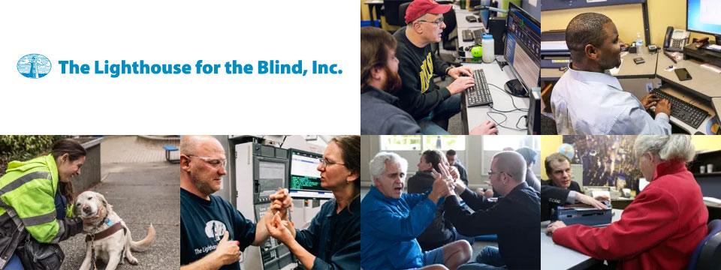
Sponsor Since: December 29, 2022 📅️
Website: https://lhblind.org/ 🌐️
Phone: (800) 914-7307 📱️
Fax: (206) 329-3397 ░
Contact Us: https://lhblind.org/contact-us/
About: The Lighthouse for the Blind, Inc. is a private, not-for-profit social enterprise providing employment, support, and training opportunities for people who are blind, deafblind, and blind with other disabilities. The Lighthouse has provided employment and support to people who are blind in our community since 1918.
The Lighthouse for the Blind, Inc. is a successful manufacturing organization with over 60 years of experience in precision machining. We produce an array of machined parts and plastic injection molding for various aerospace manufacturers, as well as a host of office products and hydration equipment sold to the Federal Government and the U.S. Military. We also own and operate stores on military bases along the West Coast. Our products and services include:
• Manufacturing: We are a successful manufacturing organization committed to making jobs accessible to individuals who are blind. Our manufacturing operations center on making quality products for the Federal Government under the AbilityOne Program and producing parts for aerospace manufacturers.
• Managed Services: The Lighthouse for the Blind, Inc. offers a variety of services to our commercial, federal, and military customers. These include Contract Management Support (CMS) services for government contracting offices.
• Base Supply Centers: We operate 12 AbilityOne Base Supply Centers (BSCs) that offer easy customer access to Lighthouse products, direct feedback and communication with customers, and employment opportunities for individuals who are blind in geographic areas not served by larger nonprofit agencies.

⬆︎ 8.) Sponsor: Wayaround

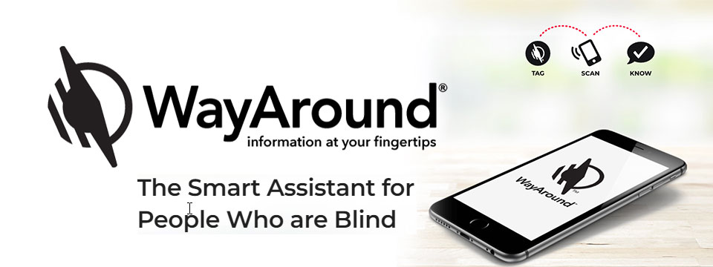
👉️ Classified Advertisement: FREE Sampler Pack with a Purchase of Any 25-pack of WayTags | Wayaround
WayAround is a smartphone-based labeling app that works with your preferred accessibility settings. You just need the free mobile app and some WayTags ® to label items in the kitchen, garden, closet, office & more.
If you want to label something that's inside, outside, wet, dry, hot, or cold, there's a WayTag that will attach securely. WayTags come as stickers, buttons, magnets, and clips. Each of the different styles of WayTags work exactly the same. Simply choose the WayTag that's best for what you want to label.
Purchase a 25-pack of any style of WayTag and get a free Sampler Pack so you can try all seven different WayTags. Enter the coupon code SAMPLE at checkout and the Sampler Pack will automatically be added to your cart. This is a $14.99 value! Limit one Sample pack per order.
Sponsor Since: January 5, 2023 📅️
Website: https://www.wayaround.com/ 🌐️
General Sales & Support: (888) 898-4465 📱️
Business Sales & Support: (888) 898-4465 📱️
Email: connect@wayaround.com 📧️
About: WayAround is the app for your smart device that provides on-demand details about everyday things. The simple tag-and-scan approach lets you quickly and easily identify things around you. It also provides extra details, like how something works or when it expires. The result? Doing more of the things you want, with more confidence and more independence.
All the information you want with just a tap of your phone. No more waiting around to ask someone. You need just two things to get started: The free mobile app for iOS or Android and some of our smart WayTags®.
Accessible labels for the blind, deafblind, and anyone with vision loss. Your biggest problem isn't poor eyesight. It's that so much of the information in the world is visual. But you shouldn't have to wait around for someone else to get the information you need. Or carry around a bulky, outdated device. There is a better way to get accurate and complete information every time. So you can reduce stress and gain independence.
Download The App (Apple): https://itunes.apple.com/us/app/wayaround-tag-and-scan/id1294361140?mt=8
Download The App (Android): https://play.google.com/store/apps/details?id=com.wayaround.wayaround

⬆︎ 7.) Sponsor: Aira

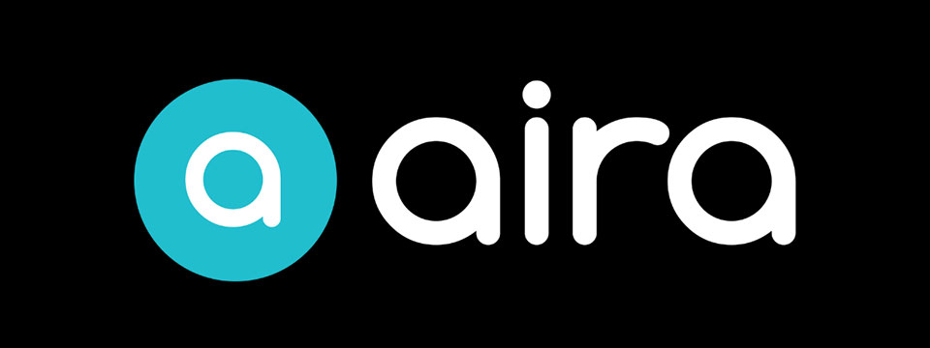
Sponsor Since: August 4, 2022 📅️
Website: https://aira.io/ 🌐️
Download the App: Apple App Store | Google Play Store
Plans and Pricing: https://aira.io/pricing/
Phone: NA: +1.800.835.1934 📱️ | AU: +1.800.765.096 📱️ | UK: +0.800.046.5668 📱️ | NZ: +1.800.425.451 📱️
Text Message: NA: +1.858.242.4457 📱️ | AU: +61.488.839.767 📱️ | UK: +44.149.320.2474 📱️
Email: support@aira.io 📧️
About: At Aira, we believe access to information is a human right. Aira breaks down accessibility barriers by providing on-demand video remote interpreting for both the blind and low-vision community, and the Deaf Community. People can download the Aira Explorer app or the Aira ASL app, and be instantly connected to a professional interpreter. Available 24/7/365, interpreters work with callers to facilitate more efficient communication and accomplish tasks together. Aira is proud to lead the way in delivering secure, on-demand, inclusive services that transform lives and open doors to new opportunities for all.
Contact Us | Access Partners | Plans and Pricing
Step One: Subscribe and Download. Pick the plan that lets you explore on your terms and on your time, sign up in a few minutes, and download the Aira app to your smartphone. Plans shown are for the United States, Canada, Australia, New Zealand and the United Kingdom. Add or cancel at any time.
Step Two: Connect with an Aira Agent. On the first call, connect with one of our certified, specially-trained Agents and learn how everything works.
Step Three: Real-time Assistance. At the touch of a button, Aira delivers instant access to visual information, when and where you want it.
Social: Twitter | Facebook | LinkedIn | YouTube | Instagram

⬆︎ 6.) Sponsor: Fable Tech Labs

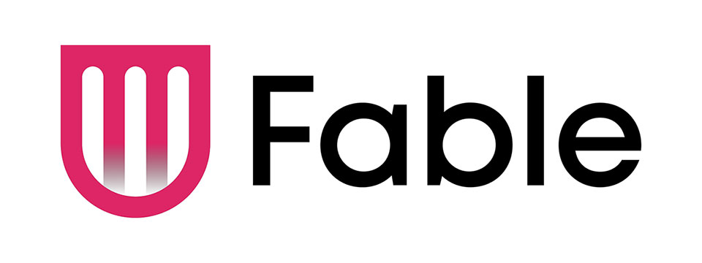
👉️ Classified Advertisement: Learn Management Skills For Free. Get The Job You Want | Fable
Everyone deserves equal access to the internet which is why Fable works with people with disabilities who use assistive technologies like switch controls to improve the accessibility of websites and apps. Fable Pathways, a free, accessible, and on-demand skill-building program, is an extension of Fable's mission. Fable Pathways provides new opportunities for people with disabilities to gain the skills they need, from experts like Judy Heumann and Kelly Ford, to contribute to improving digital accessibility.
Sponsor Since: June 30, 2022 📅️
Website: https://makeitfable.com/ 🌐️
Email: community@makeitfable.com 📧️
About: Fable is an accessibility platform powered by people with disabilities, connecting them to accessibility managers, user researchers, designers, and developers to build accessible user experiences.
Opportunities:
➜ Accessibility Tester: Testers drive meaningful change in digital accessibility by sharing feedback on the websites and apps of the companies that care. As a Tester, earn a competitive tech industry wage, learn valuable transferrable skills, and grow your career. Fable is looking for assistive technology users in the US or Canada to work the hours that they want, completely from home. No experience or resume required.
➜ Survey Respondent: Survey Respondents enjoy a remote, low-commitment income opportunity, all while contributing to accessibility research. Surveys are typically sent out once a month, and you can earn $5 to $50 per survey. Apply today if you identify as having a disability and live in the US or Canada. You do not need to use assistive technology to apply.

⬆︎ 5.) Sponsor: SelvasBLV

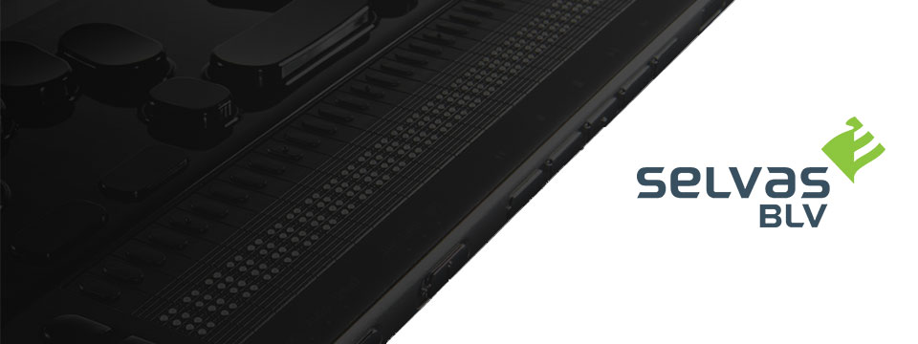
👉️ Classified Advertisement: Braillesense 6 And 6 Mini Firmware 3.0 Is Live!
We are very excited to announce the much-anticipated version 3.0 update for the BrailleSense 6 and BrailleSense 6 mini is now live! This major update delivers a redesigned Main Menu and Settings dialog, an enhanced Word Processor, a new Braille Practice app for teaching and learning Braille, the highly anticipated new Web Browser, and more.
Sponsor Since: September 30, 2021 📅️
Website: https://selvasblv.com/ 🌐️
Shop All Products: https://selvasblv.com/shop-all-products/ 🛒️
Phone: (512) 837-2000 📱️
YouTube: https://www.youtube.com/watch?v=5R9NjA1nfWo
Sales: sales@selvasblv.com 📧️
Support: support@selvasblv.com 📧️
About: SelvasBLV is a global manufacturer and distributor that has provided braille, magnification and accessible healthcare devices since 1999.

⬆︎ 4.) Sponsor: Carroll Center for the Blind


👉️ Classified Advertisement: Attend the Screen Reader User Tester Training Program at the Carroll Center for the Blind | Carroll Center for the Blind
Launch your career in the digital accessibility field! The Carroll Center for the Blind's new 7-week intensive Screen Reader User Tester Training program allows participants to learn and grow their ability to professionally explore, test, and report findings regarding the accessibility of websites, mobile applications, and digital document files using screen readers. Want to learn more? Start your journey to becoming a Screen Reader User Tester today.
Sponsor Since: August 5, 2021 📅️
Website: https://carroll.org/ 🌐️
Phone: (617) 969-6200 📱️
Fax: (617) 969-6204 ░️
Shop: https://carroll.org/store/ 🛒️
Donate: https://carroll.org/donate ❤️
Social: Facebook | Twitter | YouTube | LinkedIn | Instagram
About: The Carroll Center for the Blind is the foremost leader in vision rehabilitation services for individuals confronted by the challenges of vision loss. Our mission is to empower those who are blind or visually impaired to achieve independence and to lead a fulfilling life. Established in 1936, the renowned Carroll Center for the Blind has been serving those with vision impairment for over eight decades; we are known nationally as a premier Vision Rehabilitation Center. Located just outside of Boston on a sprawling campus in Newton, Massachusetts, we proudly serve ALL ages and ALL stages of vision loss. With the ongoing promise of improving the lives of people with vision-related problems, The Carroll Center for the Blind has pioneered many innovative services allowing people who are blind or have low vision to learn the skills to be independent in their homes, in class settings, and in their work places. Our services include vision rehabilitation, vocational and transition programs, assistive technology training, educational support, and recreation opportunities for individuals who are visually impaired of all ages. For over 80 years, the expertise of Carroll Center staff has provided help for thousands of blind and visually impaired persons with diverse opportunities for success and independent living.

⬆︎ 3.) Sponsor: Pneuma Solutions

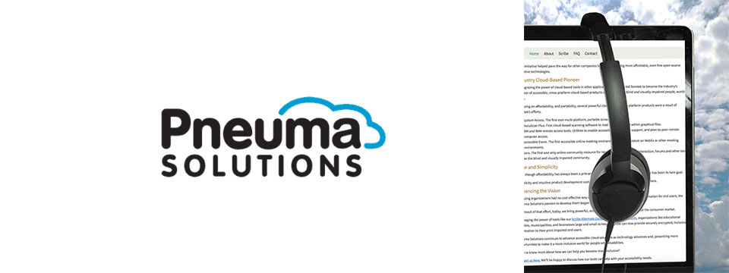
👉️ Classified Advertisement: Accessible Archive: Scalable, On-Demand Accessibility for Large Document Repositories | Pneuma Solutions
Organizations with large digital libraries, such as universities, government agencies, publishers, museums, and corporations, are under increasing pressure to provide accessible versions of their content to meet global disability and inclusion laws. But full-scale remediation of millions of documents is rarely practical or budget-friendly.
The Accessible Archive offers a scalable, just-in-time approach to document accessibility. Instead of converting every document in advance, this system makes archived content instantly available in accessible formats only when requested. The result is lower costs, faster deployment, and compliant, user-friendly output across a range of needs, including for blind, low-vision, and other print-impaired users. The Accessible Archive is designed to handle the scale and complexity of institutional digital libraries without requiring full pre-processing or re-engineering.
Sponsor Since: June 3, 2021 📅️
Website: https://pneumasolutions.com/ 🌐️
Email Newsletter: Click here to receive periodic news via email concerning Pneuma Solutions products for business, consumers and education.
Sales: (866) 202-0520 📱️
Support: (650) 249-1000 📱️
About: Backed by two decades of creating award-winning accessible cloud technologies for people with visual impairments, Pneuma Solutions is the global leader in accessible cloud-based solutions. Pneuma Solutions was founded by long-time accessibility developers Mike Calvo and Matt Campbell. For more information on their individual profiles, click on their respective bio pages. We're proud to be the first company to develop cloud-based accessibility at the network level. Our tools provide organizations, like yours, a way to deliver secure, accessible information right from your network or from our secure servers. You can provide your print disabled consumers, students, employees, and citizens with a multitude of accessible options. Additionally, we offer a suite of cloud-based applications to blind and print disabled consumers directly from our website. Our consumer products are designed to make the day-to-day lives of blind and print disabled individuals more accessible and simpler to manage. Access to information is not a privilege, it's a right. It's also your right to obtain affordable, accessible cloud solutions to serve your end user. When organizations like yours implement our tools, together we help make it a more inclusive world for people with disabilities. Want to know more about how we can help you become more inclusive?
Contact us here. We'll be happy to discuss how our tools can help with your accessibility needs.

⬆︎ 2.) Sponsor: Freedom Scientific

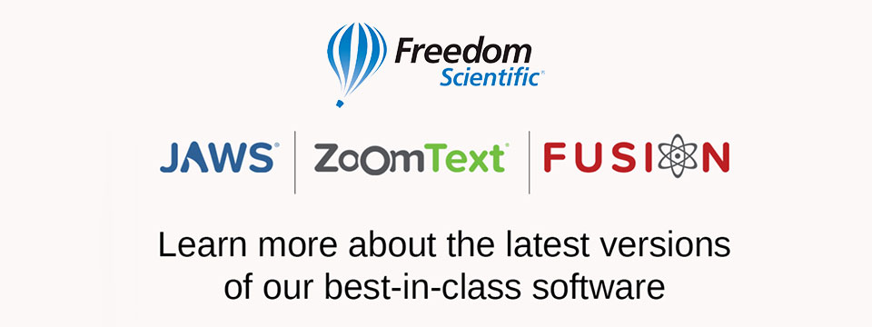
👉️ Classified Advertisement: Freedom Scientific Focus Blue 5th Generation Refreshable Braille Displays | Freedom Scientific
Our world-class refreshable Braille displays deliver efficient Braille input and outstanding output for your PC or mobile device. The robust Bluetooth® connectivity provides seamless use with Windows®, Mac®, iPhones®, iPads®, and Android TM smartphones and tablets. Ergonomic navigation features allow quick, natural hand movements for greater productivity. When used with JAWS® screen reading software, they support our popular Braille Study Mode, an interactive tool for teaching and learning Braille. Learn more today.
Sponsor Since: April 15, 2021 📅️
Website: https://www.freedomscientific.com/ 🌐️
Email: info@vispero.com 📧️
Phone: (800) 444-4443 📱️
Facebook | Twitter | YouTube (Training)
About: Freedom Scientific, a Vispero brand, is a leading worldwide brand of assistive technology products for those with vision impairments. We offer products designed to promote independence, allowing blind and low vision individuals the same access to information as their sighted peers. World-renowned JAWS (Job Access With Speech) screen reading software and ZoomText screen magnification software provide users the independence and ability to seek education and obtain or maintain a career after vision loss. Our expansive product line includes both low vision and blindness technology for all aspects of daily living. The wide range of RUBY, TOPAZ, and ONYX desktop and portable video magnifiers are designed for their ease of use and assist with daily activities. Our impressive line of blindness hardware products include refreshable Braille displays and scanning and reading devices, offering many options tailored to fit individual needs.

⬆︎ 1.) Sponsor: A. T. Guys

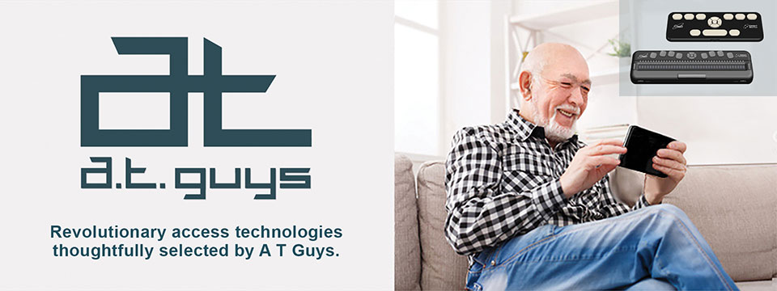
👉️ Classified Advertisement: Pluggable USB-C 7-in-1 Hub | A. T. Guys
If you're like me, you probably have more things to plug into your computer than available ports. That's why we've now added the Pluggable USB-C 7-in-1 Hub. Plug it into your laptop and you will get 3 USB ports, SD and Micro SD card slots, a USBC charging port, and an HDMI video port. It's available now for just $29.95.
Sponsor Since: June 11, 2020 📅️
Website: https://www.atguys.com/ 🌐️
Phone: (269) 216-4798 📱️
Email: support@atguys.com 📧️
Skype: atguys 💬️
X (Formerly Twitter): https://twitter.com/atguys (@atguys) 💬️
Facebook: https://facebook.com/atguys 💬️
About: ATGuys.com. Your access technology experts, home for cool gadgets, accessories, and more. Our products are all tested to work great for blind and visually impaired users but also work just as well for anyone. If there's an item you're looking for, or if you have a question, please don't hesitate to send us a message or call (269) 216-4798 📱️.

⬆︎ 19.) Sponsor: ConnectAlt
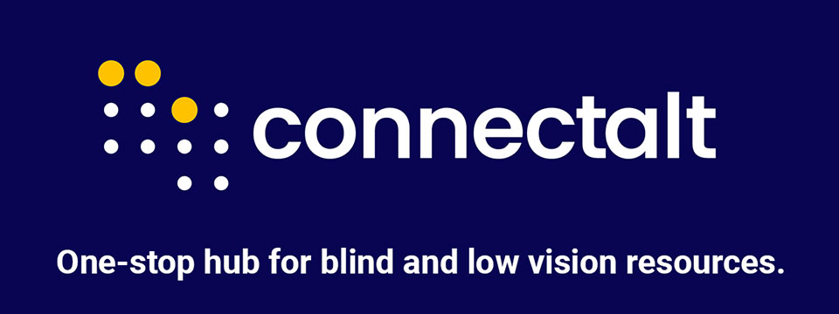

👉️ Classified Advertisement: Connect Alt: Free Accessible Calendar for the BLV Community
Stay connected with Connect Alt, the free, one-stop accessible calendar created by and for the Blind & Low Vision (BLV) community. Find events, programs, and opportunities all in one place — always easy to access and free to use.
Subscribe today and start exploring what's happening in the BLV community!

Sponsor Since: September 25, 2025 📅️
Website: https://connectalt.com/ 🌐️
About: ConnectAlt is a free, accessible hub that centralizes events, programs, and resources for the blind and low-vision (BLV) community. Built by creator/co-founder Lucie Courtois (who is blind) with Carol Trapani and Ella Deshautreaux, ConnectAlt solves the discovery problem by making it easy to find what's happening by date, topic, organization, and location including virtual offerings. The team is active across BLV networks and national convenings (e.g., exhibitor at NFB 2025) and partners with nonprofits, service providers, and assistive-tech leaders to help people quickly connect with opportunities that improve daily life, education, mobility, and employment.
Sponsoring ConnectAlt aligns your brand with tangible access and inclusion while reaching an engaged audience of BLV individuals and families, educators, VR counselors, nonprofits, employers, and assistive-tech users. Packages can include high-visibility placement alongside relevant listings and resources, partner spotlights, community giveaways, and event activations around key gatherings such as the Blind Travel Summit (Austin, Nov 13-14, 2025) — all while keeping the core platform free to users. Let's tailor a sponsorship that advances your goals and measurably expands access for the BLV community.
Social: Follow us on Instagram.

⬆︎ 18.) Sponsor: Double Tap

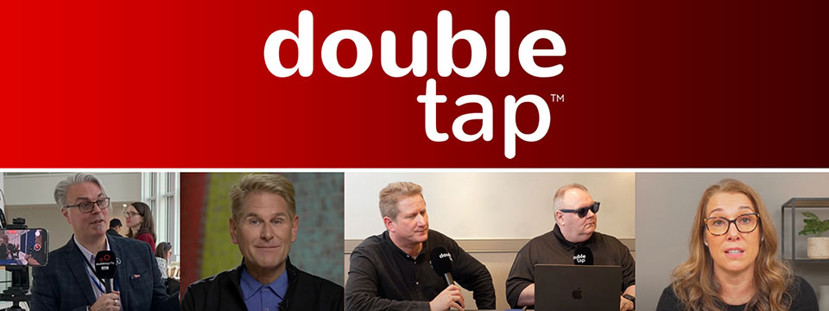

Sponsor Since: March 15, 2025 📅️
Website: https://doubletaponair.com/ 🌐️
About: Founded in 2017 as “Double Tap Canada” on AMI-audio, Double Tap has grown into a weekday podcast, radio show and YouTube series whose tagline proudly declares it "The Podcast Where Blind People Talk Tech." Its Glasgow-based creator Steven Scott, Manchester-based producer-co-host Shaun Preece and Canadian executive producer Marc Aflalo now helm more than 600 episodes that drop every weekday at noon ET, alongside written articles and video clips on DoubleTapOnAir.com.
Each episode blends mainstream gadget news with deep dives into assistive tools, all filtered through the lived experience of blind hosts. Listener emails, voicemails and WhatsApp messages are woven into the conversation, while spin-offs such as Shaun of the Shed (beginner tutorials) and past TV projects like Access Tech Live extend the brand across platforms in partnership with Accessible Media Inc. The result is a vibrant, multi-platform ecosystem that reaches audiences via AMI-audio, every major podcast app, YouTube and even specialist players like the Victor Reader Stream.
The community's enthusiasm shows: Double Tap recently surpassed one million cumulative downloads and, in March 2025 alone, attracted nearly 27K listeners generating 38K downloads; Apple Podcasts users rate it around 4.8 / 5. Authentic insights, daily consistency and professional production continue to position Double Tap as an essential, trusted voice at the intersection of mainstream tech and accessibility.
Newsletter (Double Tap Digest) | Facebook | Instagram | LinkedIn | TikTok | X (Formerly Twitter) | YouTube

⬆︎ 17.) Sponsor: Awarewolf Gear

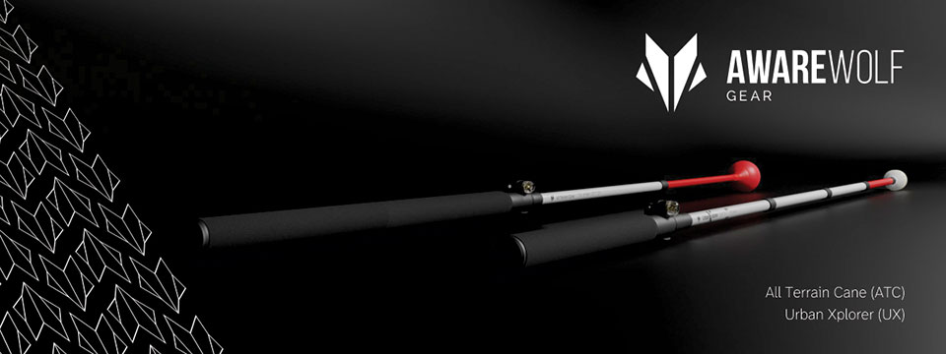

Sponsor Since: February 28, 2025 📅️
Website: https://awarewolfgear.com/ 🌐️
About: Awarewolf Gear is built on innovation, resilience, and a passion for adventure — especially for those in the blind and low vision community.
Awarewolf Gear is dedicated to redefining mobility through high-performance, thoughtfully engineered canes.
With the core belief that everyone deserves to explore confidently, our mission is encapsulated in our tagline, "Power for Life's Adventure."
Our product line, community initiatives, and inspirational storytelling all work in tandem to empower users to navigate diverse terrains with ease and independence.
Product Line
⚫️ All Terrain Cane (ATC)
Design & Purpose: The All Terrain Cane was originally engineered for the rugged trails of Sedona, Arizona. Made from durable titanium alloy, it is built to handle everything from sandy beaches to rocky mountain paths. Its adjustable 16-inch handle and high-performance roller ball tip provide stability and versatility across varied surfaces.
⚫️ Urban Xplorer Cane (UX)
Innovation & Versatility: Merging the rugged design of the ATC with enhancements for urban mobility, the Urban Xplorer Cane features an adjustable handle and a specially designed "Dome" cane tip. Available in multiple sizes (small, medium, large and extra-large), this lightweight, robust cane is ideal for navigating busy city streets as well as more challenging environments.
⚫️ Cane Tips
Customization & Performance: Awarewolf Gear's Cane Tips are designed to elevate your mobility experience by ensuring smooth, reliable navigation across all terrains. Crafted for both durability and style, these premium replacement tips allow users to personalize their canes while enhancing performance.
⚫️ Accessories and Apparel
Customization & Expression: Beyond canes, Awarewolf Gear offers a range of accessories — such as colorful replacement cane tips designed for visibility and personal expression — and apparel that carry the brand's adventurous spirit.
Instagram | Facebook | LinkedIn | YouTube

⬆︎ 16.) Sponsor: Vision Tech Academy

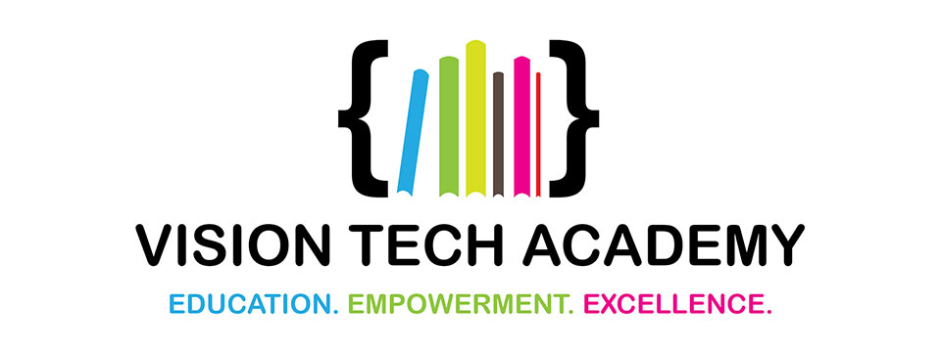

Sponsor Since: January 15, 2025 📅️
Website: https://visiontechacademy.com/ 🌐️
About: Vision Tech Academy is a website, platform and online directory dedicated to empowering blind and low-vision individuals by connecting them with trusted assistive technology educators for free.
Vision Tech Academy is the home of the free, access-technology specific, Online Directory of Educators (ODE).
Inspired by the legacy of John Panarese, the Academy website serves as a hub for accessible learning, offering a free directory of access educators, live and recorded courses, and resources to foster learning independence and success.
With an ongoing mission to provide high-quality, trusted, personalized training on tools like VoiceOver, JAWS, NVDA and Braille technology, Vision Tech Academy bridges the gap between technology and accessibility, ensuring inclusive and accessible education for all.
📖️ Free Directory for Students
📖️ Free General Profiles for All Access Educators
🏅️ Premium Profiles for Access Educators Who Want More Reach

⬆︎ 15.) Sponsor: Elegant Insights Braille Creations

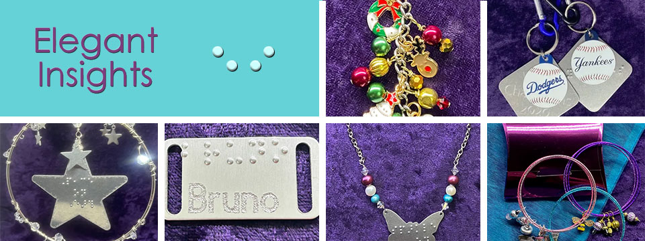
👉️ Classified Advertisement: Join Us For The 10th Edition Of Let's Go Shopping!
Are you an entrepreneur with a disability? Home based business owner? Sole proprietor? A crafter or an artist selling your work? Can you rock an awesome sales pitch? Become a vendor for the 2025 Let's Go Shopping holiday gift extravaganza, set for Saturday, November 1st and Saturday, November 8th. Let's Go Shopping is an online, accessible, virtual mall crawl that connects small businesses with the customers who need them. Discover fashion and fragrance, tech gadgets and small electronics, pet supplies, home decor, jewelry and accessories, and much more. To join the event as a vendor, start at the Let's Go Shopping info page:
https://accessibleinsights.info/blog/lets-go-shopping/
To be added to our Let's Go Shopping groups list for announcements, promotions, coupon codes, the vendor directory and a complete schedule of events, send a blank email to lgs+subscribe@groups.io 📧️ and you will receive all the exciting LGS10 details. For more info, call Laura at +1 (702) 605-1265 📱️.
x (Formerly Twitter) | Facebook | Instagram

Sponsor Since: November 22, 2024 📅️
Website: https://elegantinsightsjewelry.com/ 🌐️
About: Elegant Insights Braille Creations, founded by Laura Legendary, offers a distinctive collection of handcrafted jewelry and accessories embossed with crisp, readable braille.
Inspired by a personal experience, Laura, who is blind, established the brand to merge style with accessibility, providing beautiful and inclusive products. Each piece is made in the USA and can often be personalized or custom-designed to meet individual preferences.
Beyond her work with Elegant Insights, Laura co-founded The Fashionability Channel podcast, which provides beauty, fashion, and lifestyle information for people with disabilities. She also maintains two blogs: the Accessible Insights Blog, offering information on products and services for individuals with low or no vision, and the Sparkle On Blog, which provides jewelry education, design trends, and style information.
Laura's dedication to accessibility and advocacy extends to her role as a speaker, author, and educator specializing in these areas. Her multifaceted efforts aim to empower individuals with disabilities, ensuring they have access to stylish, functional, and meaningful products and information.
Home | About Elegant Insights | Ordering, Shipping and FAQs | My Account | Checkout | Cart | Shop The Boutique | Wish List | Testimonials | Subscribe

⬆︎ 14.) Sponsor: Florida Vision Technology

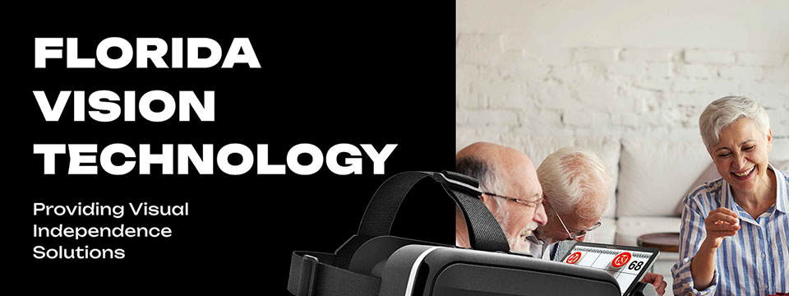

Sponsor Since: October 13, 2024 📅️
Website: https://floridareading.com/ 🌐️
About: Florida Vision Technology is officially celebrating its 20th anniversary. When I started in February 2000, the assistive technology industry was young, and there were just a handful of manufacturers.
Opening the business felt right, and I was ready to jump in. The biggest challenge, in the beginning, was getting a used bulky desk into the shed in my backyard, which my daughters named "Lesa Berg Kretschmer World Headquarters."
Three years later, in June of 2003, we moved into our first offsite location and opened a low vision superstore!
Home | Shop | Blogs | About Us | Contact Us

⬆︎ 13.) Sponsor: Access Park

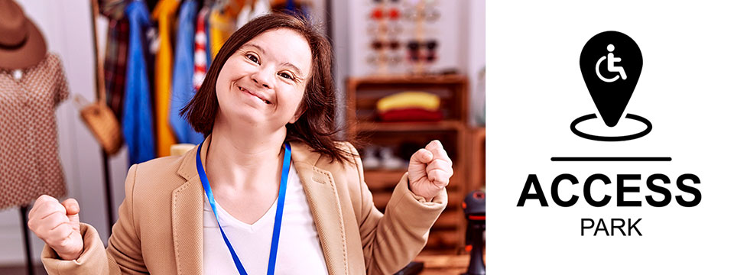
👉️ Classified Advertisement: Donna J. Jodhan's Pottery - Piece By Piece! Building Blocks For Inspiration And Creation! | Access Park
My pottery pieces are designed to inspire your creativity and imagination! Each piece is crafted with care, offering a unique touch to your home and dining experience. Whether you're looking for elegant dinnerware, functional art, or custom pieces, I can help you bring your vision to life. From rustic charm to modern elegance, I specialize in creating pottery that fits your personal style and elevates your dining table. Let me customize a one-of-a-kind creation that reflects your taste and enhances your space, adding beauty and warmth to every meal. And check out the highlight of the month.
A Perspective from World-Renowned Advocate Donna J. Jodhan - How Some Canadian Government Departments Are Using Work Arounds

Sponsor Since: September 20, 2024 📅️
Website: https://accesspark.shop 🌐️
About: Access Park is your premier destination for accessible shopping.
At Access Park, we offer a curated selection of products aimed at enhancing the daily lives of persons with disabilities.
Whether you're looking for accessible tech gadgets, specialty assistive devices, or just everyday essentials, you'll find them here.
Access Park provides a shopping experience that prioritizes keyboard navigability, screen reader compatibility, and high-contrast visuals for those with visual impairments, in addition to other enhancements that provide an elevated shopping experience to users of various assistive technologies.
Access Park. Where inclusivity is always in stock. ^{(TM)}

⬆︎ 12.) Sponsor: The Apex Program

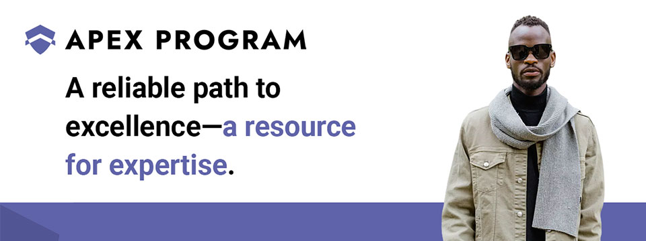
👉️ Classified Advertisement: Jumpstart Your Cybersecurity Career with the Apex Program! | The Apex Program
Are you ready to advance your career in cybersecurity? The Apex Program offers a comprehensive 12-week training course designed to prepare you for the CompTIA Network+ and Security+ certification exams. Tailored for the blind, visually impaired, disabled, and veteran communities, our program combines informative lectures, video tutorials, and quizzes, with expert instructor support every step of the way.
Get started today — Classes start on the first Monday of every month!
Don't miss this opportunity to join a diverse and inclusive workforce in the cybersecurity sector. Visit https://TheApexProgram.com to learn more and secure your spot today!
Sponsor Since: July 16, 2024 📅️
Website: https://theapexprogram.com 🌐️
About: Unlocking Abilities, Securing Futures. Founded on the principles of inclusivity and opportunity, the Apex Program is a pioneering educational initiative in cybersecurity, tailored for the blind, visually impaired, disabled, and veteran communities. Created by a Novacoast employee and inspired by his own journey from disability to Security Operations Center manager, the curriculum is designed to create a strong foundation of IT security knowledge, while instilling confidence and ensuring competence in the IT talent pool. Our ten-week program culminates in industry-recognized CompTIA certifications and a guaranteed pathway to employment, courtesy of Novacoast's dedicated IT Staffing division. At Apex, we don't just teach cybersecurity; we transform lives by unlocking potential and advocating for diversity in the IT security workforce.
Mission: The Apex Program is committed to bridging the gap in cybersecurity talent by empowering the blind, visually impaired, disabled, and veteran communities through inclusive, accessible, and comprehensive training. Our mission is to nurture a diverse workforce equipped with the necessary IT security skills and certifications to thrive in the cybersecurity sector. In partnership with Novacoast, we ensure a solid educational foundation and job placement in the industry, further fostering a future where every individual can focus their distinct abilities on building a more secure digital world.
Novacoast: Novacoast is a cybersecurity and IT services company that helps organizations enhance their security posture. They offer a range of services, including cybersecurity advisory, security engineering, identity and access management, development and integration, penetration testing, managed security services, and incident response. Their managed services include co-managed SIEM, DLP, EDR, vulnerability and patch management, phishing monitoring, and threat operations. Novacoast also provides specialized services for different industries such as finance, healthcare, and gaming. Additionally, they offer staffing solutions and training programs. Learn more today.
Home | A Division of Novacoast | Novacoast Federal | The Program | About Us | Partnerships | Media | Contact

⬆︎ 19.) Sponsor: Your Name Here

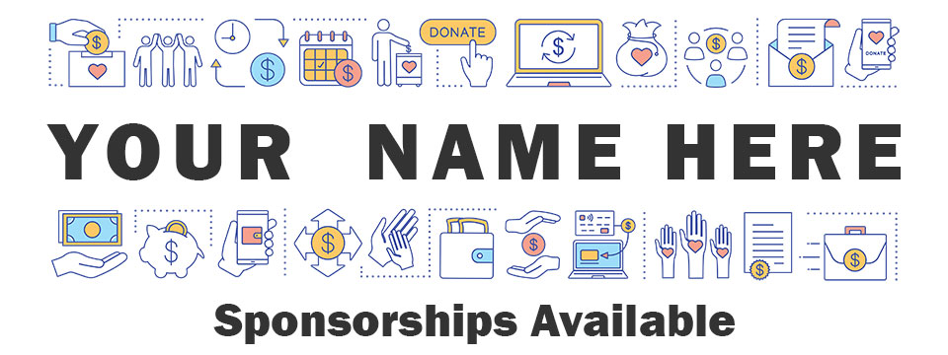
Purchase: Sponsorship Package 💸️ (Packages currently available.)
Join: Waiting List 📋️ (When there are no sponsorship packages available.)
Sponsor Since: Today 📅️
Website: https://toptechtidbits.com/sponsor 🌐️
Phone: (855) 578-6660 📱️
Email: enews@toptechtidbits.com 📧️
About: Founded in 2004, Top Tech Tidbits is the world's leading not-for-profit access technology publication that reaches over 42,000 blind, low vision, deaf, hard of hearing, deafblind, neurodivergent and/or disabled professionals, educators and enthusiasts, all over the world, each week. Subscribe here. Review the most recent issues here.

Top Tech Tidbits Supporters 🤝️
We couldn't do it without you! Thank you for your support!
Why: Top Tech Tidbits Supporters donate an amount of their choosing either one time or annually in order to assist with the ongoing distribution of the Top Tech Tidbits publication.
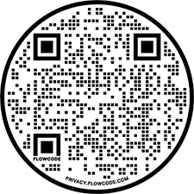
Benefits: All Top Tech Tidbits Supporters receive a listing within the "Our Supporters" section of each weekly newsletter, as well as a listing within the "Our Supporters" section of the Top Tech Tidbits website.
In addition, all Top Tech Tidbits Supporters automatically become Premium Subscribers as well, and therefore enjoy all of the benefits that a Premium Subscription has to offer.
One Time Donation: If you would like to become a Top Tech Tidbits Supporter by making a one time donation in an amount of your choosing to assist with the ongoing distribution of the Top Tech Tidbits publication, you may utilize this donate link, or scan the QR code to the right.
Annual Donation: If you would like to become a Top Tech Tidbits Supporter by making a small donation to assist with the ongoing distribution of the Top Tech Tidbits publication, we also offer the following options, all with our sincerest thanks, and most heartfelt gratitude for your ongoing support.
Support: In tandem with Our Sponsors, these are the people that make the ongoing distribution of Top Tech Tidbits possible.

Platinum Supporters:

Become a Top Tech Tidbits Platinum Supporter today.
1.) Gary Lee
Platinum Supporter since June 25, 2020
2.) Anonymous Donation
Platinum Supporter since July 9, 2020
3.) Pshon Barrett
Platinum Supporter since January 28, 2021
4.) Robin Millar
Platinum Supporter since April 6, 2023

Gold Supporters:

Become a Top Tech Tidbits Gold Supporter today.
1.) Howard Goldstein
Gold Supporter since June 4, 2020
2.) David Goldstein
Gold Supporter since June 12, 2020
3.) Katherine Crohan
Gold Supporter since January 14, 2021
4.) Neil Jarvis
Gold Supporter since April 28, 2022

Silver Supporters:

Become a Top Tech Tidbits Silver Supporter today.
1.) Timothy Gorbold
Silver Supporter since July 19, 2023
2.) Vojtech Polasek
Silver Supporter since December 29, 2023

Bronze Supporters:

Become a Top Tech Tidbits Bronze Supporter today.
1.) Steven Wettlaufer
Bronze Supporter since July 16, 2020
2.) Lions Clubs International
Bronze Supporter since July 13, 2020

One Time Supporters:
One Time Supporters donate an amount of their choosing — one time to assist with the ongoing distribution of the Top Tech Tidbits Publication.
Become a Top Tech Tidbits One Time Supporter today.
1.) Dane Trethowan
One Time Supporter on September 25, 2025
2.) Beth Wright
One Time Supporter on November 28, 2023
3.) Your name here.
One Time Supporter on ...

Top Tech Tidbits News Team 🗞️

Distribution: Sponsors, Supporters, Advertisers and Mind Vault Solutions, Ltd.

Distribution Since: 2004
As of June 4, 2020 the distribution of Top Tech Tidbits is made possible by our Sponsors, our Supporters, our Advertisers and Mind Vault Solutions, Ltd., a leading international provider of professionally outsourced marketing administration and consultation services.
Any time the Top Tech Tidbits Publication carries less than its Sponsor limit, Mind Vault Solutions, Ltd. donates the remaining dollars necessary to keep the publication running.
Please help us to support the ongoing distribution of this publication. Learn more about the benefits of Sponsorship today.

Publisher: Aaron Di Blasi

Publisher Since: June 4, 2020
Location: Cleveland, Ohio
Time Zone: Eastern Standard Time (EST/EDT) (GMT-5/GMT-4)
In addition to serving as Publisher for Top Tech Tidbits Aaron also serves as Publisher for the Access Information News and AI-Weekly newsletters, PR-Director for the AT-Newswire Press Release News Distribution Service, and President and Senior Project Management Professional for Mind Vault Solutions, Ltd.
As Publisher Aaron oversees the weekly distribution of Top Tech Tidbits on behalf of Mind Vault Solutions, Ltd.
Aaron Di Blasi, PMP
Email: publisher@toptechtidbits.com 📧️
Toll Free: +1 (855) 578-6660 📱️
PR Director (2024-Present)
AT-Newswire 🌐
Access Technology's Digital Newswire
Publisher (2024-Present)
AI-Weekly 🌐
The Week's News in Artificial Intelligence
Publisher (2022-Present)
Access Information News 🌐
The Week's News in Access Information
Publisher (2020-Present)
Top Tech Tidbits 🌐
The Week's News in Access Technology
Sr. Project Management Professional (2006 - Present)
Mind Vault Solutions, Ltd. 🌐
Innovative ideas. Solutions that perform.
Certified:
Digital Marketing Associate
Meta Certified (2022 - Present)
Social Marketing Professional
Hootsuite Certified (2020 - Present)
Email Marketing Professional
Constant Contact Certified (2019 - Present)
Specializing in:
Digital Strategy and Content Marketing
Social Media Advertising
Online Fundraising
ADA, WCAG and Section 508 Compliance

Editor: John Hanlin

Editor Since: June 4, 2020
Location: Boulder, Colorado
Time Zone: Mountain Standard Time (MST/MDT) (GMT-7/GMT-6)
In addition to serving as an Editor to Top Tech Tidbits John also serves as an Editor to the Access Information News and AI-Weekly newsletters and is also an attorney-at-law specializing in long-term disability claims for persons who are blind or low-vision.
John is also a long-time contractor and member of the Board of Trustees at Mind Vault Solutions, Ltd.
John Hanlin, Esq.
Editor (2024-Present)
AI-Weekly 🌐
The Week's News in Artificial Intelligence
Editor (2022-Present)
Access Information News 🌐
The Week's News in Access Information
Editor (2020-Present)
Top Tech Tidbits 🌐
The Week's News in Access Technology
Board of Trustees (2006 - Present)
Mind Vault Solutions, Ltd. 🌐
Innovative ideas. Solutions that perform.

Editor: Jenna Lang

Editor Since: June 4, 2020
Location: Des Moines, Iowa
Time Zone: Central Standard Time (CST/CDT) (GMT-6/GMT-5)
In addition to serving as an Editor to Top Tech Tidbits Jenna also serves as an Editor to the Access Information News and AI-Weekly newsletters and runs her own advocacy foundation.
Jenna also serves as a certified Project Management Professional (PMP) for Mind Vault Solutions, Ltd.
Jenna's son was born blind and she is always seeking new and innovative ways to empower him through technology.
Jenna Lang, PMP
Editor (2024-Present)
AI-Weekly 🌐
The Week's News in Artificial Intelligence
Editor (2022-Present)
Access Information News 🌐
The Week's News in Access Information
Project Management Professional (2022 - Present)
Mind Vault Solutions, Ltd. 🌐
Innovative ideas. Solutions that perform.
Editor (2020-Present)
Top Tech Tidbits 🌐
The Week's News in Access Technology

Editor: Stephen (Alex) Marositz

Editor Since: October 7, 2021
Location: Los Angeles, California
Time Zone: Pacific Standard Time (PST/PDT) (GMT-6/GMT-7)
In addition to serving as an Editor to Top Tech Tidbits Alex is also the Accessible Technology Coordinator for California State University, Dominguez Hills. He has worked in accessibility in higher education since 2005, is certified by the International Association of Accessibility Professionals, and in his spare time plays for the San Gabriel Valley Panthers Beep Baseball Team. He can be reached on twitter at: @samarositz.
Stephen (Alex) Marositz
Editor (2021-Present)
Top Tech Tidbits 🌐
The Week's News in Access Technology
Accessible Technology Coordinator
California State University, Dominguez Hills 🌐

Editor: Ben Moxey

Editor Since: January 1, 2022
Location: Newcastle, Australia
Time Zone: Australia Eastern Standard Time (AEST/AEDT) (GMT+10)
In addition to serving as an Editor to Top Tech Tidbits Ben is also an Access and Technology Advisor for Guide Dogs, New South Wales, Australian Capital Territory (NSW/ACT).
Hi, Tidbits readers, my name's Ben Moxey and I'm based in Newcastle, Australia. I'm really happy to be part of the Tidbits Team and look forward to supporting this valuable publication.
A bit about me and how I came to work in the BVI area. I grew up with very low vision in one eye due to retinal issues and relied on magnification and speech throughout school. They also tried to teach me Braille, but let's just say that I wasn't the best student! I was determined to use my remaining vision, no matter how impractical it was becoming.
When I was 20, the other retina came off and I've now been totally blind for about 21 years. This is when my love for assistive technology, and technology in general, really kicked in. I'll be honest, I was a bit of a computer nerd anyway, but I could quickly see how technology was my key to enhanced independence and lifestyle. I embraced screen readers, early smart phones and mobility aids. I even finally realised the huge value of Braille and finished off the course, though I'm still pretty slow!
Long story short (not one of my strong points), I've worked in the BVI area for 12 years with much of that spent reviewing, recommending and teaching assistive technology that suits the individual. I'm currently a proud employee of Guide Dogs NSW/ACT where I was the Practice Lead for the assistive technology service, and I've now moved into an Access and Technology Advisor role. Basically, this involves a strong focus on accessibility and technology innovation.
Feel free to look me up on LinkedIn, but I'll warn you in advance that I haven't given my profile the recommended attention!
All the best and happy reading!
Ben Moxey
Editor (2022-Present)
Top Tech Tidbits 🌐
The Week's News in Access Technology
Access and Technology Advisor
Guide Dogs, New South Wales, Australian Capital Territory (NSW/ACT) 🌐

Editor: David Woodbridge

Editor Since: February 6, 2023
Location: Central Coast, New South Wales, Australia
Time Zone: Australia Eastern Standard Time (AEST/AEDT) (GMT+10)
In addition to serving as an Editor to Top Tech Tidbits David also serves as an Editor to the Access Information News publication and is also the National Commercial Assistive Technology Advisor for Vision Australia where he has worked since 1990. Over this time he has assisted people who are blind or vision impaired in their home, education, and work settings to take advantage of the benefits of using assistive and main stream technology.
In the last seventeen years, he has also been involved with evaluating technology for use by people who are blind or vision impaired covering both low and high tech equipment (including Microsoft, Samsung, Google, Amazon, and Apple). David is also one of the key spokespersons for Vision Australia relating to technology.
He has been an Apple Ambassador for Apple Australia since 2009 with a group of other Ambassadors / Apple Distinguished Educators (ADE)'s covering the range of Apple's Accessibility solutions throughout Australia.
David produces a range of podcasts (since 2011) covering Apple and other technologies which are distributed on his own podcast (http://davidwoodbr.podbean.com). In addition, he also has a regular Talking Tech program (since 2013) which can be heard every Tuesday at 4:30 Eastern Summer Time on Vision Australia Radio Melbourne (available online) or via https://omny.fm/shows/talking-tech-vision-australia-radio
David also runs a weekly Tech Monday where people can chat about assistive and main stream technology, share information, and any tips and tricks.
David lost his sight when he was 8 years old and had to learn Braille. Since then, he completed high school, went to Sydney University receiving a Social Work degree, spent 4 years drug and alcohol counselling, and then moved into his current job.
As a person who is blind, David believes that as a user of the technology that he recommends to others, that he is well situated to look at the strengths and shortcomings of the assistive technology that he comes across in both his professional and personal life, in particular, mainstream technology that is accessible.
In addition to his weekly contributions to Top Tech Tidbits and Access Information News, David's regularly occurring activities are his weekly tech radio show, bi-monthly exploring tech webinars for Vision Australia, his iSee podcast when something of note grabs his attention, and the weekly Tech Monday chat sessions.
David Woodbridge
X (Formerly Twitter): @dwoodbridge
Mastodon: woody@dragonscave.space
iSee Podcast: https://davidwoodbr.podbean.com
Vision Australia Radio Talking Tech: https://omny.fm/shows/talking-tech-vision-australia-radio
Editor (2023-Present)
Top Tech Tidbits 🌐
The Week's News in Access Technology
Editor (2023-Present)
Access Information News 🌐
The Week's News in Access Information
National Commercial Assistive Technology Advisor
(1990 - Present)
Vision Australia 🌐
Live the life you choose. We're here to support all Australians who are blind or have low vision.

Editor: Vicki Walton

Editor Since: January 9, 2024
Location: Benton City, WA
Time Zone: Pacific Standard Time (PST/PDT) (GMT-6/GMT-7)
IIn addition to serving as an Editor to Top Tech Tidbits Vicki also serves as an Editor to the Access Information News publication and works as a Web Accessibility Specialist / IT Quality Assurance Tester at Washington State Board for Community and Technical Colleges.
Vicki Walton
Editor (2024-Present)
Top Tech Tidbits 🌐
The Week's News in Access Technology
Editor (2024-Present)
Access Information News 🌐
The Week's News in Access Information
Web Accessibility Specialist / IT Quality Assurance Tester
Washington State Board for Community and Technical Colleges 🌐
Better Jobs, Brighter Futures, a Stronger Washington

Subscription Information 📰️
ABOUT ♿️
Founded in 2004, Top Tech Tidbits is the world's leading not-for-profit access technology publication that reaches over 42,000 blind, low vision, deaf, hard of hearing, deafblind, neurodivergent and/or disabled professionals, educators and enthusiasts, all over the world, each week. Subscribe here. Review the most recent issues here. Access Technology broadly encompasses technologies that enable access to information and communication systems for persons with disabilities. Adaptive Technology is a subset of Access Technology designed to assist individuals in performing tasks that might otherwise be challenging due to their particular disabilities. Assistive Technology includes any device, software, or equipment that helps people work around their challenges. Top Tech Tidbits is a Mind Vault Solutions, Ltd. Publication. Publisher: Aaron Di Blasi. Editors: John Hanlin, Jenna Lang, Stephen (Alex) Marositz, Ben Moxey, David Woodbridge and Vicki Walton. Top Tech Tidbits is a sponsor, reader and advertiser supported publication.
RELEASE SCHEDULE 📅️
Top Tech Tidbits is released every Thursday morning at 6:00 AM ET.
SUBSCRIBE 📧️
Do you, a friend, or colleague wish to receive the Top Tech Tidbits newsletter? If so, please use or pass along our CAPTCHA-free sign-up link. You can also subscribe to receive the Top Tech Tidbits newsletter on the Top Tech Tidbits Website. Either of these methods will provide you with an accessibly friendly and secure medium through which you can subscribe to our mailing list. Just enter your email address, click send, and begin receiving the Top Tech Tidbits newsletter. It's that easy.
WEBSITE 🌐️
Visit the Top Tech Tidbits website online at: https://toptechtidbits.com.
PREMIUM SUBSCRIBER 💸️
Only Top Tech Tidbits Premium Subscribers receive our special quarterly issue listing the Top 60 Most Clicked News Articles of the Last 3 Months. Just $12 USD per year. This special quarterly issue is provided to Premium Subscribers as a native Microsoft Word document with full headings, links and abstracts to all 60 articles. There are no restrictions placed on these documents. Complete list of all back issues available. Premium Subscribers are entitled to all back issues, anytime they sign up. Join us today and begin receiving this incredibly informative issue every 3 months.
SPONSOR 🏅️
If you would like to become 1 of only 24 Top Tech Tidbits Sponsors whose ongoing support makes the distribution of Top Tech Tidbits possible, we offer you the following advertising benefits, with our sincerest thanks, and most heartfelt gratitude for your ongoing support.
ADVERTISE 🎯️
Top Tech Tidbits offers a variety of one-time advertising options to both Sponsors and non-Sponsors alike. Here we offer a sample newsletter that provides a breakdown of exactly what those one-time advertising options are, where they appear, and what they cost per publication.
DONATE ❤️
If you would like to become a Top Tech Tidbits Supporter by making a small donation to assist with the ongoing distribution of the Top Tech Tidbits publication, we offer the following options, with our sincerest thanks, and most heartfelt gratitude for your support.
STORE 🛒️
Are you blind or do you live with low vision? Are you deaf, hard of hearing or deafblind? Do you require a wheelchair for mobility? Do you consider yourself to be neurodivergent or otherwise disabled? The Top Tech Tidbits Online Store For Digital Downloads specializes in information that can improve your quality of life. Learn more today.
FACEBOOK 💬️
Are you on Facebook? Follow Top Tech Tidbits on Facebook to begin receiving current news and trends in Access Information as part of your Facebook News Feed.
X (FORMERLY TWITTER) 💬️
Are you on X? Follow Top Tech Tidbits on X to begin receiving current news and trends in Access Information as part of your X News Feed.
MASTODON 💬️
Are you on Mastodon? Follow Top Tech Tidbits on Mastodon to begin receiving current news and trends in Access Information as part of your Mastodon News Feed or by searching for @news@mastodon.toptechtidbits.com on your server today.
LINKEDIN 💬️
Are you on LinkedIn? Follow Top Tech Tidbits on LinkedIn to begin receiving current news and trends in Access Information as part of your LinkedIn News Feed.
YOUTUBE ▶️
Are you on YouTube? Follow Top Tech Tidbits on YouTube to begin receiving current news and trends in Access Information as part of your YouTube Video Feed.
RSS 📡️
Do you prefer RSS? Follow Top Tech Tidbits via RSS today to begin receiving current news and trends in Access Information using your choice of news aggregator.
QUESTIONS ❓️
Tidbits are intentionally concise. As a result we know that some readers may not always understand all of the items listed because little explanation is given. If a particular Tidbit brings up a question in your mind, feel free to ask, and we will try to answer as time and knowledge permit.
ARCHIVE 🗄️
Read the most recently released issues of Top Tech Tidbits online here. Visit the Top Tech Tidbits Archive here, where you can read back issues.
CONTENT CONTRIBUTORS ✍️
Any information for future issues of Top Tech Tidbits may be submitted online via our News Item Submission Form or directed to our Editors via email.
THANK YOU 🙏️
Thank you for reading. On behalf of all of us here at Top Tech Tidbits we look forward to keeping you informed.
Information provided by:
Top Tech Tidbits
https://toptechtidbits.com/ 🌐
A Mind Vault Solutions, Ltd. Publication
1284 SOM Center Road, PMB 194,
Mayfield Heights, Ohio 44124
+1 (855) 578-6660 📱️

